ASSIGNMENT -11
Question 1 :

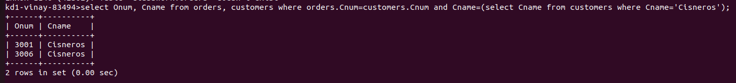
Question 2 :
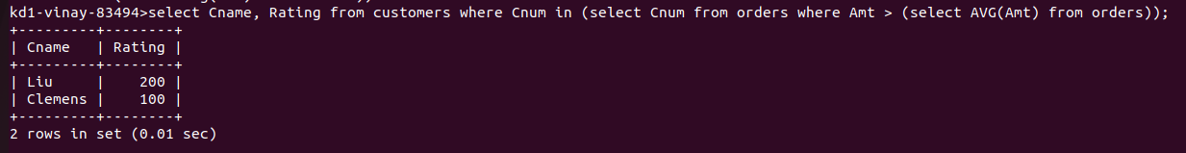
Question 3 :
