ASSIGNMENT – 12
Question 1:
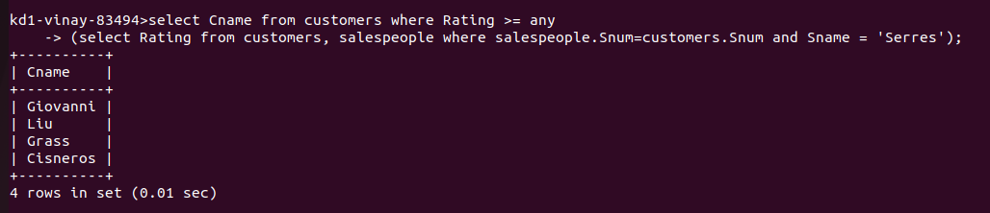
Question 2:
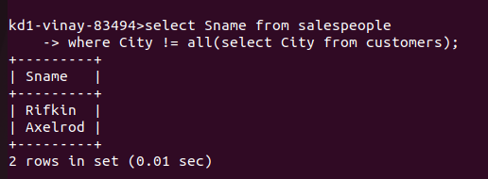
Question 3:
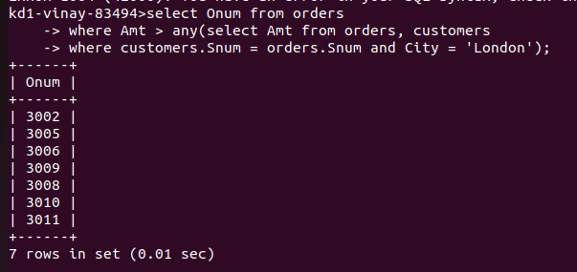
Question 4 :
