ASSIGNMENT -13
Question 1 :
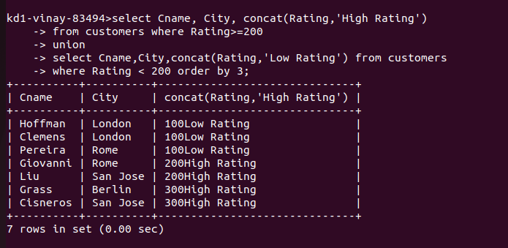
Question 2:
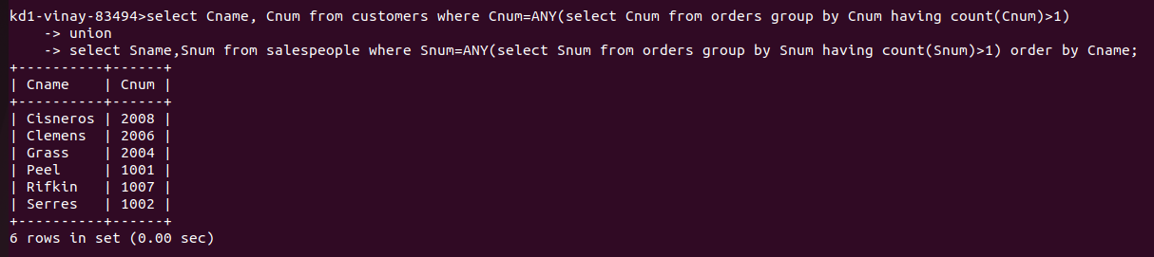

Question 3:
