ASSIGNMENT – 7
Question 1 : Write a query that counts all orders for October 3.
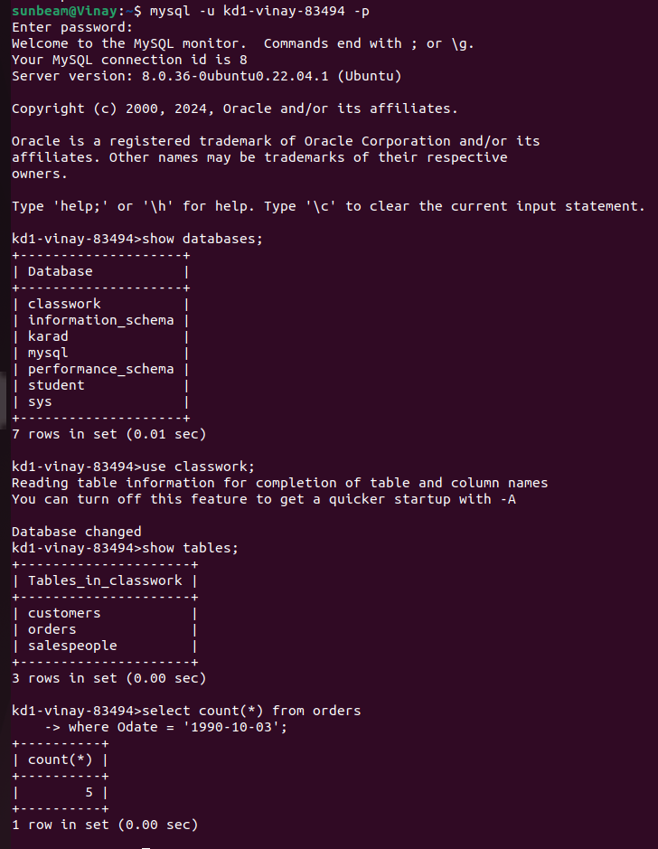

Question 2 : Write a query that counts the number of different non-NULL city values in the Customers table.
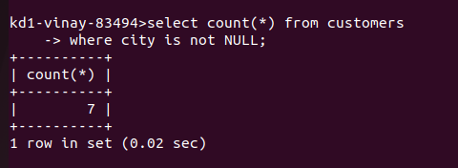

Question 3 : Write a query that selects each customers’s smallest order.
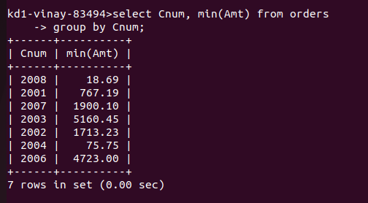
Question 4 : Write a query that selects the first customer, in alphabetical order, whose name begins with G.

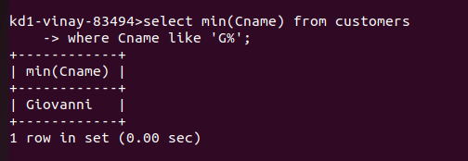

Question 5 : Write a query that selects the highest rating in each city.

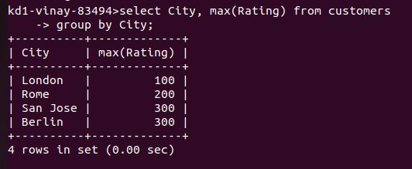
Question 6 : Write a query that counts the number of salespeople registering orders for each day. (If a salespeople has more than one order on a givenday, he or she should be counted only once.).

