ASSIGNMENT – 8

Question 1 : Assume each salesperson has a 12% commission. Write a query on the orders table that will prodce the orders number, the salesperson number, and the amount of the salesperson’s commission for that order.
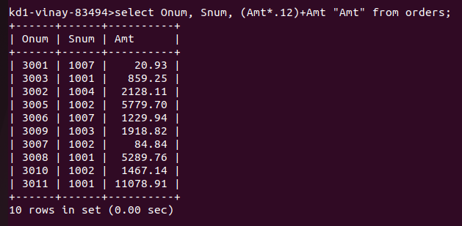
Question 2 : Write a query on the Customers table that will find the highest rating in each city. Put the output in this form :
For the city (city), the highest rating is (rating).

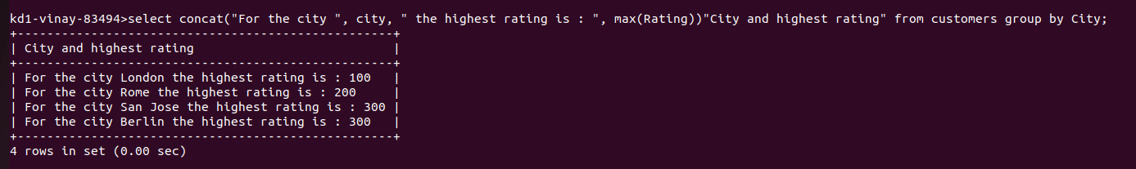

Question 3 : Write a query that lists customers in decending order of rating. Output the rating field first, followed by the customers’s name and number.
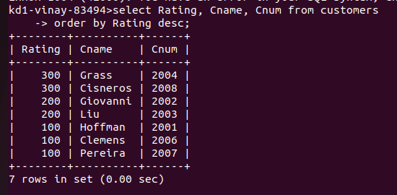
Question 4 : Write a query that totals the orders for each day and places the results in descending order.

