ASSIGNMENT – 9

Question 1 : Write a query that lists each order number followed by the name of the customer who made the order.
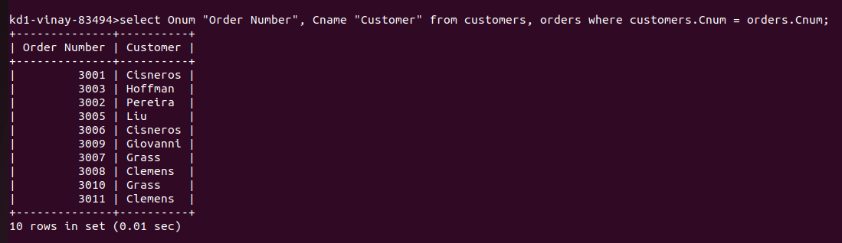
Question 2 : Write a query that gives the names of both the salesperson and the customer for each order along with the order number.

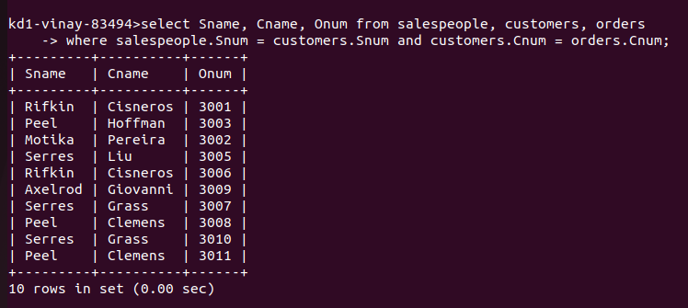
Question 3 : Write a query that produces all customers serviced by salespeople with a commission above 12%. Output the customers’s name, the salesperson’s name, and the salesperson’s rate of commission.

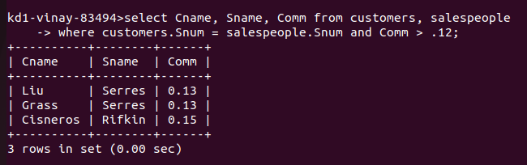
Question 4 : Write a query that calculates the amount of the salesperson’s commission on each order by a customer with a rating above 100.

