MongoDB Assignment
Question 6: View list of available databases
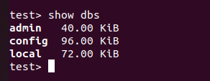

Question 7: Create a new database named CDAC and connect to it
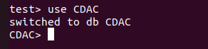

Question 8: View list of available collections in CDAC database
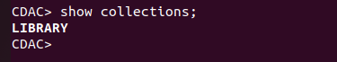

Question 9: Create a new collection by the name of LIBRARY

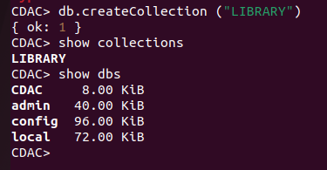

Question 10: Insert the following document in the LIBRARY collection:-
title: ‘MongoDB programming’
author: ‘Sameer’, likes: 100
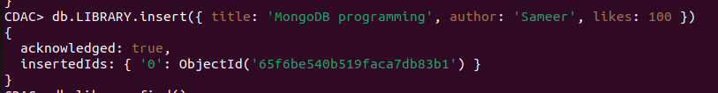
Question 11: View the recently inserted document
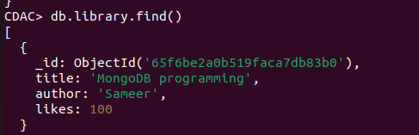

Question 12: Inserted another document in the LIBRARY collection as follows:-
title: ‘MySQL programming’,
authors: [‘Jack’, ‘Jill’], likes: 200
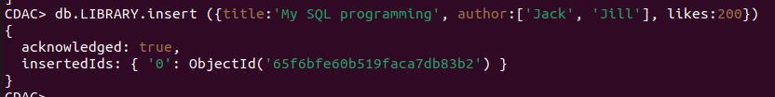
Question 13: View the inserted documents
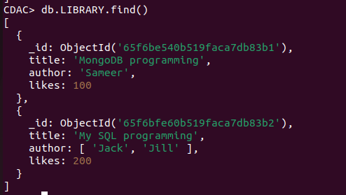
Question 14: View only the first inserted document
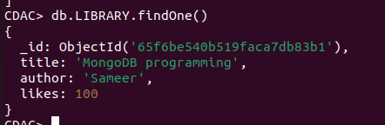

Question 15 : View the documents using the pretty() method
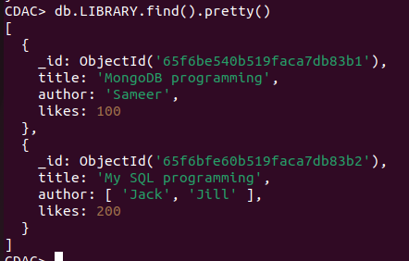

Question 16 : Upload the document where author name Sameer and change it to Sameer Dehadrai
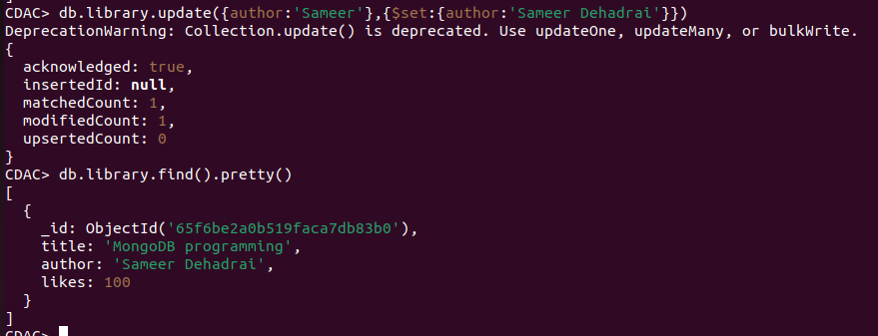
Question 17: Delete all documents that have 100 likes
Question 18: Drop the LIBRARY collection
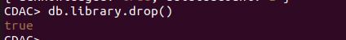

Question 19: Drop the CDAC database
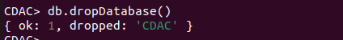

Question 20: Exit from MongoDB shell

Question 21: Stop MongoDB server

