ASSIGNMENT – 1
Creating sample tables and inserting values.

Create the following tables with the given structures and insert data as specified :-

A) SALESPEOPLE
Snum int (4)
Sname varchar (10)
City varchar (10)
Comm float (3,2)

B) CUSTOMERS
Cnum int (4)
Cname varchar(10)
City varchar(10)
Rating int (4)
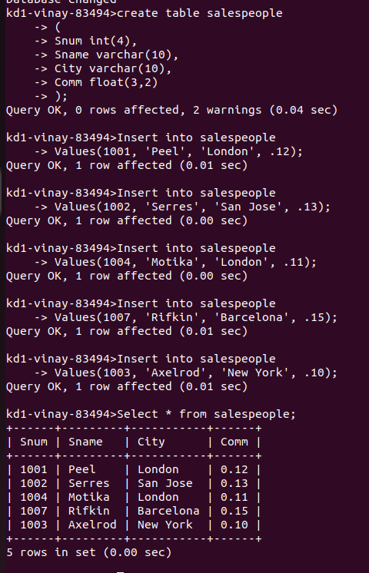

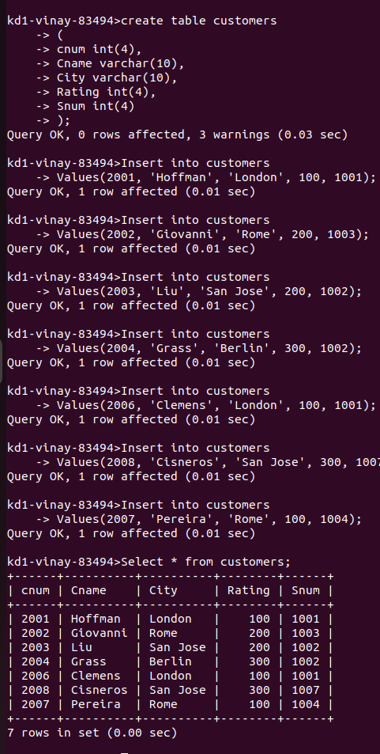
B)

C)
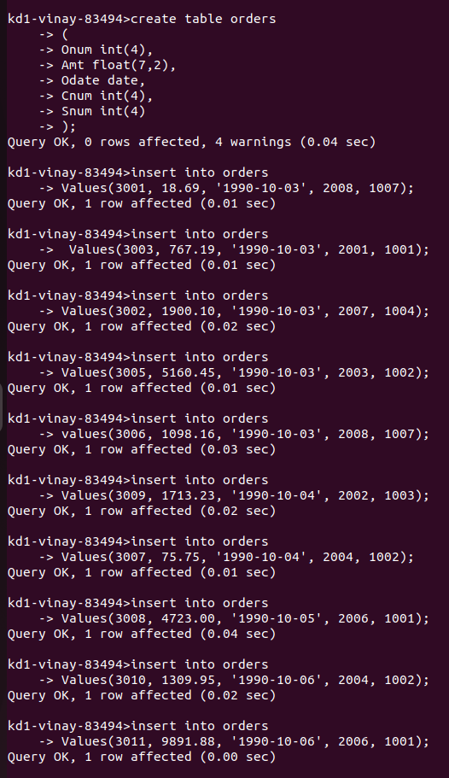

C)
