ASSIGNMENT – 4

Question 1 : Write a select command that produces the order number, amount, and date for all rows in the Orders table.
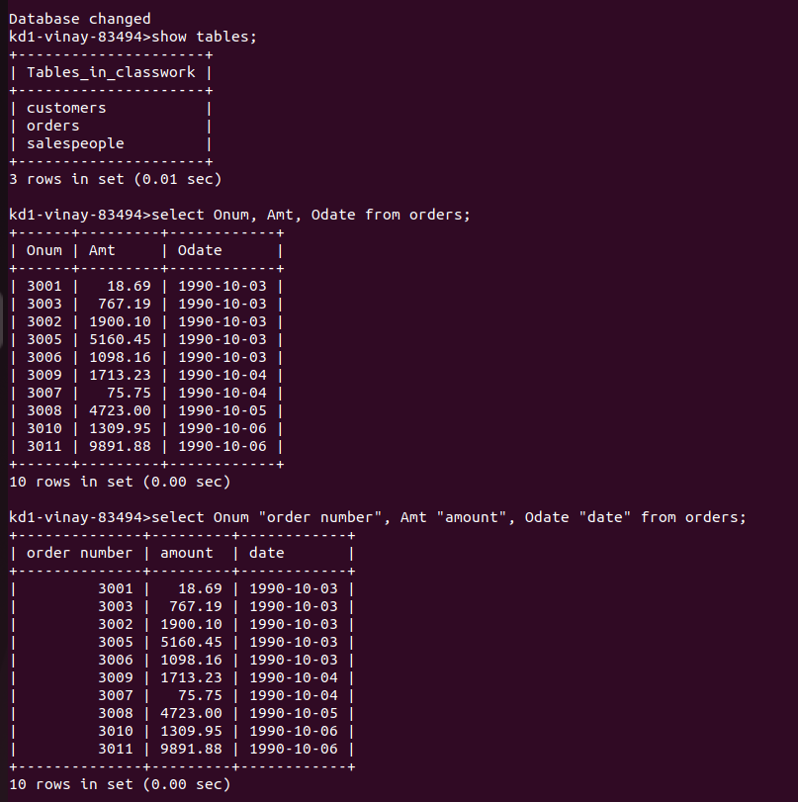

Question 2 : Write a query that produces all rows from the Customers table for which the salesperson’s number is 1001.
Question 3 : Write a query that displays the Salespeople table with the columns in the following order : city, sname, snum, comm.

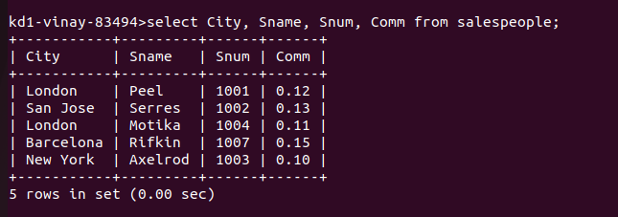

Question 4 : Write a select command that produces the rating followed by the name of each customer in San Jose.

