ASSIGNMENT – 5
Question 1 : Write a query that will give you all orders for more than Rs. 1,000.
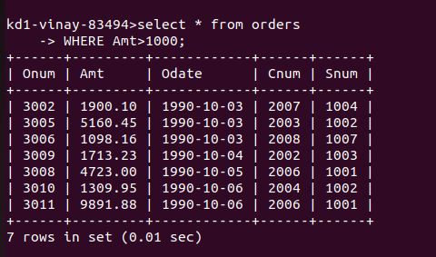

Question 2 : Write a query that will give you the names and cities of all salespeople in London with a commission above .10.
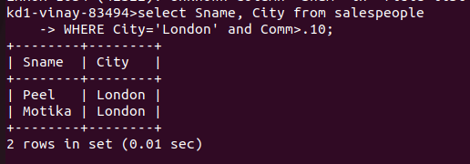

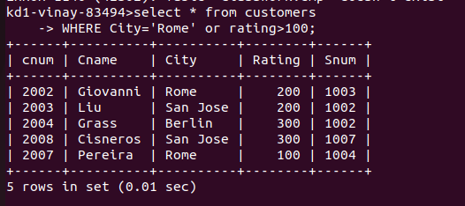
Question 3 : Write a query on the Customers table whose output will exclude all customers with a rating <= 100, unless they are located in Rome.

Question 4 : What will be the output from the following query ?
Select * from Orders
where (amt < 1000 OR
NOT (odate = ‘1990-10-03’
AND cnum > 2003));
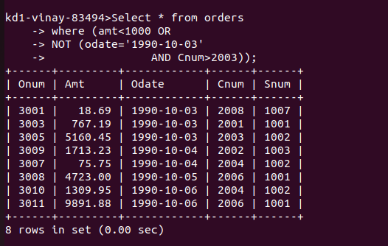

Question 5 : What will be the output of the following query ?
Select * from Orders
where NOT ((odate = ‘1990-10-03’ OR snum > 1006) AND amt >= 1500);
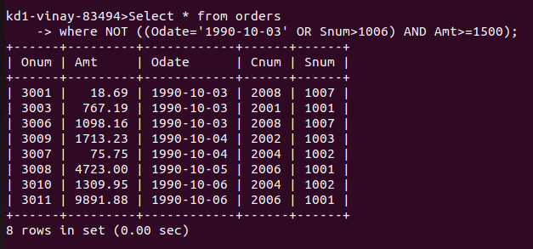

Question 6 : What is a simpler way to write this query ?
Select snum, sname, city, comm From Salespeople where ( comm > .12 OR comm < .14);

