ASSIGNMENT – 6

Question 1: Write two different queries that would produce all orders taken on Oct 3 or 4, 1990.
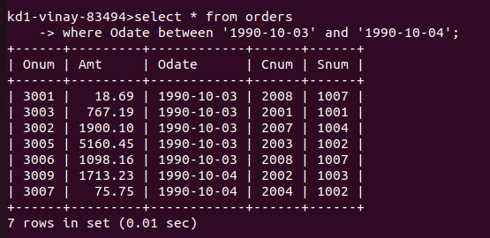
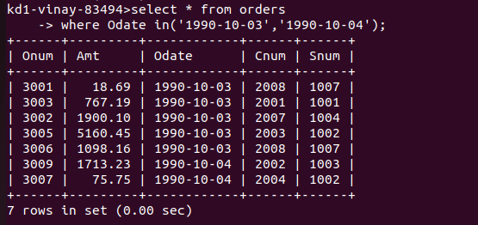

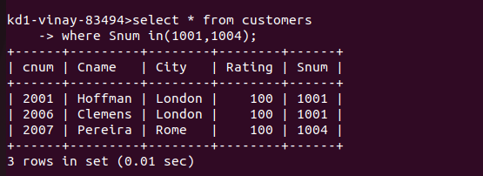
Question 2 : Write a query that selects all of the customers serviced by Peel or Motika.

Question 3: Write a query that will produce all the customers whose names begin with a letter from ‘A’ to ‘G’.

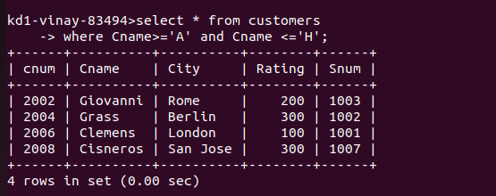
Question 4 : Write a query that selects all customers whose names begin with the letter ‘C’.

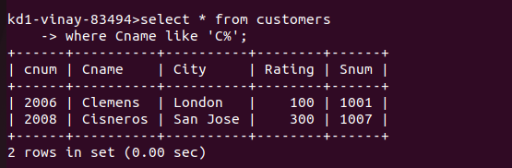

Question 5 : Write a query that selects all orders except those with zeroes or NULLs in the am field.

