ASSIGNMENT :-14

1) Write a command that puts the following values , in their given order, into the salespeople table: city- San Jose, name – Blanco, comm – Null, cnum – 1100.

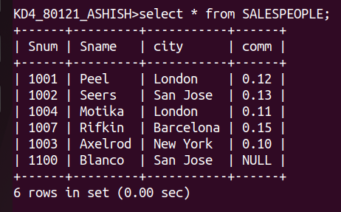
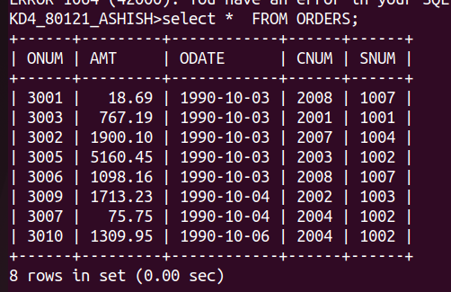
2 )Write a command that removes all orders from customer Clemens from the Orders table.
3) Write a command that increases the rating of all customers in rom by 100.
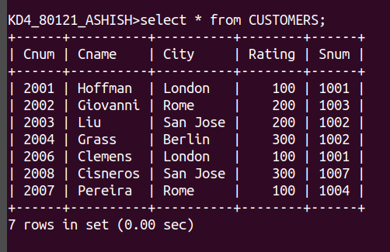

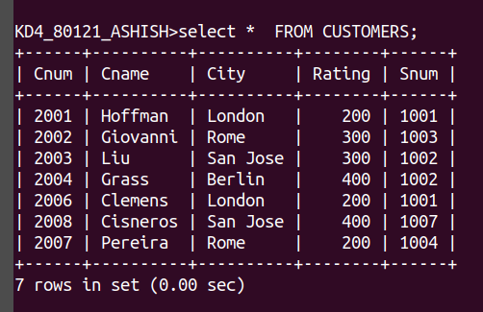

4)Salesperson Serres has left the company. Assign her customers to Motika.

