ASSIGNMENT :-15

Using Subqueries with DML Commands.

1) Assume their is a table called Multicast, with all of the same column definations as salespeople . Write a command that inserts all salespeople with more than one customers into this table.
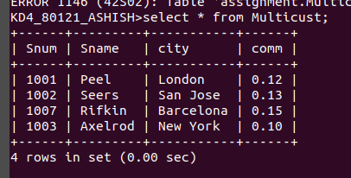

2) Write a command that deletes all customers with no current orders.
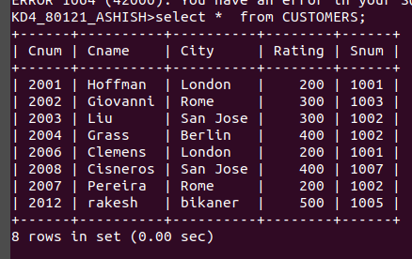

3) Write a command that increases by twenty percent the commissions of all
salespeople with total current orders above Rs. 3,000.

