MONGODB ASSIGNMENT

1. Install MongoDB database server

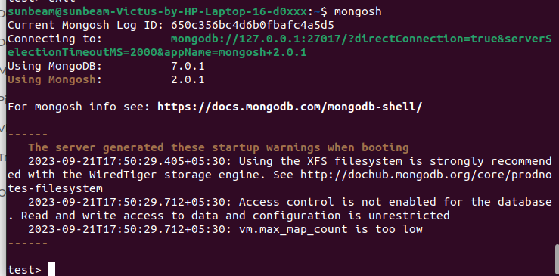

2. Create a new database named CDAC and connect to it

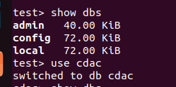

3. View list of available collections in CDAC database

4. Create a new collection by the name of LIBRARY

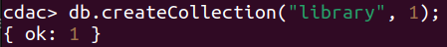

5. Insert the following document in the LIBRARY collection
title:'MongoDB programming', author:'Sameer', likes:100

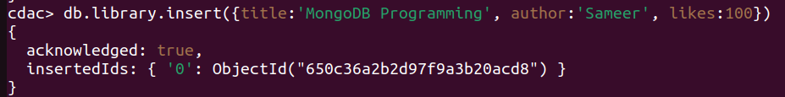

7. Insert another document in the LIBRARY collection as follows:-
title:'MySQL programming', authors:['Jack','Jill'], likes:200
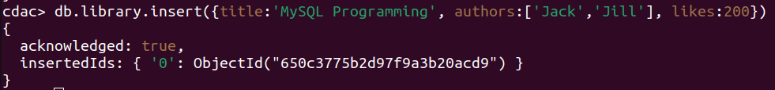

8. View the inserted documents

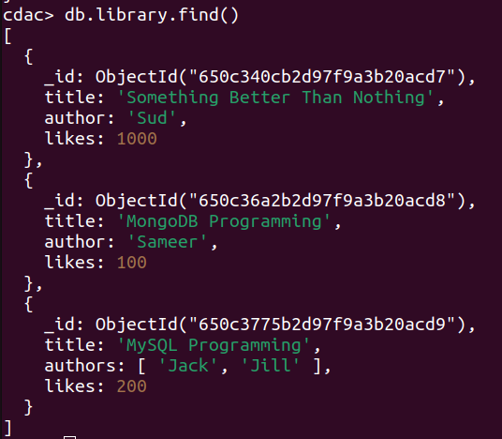
9. View only the first inserted document

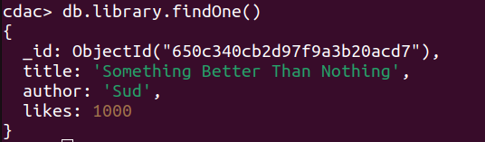

10. View the documents using the pretty() method
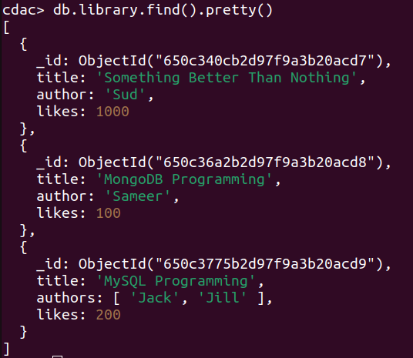
11. Update the document where author name = Sameer and change it to Sameer Dehadrai
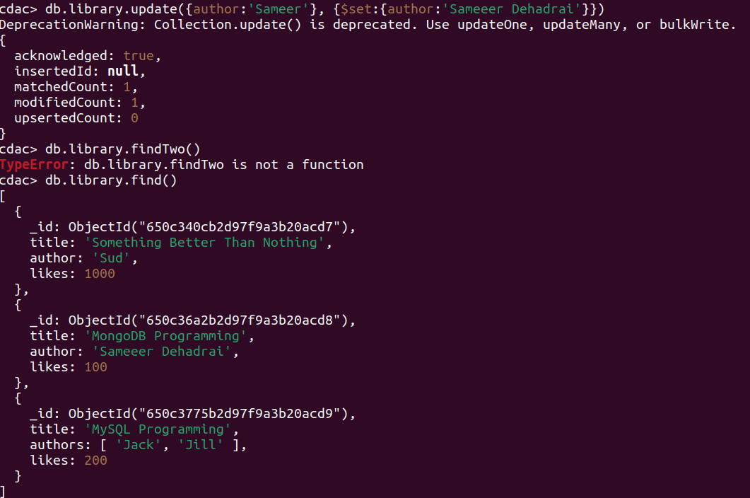

12. Delete all documents that have 100 likes
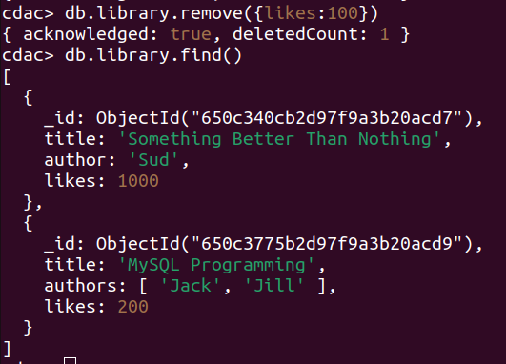

13. Drop the LIBRARY collection

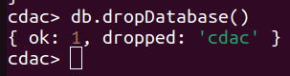

14. Drop the CDAC database

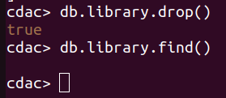

15. Exit from MongoDB shell
