ASSIGNMENT – 1

Q. Create the following tables with the given structures and insert sample data as specified.

1.SALESPEOPLE
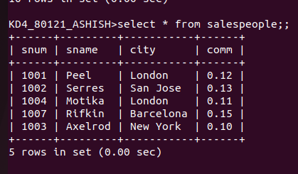
2.CUSTOMERS
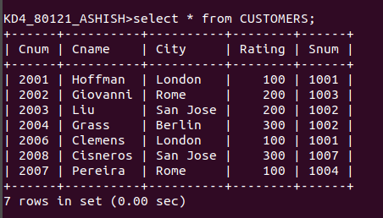
3.ORDERS
