ASSISGNMENT :- 9

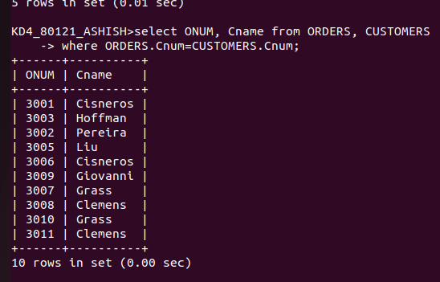
1) WRITE A QUERY THAT LIST EACH ORDERS NUMBER FOLLOWS BY THE NAME BY THE NAME OF THE CUSTOMER WHO MADE THE ORDERS

2) WRITE A QUERY THAT GIVES THE NAME OF BOTH THE SALESPERSON AND THE CUSTOMERS FROM EACH ORDERS ALONG WITH THE ORDERS
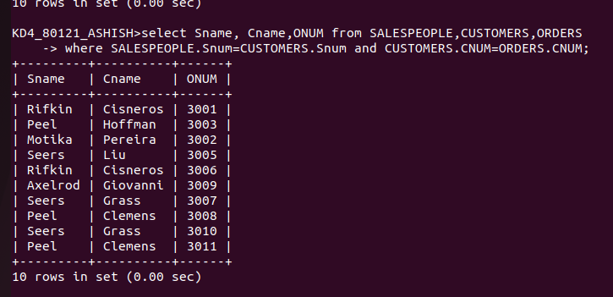

3) WRITE A QUERY THAT PRRODUCES ALL CUSTOMERS SERVICED BY SALESPEOPLES WITH A COMMISSION ABLVE 12% OUTPUT THE CUSTOMERS NAME THE SALESPEOPLES NAME AND THE SALESPERSONS RATE OF COMMISSION

