Q1. Deploy a website on localhost using either apache2 or Nginx. Create a DNS name for this website as ‘awesomeweb’. You can use any web template you want or can write your own simple HTML code.

Step -1 Launch an EC2 instance.

Login to AWS account > click on launch instance > give a name to server, select ubuntu OS, select a key pair, and also make sure to add right Security Group so that you can SSH into the server.

ssh -i "myEC2key01.pem" ubuntu@54.82.44.176

Step-2 installing nginx 🡪 apt-get install nginx -y

start nginx service 🡪 systemctl start nginx

check the status of the service 🡪 systemctl status nginx

Once checked it's up and running, enable the service 🡪 systemctl enable nginx

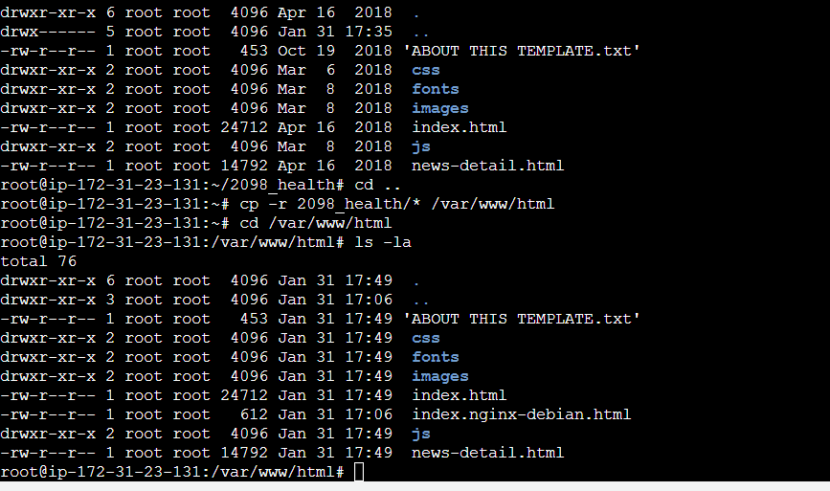

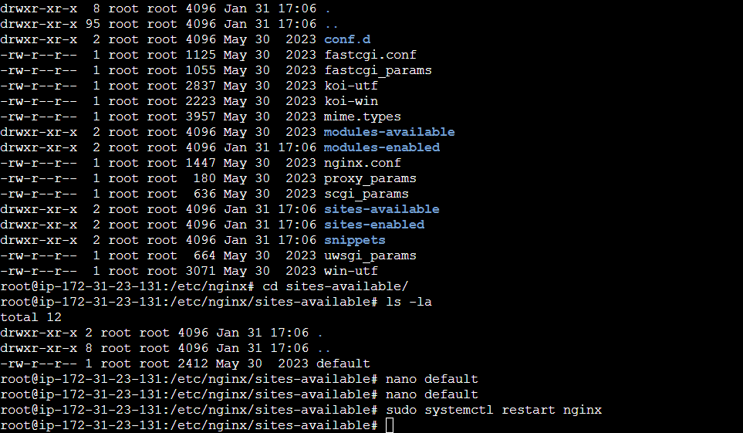

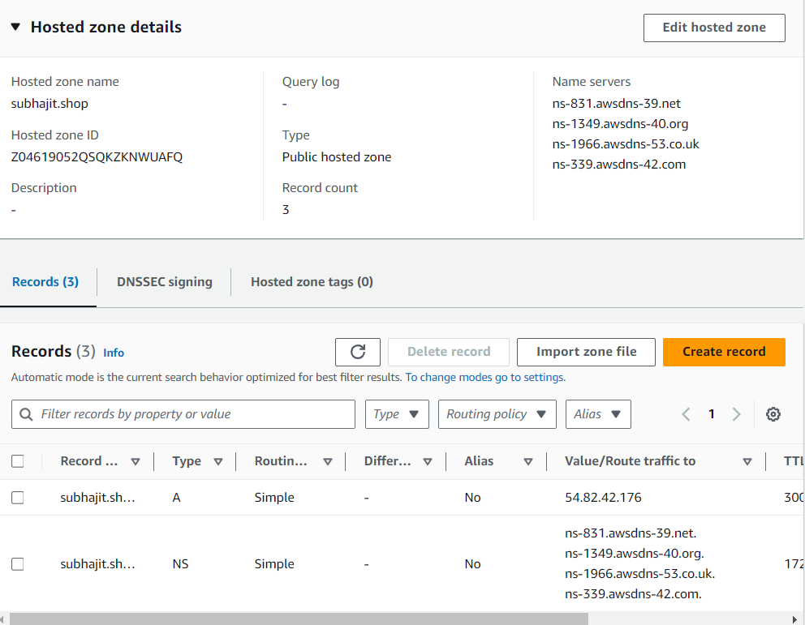

\* Open the website and you will see that the new website is deployed.

