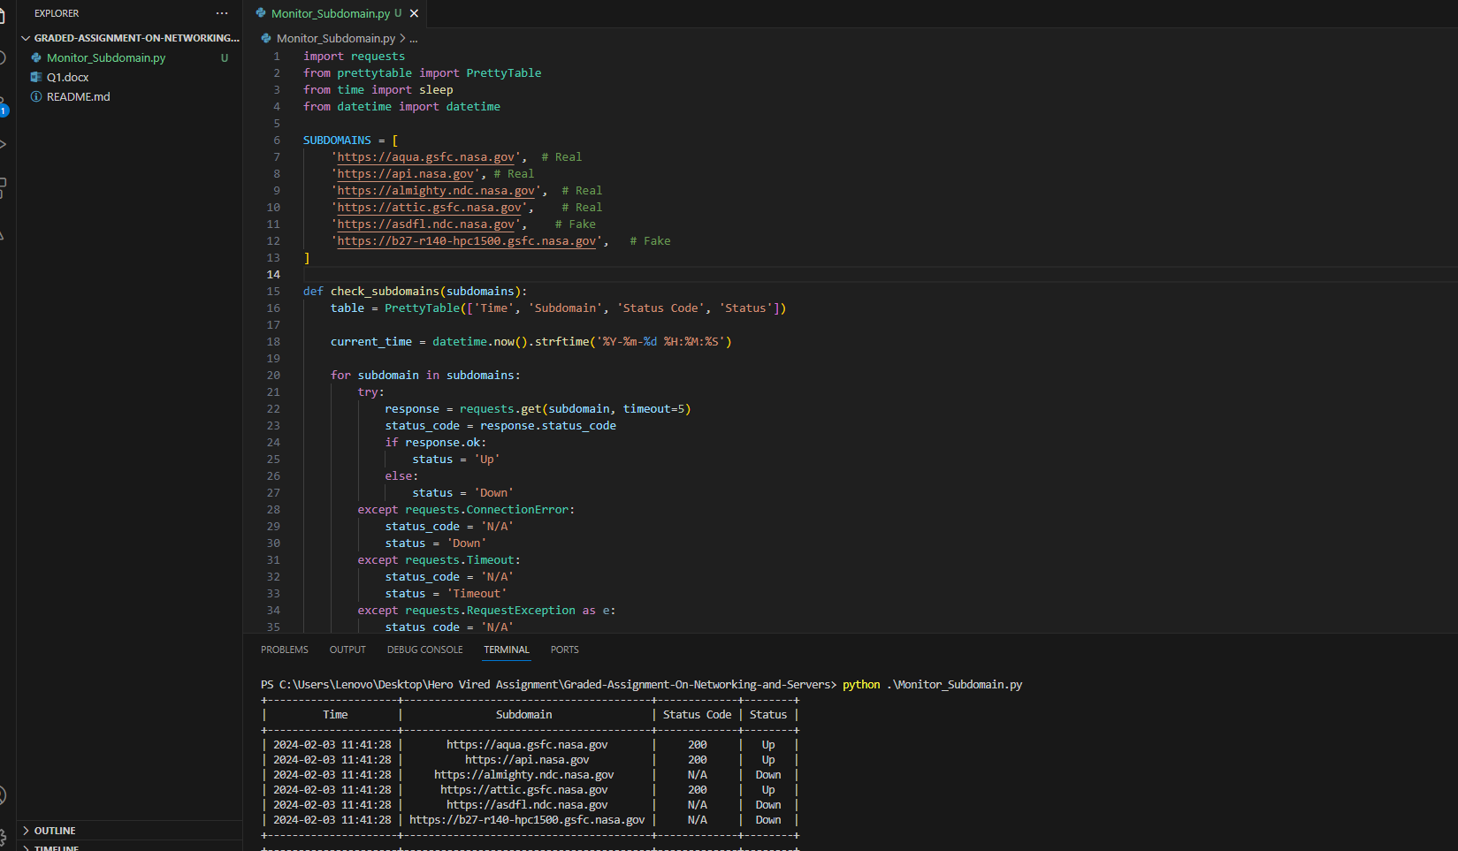

Python Code:

import requests

from prettytable import PrettyTable

from time import sleep

from datetime import datetime

SUBDOMAINS = [

    'https://aqua.gsfc.nasa.gov',  # Real

    'https://api.nasa.gov', # Real

    'https://almighty.ndc.nasa.gov',  # Real

    'https://attic.gsfc.nasa.gov',    # Real

    'https://asdfl.ndc.nasa.gov',    # Fake

    'https://b27-r140-hpc1500.gsfc.nasa.gov',   # Fake

]

def check_subdomains(subdomains):

    table = PrettyTable(['Time', 'Subdomain', 'Status Code', 'Status'])

    current_time = datetime.now().strftime('%Y-%m-%d %H:%M:%S')

    for subdomain in subdomains:

        try:

            response = requests.get(subdomain, timeout=5)

            status_code = response.status_code

            if response.ok:

                status = 'Up'

            else:

                status = 'Down'

        except requests.ConnectionError:

            status_code = 'N/A'

            status = 'Down'

        except requests.Timeout:

            status_code = 'N/A'

            status = 'Timeout'

        except requests.RequestException as e:

            status_code = 'N/A'

            status = 'Error'

        table.add_row([current_time, subdomain, status_code, status])

    return table

def main():

    while True:

        table = check_subdomains(SUBDOMAINS)

        print(table)

        sleep(60)  # Wait for 1 minute

if __name__ == "__main__":

    main()

Desired Output:

PS C:\Users\Lenovo\Desktop\Hero Vired Assignment\Graded-Assignment-On-Networking-and-Servers> python .\Monitor_Subdomain.py

+---------------------+----------------------------------------+-------------+--------+

| Time | Subdomain | Status Code | Status |

+---------------------+----------------------------------------+-------------+--------+

| 2024-02-03 11:41:28 | https://aqua.gsfc.nasa.gov | 200 | Up |

| 2024-02-03 11:41:28 | https://api.nasa.gov | 200 | Up |

| 2024-02-03 11:41:28 | https://almighty.ndc.nasa.gov | N/A | Down |

| 2024-02-03 11:41:28 | https://attic.gsfc.nasa.gov | 200 | Up |

| 2024-02-03 11:41:28 | https://asdfl.ndc.nasa.gov | N/A | Down |

| 2024-02-03 11:41:28 | https://b27-r140-hpc1500.gsfc.nasa.gov | N/A | Down |

+---------------------+----------------------------------------+-------------+--------+