ASSIGNMENT-9
Quering Multiple Tables at Once

1.Write a query that lists each order number follwed by the name of the customer who made the order.
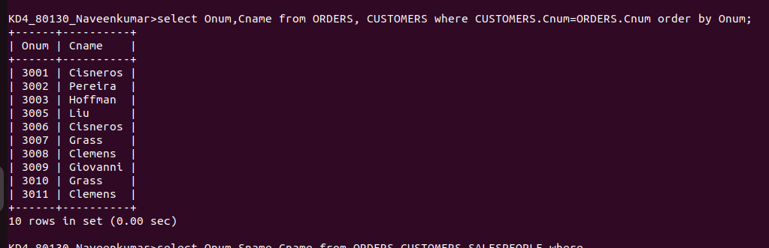

2.write query that gives the names of both the salesperson and the customer for each order along with the order number .
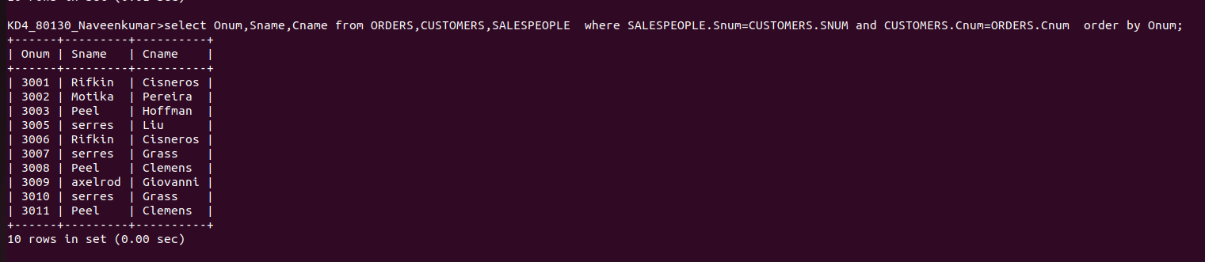

3.Write a query that produces all customer serviced by salespeople with a commission above %12. output the customer’s name ,the salesperson ‘name , and the salespersons rate of commisssion.
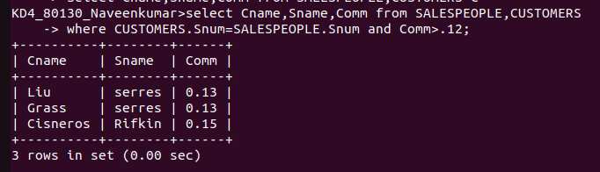

4.Write a query that calculates the amount of the salesperson ‘s commisssion on each order by a customer with the rating above 100.
