ASSIGNMENT-15

Using Subqueries with DML Commands.

1.Assume there is a table called multicust, with all of the same column definitions as salespeople. Write a command that inserts all salespeople with more than one customer into this table.
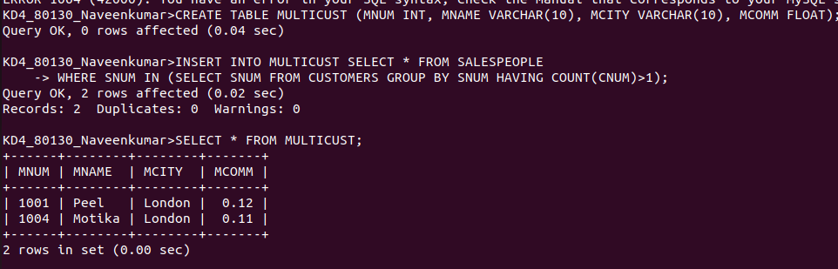

2.Write a command that deletes all customers with no current orders.
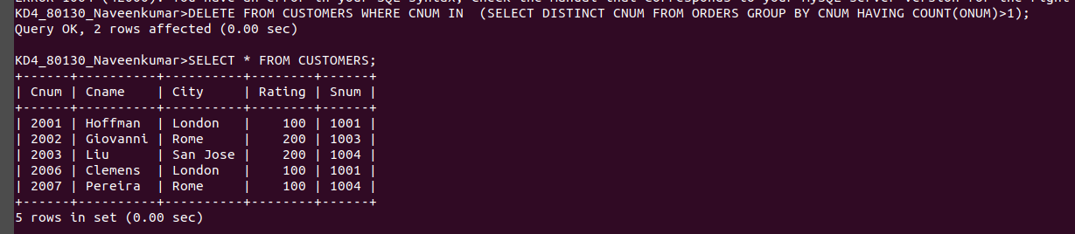
3.Write a command that increases by twenty percent the commisssion of all salespeople with total orders Rs.3000.
