ASSIGNMENT -14

Entering ,Deleting , and Changing Field Values.

1.Write a command that puts the follwing values, in their given order , into the salespeople table; city-San Jose, name- null, cnum-1100.
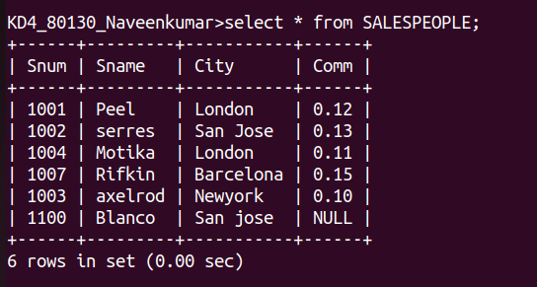

2.Write a command that removes all orders from customer clemens from the orders table.
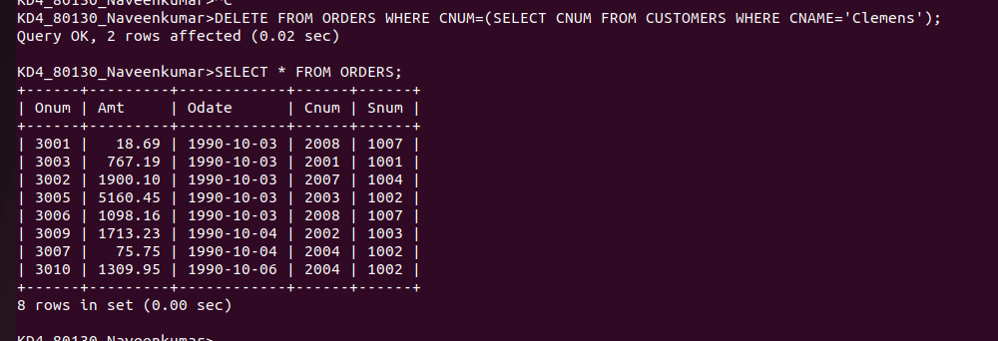

3.Write a command that increases the rating of all customers in Rome by 100.
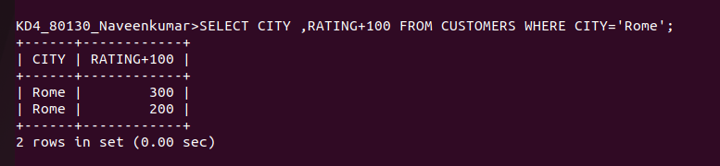

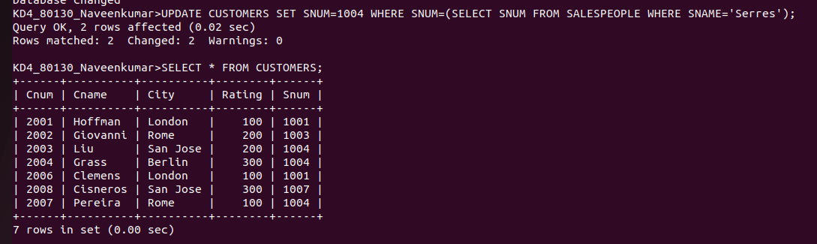
4.Salesperson Serres has left the company .Assign her customers to Motika.

