SQL ASSIGNMENT -4
1.Write a select command that produces the order number ,amount and date for all rows in yhe orders table.
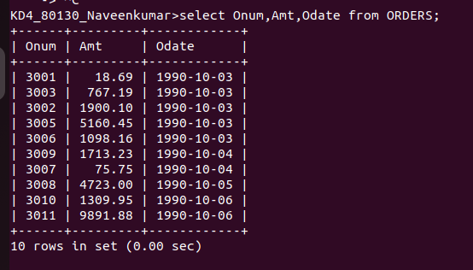

2.Write a query that produces all row from the customers table for which the salespeople’n number is 1001.
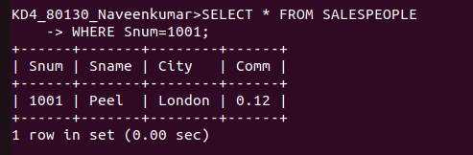

3.Write a query that displays the salespeople table with the column in the follwing order:city,sname,snum,comm.
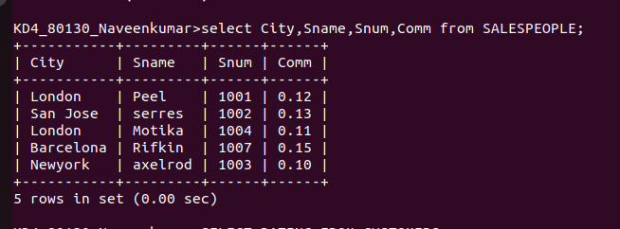

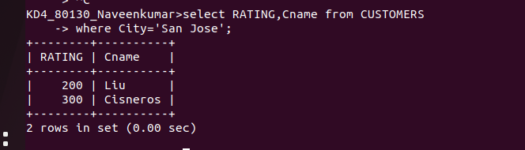
4.Write a select command that produces the rating followed by the name of each customer in San Jose

