ASSIGNMENT-12
Using the operators IN,ANY and ALL.

1.Write a query that selects all customers whose rating are equal or greatre than ANY of ‘Serres’.
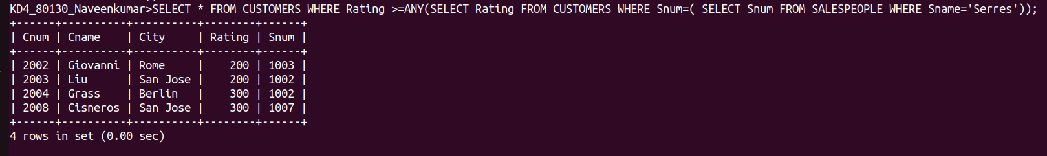

2.write query using ANY OR ALL that will find all salespeople who have no customers located in their city .
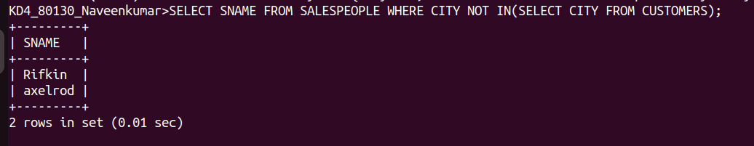

3.Write a query that selects all orders for amounts greater than any for the customers in LONDON.
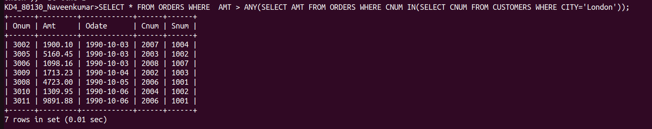

4. Write the above query using MIN or MAX.
