SQL ASSIGNMENT -5
1.Write a query that give you all orders for more than Rs.1000.
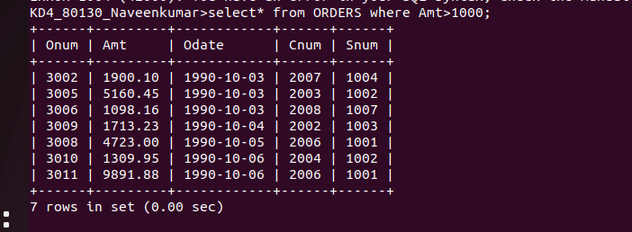

2.Write a query that will give you the names and cities of all salespeople in london with commission above .10.
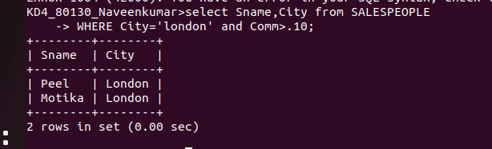
3.Write query on the customers table whose output will exclude all customers with rating <=100,unless they are located in Rome.
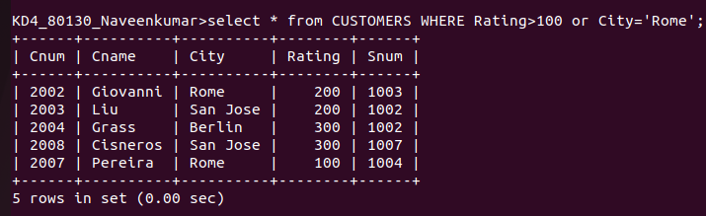
4.what will be the output from the following query?
Select * from orders
where (Amt <1000 or
not (Odate =’1990-10-03’ and Cnum>2003));
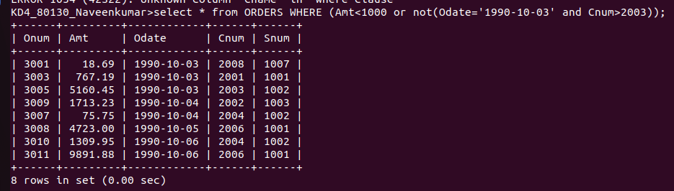

5. what will be output of the following query/
select * from orders
where not((Odate =’1990-10-03’ or Snum>1006) Amt>=1500);
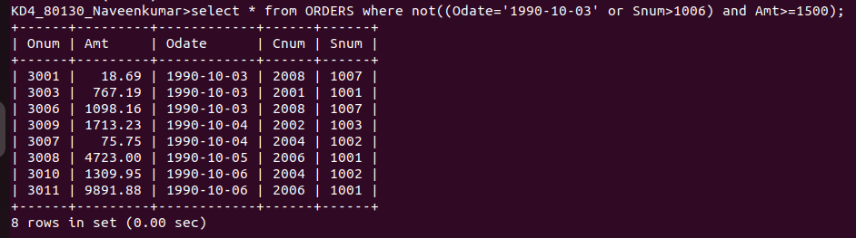

6.what is asimpler way to write this query?
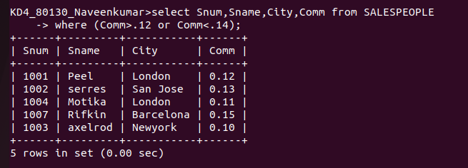
Select Snum,Sname,City,Comm from SALESPEOPLE where (Comm>.12 or <.14);

