ASSIGNMENT-7

1.write a query that counts all orders for october 3.
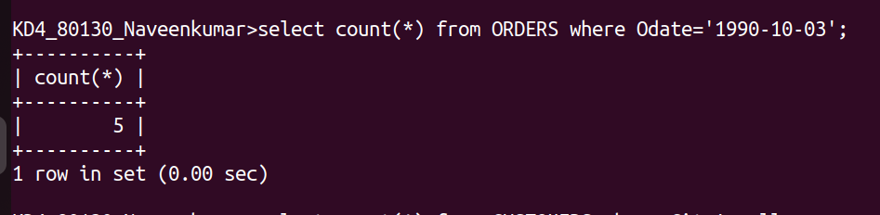

2.Write a query that counts the number of different non-null city values in the customers table.
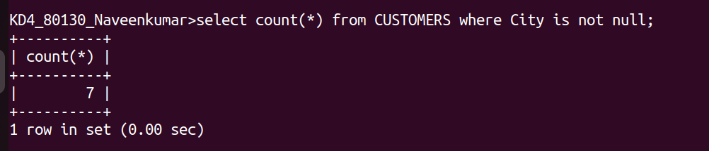

3.write a query that selects each customer’s smallest order.
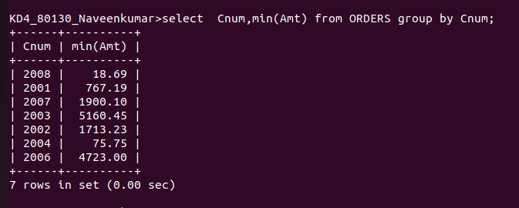

4.write a query that selects the first customer in alphatical order, whose name begins with G.
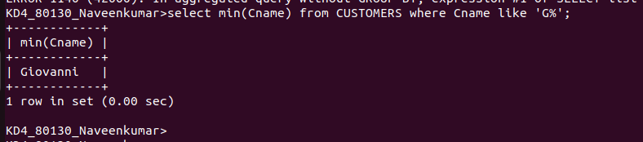

5.write a query that selects the highest rating in each city.
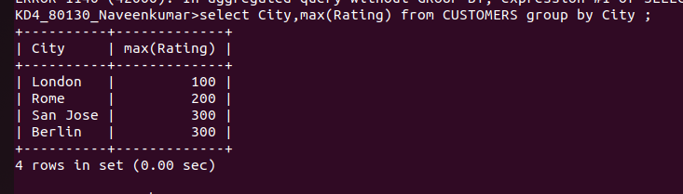

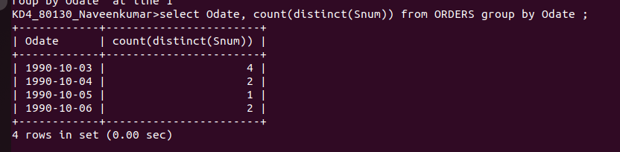
6. write a query that counts the number of salespeople registering orders for each day.(if a salesperson has more than one order on a givenday,he or she should be counted ony once).

