ASSIGNMENT-8
FORMATTING QUERY OUTPUT

1.Assume each salesperson has a12% commission .write query on orders table that will produce the order number,the sales number,and the amount of salesperson commssion for that order.
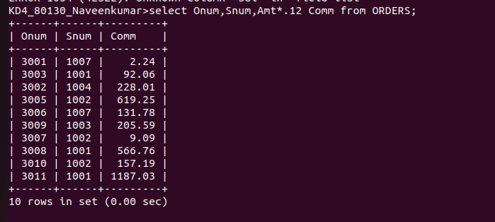

2.write a query on the customers table that will find the highest rating in each city.put the output in this form:
for the city(city), the highest rating is :(rating)
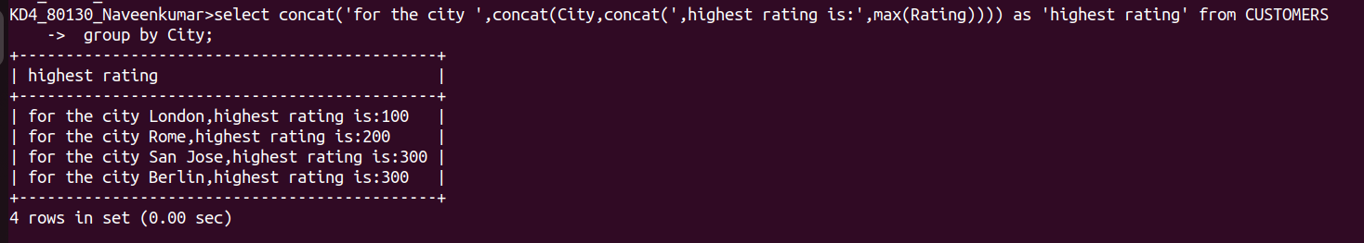

3.write a query that lists customers in descending order of rating .output the rating field first, followed by the customers’s name and number.
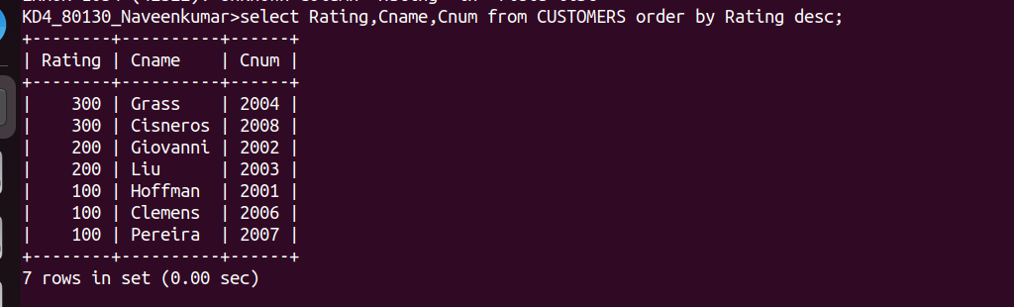

4.write a query that totals the orders for each day and places the results in descending order.
