ASSIGNMENT -6

1.Write two different queries that would produce all orders taken
on october 3rd and 4th ,1990.
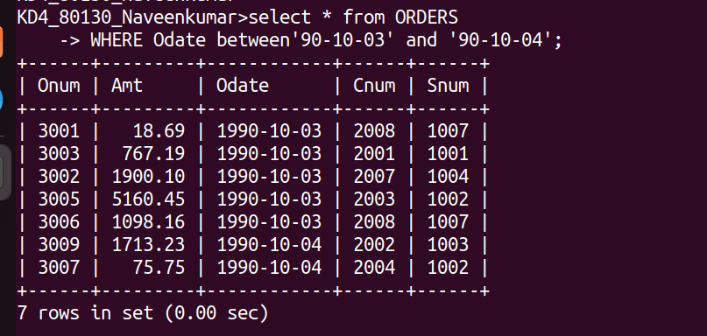
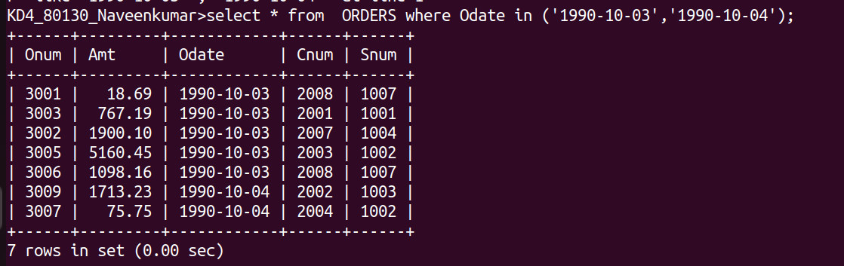
2.Write query the selects all of the customer serviced by Peel or Motika .(hint: the snum field relates the two tables to one other)
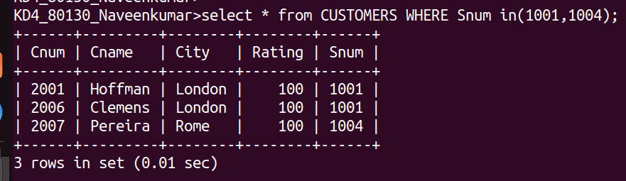
3.Write a query that will produce all the customers whose names begin with a letter from `A` TO`G`.
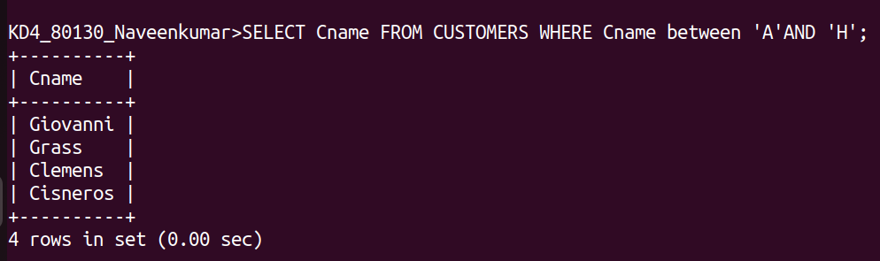

4. Write a query that selects all customers whose names begin with letter `C`.
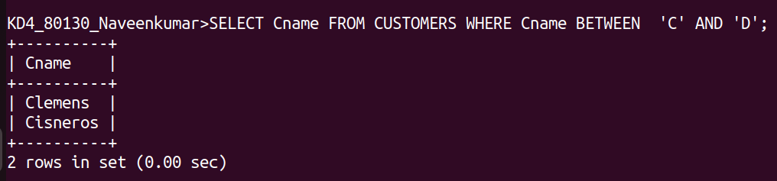

5.Write a query that selects all orders except those with zeroes or nulls in the amt field.
