ASSIGNMENT-11
1.Write a query that uses a subquery to obtain all orders for the customer named Cisneros.Assume you don’t his customer number(cnum).
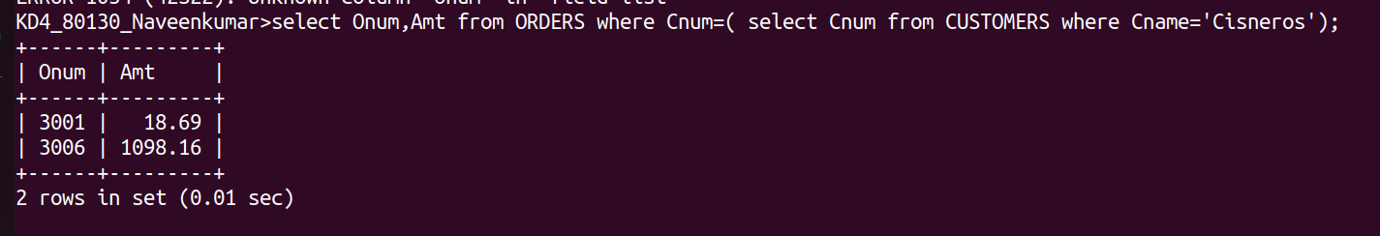

2.Write a query that produces the names an rating of all customers who have above - average orders.
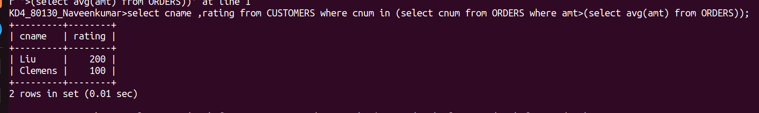

3.Write a query that selects that total amount in orders for each salesperson for whom this total is greater than the amount of the largest order in the table.
