ASSIGNMENT-13

Using the UNION clause.

1.Create a union of two queries that shows the names ,cities,and rating of all customers . Those with rating of 200 or greater will also have the words “High Rating” , while the others will have the words “Low Rating”.
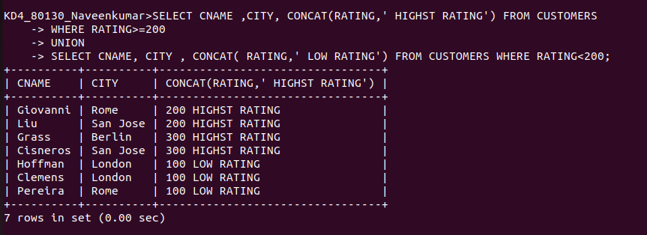

2.Write a command that produces the name and number of each salesperson and each customers with more than one current order.Put the results in alphabetical order.
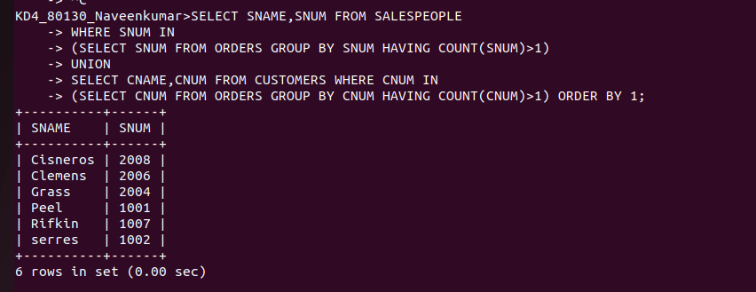

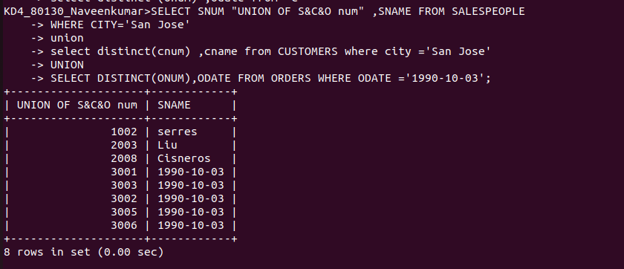
3.Form a union of three queries.Have the first select the snums of all salespeople in San Jose .the second , the cnums of all customers in San Jose; and the third the onums of all orders on october 3.Retain duplicates between the last two queries but eliminates any redundancies between either of them and and the first.

