MongoDBASSIGNMENT

1. Install MongoDB database server
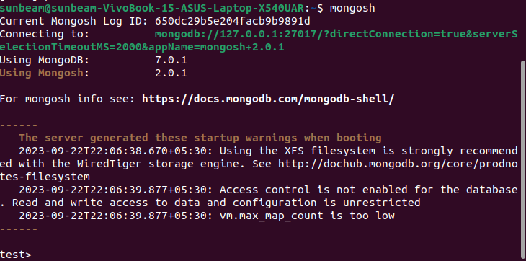

2. Create a directory/folder to store MongoDB datafiles
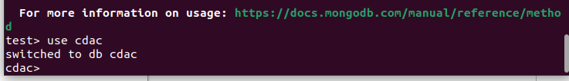

3. View list of available databases
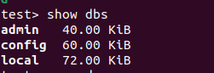

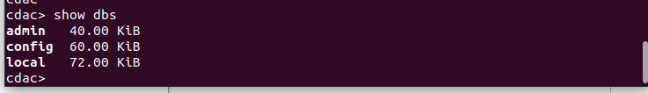
4. Create a new database named CDAC and connect to it

5.View list of available collections in CDAC database
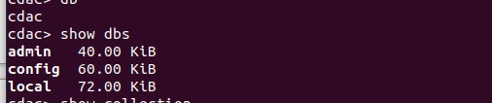

6. Create a new collection by the name of LIBRARY
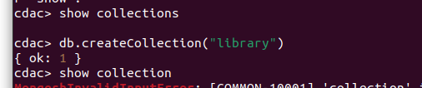

7. Insert the following document in the LIBRARY collection:-
title:'MongoDB programming', author:'Sameer', likes:100
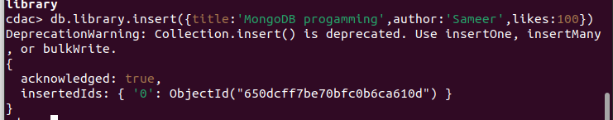

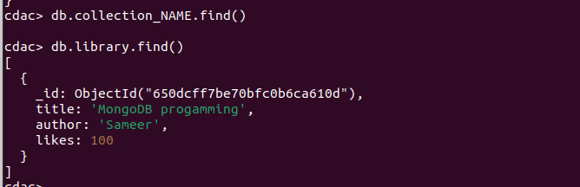
8. View the recently inserted document and note the _id field
9. Insert another document in the LIBRARY collection as follows:-
title:'MySQL programming', authors:['Jack','Jill'], likes:200
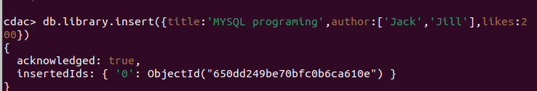

10. View the inserted documents
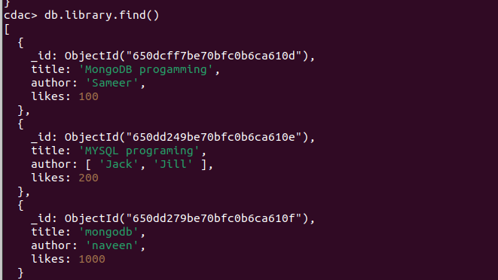

11. View only the first inserted document
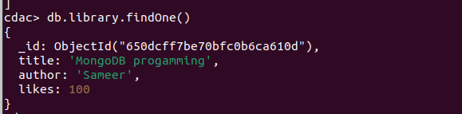
12. View the documents using the pretty() method
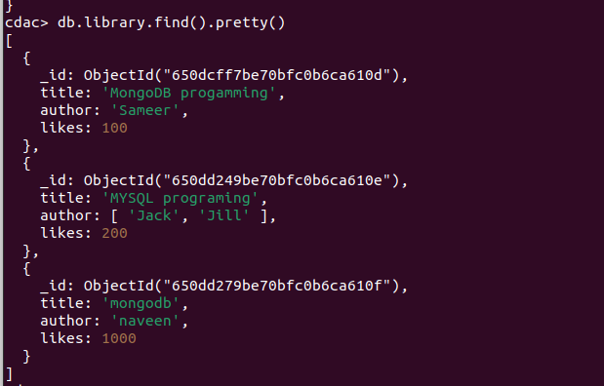

13. Update the document where author name = Sameer and change it to Sameer Dehadrai
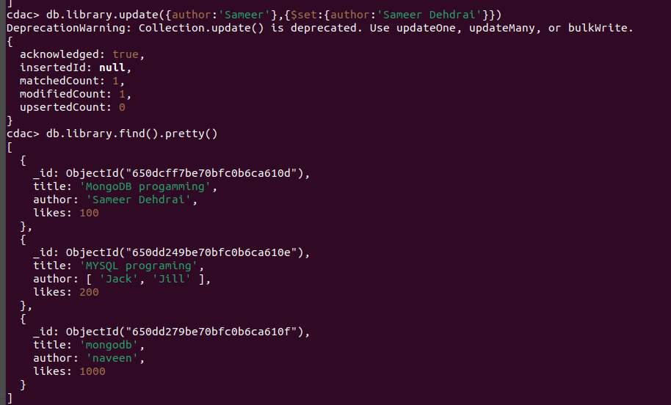

14. Delete all documents that have 100 likes
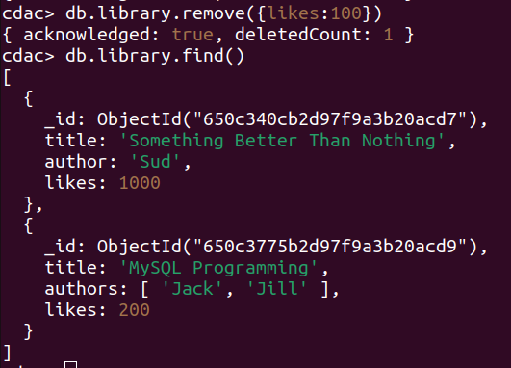

15. Drop the LIBRARY collection
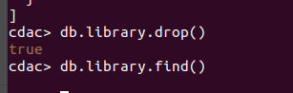

16. Drop the CDAC database

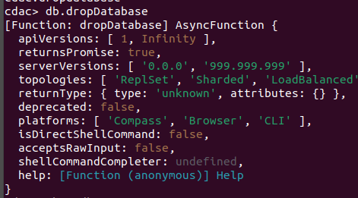

17. Exit from MongoDB shell

