MONGO DB Assignment 1

1)Install MongoDB database server

$ sudo apt-get install gnupg curl
$ curl -fsSL https://pgp.mongodb.com/server-7.0.asc | \sudo gpg -o /usr/share/keyrings/mongodb-server-7.0.gpg \--dearmor

2) Create a directory/folder to store MongoDB datafiles

$ echo "deb [ arch=amd64,arm64 signed-by=/usr/share/keyrings/mongodb-server-7.0.gpg ] https://repo.mongodb.org/apt/ubuntu jammy/mongodb-org/7.0 multiverse" | sudo tee /etc/apt/sources.list.d/mongodb-org-7.0.list

3) Set necessary path environment variable

title:'MySQL programming', authors:['Jack','Jill'], likes:200Answer:
$ echo "deb [ arch=amd64,arm64 signed-by=/usr/share/keyrings/mongodb-server-7.0.gpg ] https://repo.mongodb.org/apt/ubuntu jammy/mongodb-org/7.0 multiverse" | sudo tee /etc/apt/sources.list.d/mongodb-org-7.0.list

4) Startup MongoDB database
$ sudo systemctl start mongod
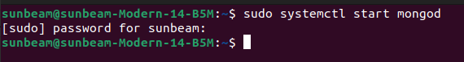
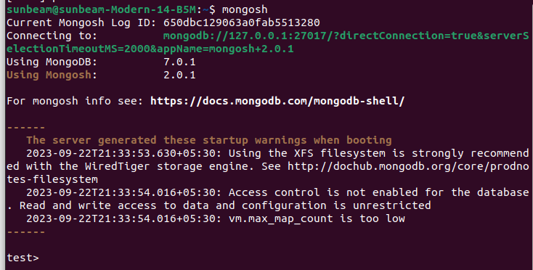
5) Connect to MongoDB database through the MongoDB shell command line interface
6)View list of available databases
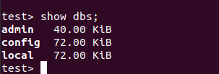

7) Create a new database named CDAC and connect to it
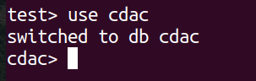

8)View list of available collections in CDAC database
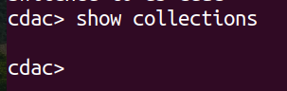

9)Create a new collection by the name of LIBRARY
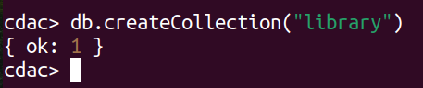

10)Insert the following document in the LIBRARY collection:-
title:'MongoDB programming', author:'Sameer', likes:100
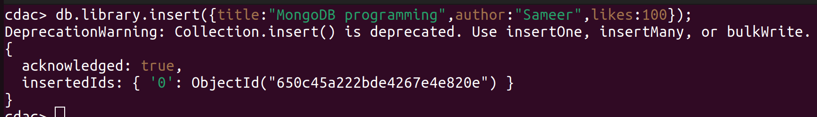

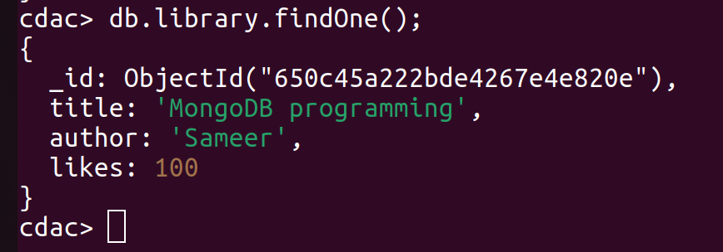
11) View the recently inserted document and note the _id field 12) Insert another document in the LIBRARY collection as follows:-

12) Insert another document in the LIBRARY collection as follows:-

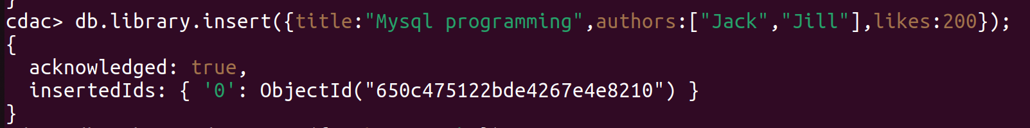
13) View the inserted documents

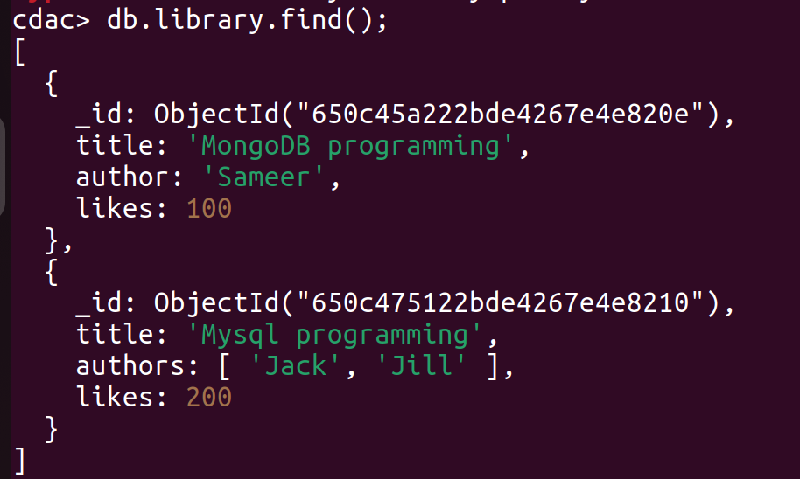

14) View only the first inserted document

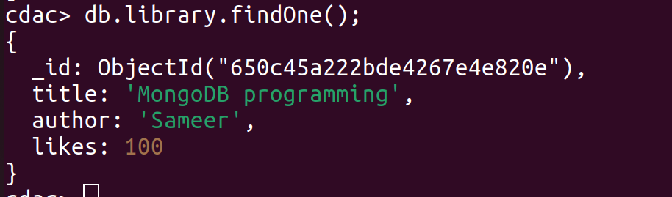

15) View the documents using the pretty() method
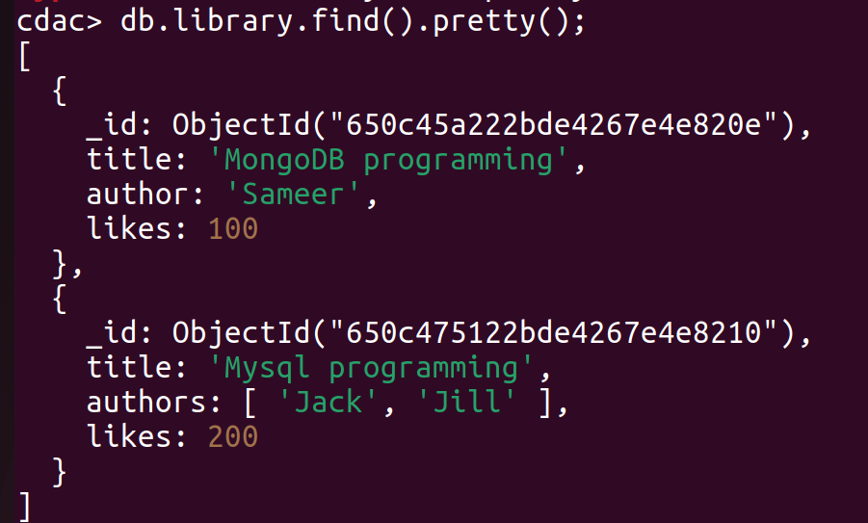
16) Update the document where author name = Sameer and change it to Sameer Dehadrai

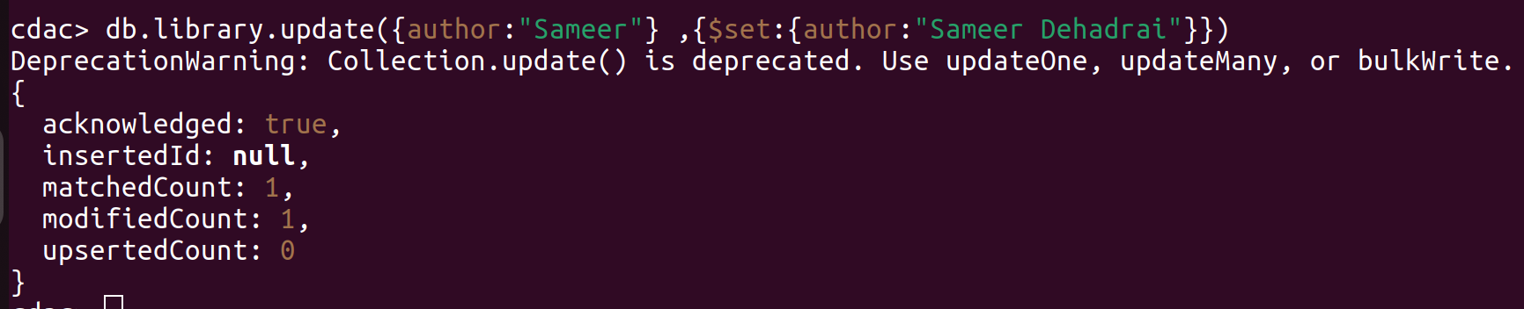
17) Delete all documents that have 100 likes

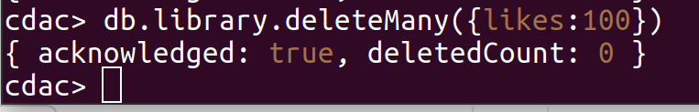
18) Drop the LIBRARY collection
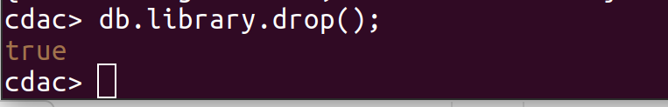
19) Drop the CDAC database

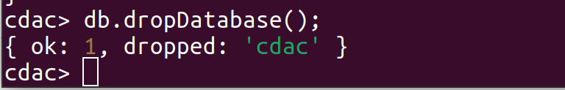

20) Exit from MongoDB shell

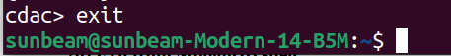

21) Stop MongoDB server

