SQL Assignment -5
Q1) Write a query that will give you all orders for more than Rs. 1,000.
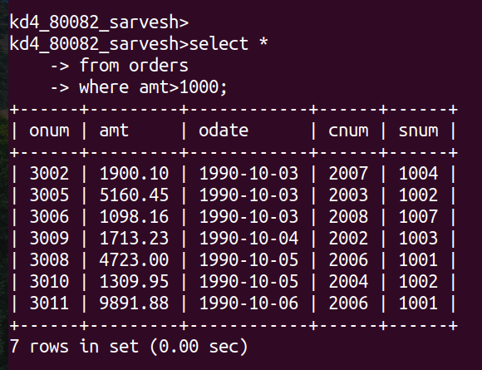

Q2)Write a query that will give you the names and cities of all salespeople in London with a commission above .10
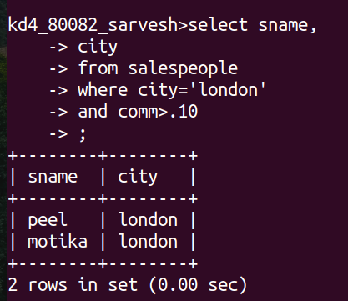

Q3)Write a query on the Customers table whose output will exclude all customers with a rating <= 100, unless they are located in Rome.

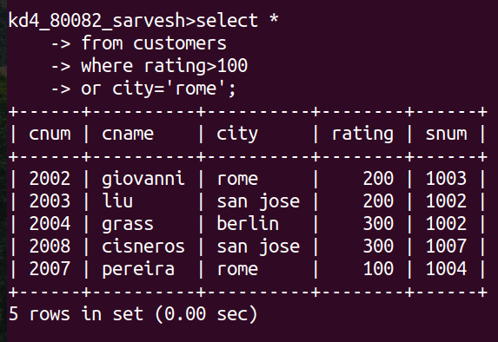
Q4) What will be the output from the following query?
select *
-> from orders
-> where (amt< 1000
-> or not (odate='1990-10-03'
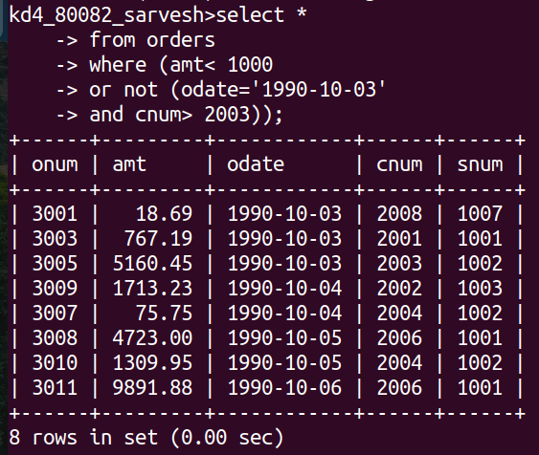
-> and cnum> 2003));

Q5) What will be the output from the following query?
select *
-> from orders
-> where not ((odate='1990-10-03'
-> or snum>1006)
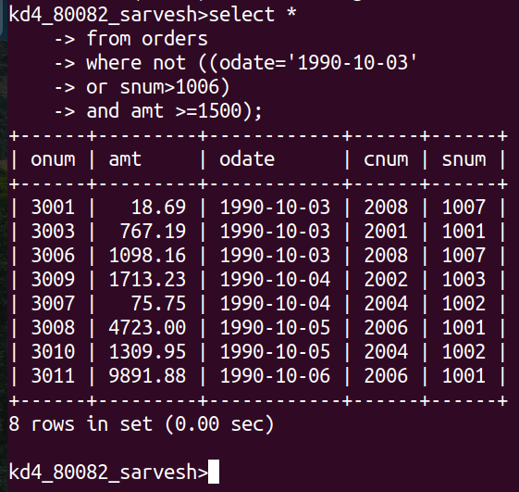
-> and amt >=1500);

Q6) What is a simpler way to write this query?
Select snum, sname, city, comm from salespeople where (comm > .12 OR comm <.14);

