SQL Assignment -14

Entering , Deleting, and changing field values.

Q1) Write a command that puts the following values, in their given order, into the salespeople table: city – San Jose, name – Blanco, comm – NULL, snum – 1100.

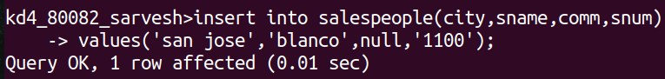
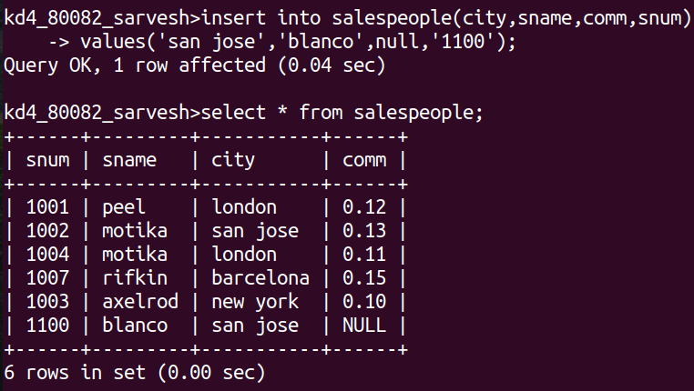

Q2) Write a command that removes all orders from customer Clemens from the orders table

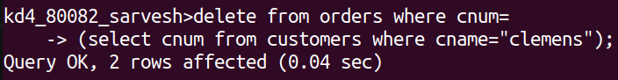

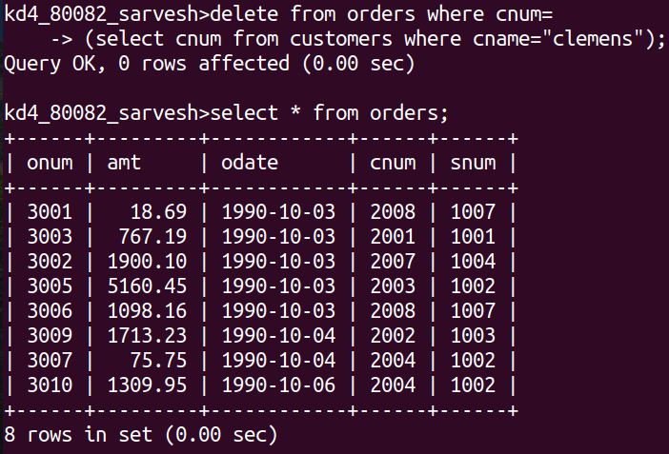

Q3) Write a command that increases the rating of all customers in Rome by 100.

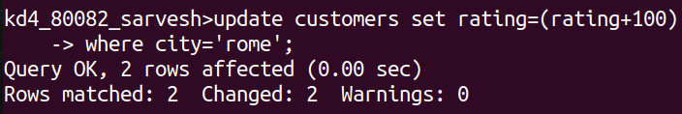
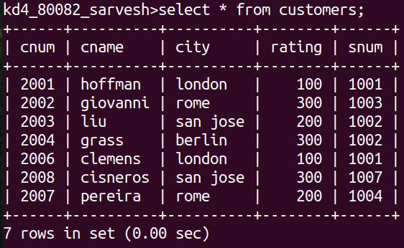

Q4) Salesperson Serres has left the company. Assign her customers to Motika.

