SQL Assignment -6
Q1) Write two different queries that would produce all orders taken on october 3rd or 4th, 1990.
1st-
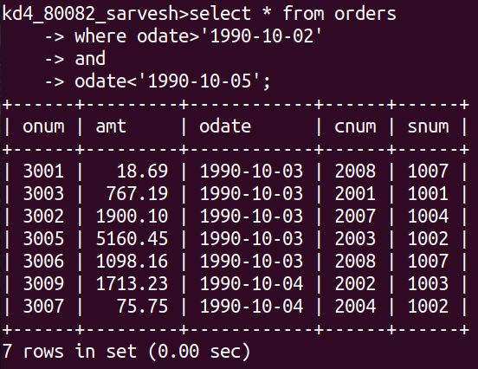
2nd-

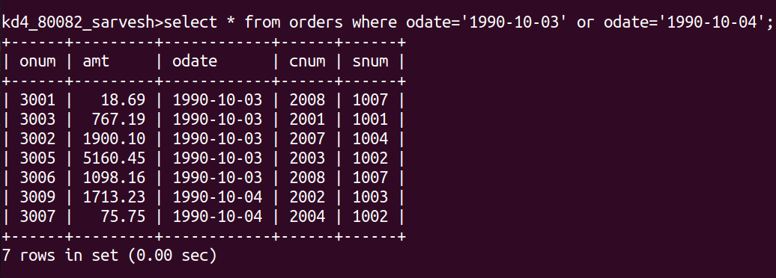

Q2) Write a query that selects all of the customers serviced by Peel or Motika .

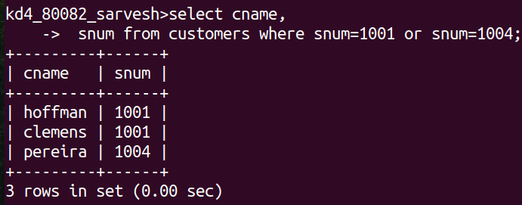

Q3) Write a query that will produce all the customers whose names begin with a letter from ‘A’ to ‘G’.

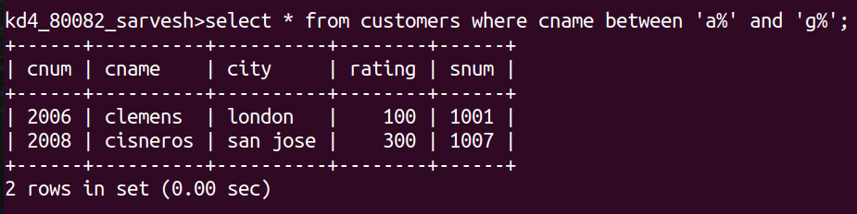

Q4) Write a query that selects all customers whose names begin with the letter ‘C’.

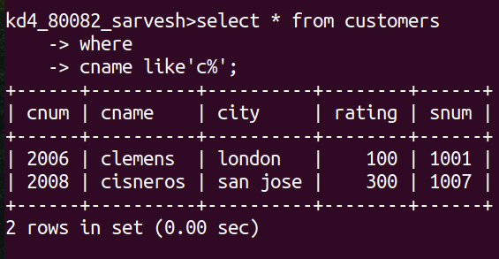

Q5) Write a query that selects all orders except those with zeroes or nulls in the amount field.

