SQL Assignment -15

Using subqueries with DML commands.

Q1)Assume there is a table called Multicust, with all of the same column definitions as Salespeople. Write a command that inserts all salespeople with more than one customer into this table.

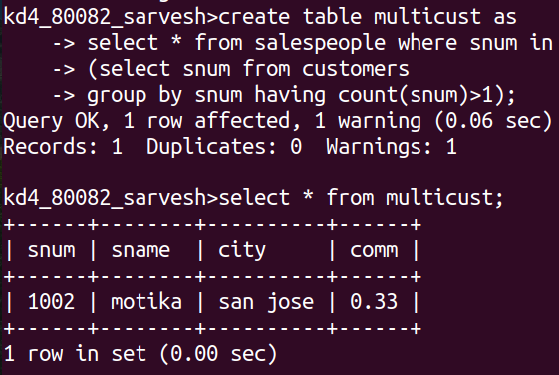

Q2) Write a command that deletes all customers with no current orders.

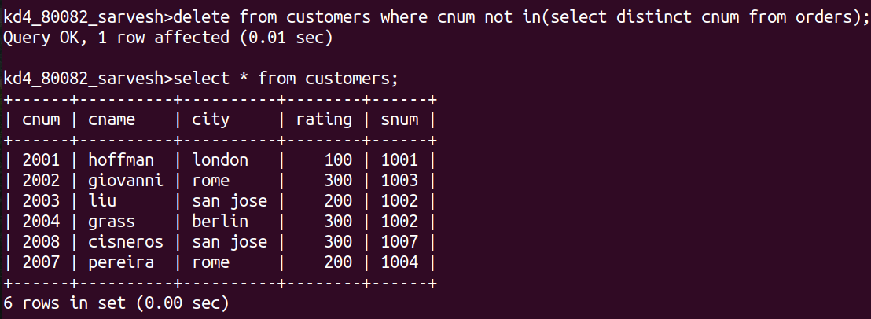

Q3) Write a command that increases by twenty percent the commissions of all salespeople with total current orders above Rs. 3,000.

