SQL Assignment -9
Ouerying Multiple Tables at once
Q1) Write a query that lists each order number followed by the name of the customer who made the order.
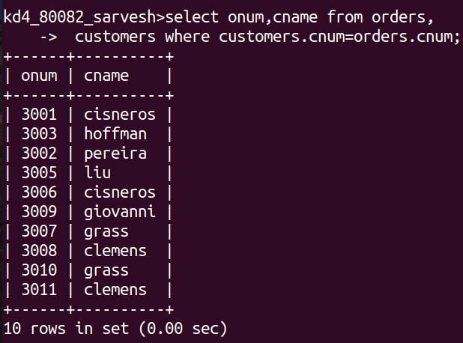
Q2) Write a query that gives the names of both the malesperson and the customer for each order along with the order number.

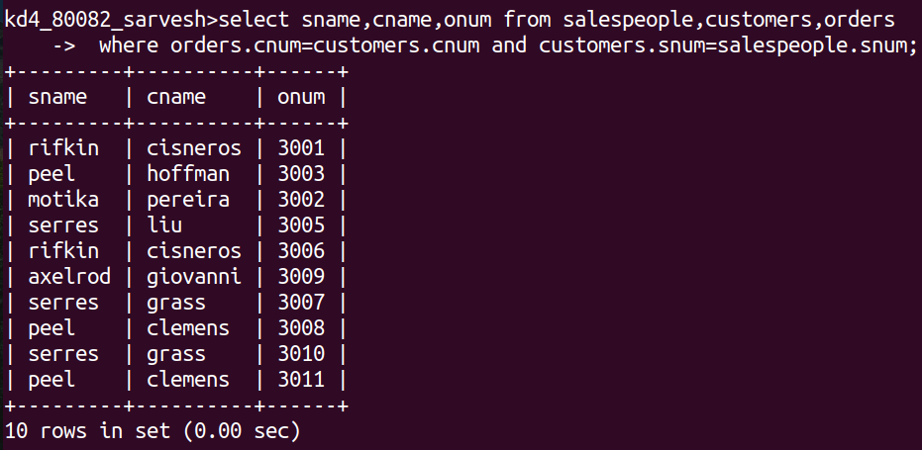

Q3) Write a query that produces all customers serviced by salespeople with a commission above 128 Output the customer's name, the salesperson's name, and the salesperson's rate of commission.

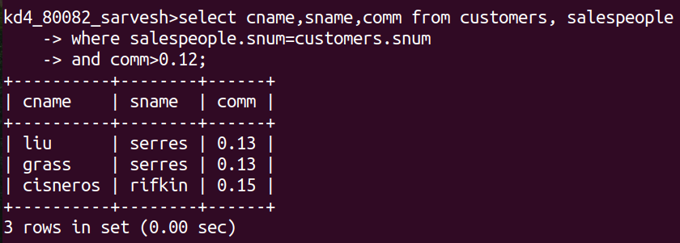

Q4) Write a query that calculates the amount of the salesperson's commission on each order by a customer with a rating above 100

