SQL Assignment -1
Creating sample table and inserting values.

A)salespeople with given structure-

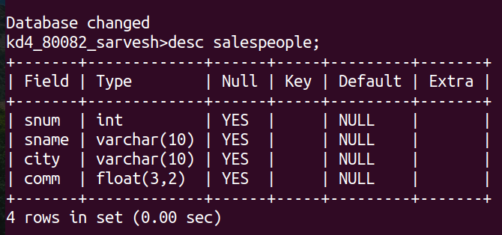

B) customers with given structure-

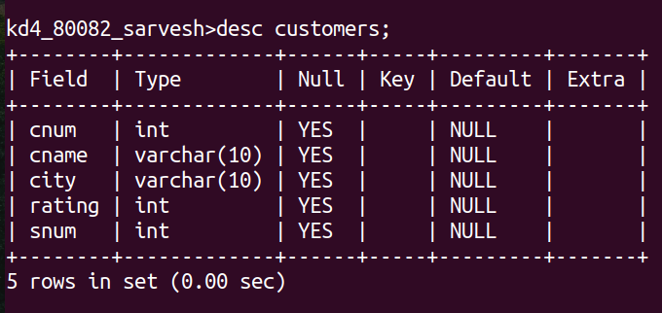

C) orders with given structure-
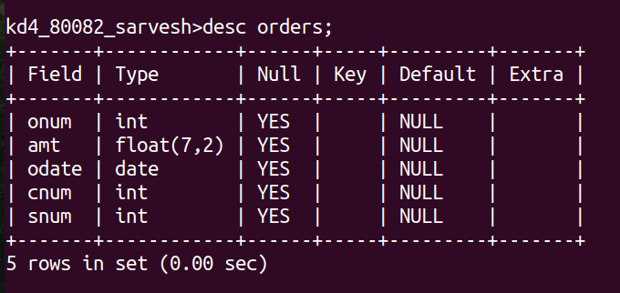

Sample Data Inserted in salepeople-

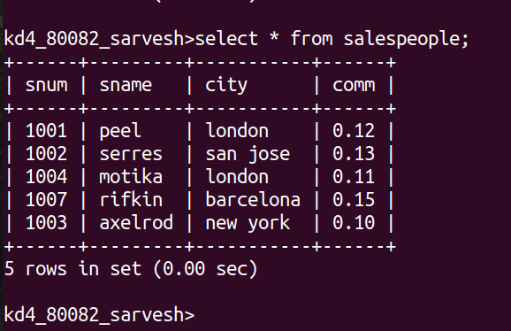

Sample Data Inserted in customers-

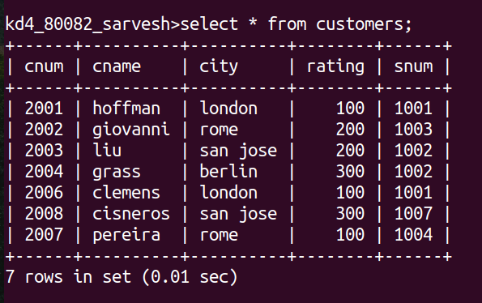
Sample Data Inserted in orders-
