Video Stabilization

Parameter Exploration and Failure Cases

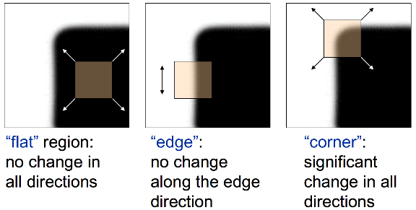
Harris Corner Detector
The Harris Corner Detector is a method to find corners in an image. Corners are points where the intensity changes strongly in all directions.
The idea is to take a small window around a pixel and measure how much the image intensity changes when the window is shifted. If the change is large in every direction, the point is likely a corner.
Parameter | Low Value | High Value
maxCorners | Too few features | Dense features, more computation
qualityLevel | Many weak features (unstable) | Few strong features (stable)
minDistance | Dense clusters | Sparse distribution
blockSize | Sensitive/noisy | Strong but fewer corners
apply_gaussian_blur | More details but more noise | Cleaner, fewer corners
gaussian_ksize | Light smoothing | Heavy smoothing, coarse features
Visual effect overall:
Low thresholds and small blockSize produce many scattered features that jitter or disappear; high thresholds, larger neighborhoods and moderate blur produce fewer but much more stable tracks and smoother stabilization.

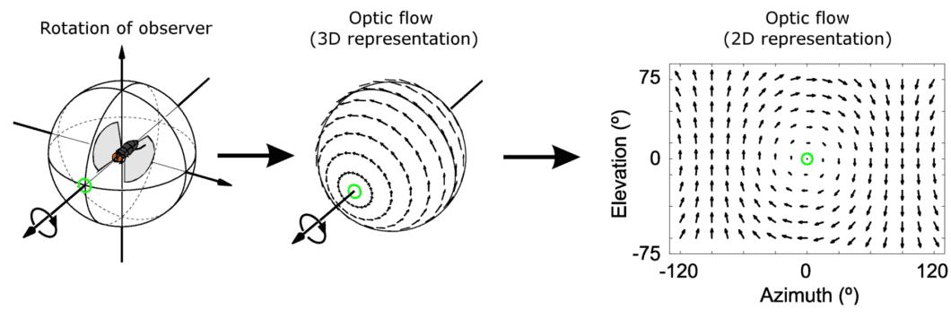
Lucas-Kanade Optical Flow

Optical Flow
Optical flow quantifies the motion of objects between consecutive frames captured by a camera. These algorithms attempt to capture the apparent motion of brightness patterns in the image.

Lucas-Kanade Method
The Lucas–Kanade method estimates how points move between two video frames.
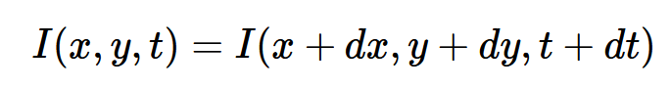
It is based on two key assumptions:
- Brightness of a pixel stays the same between frames:
- Neighboring pixels move in the same way. (all pixels inside this small block belong to the same object surface, so when the object moves, the whole block moves together):
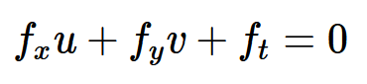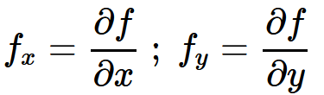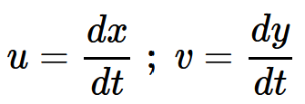
Because a single pixel does not give enough information to determine motion, Lucas–Kanade takes a small window (e.g., 3×3 or larger) around the pixel. All pixels in this window are assumed to have the same motion.
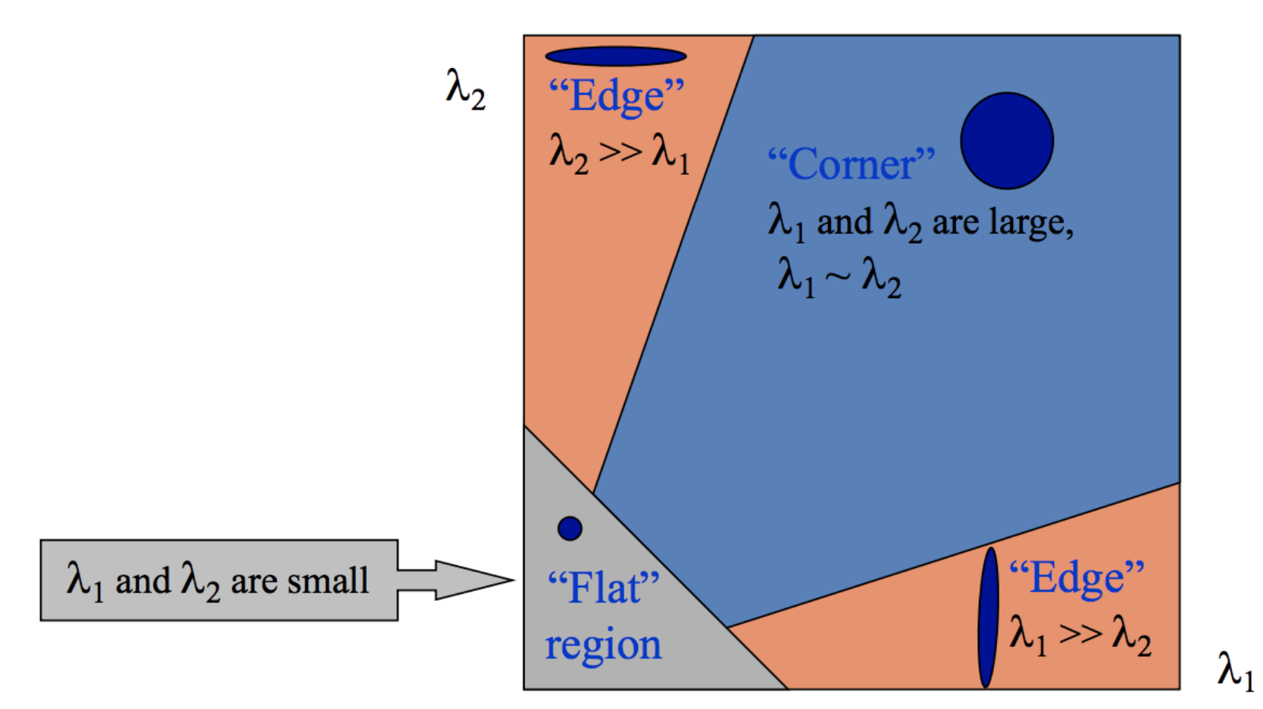
Using image gradients in x, y, and time, this window creates multiple equations that can be solved with least squares, producing the motion vector: $(u,v)=\text{the movement of the pixel}$
Corners are the best points to track because they have strong gradients in both directions (edges and flat areas don’t work well).
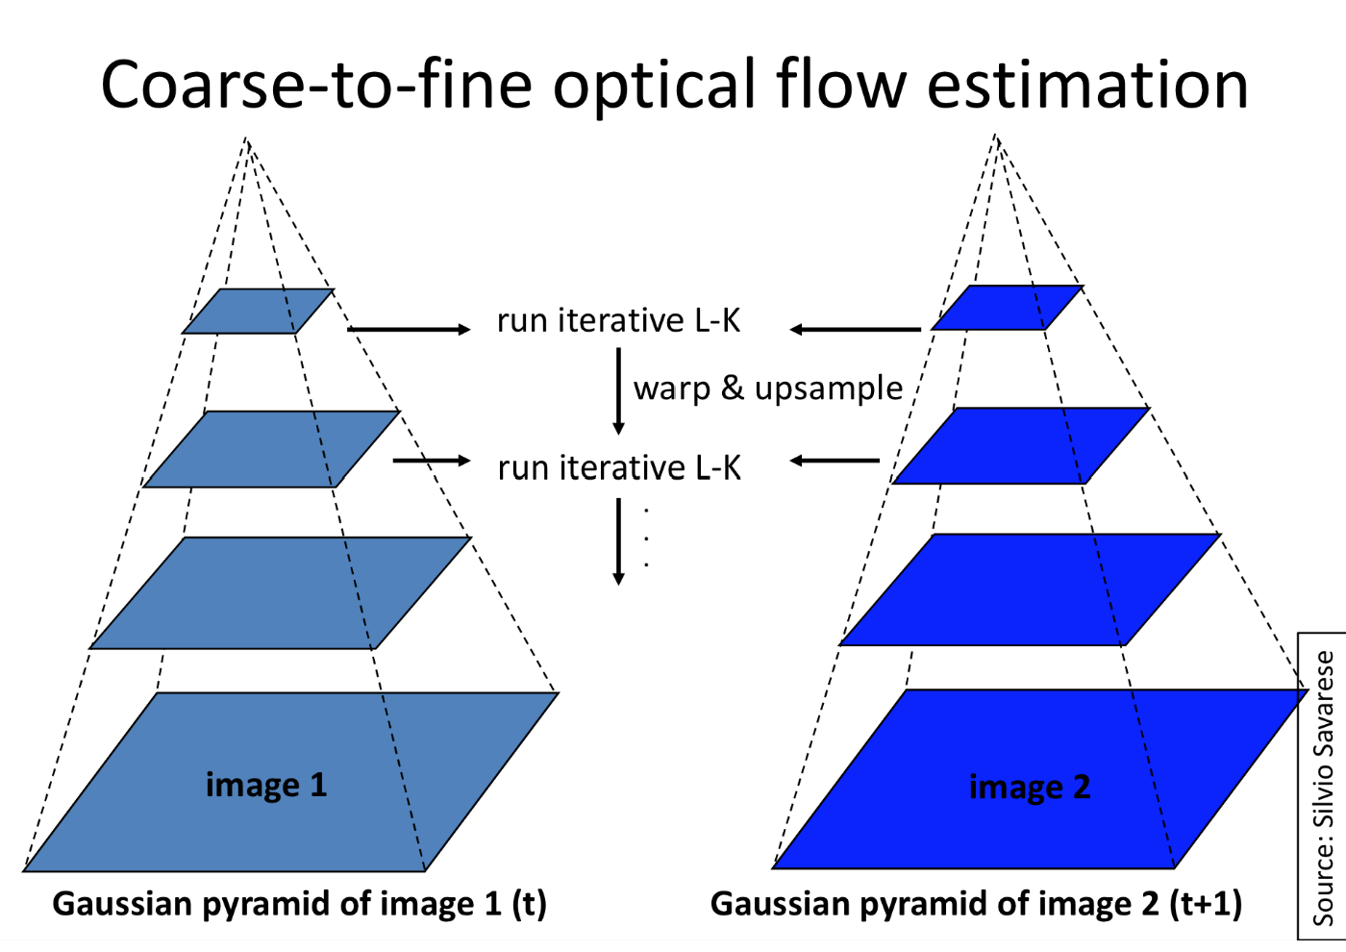
Since Lucas–Kanade only handles small motions, it uses image pyramids to detect large motions by gradually refining motion from coarse to fine scales.

Parameter | Low Value Effect | High Value Effect
Window Size | Accurate for small motion, noise-sensitive | Robust to large motion, less precise
Pyramid Levels | Fast, only small displacements | Robust for large motion, higher compute
Max Iterations | Fast but less accurate | More accurate but slower
Epsilon | Precise convergence | Faster but less accurate
Visual effect overall:
Smaller windows, few pyramid levels, few iterations and large epsilon give fast but fragile tracking (many features die or jitter). Larger windows and more pyramid levels plus tighter convergence criteria yield stable, long-lived tracks and therefore smoother stabilized videos, at the cost of speed.

Failure Cases
- Low-texture surfaces (e.g., plain walls, sky):
  - Few or no detectable corners → KLT has nothing reliable to track.
  - Leads to drifting, disappearing, or noisy tracks.
- Motion blur / fast camera movement:
  - Feature appearance changes significantly; LK’s small-motion and brightness-constancy assumptions are violated.
  - Many tracks fail or jump between frames.
- Parallax or moving foreground objects:
  - Different scene depths move inconsistently → cannot be represented by a single affine transform.
  - Causes wobbling or distorted stabilization.
- Strong lighting changes:
  - Harris responses weaken; LK mismatches features.
  - Results in unstable and inconsistent tracking.

Connecting Observations to the Implementation
The behavior seen during experimentation directly follows from how the detector and tracker are implemented in the code. The Harris detector relies on cv2.goodFeaturesToTrack with useHarrisDetector=True, and all GUI parameters (such as qualityLevel, maxCorners, minDistance, and blockSize) are passed straight into this function. This explains why lowering thresholds produced many weak, unstable corners and why increasing them resulted in fewer but stronger, more reliable points.
Likewise, the Lucas–Kanade tracker uses cv2.calcOpticalFlowPyrLK, with the window size, pyramid levels, and stopping criteria taken directly from the GUI settings and fed into self.lk_params. Because of this, small windows and shallow pyramids led to frequent tracking failures under fast motion, while larger settings produced more stable but more computationally expensive tracks. The resulting point correspondences are then given to the stabilizer, so any instability in detection or tracking appears visibly as jitter or frame wobble in the stabilization output.

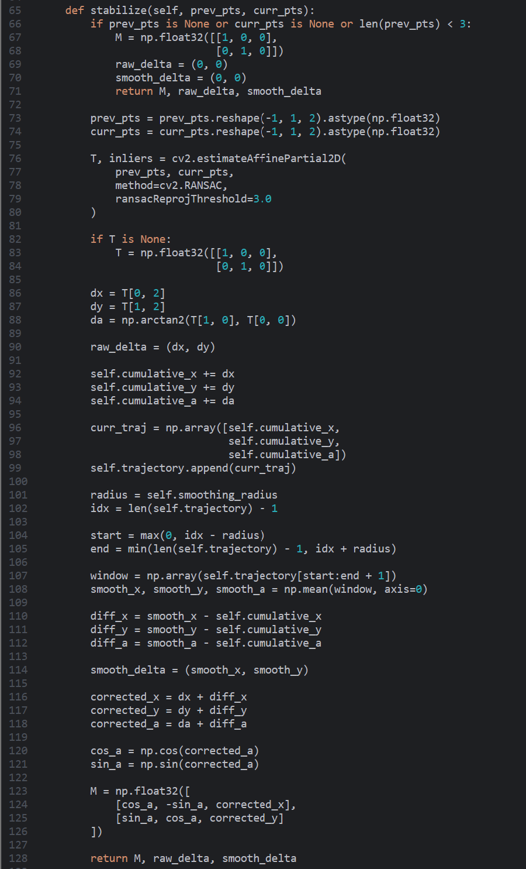
Implementing Video Stabilization

When does the Stabilizer works well and when not?
When the stabilizer works well
- Moderate hand-held camera shake
- Good lighting and minimal blur
When the stabilizer fails
- Motion blur or large frame-to-frame displacements
- Low-texture environments (Not enough features → motion estimation becomes unstable.)
- Large or rapid rotations (only translation + small rotation)

