Fun with faces

State-of-the-Art Review
Face analysis has progressed rapidly in recent years due to advances in deep learning, large annotated datasets, and specialized architectures designed for understanding human facial features. Tasks such as face detection, face recognition, face verification, and facial attribute analysis are now commonly addressed using convolutional neural networks (CNNs) and embedding-based models. DeepFace, the framework used in this project, integrates several of these state-of-the-art approaches into an accessible Python library.

DeepFace Overview
Task | DeepFace Models
Face Detection | RetinaFace, MTCNN, OpenCV, SSD, Dlib
Face Recognition (1:1 comparison) / Verification  (1:N search) | VGG-Face, Facenet, Facenet512, ArcFace, DeepID, OpenFace, Dlib, SFace
Attribute Analysis  (age, gender, emotion, race) | Pretrained CNNs

First Example: Face Detection & Attribute Analysis
For the first experiment, I applied DeepFace to the image cristoforetti_samantha.jpg in order to test the framework’s capabilities in face detection and facial attribute analysis. The image shows a single subject in frontal view, with good lighting and clear facial visibility.

Steps
- Load the image using OpenCV.
- Run DeepFace’s analyze() function to estimate:
  - Age
  - Gender
  - Emotion
  - Race
- Use RetinaFace as the face detector due to its strong performance and reliability.
- Extract the returned face region coordinates and draw a bounding box on the detected face.
- Display the image along with the predicted attributes below it.

Results
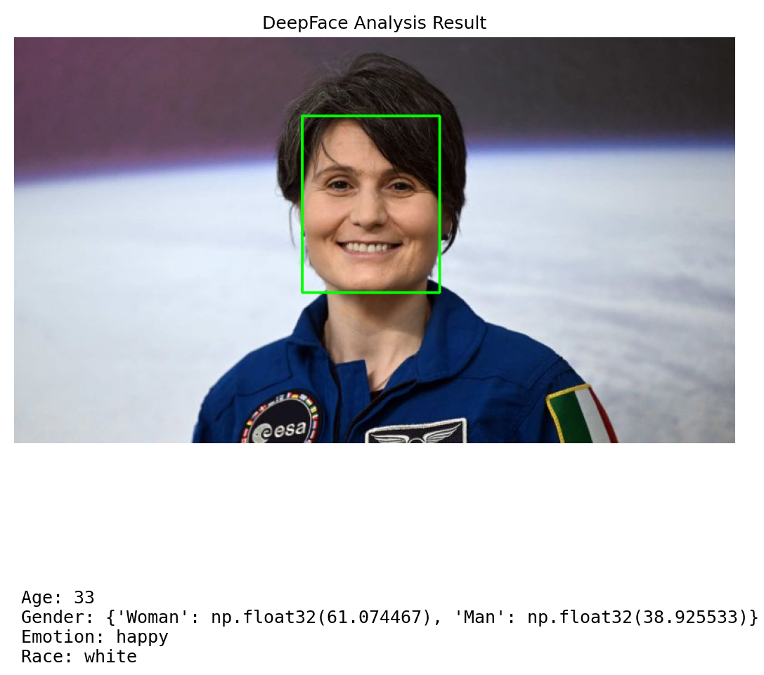
DeepFace successfully detected the subject and returned the following attributes:
The bounding box was placed accurately around the face, demonstrating the robustness of the RetinaFace detector. The predicted emotion (“happy”) aligns with the expression in the image.

Insight
- Age estimation:
Based on the provided birthdate (26 April 1977), the actual age of the person in the image would be around 47–48 years at the time of analysis.
DeepFace predicted 33, which is a significant underestimate. This outcome aligns with a known limitation of deep-learning age estimators: they often underestimate age for adults, especially in cases of good skin condition, smooth lighting, or professional portrait photography. Age estimation models rely heavily on texture cues and can therefore misinterpret well-lit or stylized images as belonging to a younger person.
- Gender detection:
DeepFace classified the subject as woman with high confidence.
- Emotion analysis:
The dominant emotion was labeled as happy, driven by the visible smile and relaxed facial features. DeepFace tends to strongly weight the curvature of the mouth when predicting emotion.
- Race classification:
The system categorized the subject as "white." Race prediction is a coarse and often unreliable category, reflecting dataset bias rather than true demographic precision.

The detection was accurate, and the bounding box aligned perfectly with the face, showing the strength of the RetinaFace detector. Attribute predictions, however, illustrate the typical variability and limitations of deep-learning models when interpreting high-level human traits.

Another Example: Face Verification
In the second experiment, I examined DeepFace’s face verification performance by comparing two images of the same person captured under highly contrasting conditions. Image A presents the subject in a controlled, well-lit setting, whereas Image B shows the subject inside a spacesuit, viewed through reflective glass and affected by uneven lighting and visual obstructions.
This setup provides a challenging test case for evaluating DeepFace’s robustness against pose differences, lighting variability, and partial occlusion.

Steps
- Load both images using OpenCV.
- Apply DeepFace.verify() using the ArcFace model, which is known for high accuracy and robustness.
- Use RetinaFace as the detector to ensure consistent and high-quality facial alignment.
- Display both images side by side along with the verification results (boolean match and embedding distance).

Results
Despite the challenging conditions in Image B, including reflections, shadows, helmet structure, and partial occlusion, DeepFace correctly determined that both images depict the same individual.
The distance value (0.642) is relatively high compared to typical well-aligned frontal comparisons, but it remains below the ArcFace threshold, which is why the verification result is still positive.
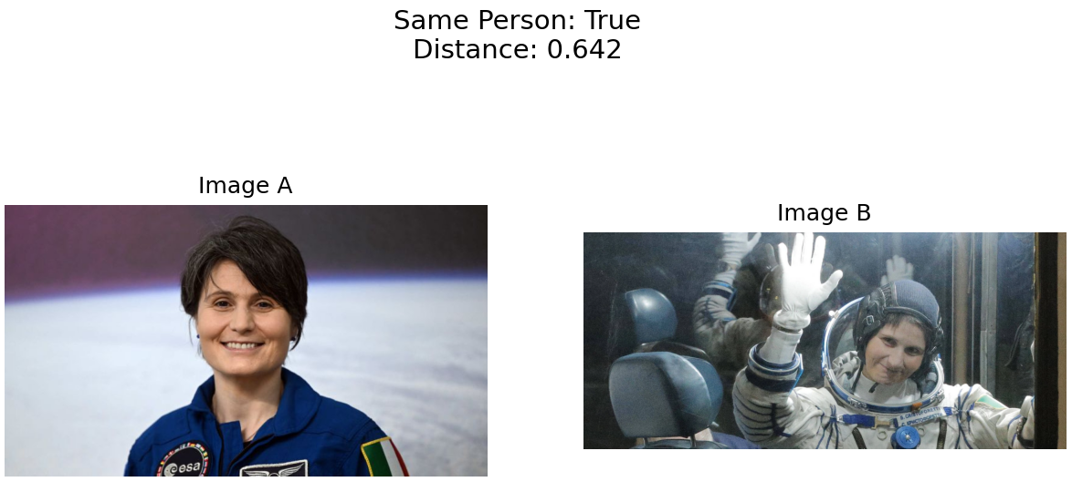

Insight
- Effect of image quality:
Image B introduces substantial noise due to reflections and the spacesuit helmet. These distortions reduce the model’s confidence, leading to a higher embedding distance.
- Robustness of ArcFace:
Even with environmental noise and differences in pose, ArcFace successfully recognized the match. This demonstrates its robustness in real-world scenarios where images are far from ideal.
- Importance of face alignment:
RetinaFace likely contributed to the successful verification by accurately detecting and aligning the face in both images. A weaker detector could have increased the distance further or caused a mismatch.
- Distance interpretation:
While the verification is correct, the elevated distance shows clear sensitivity to extreme visual conditions. In practical applications, such images would require threshold tuning or additional preprocessing.

