Jaeho Jeon 전재호 · 田宰昊  Ph.D. Student, Department of Electrical Engineering and Computer Science, DGIST  Privacy and Applied Cryptography Lab (PACL) · Advisor: Prof. Young-Sik Kim  Email dgwogh@dgist.ac.kr Web my-rooftop.github.io GitHub my-rooftop Scholar h2pBQrcAAAAJ  ORCID 0009-0007-9074-8491 LinkedIn jaeho-jeon-3a063425b Location Daegu, South Korea | 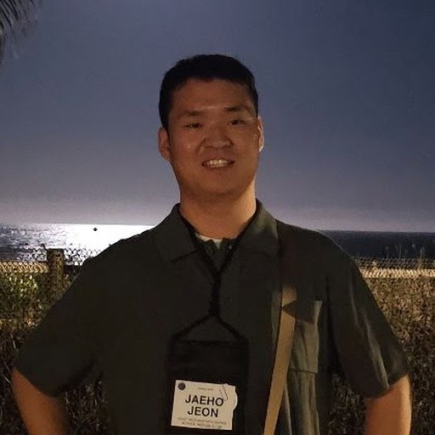

RESEARCH INTERESTS
Side-channel analysis · Hardware security · Post-quantum cryptography implementation · Cryptographic engineering · Computer architecture · Coding theory
My research focuses on side-channel analysis. My goal is to become a uniquely recognized expert in side-channel analysis, and to gradually expand into computer architecture, quantum computing, networking, and coding theory.
EDUCATION
2026.02 – present | Ph.D. student, Electrical Engineering and Computer Science, DGIST
2024.02 – 2026.02 | M.S., Electrical Engineering and Computer Science, DGIST
2017.02 – 2024.02 | B.S., School of Undergraduate Studies, DGIST
2014.03 – 2017.02 | Cheonan Upsung High School, Cheonan
PUBLICATIONS
RB-LDC: Redundancy-Balanced Latent Coding for Robust Diffusion. Hyunseok Jeong, Jaeho Jeon, Young-Sik Kim. The Fortieth Annual Conference on Neural Information Processing Systems (NeurIPS 2026), accepted.
Codeword Masking Can Be Harmful Under Replay Attacks on HQC. Jaeho Jeon, Yongseong Park, Jaeyeon Lee, Suseong Lee, Donghyen Kim, Young-Sik Kim. International Conference on the Theory and Application of Cryptology and Information Security (ASIACRYPT 2026), accepted. Cryptology ePrint Archive 2026/071.
HONORS & AWARDS
2026.09 | Grand Prize, 4th KICS HFR Paper Award (제4회 KICS HFR 논문대상), Korean Institute of Communications and Information Sciences. Yongseong Park, Hyunseok Jeong, Jaeho Jeon. Total prize $10,000.
2026.06 | GRAVITY 2026 Startup Competition, passed the DGIST preliminary round with a hardware-hacking (side-channel) certification service for cryptographic products. Prize $10,000.
TEACHING & MENTORING
2026.06 – 2026.09 | Teaching Assistant, Pre-URP, DGIST. Mentored a student team on “Reading the Current to Break Ciphers: Side-Channel Analysis on RSA/AES”.
2025.03 – 2025.12 | Teaching Assistant, UGRP (Undergraduate Group Research Program), DGIST. Supported the team that built an optimized PQC implementation on ARM Cortex-M4. The team won two Grand Prizes: PQC Migration Challenge (NIA, 2025.11) and Undergraduate Best Paper Award, 2025 KICS Fall Conference.
ACADEMIC & STUDENT SERVICES
2026.07 | Staff, DGIST AI & Crypto Summer Camp 2026 — organized the camp, hosted the rump session
2026.04 – 2026.09 | President, DGIST Graduate Student Council — representing graduate students of all departments
2026.03 – present | Graduate Student Representative, Department of EECS, DGIST
2024.10 | Treasurer, 2024 EECS & AI DGIST Student Conference & Happy Hour

ASIACRYPT 2026 · STUDENT STIPEND APPLICATION
Student Statement
Jaeho Jeon · Ph.D. student, Department of Electrical Engineering and Computer Science, DGIST (Daegu, South Korea) · Privacy and Applied Cryptography Lab (PACL), advised by Prof. Young-Sik Kim · dgwogh@dgist.ac.kr
Presenting: “Codeword Masking Can Be Harmful Under Replay Attacks on HQC” (presenting author), accepted to Asiacrypt 2026
Summary of research interests
My research focuses on side-channel analysis and the implementation security of cryptographic systems. I study how secret information leaks from devices through physical channels such as power consumption, and how countermeasures that look sound on paper can fail, or even backfire, when they meet a concrete attacker model. My recent work centers on post-quantum cryptography (PQC), in particular code-based schemes: our Asiacrypt 2026 paper shows that codeword masking, a widely used countermeasure in HQC implementations, can actually be harmful under replay attacks, and analyzes the conditions under which it reduces rather than improves security.
My long-term goal is to become a recognized expert in side-channel analysis and to grow outward from it into computer architecture, networking, and coding theory, so that the security of a cryptographic system can be assessed end to end, from the algorithm down to the silicon.
How I will benefit from participating in Asiacrypt
Asiacrypt 2026 will be my first time presenting at an IACR flagship conference. I am a first-year Ph.D. student, and I will present this paper on behalf of our team. Presenting it in person to the researchers who design, implement, and attack code-based schemes is the most direct way to test our claims, to learn which assumptions the community finds convincing, and to understand which follow-up questions matter most. Since HQC was selected by NIST for standardization, the question of which countermeasures are safe to deploy has become urgent, and I expect the discussions around our result to shape the next steps of my thesis.
Beyond my own talk, Asiacrypt is where the PQC, implementation-security, and side-channel communities meet. My lab is relatively small and geographically distant from most of these groups, so a few days of conversations at the conference are worth months of reading papers alone. What I learn at Asiacrypt will also be shared with the other members of my laboratory.
I would be grateful for the opportunity to present our work and to take part in the conference in person. Thank you for considering my application.

Jaeho Jeon · October 19, 2026
DGIST · Privacy and Applied Cryptography Lab (PACL) 
Department of Electrical Engineering and Computer Science, Daegu Gyeongbuk Institute of Science and Technology, Daegu, South Korea
October 19, 2026
To the Asiacrypt 2026 Student Stipend Committee
Re: Letter of support and justification of financial need for Jaeho Jeon
I am writing to support the student stipend application of my Ph.D. student, Jaeho Jeon, who will present the paper “Codeword Masking Can Be Harmful Under Replay Attacks on HQC” at Asiacrypt 2026 on behalf of our team.
Jaeho joined my laboratory as a master's student in 2024 and began his Ph.D. in February 2026. He works on side-channel analysis and the implementation security of post-quantum cryptography. The Asiacrypt paper, which shows that codeword masking, a common countermeasure for HQC, can be harmful under replay attacks, is a joint work of our laboratory, and Jaeho will present it at the conference as the representative of the team. He is exactly the kind of early-career researcher who benefits most from presenting at, and meeting the community of, an IACR conference.
Supplementary funding. The laboratory will cover Jaeho's travel expenses for Asiacrypt 2026 in Hong Kong, including airfare and accommodation. However, we do not have funding available for the conference registration fee, and I would appreciate the committee's support for the registration cost.
I am confident that Jaeho will make full use of the opportunity, and that his participation will benefit both his development and the discussion of countermeasures for code-based PQC at the conference. Please do not hesitate to contact me if any further information is needed.
Sincerely,

Young-Sik Kim, Professor
Department of Electrical Engineering and Computer Science, DGIST
Privacy and Applied Cryptography Lab (PACL)
ysk@dgist.ac.kr · +82-10-3251-1418

