
GROUP ASSIGNMENT
TECHNOLOGY PARK MALAYSIA
CT108-3-1-PYP
PROGRAMMING WITH PYTHON
INTAKE CODE: APU1F2503CS(CYB)
ASSIGNMENT HAND OUT DATE: Monday 14th APRIL 2025
ASSIGNMENT HAND IN DATE: Monday 16th JUNE 2025

STUDENT DETAILS:
Name | TP No
LEE WEI YI | TP089398
NURSASI ALFIAH | TP087290
WAYNE TIEW CHEN YUAN | TP088030
LIM JIA HOW | TP088710

TABLE OF CONTENTS:
1.0 Introduction & Assumptions 1
1.1 Introduction 1
1.2 Assumptions 1
2.0 System Design Overview 2
2.1 Overall System Architecture 2
2.2 File structure 4
2.3 Pseudocode 5
2.4 Screenshot & Explanation of Programming Concepts 8
2.5 Input & Output Screenshot & Explanation 11
3.0 Role-Based System Implementation 12
3.1 Event Organizer 12
3.1.1 Program Design with Pseudocode 13
3.1.2 Screenshot & Explanation of Programming Concepts 25
3.1.3 Input & Output Screenshot & Explanation 39
3.2 Participant 44
3.2.1 Program Design with Pseudocode 44
3.2.2 Screenshot & Explanation of Programming Concepts 53
3.2.3 Input & Output Screenshot & Explanation 61
3.3 Administrator 64
3.3.1 Program Design with Pseudocode 64
3.3.2 Screenshot & Explanation of Programming Concepts 76
3.3.3 Input & Output Screenshot & Explanation 84
3.4 Venue Manager 88
3.4.1 Program Design with Pseudocode 89
3.4.2 Screenshot & Explanation of Programming Concepts 105
3.4.3 Input & Output Screenshot & Explanation 128
4.0 Conclusion 140
5.0 References 141
6.0 Appendix 142
6.1 Workload Matrix 142
6.2 Text File Contents 142
6.2.1 users.txt 142
6.2.2 organizers.txt 142
6.2.2 event.txt 143
6.2.3 participants.txt 143
6.2.4 registrations.txt 143
6.2.5 adminstrator.txt 143
6.2.6 venues.txt 144
6.2.7 venue_requests.txt 145

1.0 Introduction & Assumptions

1.1 Introduction
The Smart Campus Event Management System is a command-line application developed to manage events within a university campus. The system is designed to support four roles, event organizer, participant, administrator and venue manager.

This system aims to reduce manual coordination between departments by managing all using a text-based storage system online. The system is built using Python code and applies function-based programming principles without any use of classes or external libraries.

1.2 Assumptions
To simplify the system design and ensure proper functionality, several assumptions were made during development:

All inputs are only in English:
Inputs are restricted to characters that can be typed only on English mode (letters A-Z or a-z, numbers 0-9, standard English symbols). No Chinese characters, symbols, emoji or any non-Latin characters are supported.

No user authentication is required:
The system assumes that users manually choose their roles upon starting the program without any login or password protection.

All data are saved in .txt files:
The system uses plain text file to store events, venues, events requests, venue requests, and participant data. No databases or binary files are used.

Menu interface:
The user interface is text-based and relies on numbered menu selections via command line.

Date and time format:
All date inputs are expected in a consistent format (YYYY-MM-DD).

Text file usage and data preparation:
This group project consists of four main modules: Event Organizer, Participant, Administrator and Venue Manager. Each module is developed by a different team member. Each module is responsible for reading and writing its relevant .txt files such as event.txt, venues.txt, venue_requests.txt and user.txt.
Since each role operates independently, some .txt files used during testing or shown in screenshots were generated by another module's function. For example, event.txt, used by the Venue Manager, is generated by the Event Organizer's event creation process.
To facilitate independent testing and demonstration, each team member prepared their own set of .txt files, with relevant, realistic entries generated through the program, not written manually. While file contents may differ among team members, the workflow mimics a real-world modular system where departments share files while handling different responsibilities.
These assumptions allow our system to maintain simple functions while demonstrating key programming concepts.

2.0 System Design Overview

2.1 Overall System Architecture
This section provides a high-level overview of the Smart Campus Event Management System, outlining its architecture, file structure, core logic via pseudocode, and the programming concepts applied.
The Smart Campus Event Management System is a command-line Python application. The system is divided into four major roles, each with access to specific functionalities.
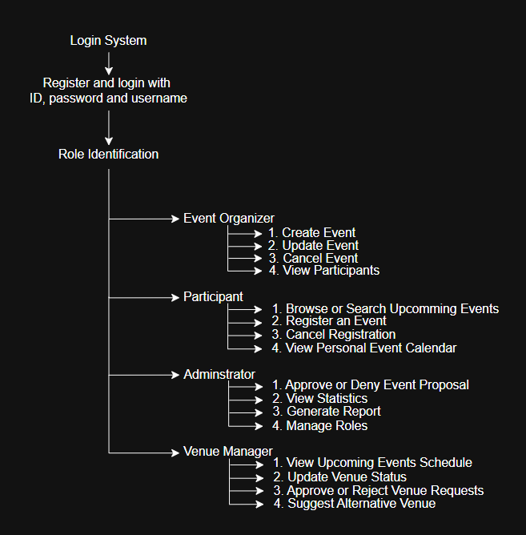
Each role accesses their menu and specific functionalities. The system relies on separate Python functions for each operation. The system utilizes plain text files (.txt) for persistent data storage instead of databases. All informations such as events, venues, requests, participants are stored and read from .txt files.

2.2 File structure
The system uses the following text files to process data:
users.txt | Stores user details (user ID, password, username, role)
event.txt | Stores event details (event ID, event name, date, venue ID, description, capacity, organizer ID, event status and venue status)
organizers.txt | Stores organizer details (organizer ID and name)
participants.txt | Stores participant details (participant ID and name)
registrations.txt | Stores participant’s registration details (participant ID, event ID and status with “Registered”)
adminstrator.txt | Stores the events’ report which generated by Adminstrator (event ID, title, status and number of participants)
venues.txt | Stores venue details (venue ID, venue, status and unavailable reason)
venue_requests.txt | Stores venue request details (event ID, venue ID, venue, date, organizer ID and reason)

2.3 Pseudocode
FUNCTION user_register()
PRINT "=== Event User Registration ===”
INITIALIZE username = INPUT "Create username: "
INITIALIZE password = INPUT "Create password:
INITIALIZE user_id = INPUT "Create ID (ex: admin1) : "
role = INPUT "Enter role (admin/organizer/participant/venue): "
##input validation
IF role NOT IN ["admin", "organizer", "participant", "venue"] THEN
PRINT "Invalid role! Must be: admin, organizer, participant, or venue."
RETURN
END IF

IF username IS EMPTY OR password IS EMPTY OR user_id IS EMPTY THEN
PRINT "Username, password, and ID cannot be empty."
RETURN
END IF

## save data from user
TRY
OPEN FILE "users.txt" IN APPEND MODE
WRITE username,password,user_id,role TO FILE (CSV format)
PRINT "Registration successful!"
PRINT "Please login after registration"
CATCH ERROR
PRINT "Failed to save user:", ERROR_MESSAGE
END FUNCTION

FUNCTION login(username, password, user_id)
TRY
OPEN FILE "users.txt" IN READ MODE
FOR EACH line IN FILE
parts = SPLIT line BY ',' AND TRIM
IF LENGTH(parts) != 4 THEN CONTINUE
INITIALIZE stored_user = TRIM (parts[0])
INITIALIZE stored_pass = TRIM (parts[1])
INITIALIZE stored_id = TRIM (parts[2])
INITIALIZE role = LOWERCASE(TRIM (parts[3]))
END IF
IF username == stored_user AND password == stored_pass AND user_id == stored_id THEN
RETURN role
END IF
END FOR
RETURN NULL
CATCH FileNotFoundError
PRINT "User file not found."
RETURN NULL

END FUNCTION

FUNCTION user_login()
WHILE TRUE DO
PRINT "=== EVENT LOGIN SYSTEM ==="
INITIALIZE new_user = INPUT "Are you a new user? (Y/N): " (uppercase and trim)
###REGISTER NEW USER
IF new_user == "Y" THEN
CALL user_register()
CONTINUE
END IF
## LOGIN
PRINT "=== LOGIN ==="
SET username = INPUT "Username: "
SET password = INPUT "Password: "
SET user_id = INPUT "ID (ex: admin1): "

role = CALL login(username, password, user_id)

IF role != NULL THEN
PRINT "Welcome, " + username + "! You are logged in as " { role } "."

IF role == "admin" THEN
IMPORT Administrator MODULE
CALL Administrator.admin_menu()
ELSE IF role == "organizer" THEN
IMPORT Event_Organizer MODULE
CALL Event_Organizer.organizer_menu()
ELSE IF role == "participant" THEN
IMPORT Participants MODULE
CALL Participants.participant_menu()
ELSE IF role == "venue" THEN
IMPORT venue_manager MODULE
CALL venue_manager.venue_manager_menu()
ELSE
PRINT "Unknown role."
BREAK
END IF
ELSE
PRINT "Invalid login credentials."
END IF
END WHILE
END FUNCTION
##call main menu

CALL user_login()

2.4 Screenshot & Explanation of Programming Concepts
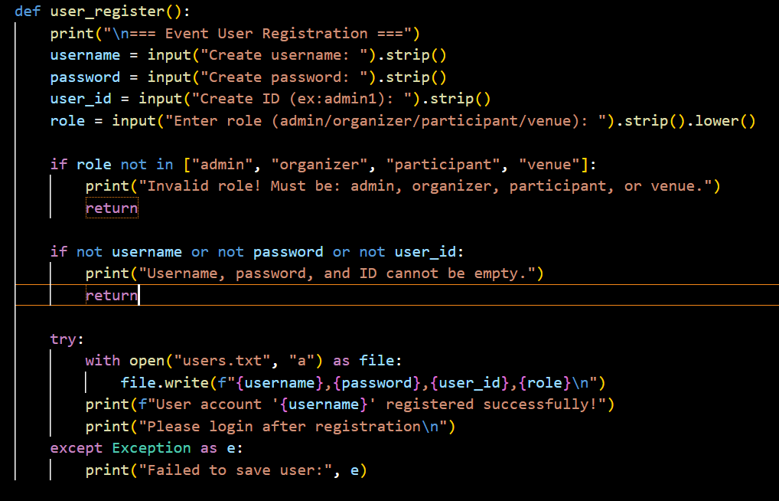

Following data entry, the system will verify that the role—which needs to be one of admin, organiser, participant, or venue—is valid through a number of tests. If not, an error message will appear and the program will terminate. Make sure no fields are left blank. The application will display an error message and terminate if the ID, password, or username are not entered. The application stores the user data in a text file named users.txt if all the data is correct.

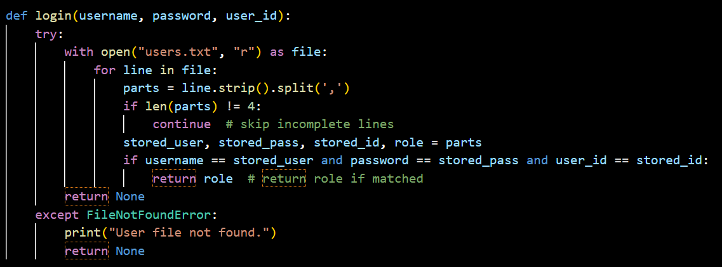

The purpose of the login() function is to check whether the user's login information is genuine by looking up the user's ID, password, and username in the users.txt file. The application will access users.txt, which contains user data that has already been entered; if it is unable to do so, an error message will be displayed. If the user's username, password, and user ID match the information included in the file, the function will be to determine the user's role (for example, administrator, organizer, etc.).

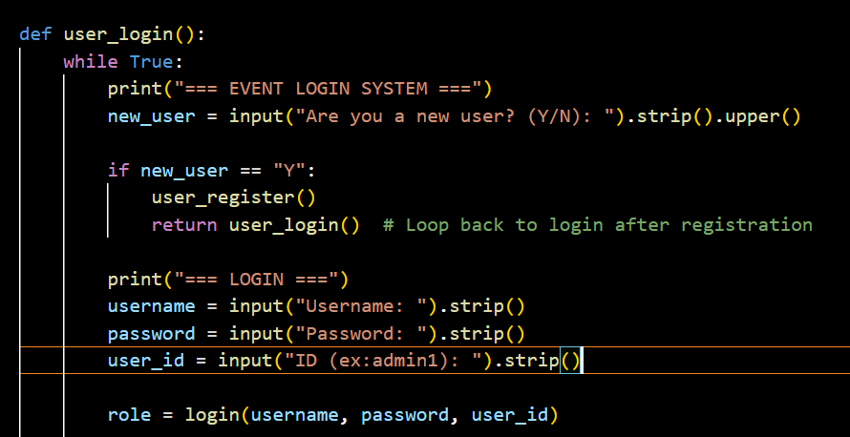

The operations the program will execute when the user inputs their role correctly are demonstrated in the code snippet below. The program will print a welcome message to the user upon successful login, and then:
- If the role is "admin", it loads the Administrator module and calls the admin_menu() function to display the custom admin menu.
- If the role is “organizer”, the program imports the Event_Organizer module and calls organizer_menu().
- If the role is “participant”, the program imports Participant and invokes participant_menu().
- The application loads venue_manager and calls venue_manager_menu() when the role is "venue."
The program will exit the login loop and display the message "Unknown role" if no matching role is present. Users are sent to the corresponding menu under this section based on where they are in the campus event system

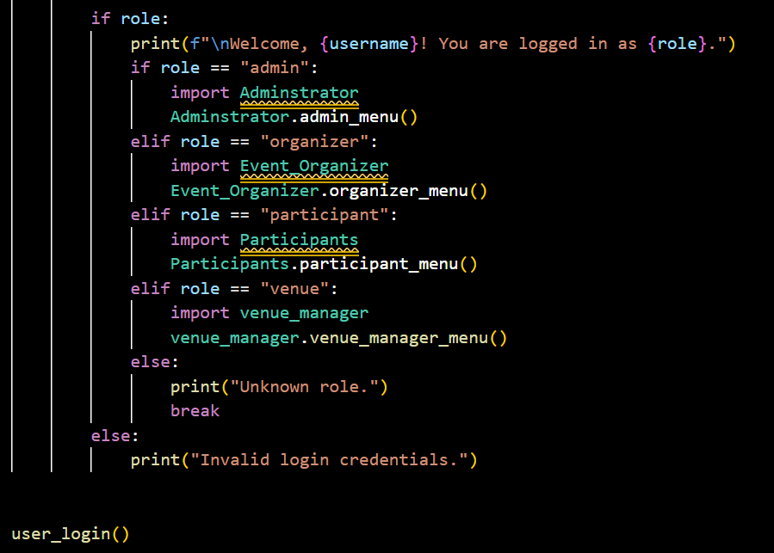

The steps that the program will take after the user has successfully logged in are illustrated under the code section below. The application will present a greeting message to the user upon successful login followed by:
- If the role is "admin", the application imports Administrator module and calls the admin_menu() function to display the custom admin menu
- If the role is “organizer”, the program imports the Event_Organizer module and calls organizer_menu().
- If the role is “participant”, the program imports Participant and invokes participant_menu().
- The app imports venue_manager and calls venue_manager_menu() when the role is "venue."
The program will exit the login loop and display the message "Unknown role" in case there is no corresponding role. Based on their position in the campus event system, users are guided to the right menu in this section.

2.5 Input & Output Screenshot & Explanation

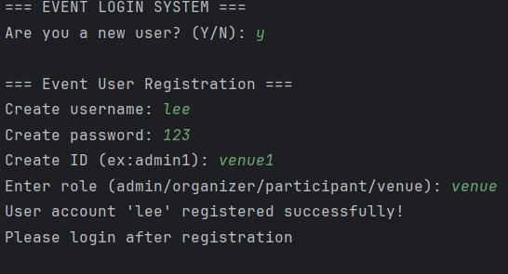

This screenshot shows the output of the login system which allows users to register or login to the system. The user is asked to enter “y” or “n” to answer whether they are a new user. If the user enters “y” as a new user, it displays event user registration to let user create username, password, ID and the role.
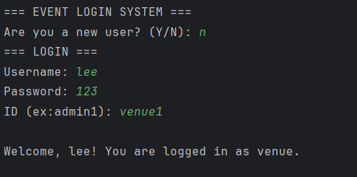
This screenshot shows the output of the login system. If user already has an account, user can enter “n” to enter the login page. Users can type their username, password and ID they created before to login their role.

3.0 Role-Based System Implementation

3.1 Event Organizer
For this assignment, Wayne Tiew Chen Yuan was tasked with coding the event organizer functionalities of the Smart Campus Event Management System.
The Event Organizer in the Smart Campus Event Management System plays an important role in the organization and administration of university events. Organizers of new events will have to fill in the some basic data of their event title, date, location description and capacity of participant. Organizers do have the ability to edit those details should anything change after the event has been created. Should one need to be called off for any reason, event organizers have the ability to cancel the event directly through the system. What’s more, they get to see who is attending their events, monitoring who has signed up and who is engaging. This position is accountable for the efficient planning and management of events, which is vital to the success of campus events operations.
The implementation plan started with writing a pseudocode outline. The following sections will describe the major functionalities implemented for the event organizer.

3.1.1 Program Design with Pseudocode

Initial design for the pseudocode was developed keeping these key features in mind:

organizer_login() | Logs in or registers a new organizer
organizer_menu() | Main loop for organizer interactions
create_event() | Creates a new event with validation and file writing
update_event() | Allows editing of title/date/venue/desc/capacity
cancel_event() | Marks an event and related registrations as cancelled
view_participants() | Shows registered participants for approved events
generate_event_id() | Generates a new unique event ID based on file data
get_organizer_eventss() | Retrieves all events created by an organizer
get_available_venues() | Filters available venues based on date and status
update_event_record() | Writes updated event details back to file

START

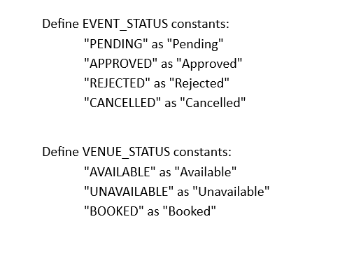

Function Organizer Menu
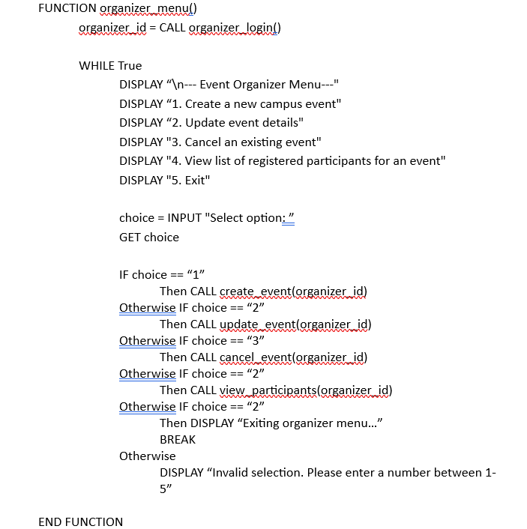

Function Create Event
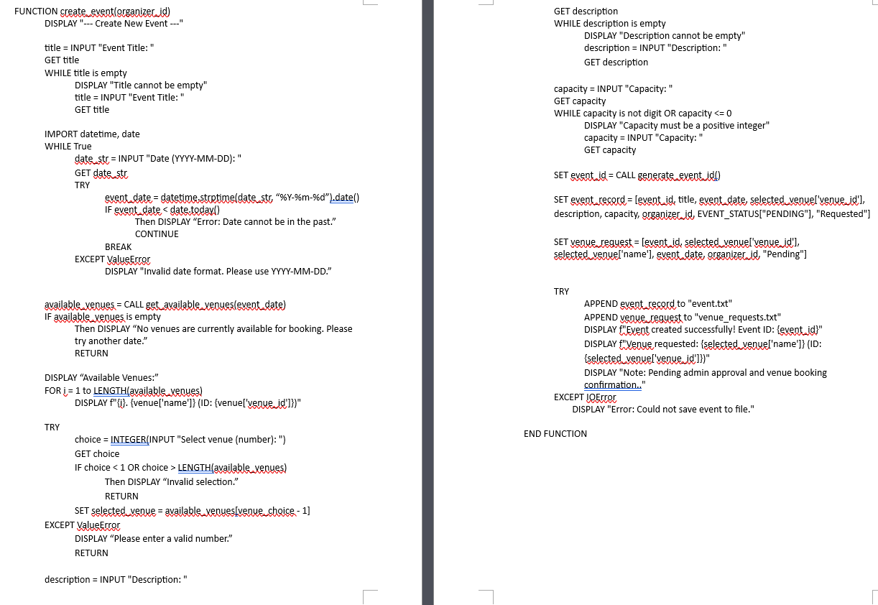

Function Update Event
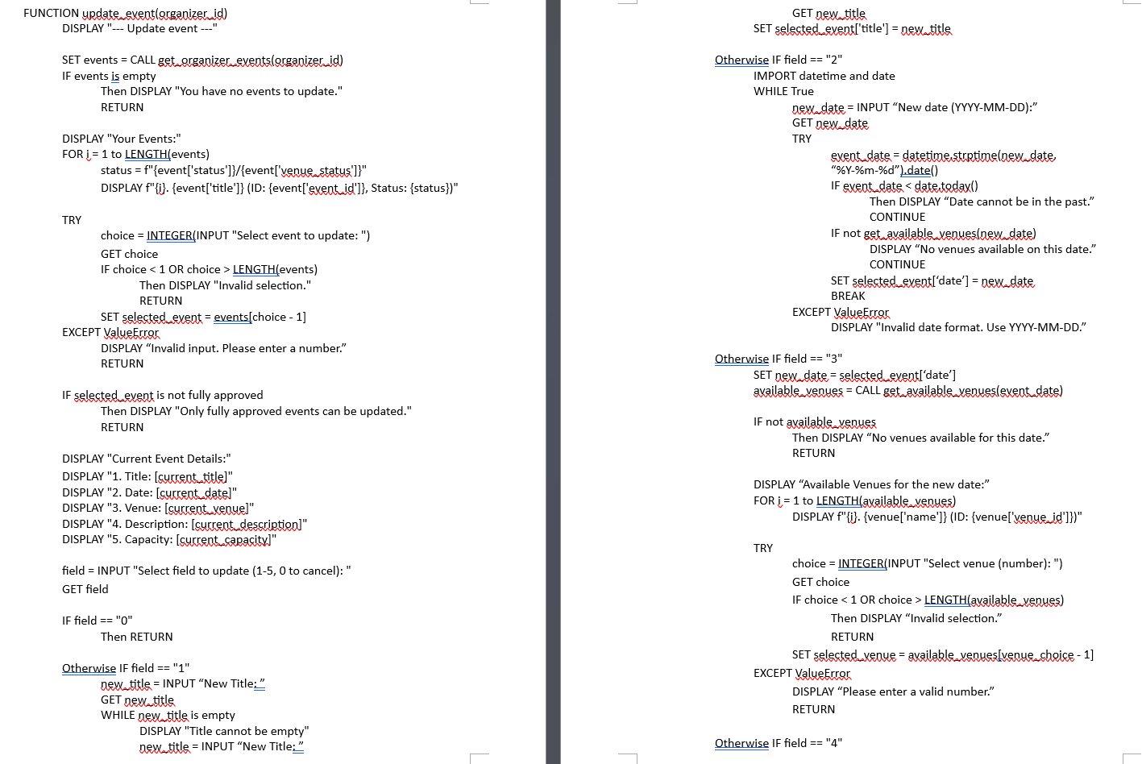
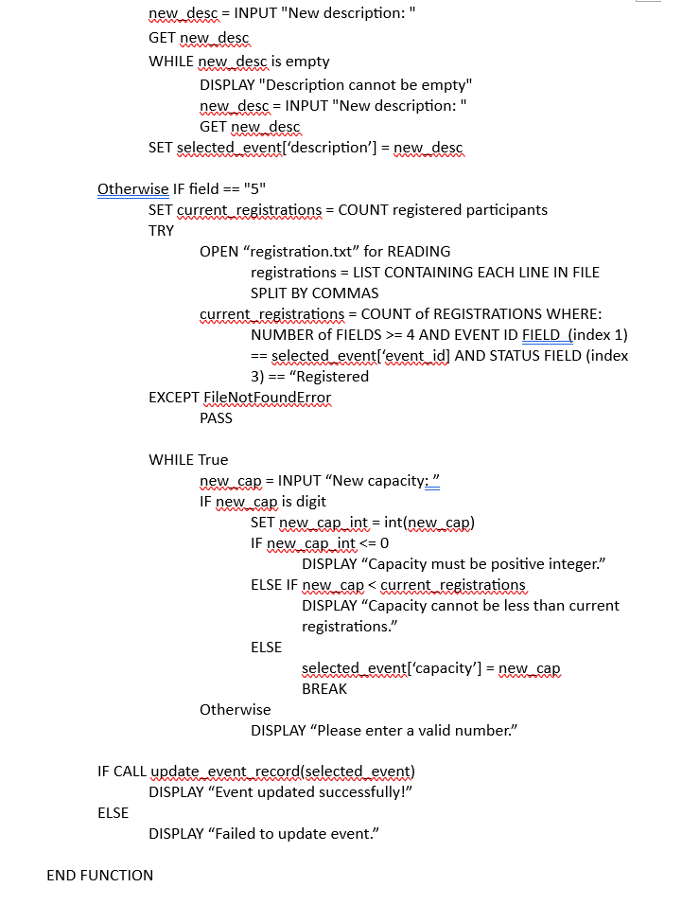

Function Cancel Event
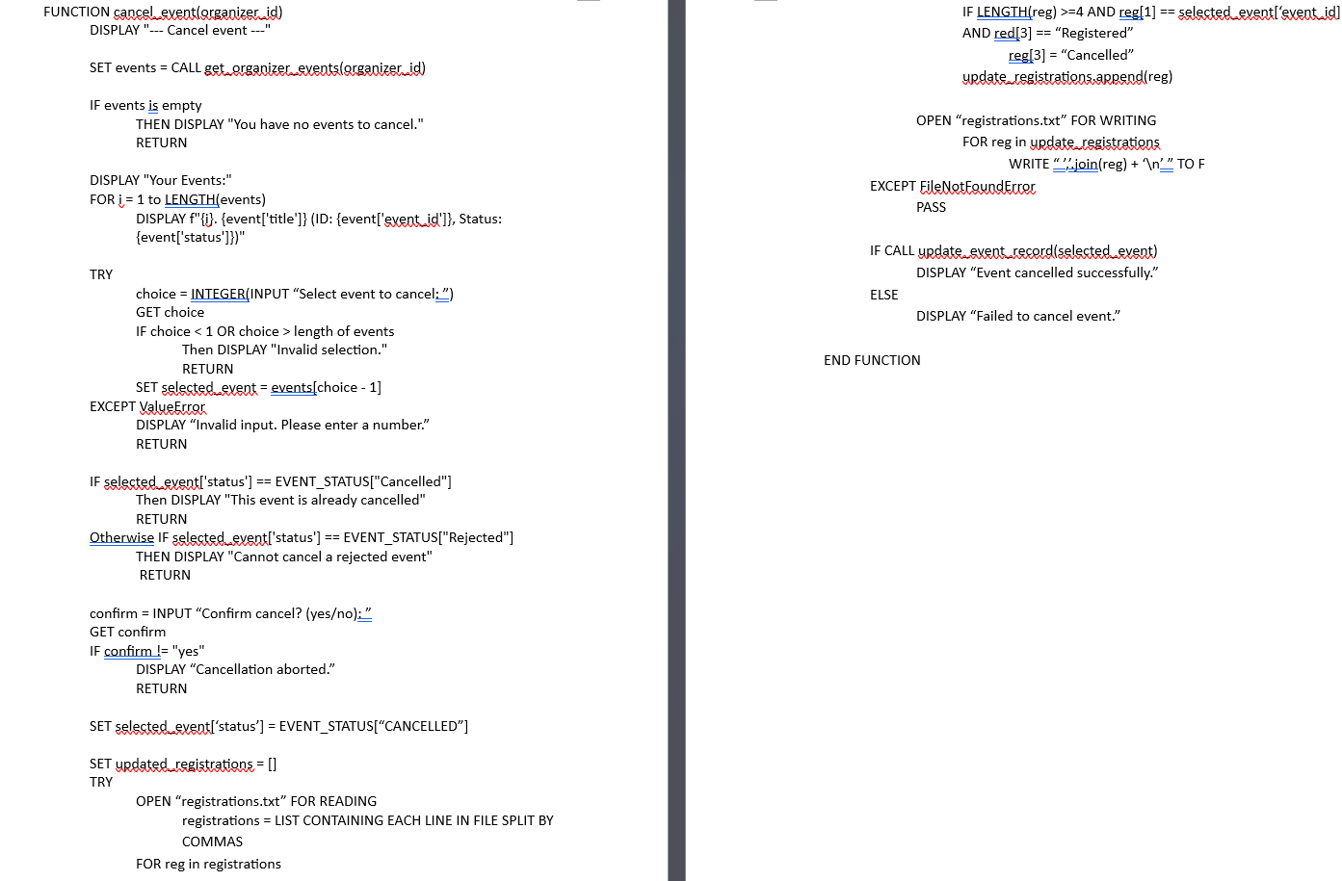

Function View Participant
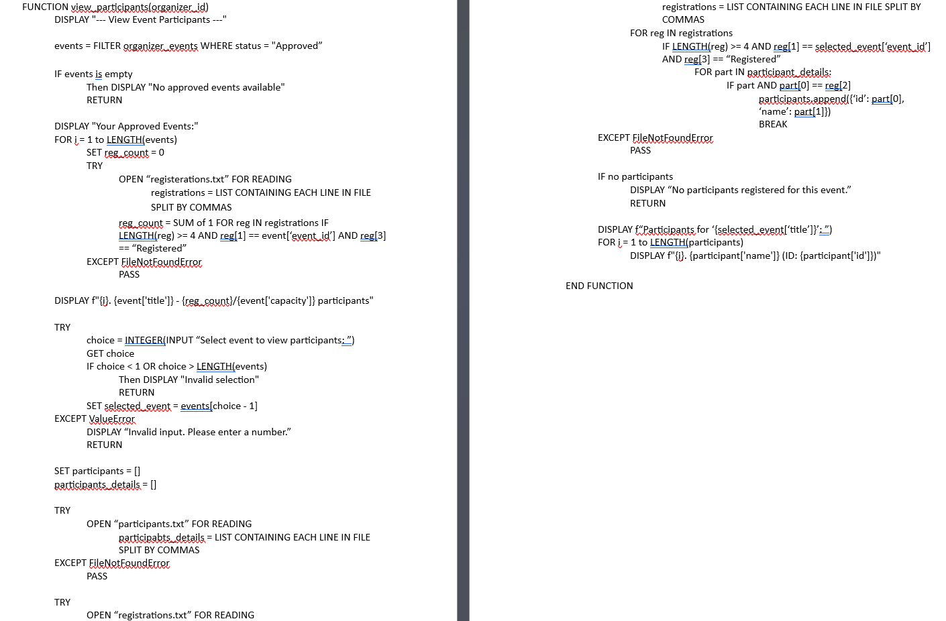

Helper Function Organizer Login
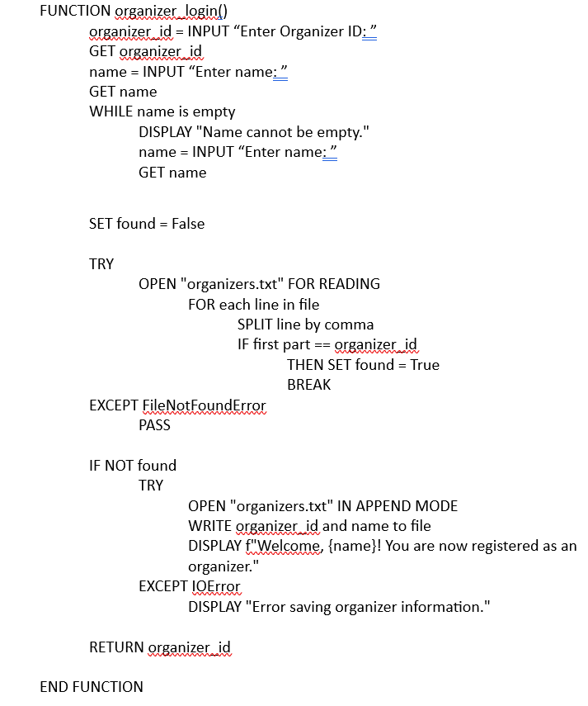

Helper Function Generate Event ID
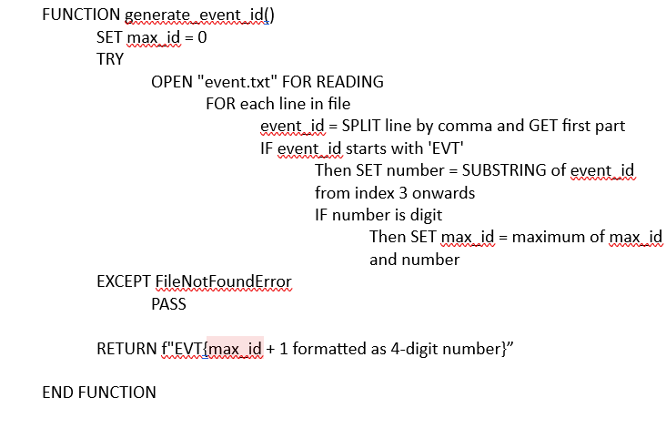

Helper Function Get Organizer Events
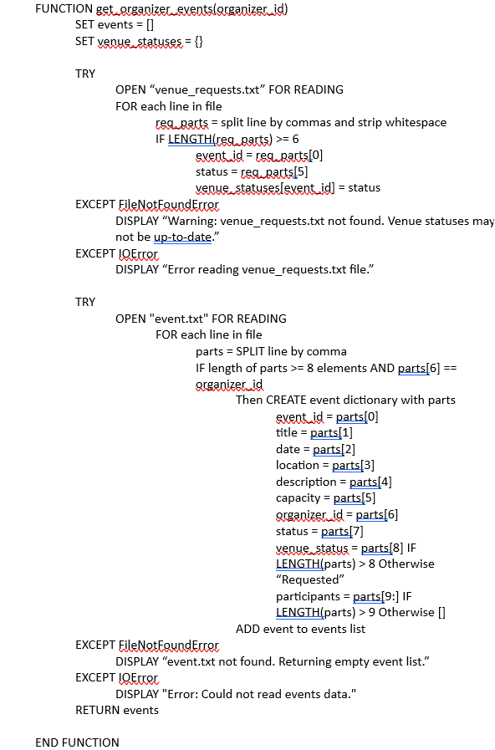

Helper Function Update Event Record
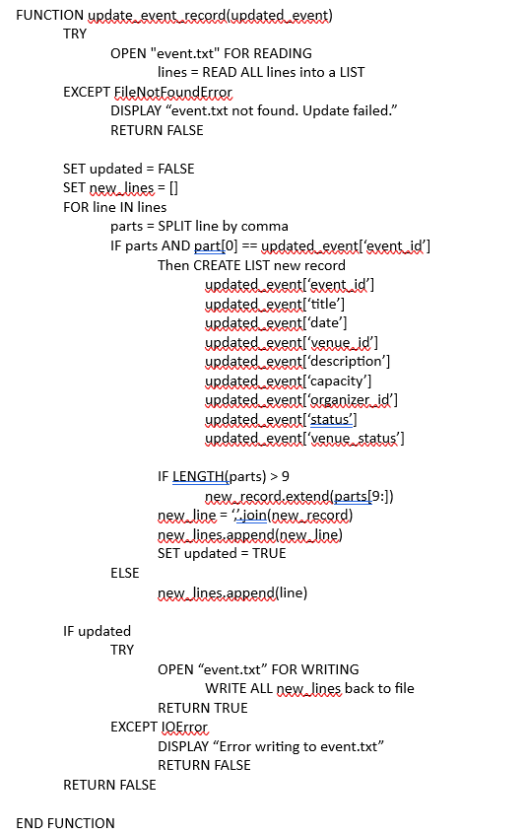
Helper Function Get Available Venues
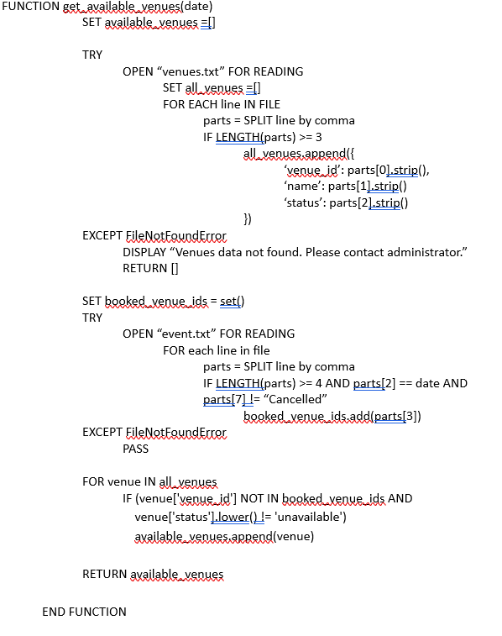

CALL FUNCTION organizer_menu()

END

3.1.2 Screenshot & Explanation of Programming Concepts

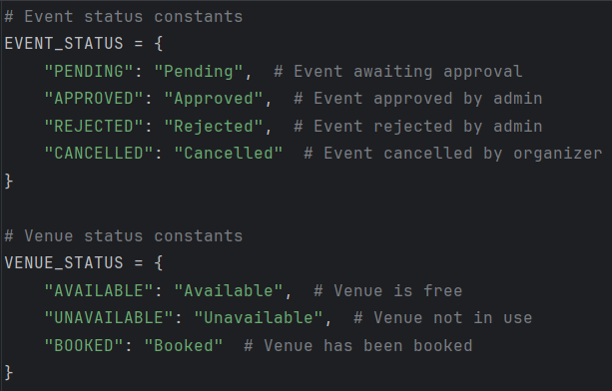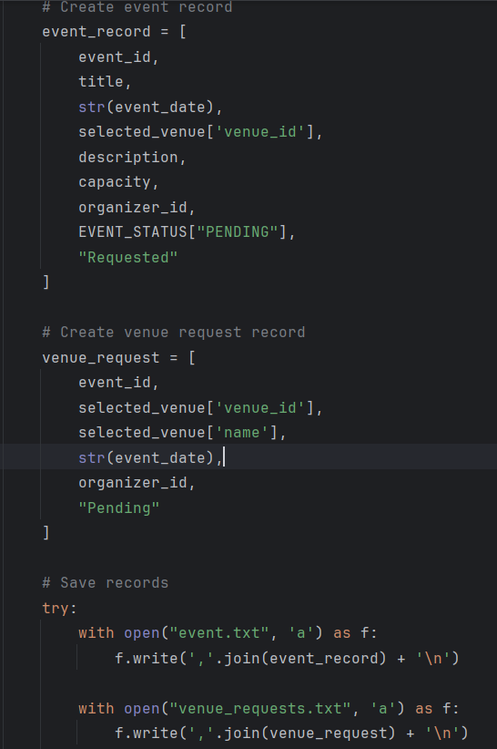
Storage Types Used in the System: In this event organizer system, multiple storage types are used throughout the program to manage event-related data. Firstly, two dictionaries are declared at the top of the code: EVENT_STATUS and VENUE_STATUS, which are used to hold constant values for different status categories of events and venues. These dictionaries map internal status codes such as “PENDING” or “APPROVED” to user-friendly labels. Lists are also used heavily in the system—for example, in the create_event() function, new records such as event_record and venue_request are created using lists that store all relevant event attributes like ID, title, date, venue, description, etc. Finally, the system uses external text files (event.txt, organizers.txt, venue_requests.txt) to store data persistently. Data is saved to these files using write() functions and retrieved using readlines() and string splitting methods. These storage techniques ensure both temporary and long-term data management across different user sessions.

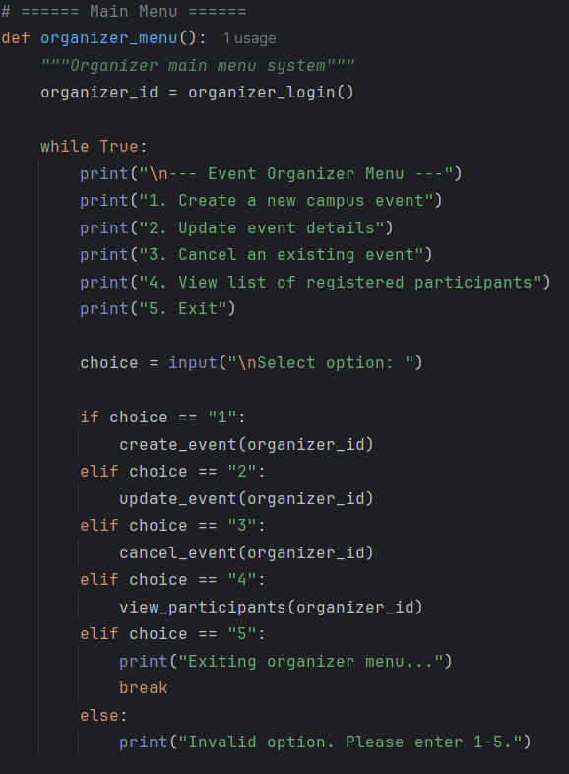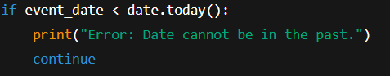
Application of If...Else and Nested If: The program uses if-else and nested if conditions to implement user decision logic and input validation throughout the application. In the organizer_menu() function, an if-else structure is used to route the organizer to different functions based on the option they select from the menu. For example, if the user chooses option "1", the create_event() function is called; if they select "5", the loop breaks and exits the menu. Nested if statements are commonly used for deeper validation. For instance, in the create_event() function, after checking the format of the input date using datetime.strptime(), another nested if condition checks whether the date is in the past. If it is, an error message gets displayed and re-enter by the user. These layered if structures help enforce logical flow and robust error handling in the program.

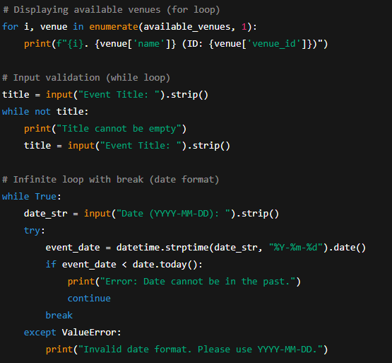
Application of For Loop and While Loop: Both for and while loops are used in this system to facilitate repeated operations and input validation. For loops are commonly used to iterate through collections, such as in get_available_venues() where each line from a text file is read and converted into a dictionary for easier access. Another example is in view_participants() where a for loop is used to iterate over registration records to find participants for a selected event. While loops are applied mainly in input validation scenarios. In create_event(), a while not title: loop ensures that the user cannot proceed without entering a valid event title. Similarly, the program uses while True: loops to continuously prompt users for correct input formats, such as dates or positive integers for capacity, until valid data is provided. These looping structures ensure that the system maintains correctness and does not allow invalid data to proceed further.

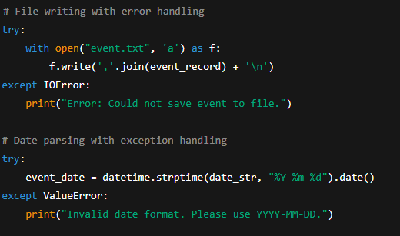
Application of Try and Except in the System: The event organizer system uses try-except blocks to handle potential runtime errors, particularly those related to file operations and user input formats. In the create_event() function, when the user inputs a date, the system uses a try block to attempt converting the string into a valid datetime.date object using datetime.strptime(). If the user enters an incorrect format, a ValueError is raised, and the except block catches the error and displays an appropriate message without crashing the program. File reading and writing operations, such as reading from event.txt or organizers.txt, are also wrapped in try-except blocks to catch FileNotFoundError or IOError, which might occur if the file doesn't exist or is unreadable. These try-except implementations provide robustness and prevent the system from terminating unexpectedly due to common input or file-related errors.

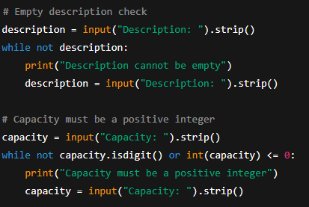
Input Validation Techniques in the System: Input validation is critical in this system to ensure data integrity and to guide users through correct input formats. In the create_event() function, the system performs validations such as checking if the event title or description is empty using a while not condition. For the date field, it verifies not only the format but also whether the entered date is not in the past. Another example is in the capacity input, where the program checks if the input is a digit and whether it is a positive integer. In the update_event() function, when the user changes capacity, the system compares the new value with the current number of registered participants and disallows values that are too small. These validation mechanisms ensure that the system maintains meaningful and usable data across all functions.

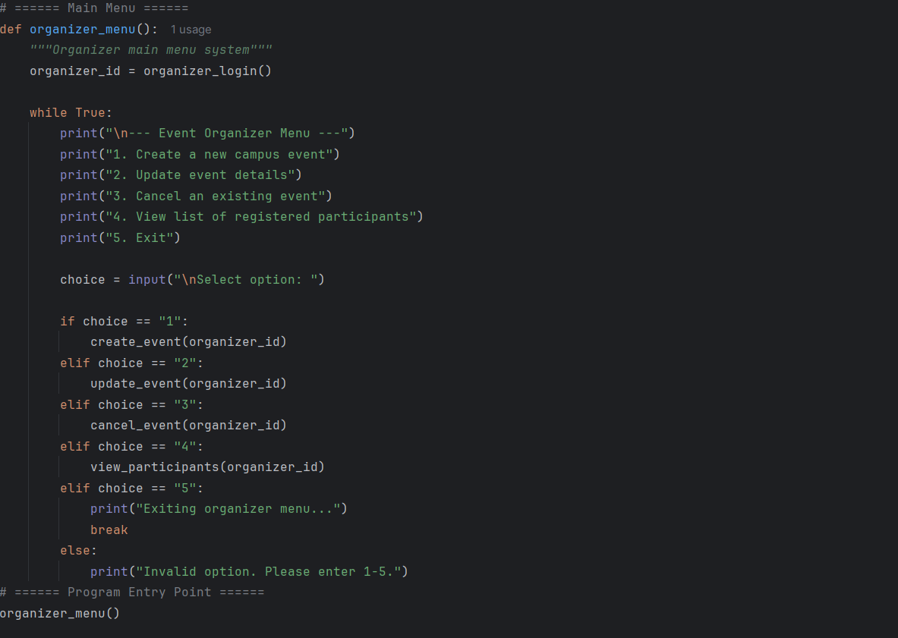
Main Entry Point Using organizer_menu(): The function organizer_menu() serves as the main user interface for the event organizer. It first calls the organizer_login() function to verify or register the organizer’s identity, and then enters an infinite loop to repeatedly display a menu of options. Using an if-else control structure, the user’s menu choice is evaluated and redirected to the respective function, such as create_event(), update_event(), or cancel_event(). The loop continues until the user selects the exit option. This centralized menu approach improves user navigation and ensures that all organizer-related features are accessible from a single, cohesive point.

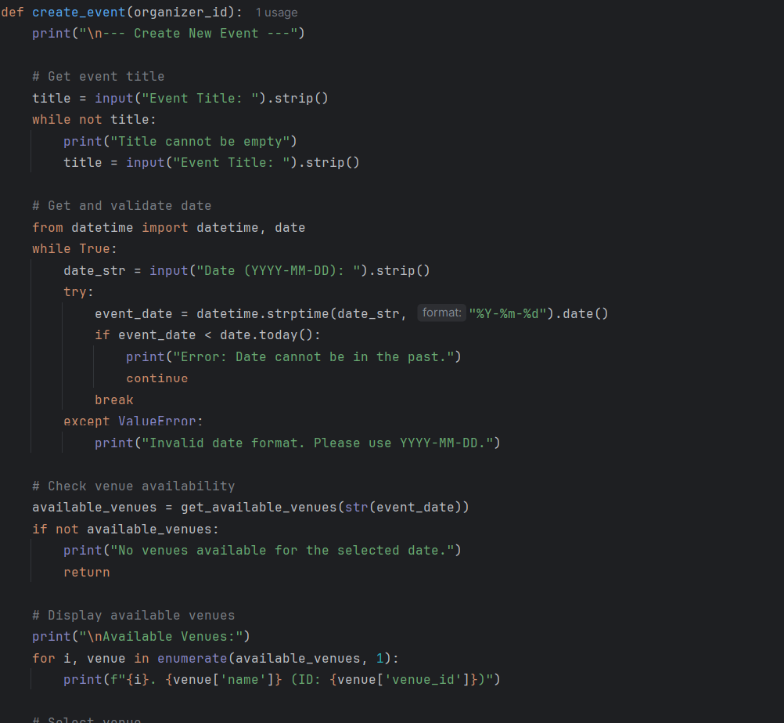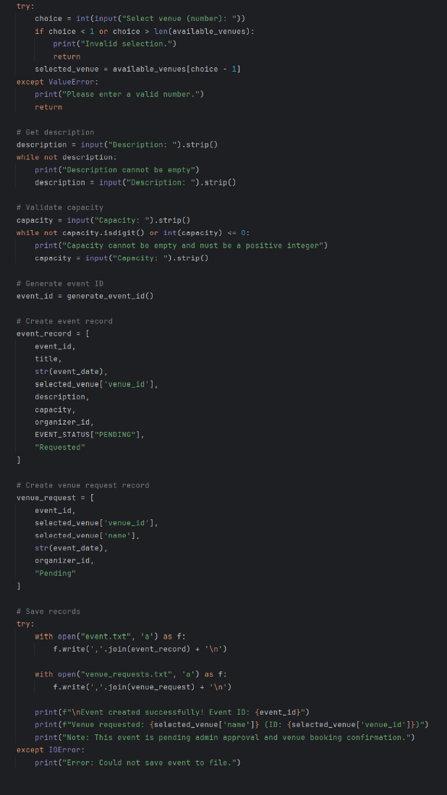
Event Creation Process with create_event(): The create_event() function enables the organizer to create a new event by guiding them through a step-by-step input and validation process. It begins by prompting for basic details such as the event title, date, and description. A try-except block is used to validate the date format, and logical checks are applied to ensure the date is not in the past. The function then retrieves available venues for the selected date by calling get_available_venues(), and prompts the user to choose one. It also verifies that the entered capacity is a valid number. Once all inputs are confirmed, the function generates a unique event ID using generate_event_id(), creates the event and venue request records, and writes them to the corresponding text files. This function demonstrates integration of input validation, file handling, and data organization.
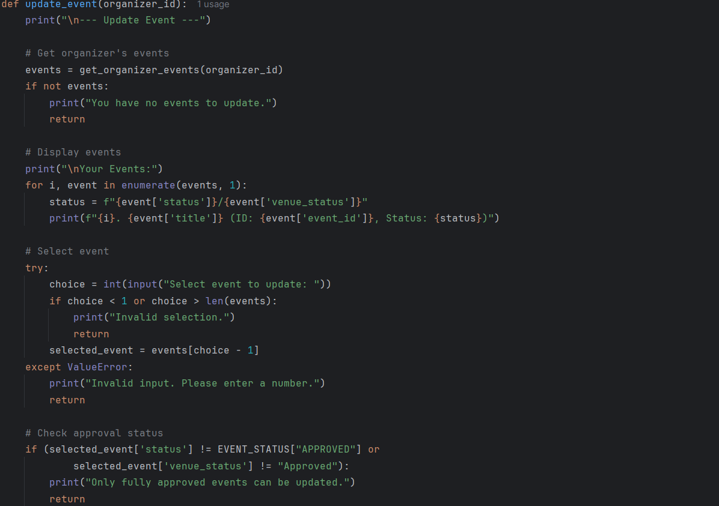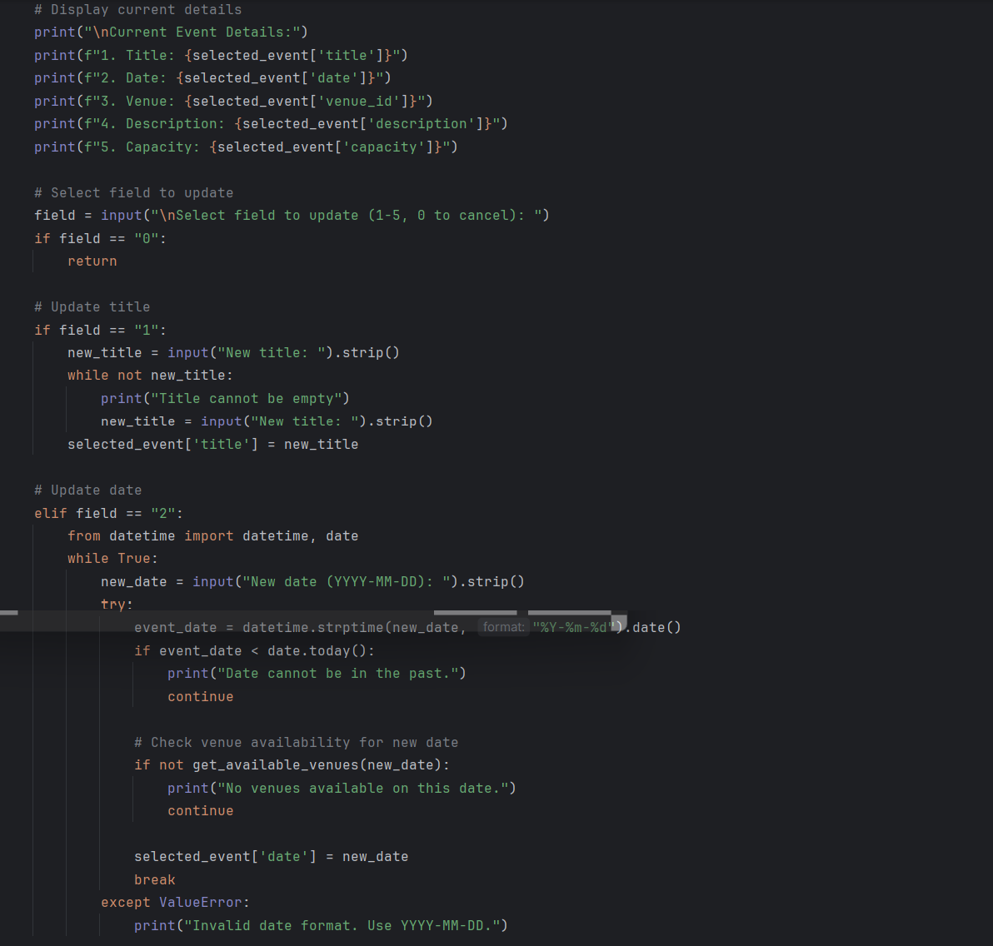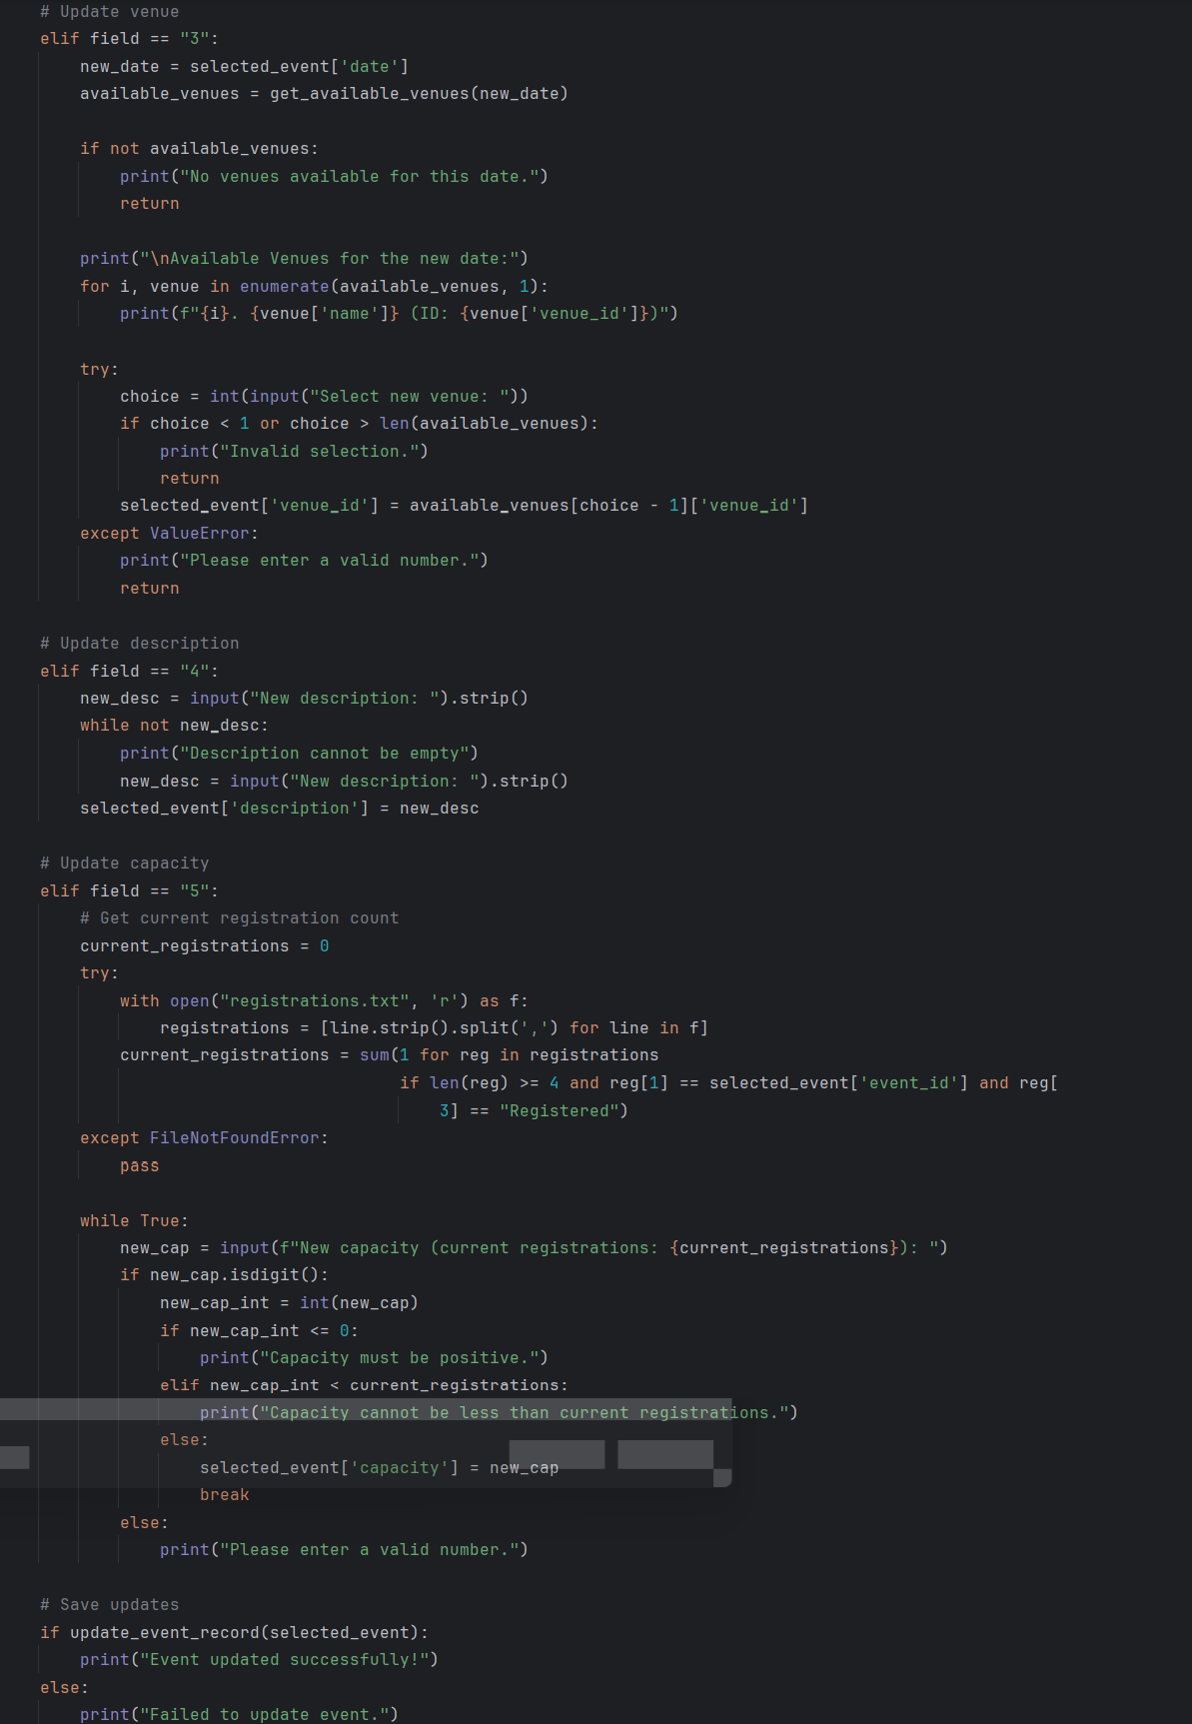
Editing Event Details with update_event(): The update_event() function allows organizers to modify details of their existing events. It first retrieves all events created by the logged-in organizer using get_organizer_events(), and filters for approved events only. After displaying these events, the user selects which event to update. The function then presents a list of editable fields such as title, date, venue, description, and capacity. Each update action is handled with proper validation—for example, the system checks that the new date is not in the past, and that a venue is available for the updated date. If the organizer changes the capacity, it ensures the new value is not lower than the number of current participants. Once all changes are validated, the function saves the updates using update_event_record(). This function demonstrates dynamic field editing and safeguards against invalid updates.
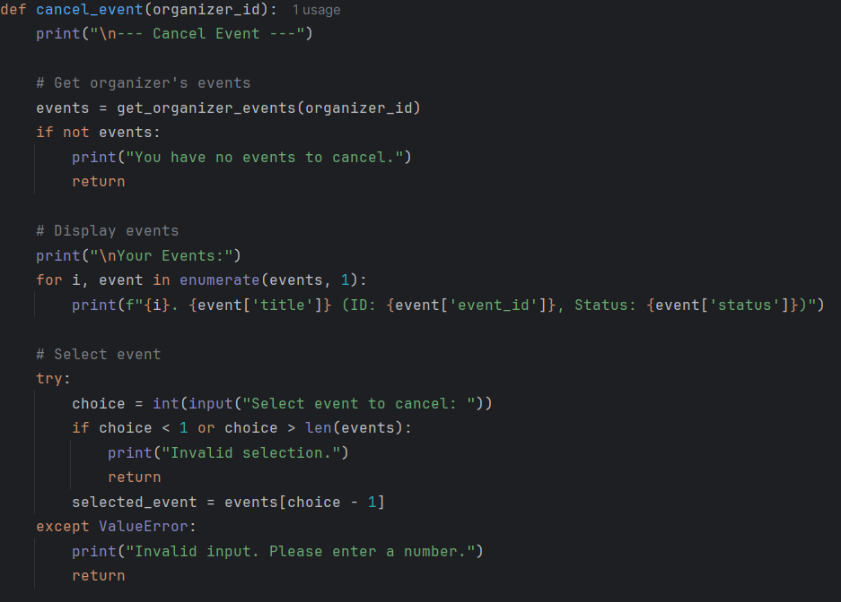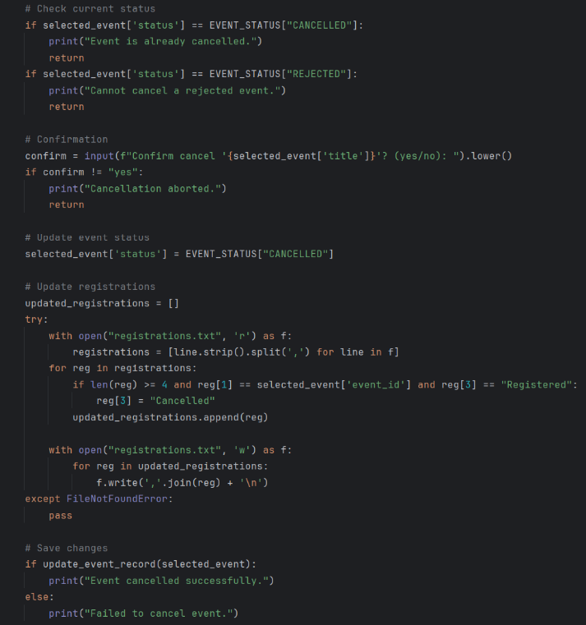
Cancelling Events with cancel_event(): The cancel_event() function provides the organizer with the ability to cancel a previously scheduled event. It first retrieves the list of events created by the organizer and allows them to choose one from the list. The function checks the event’s current status to ensure it is not already cancelled or rejected. Upon confirmation from the user, the event status is updated to “Cancelled”. The function then accesses the registrations.txt file and updates the registration status of all participants for that event to “Cancelled” as well. This ensures that participant records are synchronized with the event’s status. Finally, the event record is updated in the main data file through update_event_record(). This function ensures consistent data handling between event and participant records when an event is cancelled.

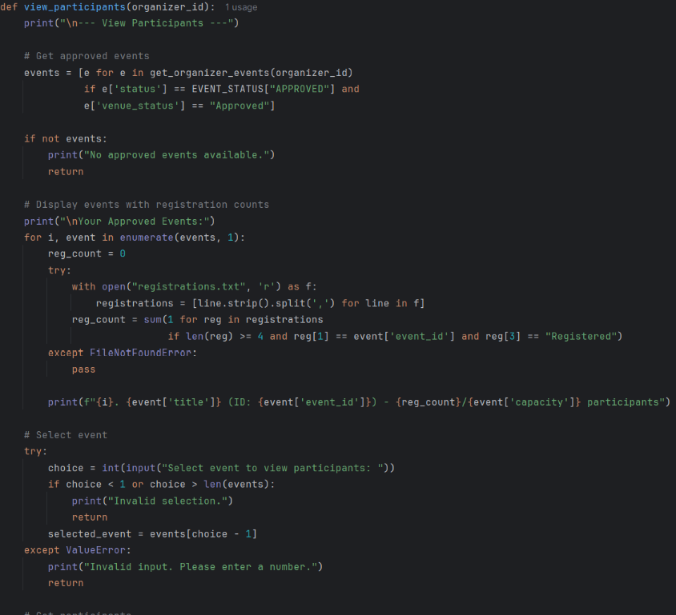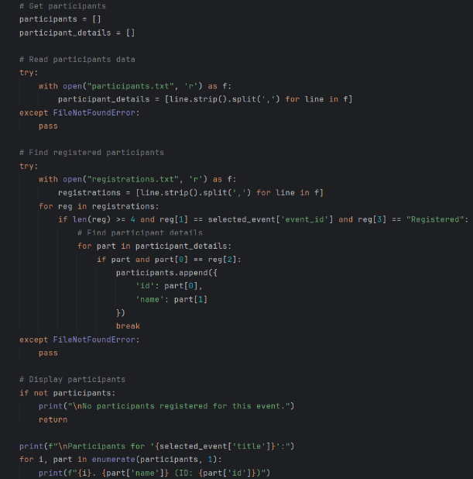
Viewing Registered Participants: The view_participants() function allows the organizer to view participants registered for their approved events. It begins by filtering only events that are approved both by status and venue. The function then displays each event along with the current number of participants. After the user selects a specific event, the system reads from both registrations.txt and participants.txt to identify participants who registered for that event and are still marked as “Registered”. It matches participant IDs across the files to retrieve full names. The final output is a numbered list of participant names and IDs. This function illustrates file cross-referencing and real-time participant listing for organizer review.

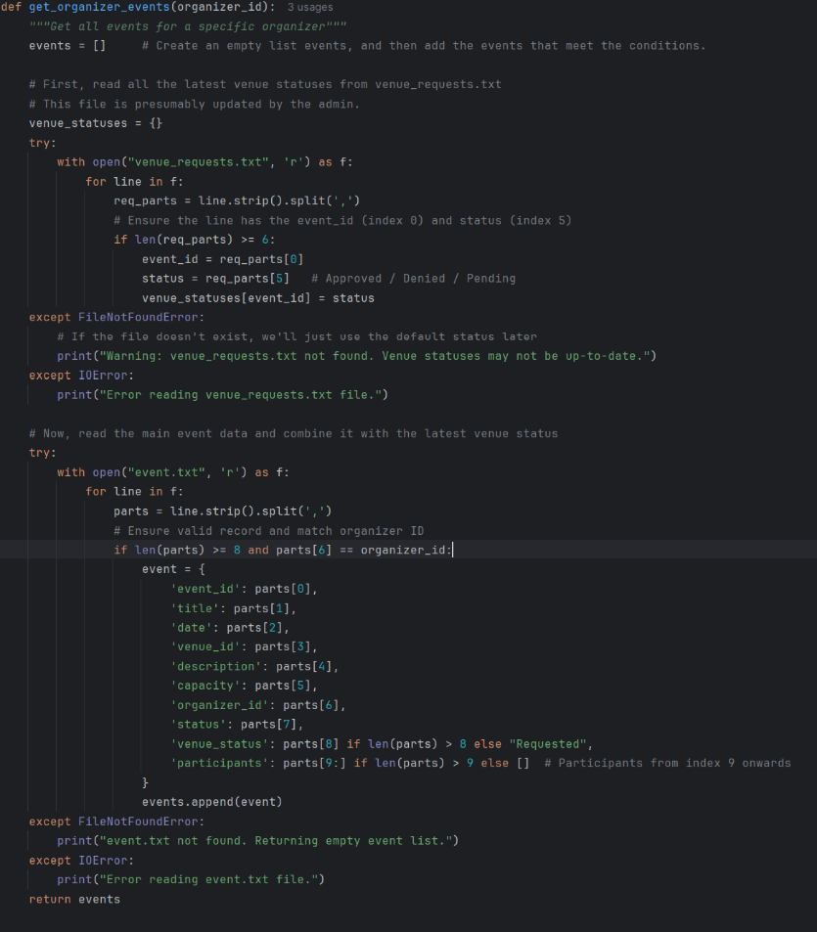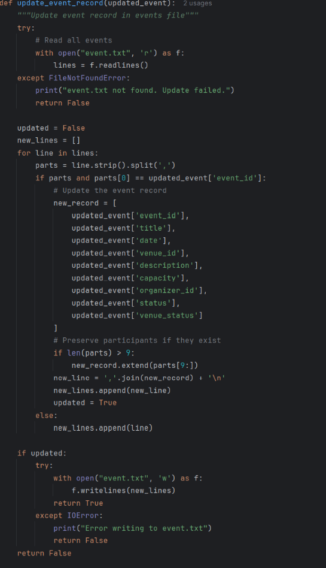
Managing Event Records: The get_organizer_events() function retrieves all events from event.txt that are linked to the currently logged-in organizer. It also reads from venue_requests.txt to merge venue approval statuses with the events. Each event is stored as a dictionary with relevant fields such as ID, title, date, description, and status. On the other hand, the update_event_record() function is responsible for modifying an existing event’s record. It loads all events, locates the matching event by ID, and rewrites the updated record back to the file, preserving participant data if any. These two functions ensure accurate reading and writing of event data and support features like updating and cancelling events.
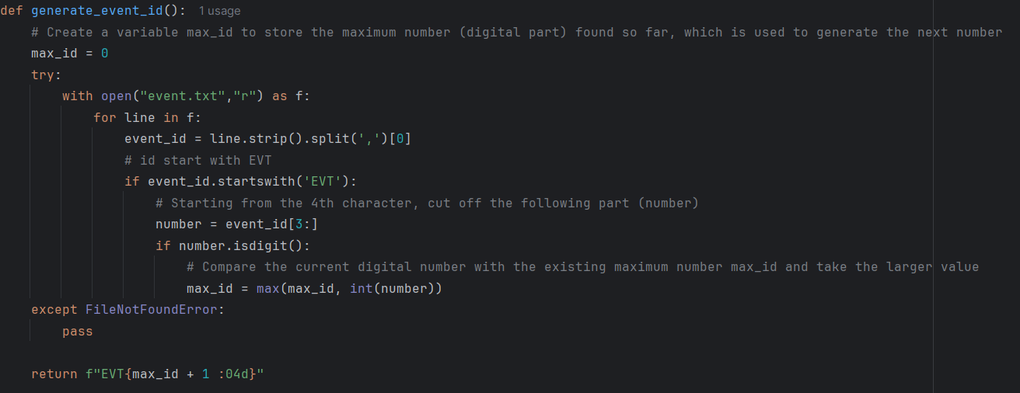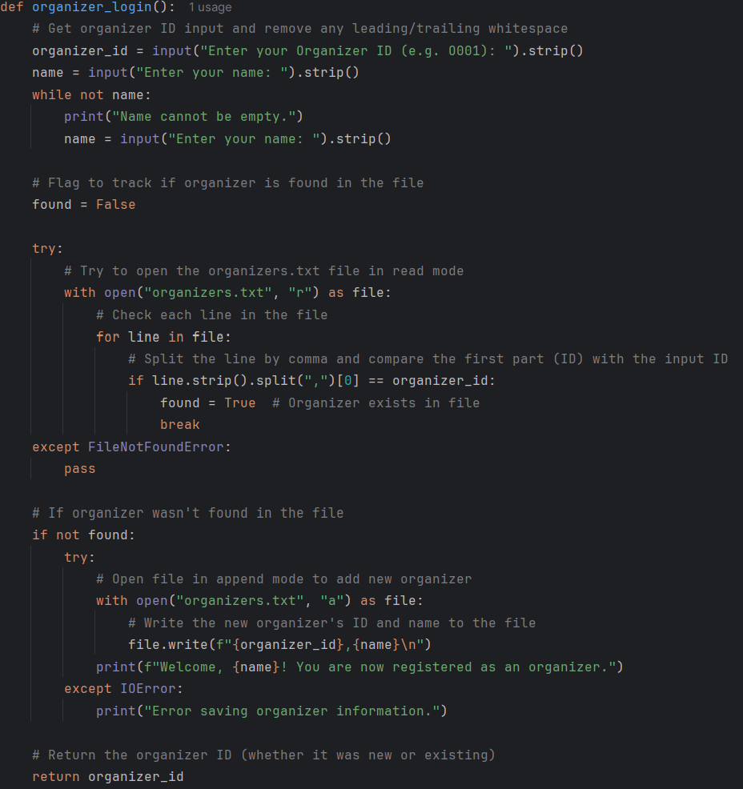
Supporting User Registration and ID Generation: The organizer_login() function is used at the start of the system to either verify the identity of an existing organizer or register a new one. It checks the entered ID against the records in organizers.txt, and if the ID is not found, it appends the new organizer’s ID and name to the file. Meanwhile, the generate_event_id() function is used to automatically create a unique event ID by scanning all existing event records in event.txt, extracting the numeric part of the latest ID, and incrementing it. It formats the ID as EVTXXXX, padding the number with leading zeroes. These utility functions simplify repetitive tasks and ensure that organizers and events have unique identifiers in the system.
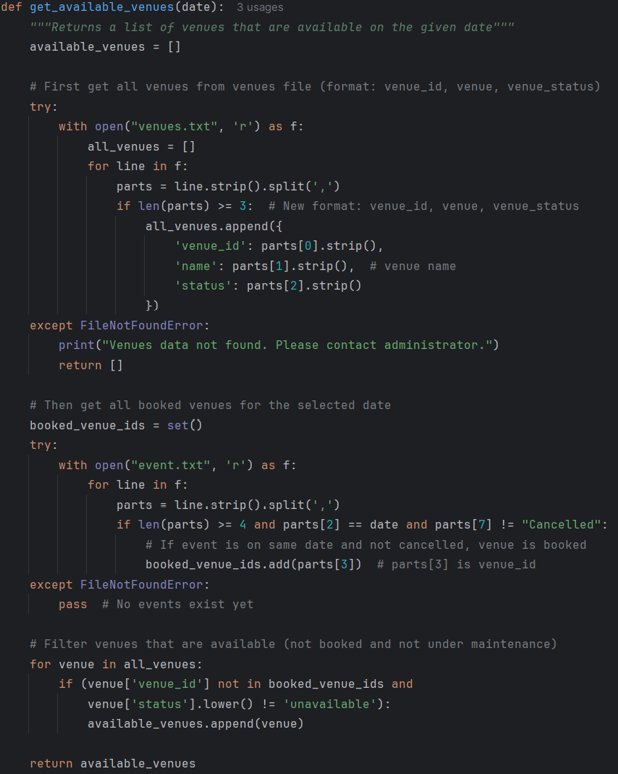
get_available_venues(date) – File Filtering and Logic: This function returns a list of available venues on a specified date. It reads the full venue list from venues.txt, filters out those that are booked on the given date by checking event.txt, and excludes venues marked as “unavailable.” It demonstrates usage of file reading, list filtering, and dictionary handling in Python. This function is reused in multiple parts of the system to dynamically provide venue options based on the event date.

3.1.3 Input & Output Screenshot & Explanation

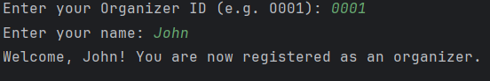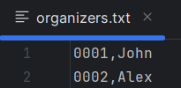
Screenshot 3.1.3.1 Screenshot 3.1.3.2
Organizer Login
- The program asks for an Organizer ID and name (Screenshot 3.1.3.1).
- It checks if the ID already exists in organizers.txt (Screenshot 3.1.3.2):
- ✅ If found: It logs them in silently.
- ❌ If not found: It registers the new organizer by appending to the file and welcomes them.

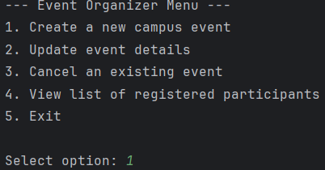
Screenshot 3.1.3.3
Organizer Main Menu
- This is the main menu for event organizers after logging in.
- The user selected option 1 to create a new event.
- Other available options:
- 2 to update details of an approved event.
- 3 to cancel an existing event.
- 4 to view participants of approved events.
- 5 to exit back to the main program or logout.

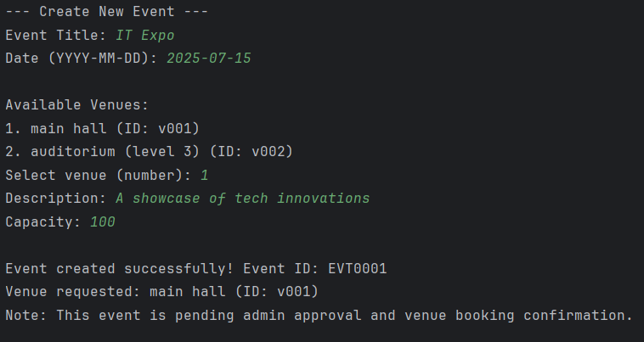 Screenshot 3.1.3.4

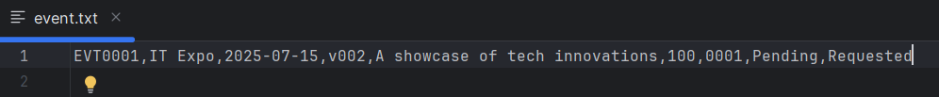 Screenshot 3.1.3.5

Create a New Event
- The organizer enters the event title, future date, selects from available venues, writes a description, and defines a capacity.
- Venue availability is checked against existing bookings and statuses.
- A new event_id is generated (e.g., EVT0001).
- The event is saved to event.txt and marked as Pending (Screenshot 3.1.3.5).
- A venue request is also saved for admin approval.

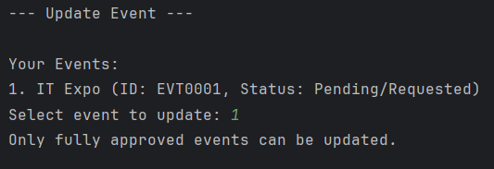
Screenshot 3.1.3.6

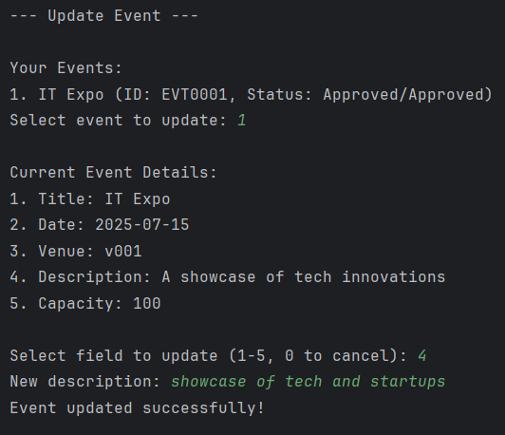
Screenshot 3.1.3.7

Screenshot 3.1.3.8
Update Event
- Only can update the event that is fully approved (Screenshot 3.1.3.5).
- Organizer selects an approved event and chooses a field to update.
- Example shows changing the description (Screenshot 3.1.3.6).
- Validations ensure logical values (e.g., dates must be in the future, capacity can't be below current registrations).
- Updates are written back to event.txt (Screenshot 3.1.3.8).

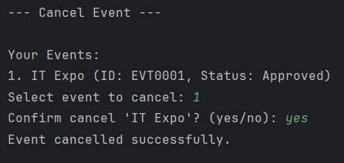
Screenshot 3.1.3.8

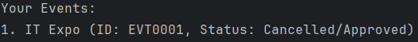
Screenshot 3.1.3.9
Cancel Event
- Organizer can cancel events that are not already cancelled or rejected (Screenshot 3.1.3.7).
- System confirms before changing status (Screenshot 3.1.3.7).
- Registered participants are marked as "Cancelled" in registrations.txt (Screenshot 3.1.3.8).

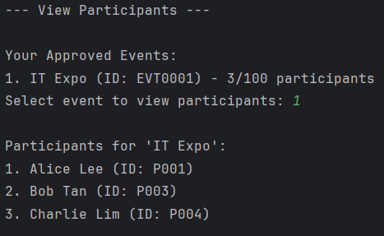
Screenshot 3.1.3.10
View Participants
- Displays a list of approved events and current participant count.
- Get the count of participant from registrations.txt
- On selection, lists participant names and IDs from participants.txt.

3.2 Participant
The Participant role in the Smart Campus Event Management System is for participants (including students and faculty) to join campus events. Participants can browse and search upcoming events, where they can view the event ID, title, date, location, description, and capacity. After that, they can register for events or cancel their registrations. Finally, they will get a calendar that shows all the events they have registered for.

3.2.1 Program Design with Pseudocode
START
FUNCTION participant_login():
PROMPT user to input Participant ID PROMPT user to input Name SET found = False
TRY:
OPEN "participants.txt" FOR reading
FOR each line in the file:
IF first element == entered Participant ID:
SET found = True
BREAK loop
EXCEPT FileNotFoundError:
Pass
IF found is False:
TRY:
OPEN "participants.txt" FOR appending
WRITE Participant ID and Name to the file
DISPLAY " Welcome, {name} you are now registered as a participant."
EXCEPT: DISPLAY " invalid saving participant."
RETURN Participant ID
FUNCTION participant_menu():
CALL participant_login() and assign result to participant_id
While True:
DISPLAY "---Participant Menu---"
DISPLAY "1. Browse/Search Upcoming Events"
DISPLAY "2. Register for an event"
DISPLAY "3. Cancel Registration"
DISPLAY "4. View Personal Event Calendar"
DISPLAY "5. Log out"
PROMPT user for choice
IF choice == "1":
DISPLAY "1. Browse all upcoming events"
DISPLAY "2. Search all upcoming events"
PROMPT user for sub-choice
IF sub-choice == "1":
CALL browse_upcoming_events()
ELSE IF sub-choice == "2":
CALL search_upcoming_events()
ELSE:
DISPLAY "Not available choice, please try again"
ELSE IF choice == "2":
CALL register_for_event(participant_id)
ELSE IF choice == "3":
CALL cancel_registration(participant_id)
ELSE IF choice == "4":
CALL view_personal_calendar(participant_id)
ELSE IF choice == "5":
DISPLAY "Log out"
EXIT loop
ELSE:
DISPLAY "Invalid choice, please write a correct option"

FUNCTION browse_upcoming_events:
Try ：
open "venues.txt" for reading
For each line in the file:
Split the line by comma into parts
If there are at least 2 parts:
Set venue_id = first part
Set venue_name = second part
Store venue_id and venue_name in location_dict
If "venues.txt" not found:
Print VENUES FILE NOT EXISTING
Try：
open "event.txt" for reading
Print the header "Upcoming Events"
Print column headings in formatted table layout
For each line in the file:
Split the line by comma into parts
If there are at least 8 parts AND event status is "Approved":
Extract event_id, title, date, location_id, description, capacity from the parts
Lookup location_name from location_dict using location_id
If not found, use location_id as fallback
Print event details in formatted table layout
If "event.txt" not found:
Print EVENT FILE NOT EXISTING
FUNCTION search_upcoming_events():
PROMPT user to enter a keyword AND CONVERT to lowercase
SET found = False
TRY:
OPEN "event.txt" for reading as f
FOR each line in file f:
SPLIT line by comma into parts
IF parts has at least 8 elements AND parts[7] == "approved":
IF keyword found in any of parts[0] to parts[4] (converted to lowercase):
DISPLAY parts[0], parts[1], parts[2],parts[3],parts[4]
SET found = True
IF found == False:
DISPLAY "No events found."
EXCEPT FileNotFoundError:
DISPLAY "EVENTS FILE NOT EXISTING!"
FUNCTION register_for_event(participant_id)
CALL browse_upcoming_events()
PROMPT user to "Enter the Event ID to register for:"
SET event_id to user input
SET event_exists to False
TRY
OPEN "event.txt" for reading
FOR each line in file
SPLIT line by "," into parts
IF length of parts >= 8 AND parts[0] == event_id AND parts[7] (lowercased) == "approved" then
SET event_exists to True
BREAK loop
EXCEPT FileNotFoundError
DISPLAY "Event file not found!"
RETURN
IF not event_exists
DISPLAY "The event ID you entered does not exist or has not been approved."
RETURN
TRY
OPEN "registrations.txt" for reading
FOR each line in file
SPLIT line BY "," into parts
IF length of parts >= 2 and parts[0] == participant_id and parts[1] == event_id then
DISPLAY "You have already registered for this event."
RETURN
EXCEPT FileNotFoundError
pass
TRY
OPEN "registrations.txt" for appending
WRITE participant_id, event_id, "Registered" to file
DISPLAY "Registration successful!"
EXCEPT IOError
DISPLAY "Registration failed! Please try again."
FUNCTION cancel_registration(participant_id)
Read registration records
TRY
OPEN "registrations.txt" for reading
FOR each line in file
SPLIT line by comma into parts
IF parts has at least 2 elements and parts[0] == participant_id then
APPEND parts[1] (event_id) to registered list
EXCEPT FileNotFoundError
PRINT "Cannot find the records"
RETURN
Check if participant registered any events
IF registered is empty then
PRINT "No register any event"
RETURN
Display participant's registered events
PRINT "---Your Registered Details---"
TRY
OPEN "event.txt" for reading
FOR each line in file
SPLIT line by comma into parts
IF parts[0] IS IN registered list then
PRINT parts[0], parts[1], parts[2], parts[3], parts[4]
EXCEPT FileNotFoundError
PRINT "No information"
RETURN
Ask for event ID to cancel
PROMPT user to input event_id to cancel
Check if the event_id is registered
IF event_id NOT IN registered then
PRINT "You are not registered for this event."
RETURN
TRY
OPEN "registrations.txt" for reading
READ all lines into memory
OPEN "registrations.txt" for writing
FOR each line IN previously read lines
IF line does not start with "participant_id,event_id" THEN
WRITE line back to file
PRINT "Registration cancel successfully."
EXCEPT IOError
PRINT "Failed to cancel registration."
FUNCTION view_personal_calendar(participant_id)
Initialize an empty list called registered_events
Initialize an empty dictionary called location_dict
Try ：
open “venues.txt” for reading:
For each line in the file:
Split the line by commas into parts
If there are at least two parts:
venue_id = first part
venue_name = second part
Store in location_dict[venue_id] = venue_name
If file not found:
Display VENUES FILE NOT EXISTING
Try：
open “registrations.txt” for reading:
For each line in the file:
Split the line by commas into parts
If the line belongs to the current participant:
Add the event_id to registered_events list
If file not found:
Display cannot find the records
If registered_events is empty:
Display "No registered events"
Stop
Print the table header (Event ID, Title, Date, Location, Description, Capacity)
Try:
open 'event.txt' for reading:
For each line in the file:
Split the line by commas into parts
If event_id is in registered_events:
Look up location name using location_dict
Print the formatted event details using event data and resolved location name
If file not found:
Display cannot find you calendar
END

3.2.2 Screenshot & Explanation of Programming Concepts
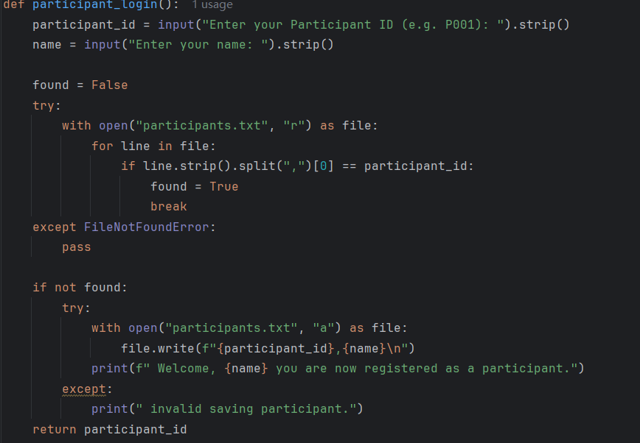
This function is to fulfil participants login. First, participants need to input their participant id and name for check if this id have or not already registered. Then if not register, it will automatic to help you to register as a new participant. Finally, return participant id is for the others function.

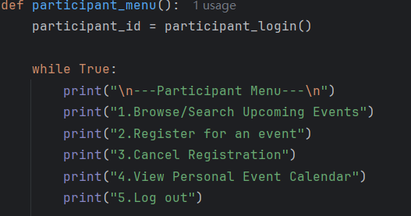
Calls the login function to get the current participant’s id. Then starts an infinite loop to keep showing the menu until the user logs out. Display the participant menu that have 5 options.
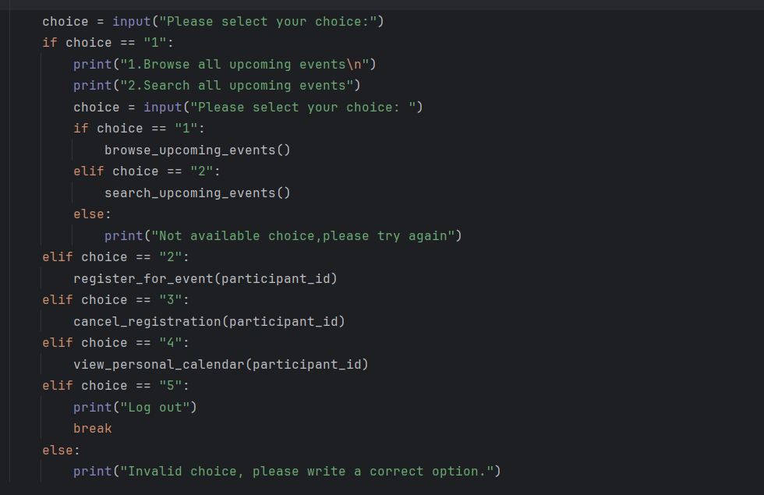
Participants can choose which choice they wanted , each option corresponds to a respective function.Participant can browse and search upcoming events,register for event,cancel registration,view personal calendar.Register for event need participant id because it need to identify who is registering、check if this participant already registered for the same event or not、save the participant id with the event id in registrations.txt.Cancel registration need participant id because find which events this participant has registered for、delete the specific registration releated this participant.View personal calendar need participant id because find out all events the participant has registered for from registrations.txt、fetch the events details from event.txt、only dispaly the personal calendar.
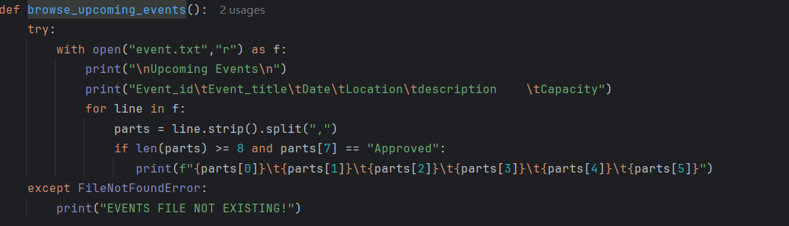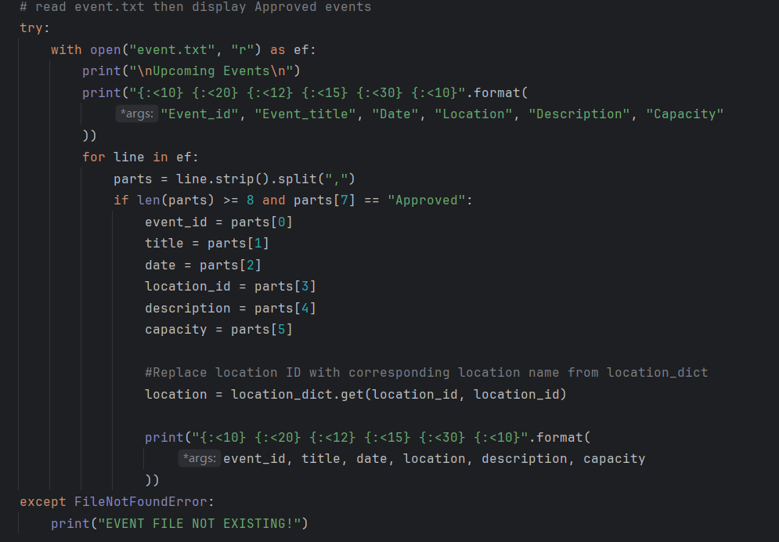

The design of the browse upcoming events function follows a logical and modular approach to ensure that event data is presented clearly and meaningfully to users. The function begins by constructing a dictionary that maps venue id to human-readable venue names by reading from venues.txt. This mapping is essential because the event records in event.txt store only the venue id, which are not user-friendly. By replacing these id with actual venue names, the displayed output becomes more understandable and informative for participants. After building the mapping, the function proceeds to read the event data from event.txt and filters out only those events that have been approved for display. This ensures that users only see valid and confirmed upcoming events. To enhance readability, each piece of event information—such as event id, title, date, location, description, and capacity—is assigned to a clearly named variable instead of using raw list indices. Finally, the function uses formatted string output to neatly align the columns in a tabular format, making the list of upcoming events easy to read. This overall design improves clarity, usability, and maintainability of the system, while ensuring that participants are presented with accurate and relevant event details.

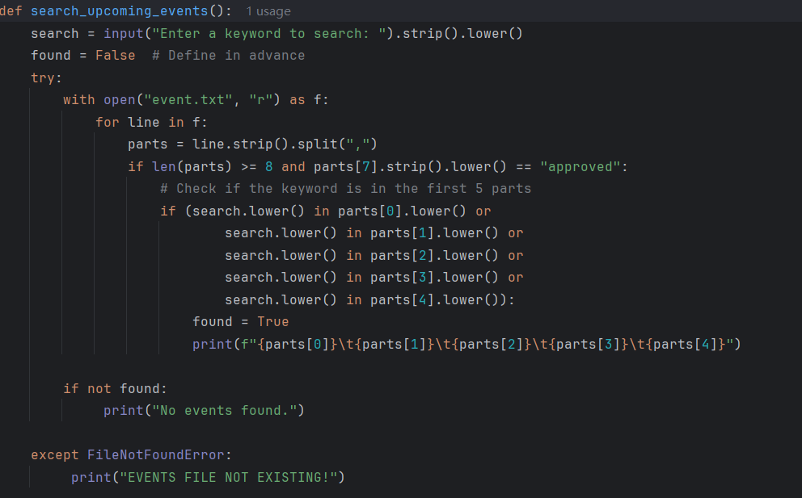Search upcoming events function is designed for participant can efficiently searching. By default, assume not found，then read from the event.txt and ensure the data at least 8 parts and approved by the admin, It then searches for the keyword within the event id, title, date, location, or description.Until found True ,the loop will stop then display details.On the other hands,if loop stop and found still false dispaly no events found.If cannot find the file,dispaly EVENTS FILE NOT EXISTING.
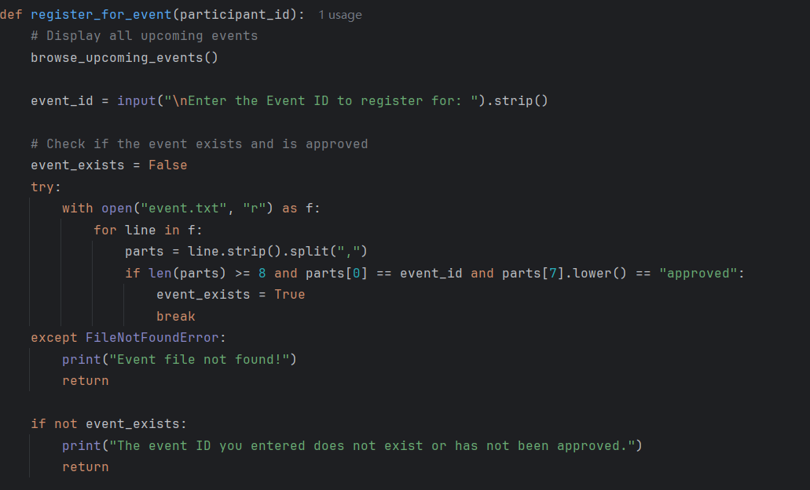First，register for event function call browse upcoming events to display all upcoming events then participants can clearly choose the events.Next,participants need to input which event id they want to register. By default, assume not event exists,read the event.txt ensure the data at least 8 parts , input current id match the event id within event.txt and the events had been approved.Until event exists True,the loop will break.. If the event file cannot found, notify the user and stop. The file is existing but no matching approved event was found, inform the user and exit the function.
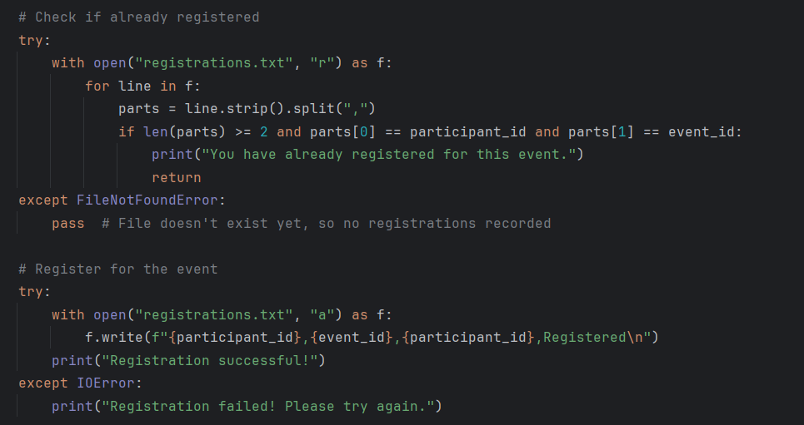

This part is check if participants already registered.Read the registrations.txt,if current participant id and event id exist in refistrations,txt,diapaly you have already registered for this event. If a match is found, the system notifies the user and returns immediately to avoid proceeding further.If the file cannot found(probably the first time system run so registrations.txt is empty,pass can ignore this not important mistake then continue proceed.
Append the registrations.txt,participants can register the events,write their participant id , event id and registered status into file,if success display registration successful!If failed like disk or permission issues display Registration failed!Please try again.

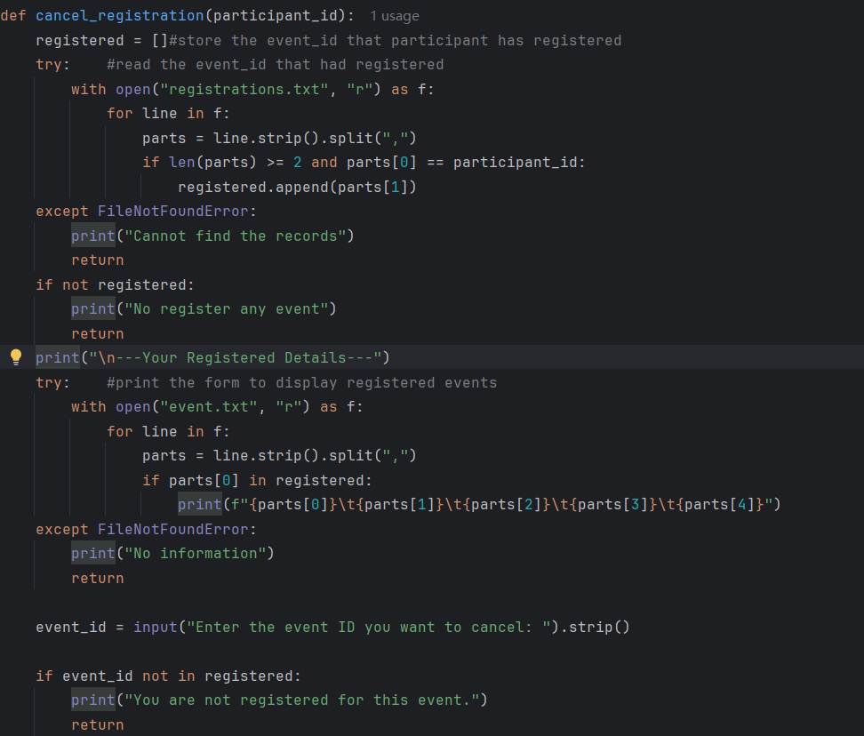This cancel registration function is designed to allow a participant to view and cancel their previously registered events. It begins by initializing an empty list called registered to store the event id the participant has signed up for. It then reads the registrations.txt and collects all event id that match the given participant id, ensuring only the current user's registrations are considered. If the file doesn't exist or the participant has not registered for any events, appropriate messages are displayed and the function exits early.Next, the function reads from event.txt to display detailed information about the registered events, such as event id, title, date, and location. This gives the participant a clear view of which events they are involved in. The user is then prompted to input the event id they wish to cancel. The function checks whether this id exists in the user's registered list, and if it does not, it informs the user that they are not registered for the specified event and exits.
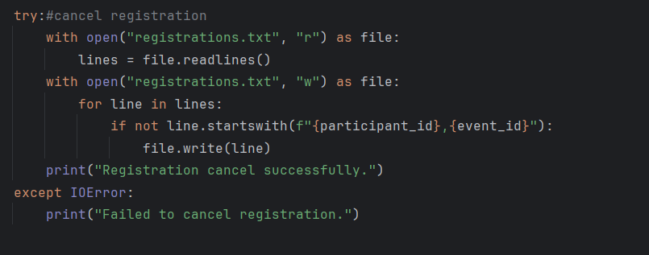This is for cancel registration,read the data one by one .Check if event you want to cancel, if the record is not the one to be deleted, write it back to the file; otherwise, skip that line.
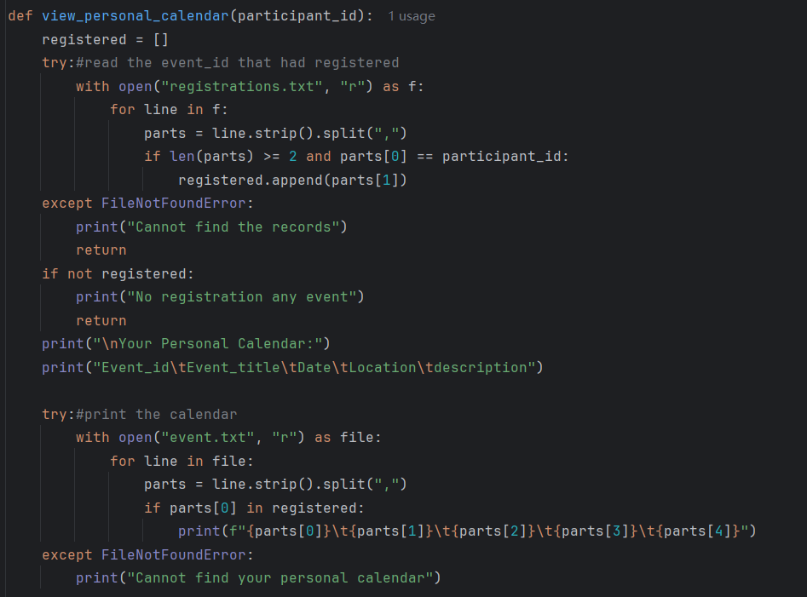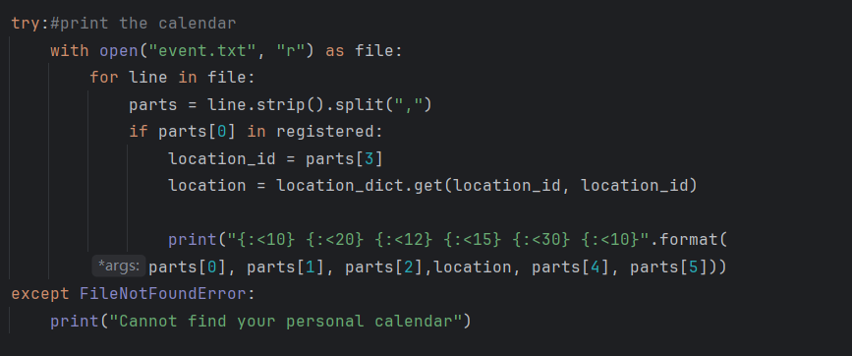

At the beginning, it creates an empty list called registered to collect all the event id that the participant has signed up for. It then reads the registrations.txt line by line to check which events this specific participant (identified by their ID) has registered for. If any match is found, the event id is added to the list. If no records are found or the participant hasn’t registered for anything, it simply prints a message and stops there. If there are registrations, it moves on to read the event.txt , which contains the full details of each event. For every event that matches one of the registered event id, it prints the full event. This makes it easy for the participant to see their personal schedule.

3.2.3 Input & Output Screenshot & Explanation
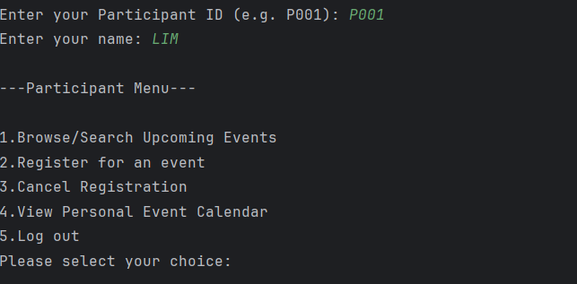
First,system want participant input their ID and NAME.If you enter correct information you can view the participant menu,there have 5 options.
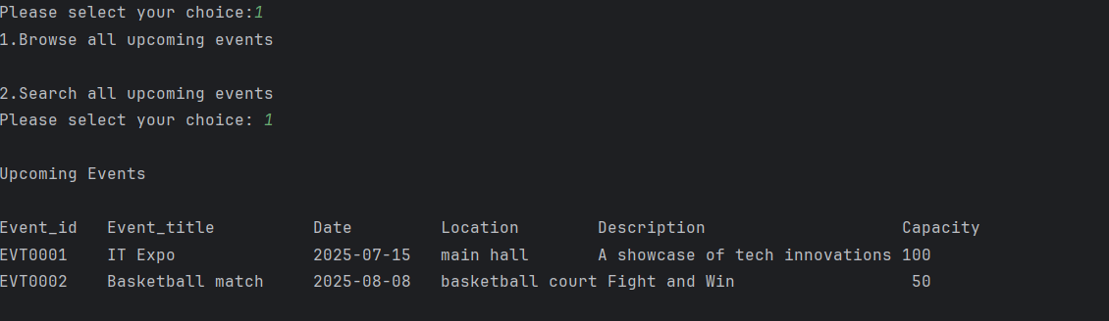
When you choose section 1,you will see section 1(browse all upcoming events) and section 2(search all upcoming events).Then if you choose section 1,you will see all upcoming events details.This form details are read from event.txt.
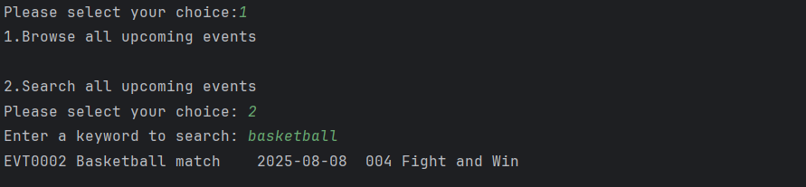If you choose section 2, you need to input keyword of the event then will show you all details you want from event.txt.
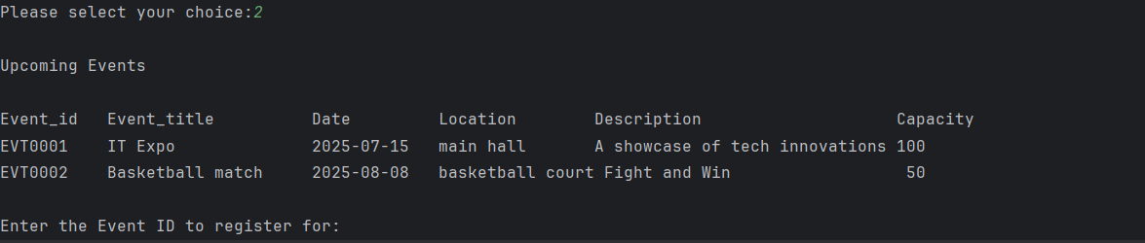If you choose register for event, system will show you upcoming events details from event.txt.
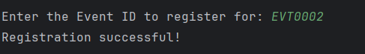
Input the correct event id, system will record your registration into registrations.txt.
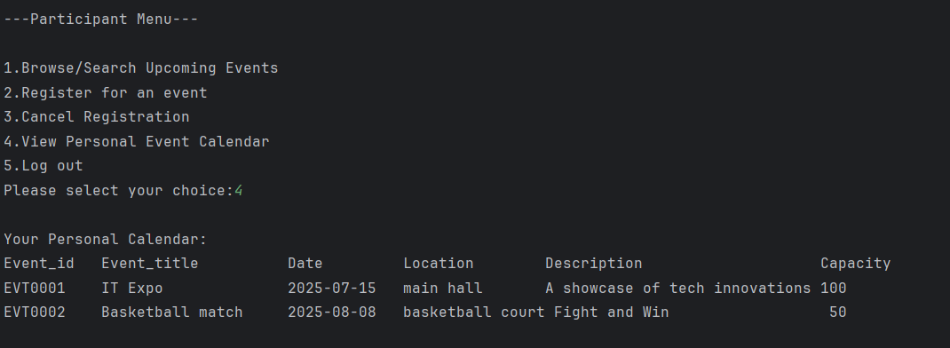If you choose view personal calendar, you will see all details from the event.txt and registrations.txt.
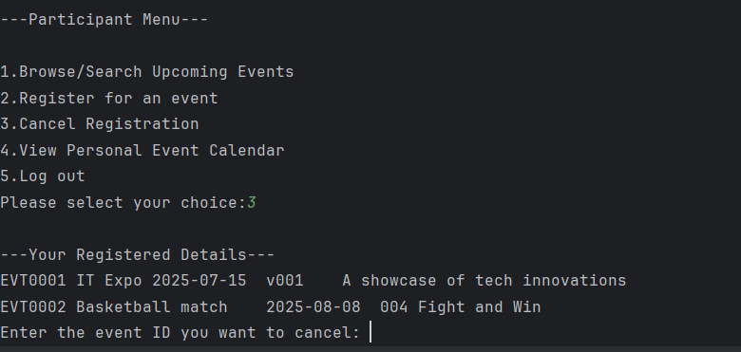If you want to cancel your registration, choose section 3. You can see what events you have registered from event.txt and you can enter the event ID you want to cancer.
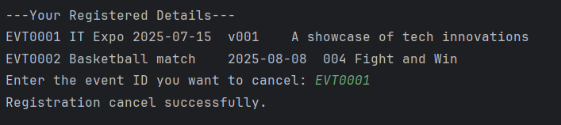
Input the event id you want to cancel and the record will rewrite to event.txt.
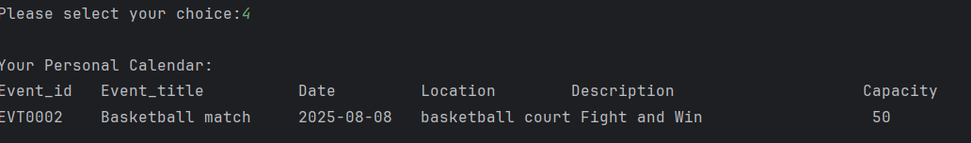After you cancel the event, the event.txt just rest one event.

3.3 Administrator
The administrator has the task of approving or rejecting the event to be organized. This process is done through the proposal_event() function, where the administrator can see the status of each event and give the appropriate decision. Not only that, an administrator is also in charge of creating a menu to display statistics through the statistics() function, statistics that are created such as the total events that get rejected and approved proposals, the number of users, and the most popular events.

Administrators can also generate reports in the form of text files using report() which will record the event ID, title, status, and number of participants. The last one is to change the role of participant to organizer. This function is to change the user from participant to organizer or vice versa.

3.3.1 Program Design with Pseudocode

Proposal_event | Is the function of approve or reject the proposal from event organizer
admin_menu | This is the admin main menu that shows proposal_event, statistic, report, and manage role.
Statistic() | function to displays event counts such as pending, approved, rejected events, also find the most popular event, and participants in total
changed_participants() | is it the function under manage roles with main function to changed participants to organizer
changed_organizer() | is it the function under manage roles with main function to changed organizer to participants
total_events | Allows to view total event
pending_event | Counts the number of pending events.
approved_events | Counts the number of approved events.
rejected_events | Counts the number of rejected events.
Participants_counts | Counts the number of participants at events.
admin.txt | The name of report for administrator
Event_participants | A dictionary variable to store the number of participants per event

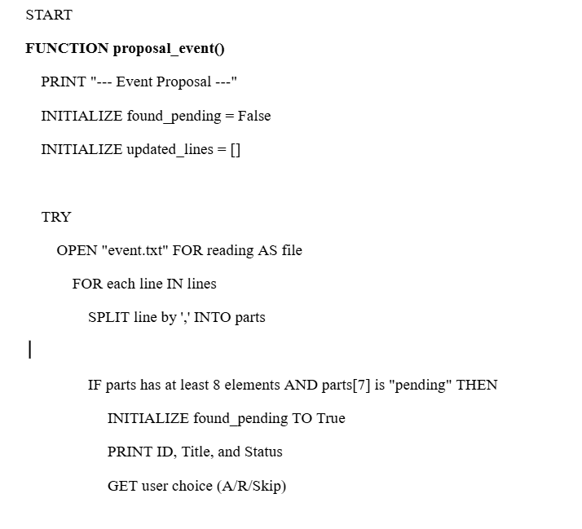

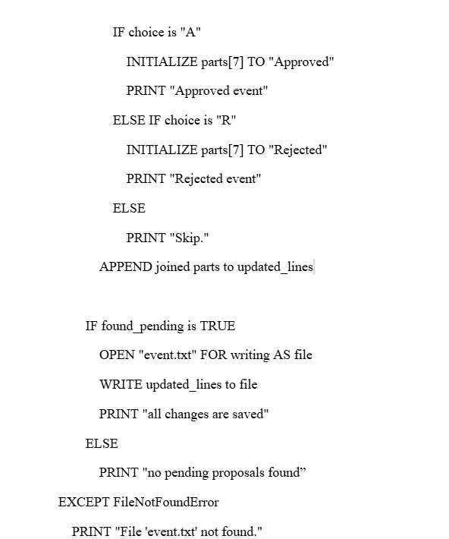
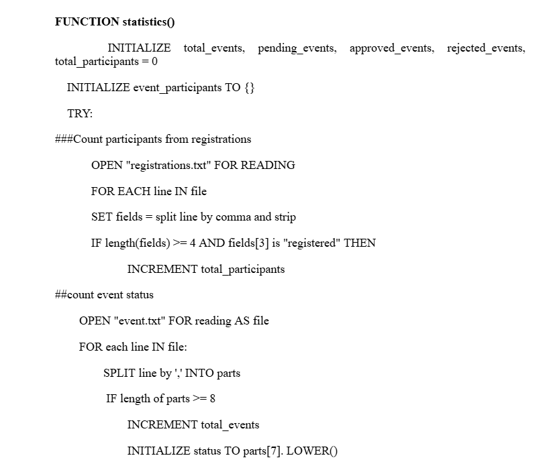
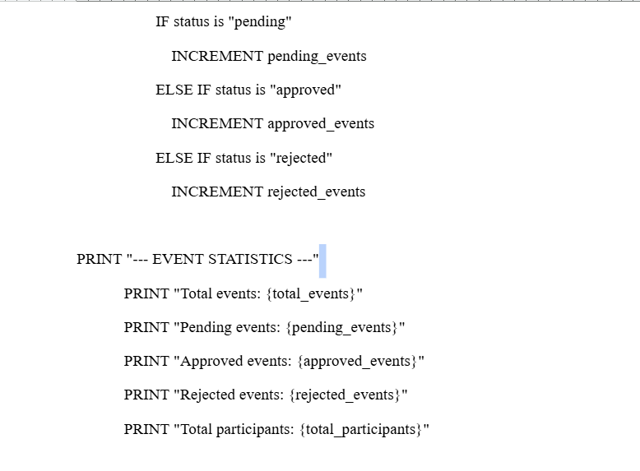
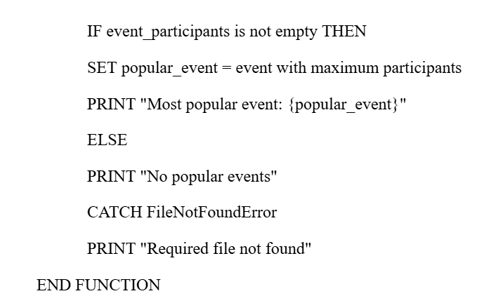
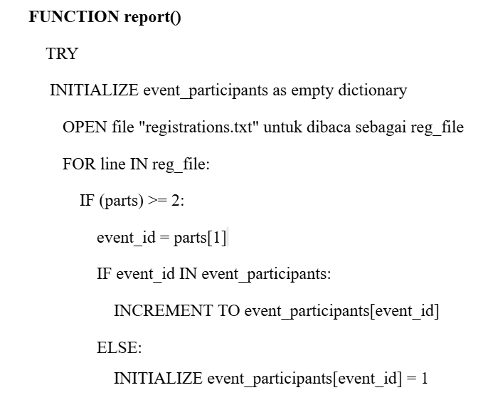
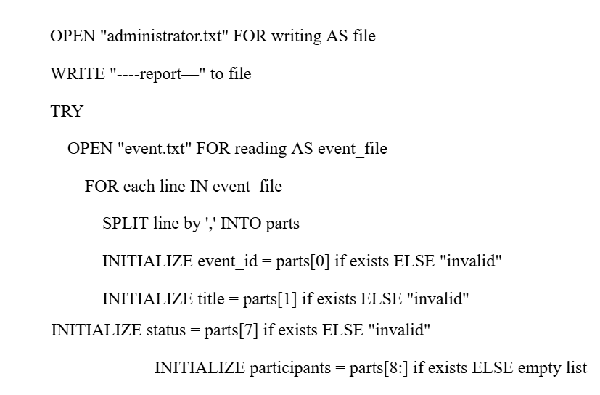
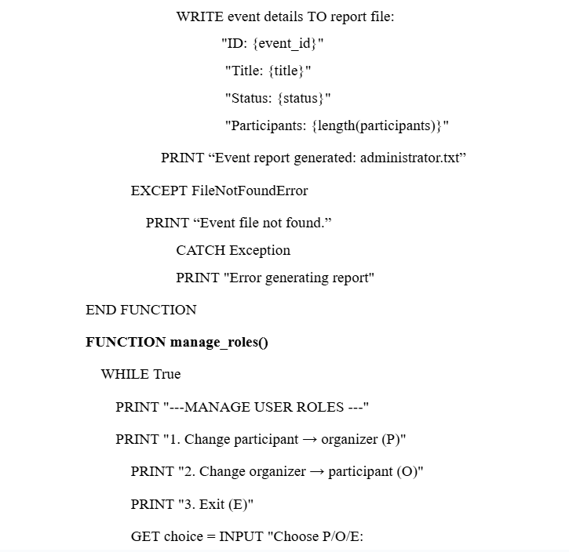
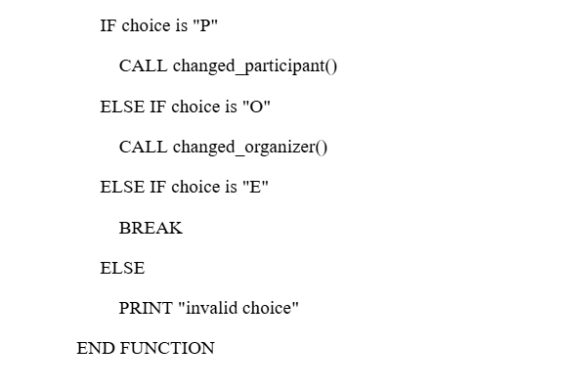
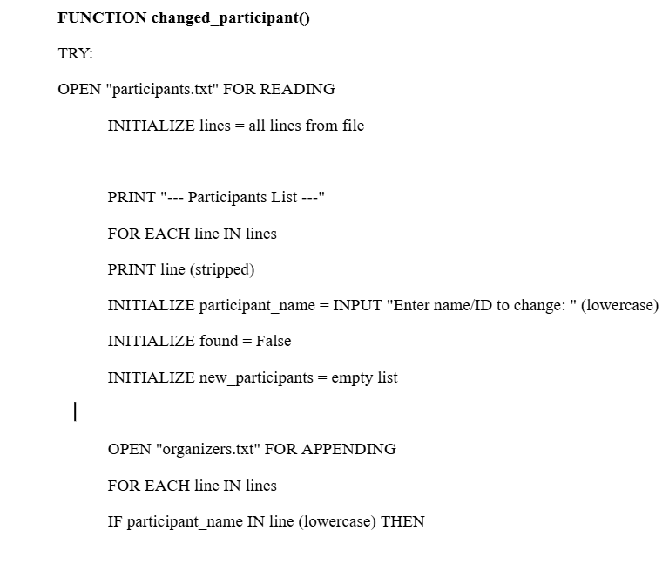
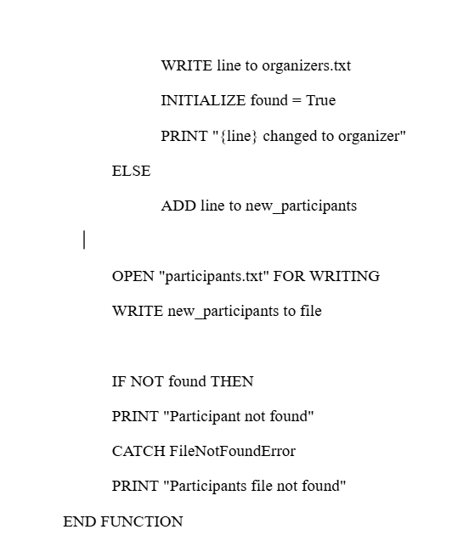
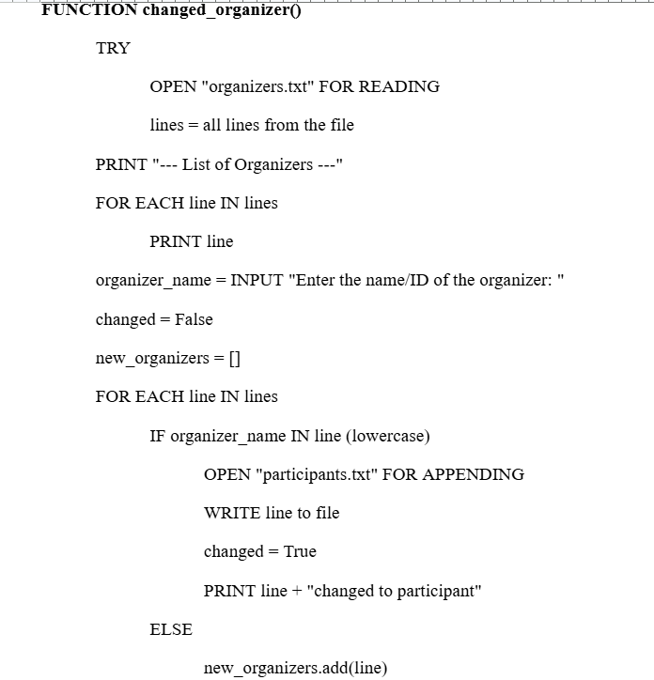
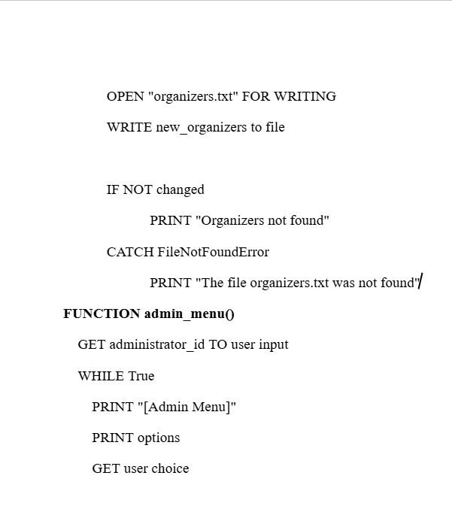
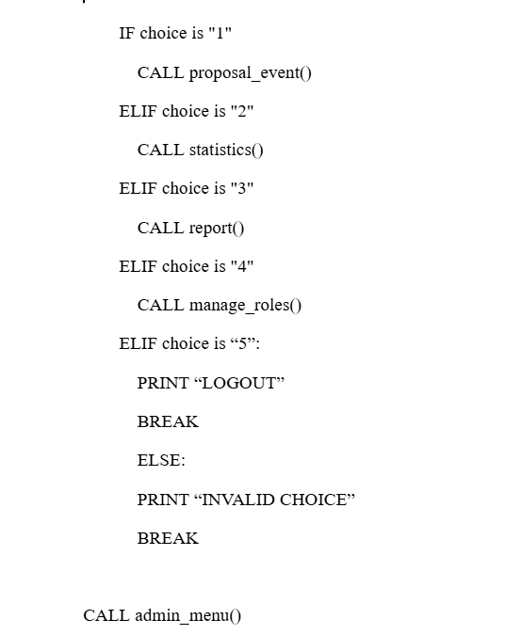

3.3.2 Screenshot & Explanation of Programming Concepts

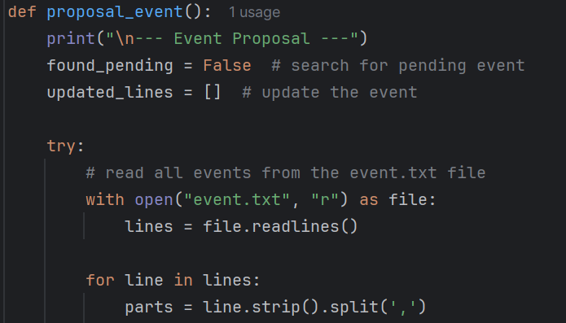
Def proposal_event(): is a function for approving proposals from event.txt in the event organizer whose previous status is still ‘pending’. The variable found_pending is stored whether there are pending events or not, then it will be updated_line to store a new file of all events that have been processed. The purpose of try-except is to overcome the program if no file is found.
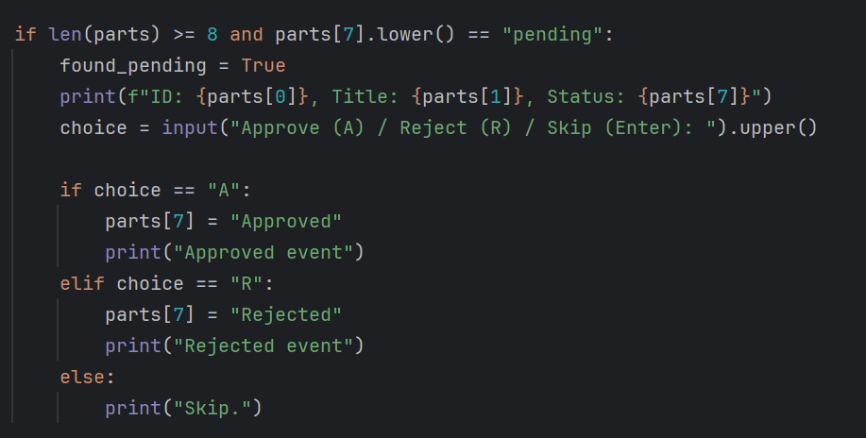

This code displays the menu for approve, rejected, and skip events. The program will check the data in event.txt after the code reads line number 8 which contains “pending” and 7 first to see which proposals are still pending. After that, it displays event info such as the event ID taken from the first line, the title from line 2, and the status of line 7. Then the program will ask for input from the user if you choose A then the event status will change to “Approved”, if you choose R then the event status will change to “Rejected”, and enter to skip.

In the code image above there are also parts which are a form of list derived from split (,) which means that the event data per line is separated into a list based on commas for easy reading. String is also used to retrieve parts[0] which is the ID, parts[1] which is the Title, and parts[7] which is the status. .upper() in input is used to input that should only be lowercase, now it can be capitalized too.

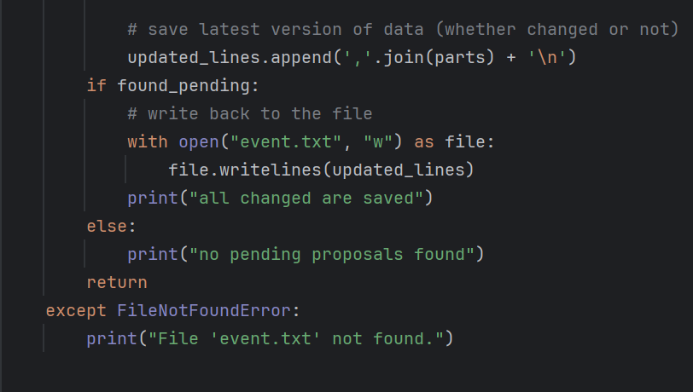

In this program, all parts whether changed or not will be concatenated into a comma-delimited string and put into updated_lines. If there is a pending event, the program will open “event.txt” with writing mode, then write in updated_lines into the file, then print “all changes have been saved”. If there is no pending event, it will print “no pending proposals found”. The list data structure used for updated_lines will be stored with .append(). String.join() is used to join the list into a comma separated string.

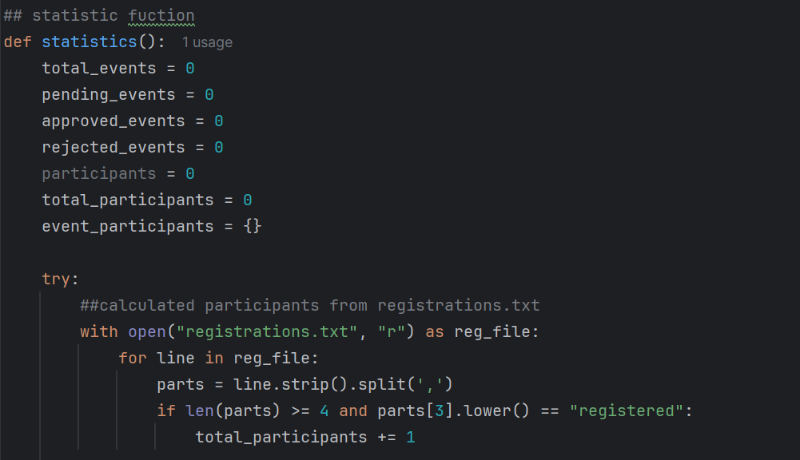

The program for this statistics function aims to display total_event, pending_event, approved_event, rejected_event, participants, total_participants, event_participants, before calculating all variables are initialized to 0 so that all variables will be calculated from zero. Read the registrations.txt file to count the number of registered participants. For each row, check if the status is “registered” then the total_participants counter will be incremented.

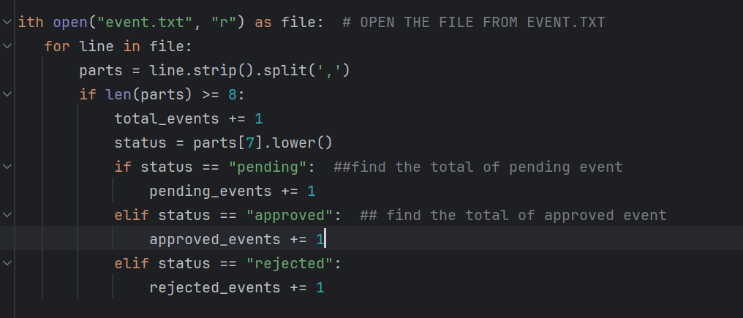
This code can calculate and categorize event statistics based on their status by reading the event.txt file sequentially. First, file will open in read mode ‘r’ . Next, a comma (,) is used to split each line, creating a list of named parts. After checking that len(parts) >= 8, the script will increment total_events and look at the status of the event at index 7 (parts[7]), which will be lower() if there are uppercase letters on the line to be tested. After determining its current status, it will increment pending_events, approved_events, or rejected_events. In this process, the occurrence count is stored as an integer and status is stored as a string data type with individual data stored in list parts. This allows the controller to keep track of the amount of events automatically based on status.

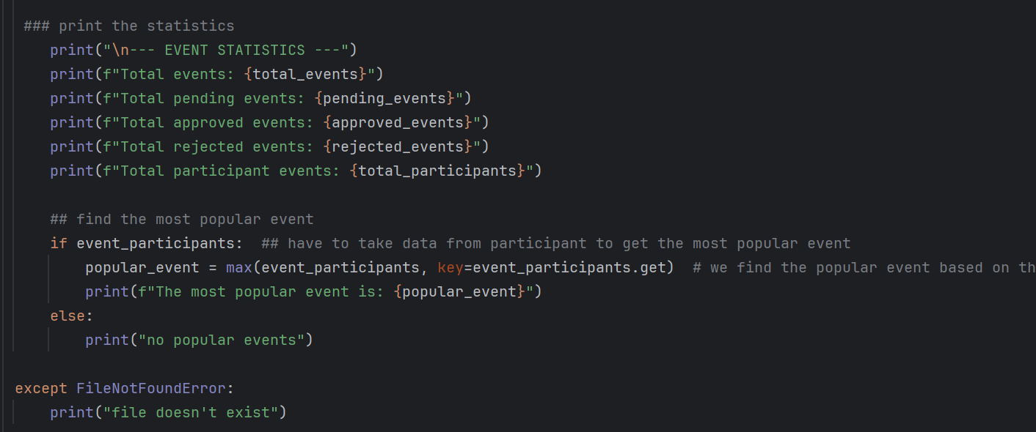
This code serves to display total events, pending events, approved events, rejected events, total participants, and search for the most popular events that take data from event.txt. The code The max() function finds the largest value from the list/dictionary based on the number of participants, with the key parameter specifying how to compare the values, the dictionary method event_participants.get returns the number of participants of each event title(key), and the .get() function retrieves the value based on the key.
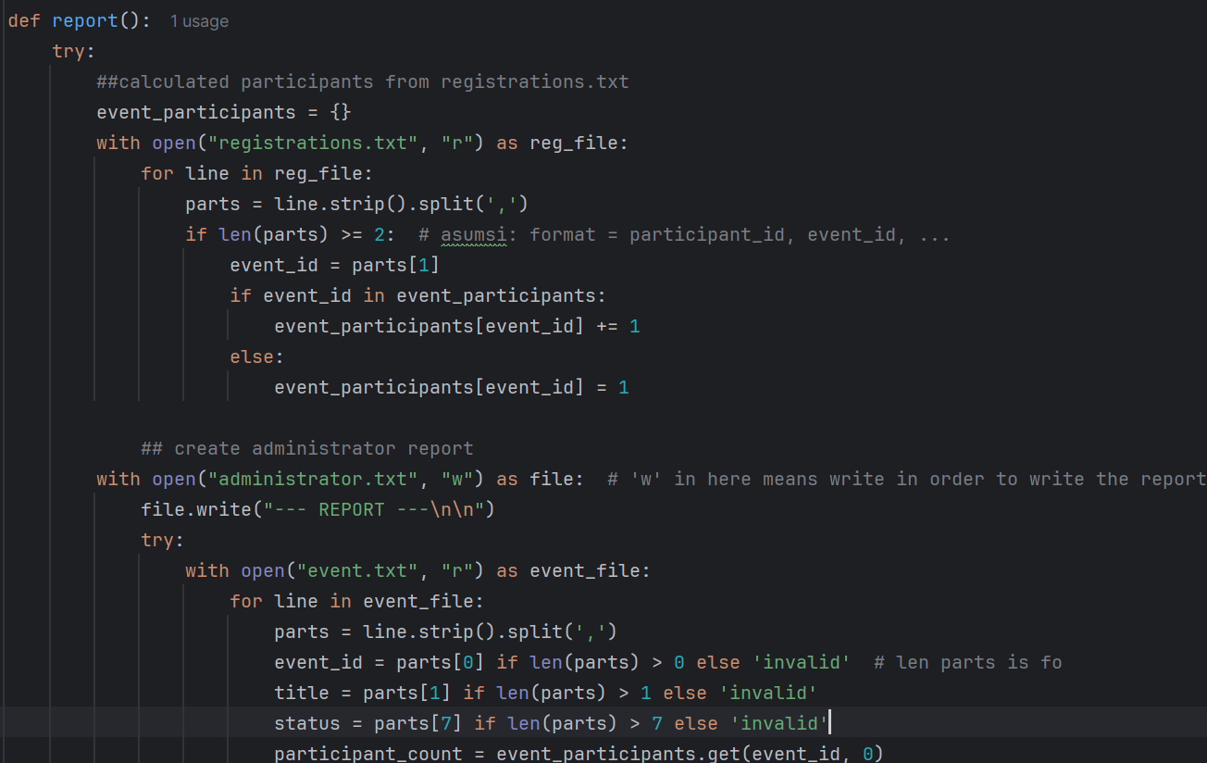

The purpose of the report() function is to create a statistical report on the study by counting the number of participants from the registrations.txt file and comparing it with the event data from the events.txt. First, the code reads the registration file using the “event_participants” dictionary to determine the number of participants for each study (for example, “{‘EVT001’:5}”). Next, the code writes the file administrator.txt. Split(‘.’) is used to convert the data into a list of items to extract each line of events. Next, the information is presented in the report, including the number of participants who have previously been contacted by the company. A try-except block appears in the event of an error, such as a file not being able to be opened. The program's code makes use of data types including lists to display the output of string splitting, files to read or write to, and dictionaries to handle user input. As such, administrators can obtain automated reports that include event statistics such as the number of participants and their destination status.

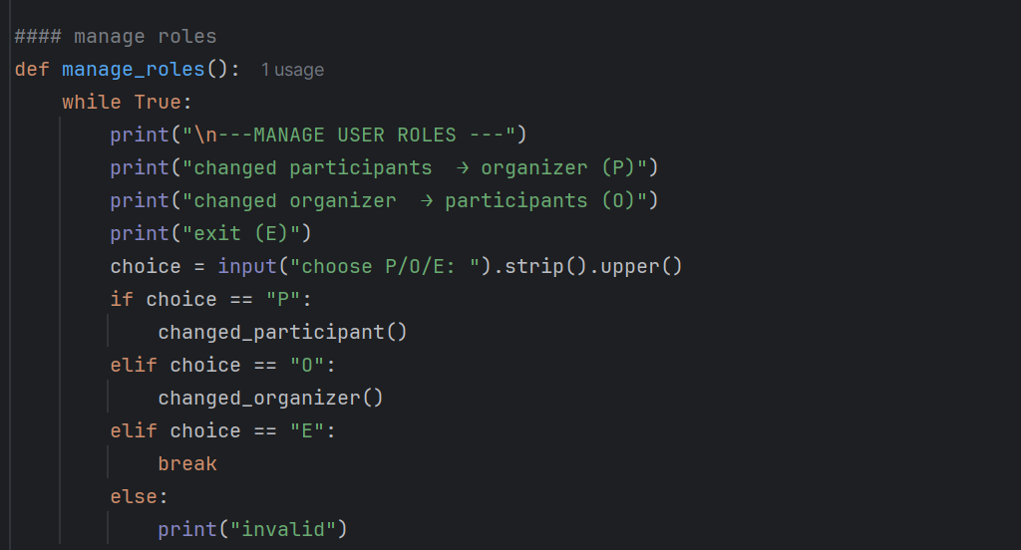
The manage_roles() function used by this code to change user roles between participants and organizers. A menu with the choices to switch from participant to organiser, switch organiser (O), or quit the program (E) will be displayed by the software. An if-elif-else loop will be used to process user input after it has been read using input().

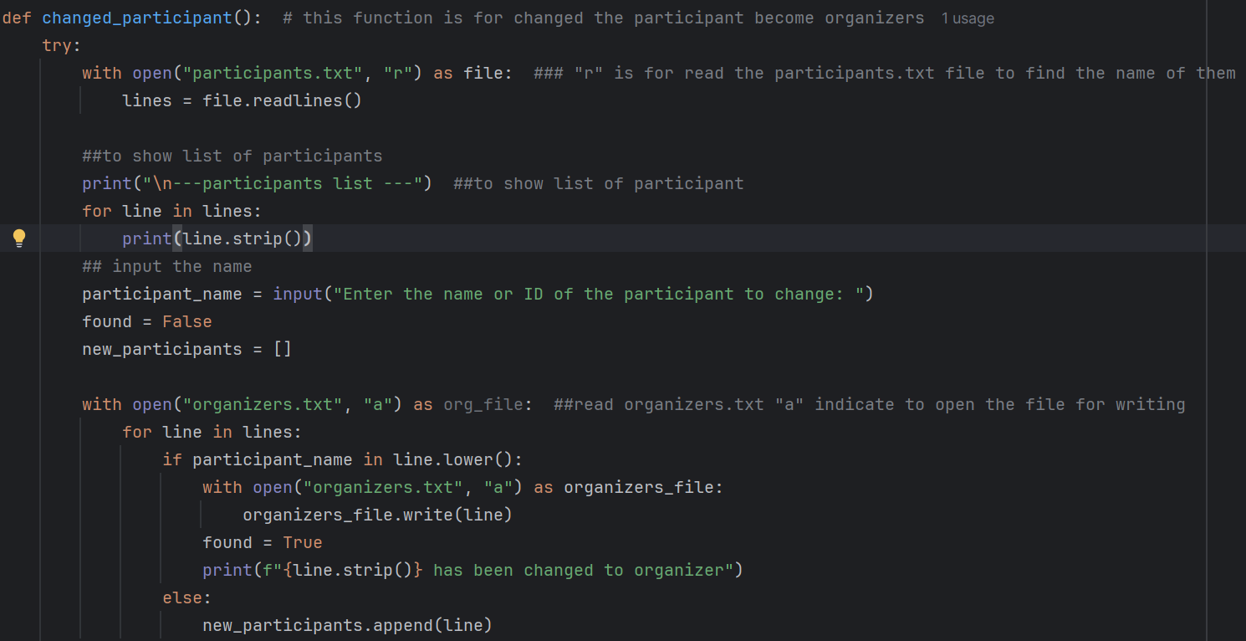
Updating a participant's status to organizer is the primary purpose. To create the update, the application initially asks the user to enter the participant's name or ID after printing the participants.txt file containing the participant listing. The organizers.txt file will be updated with the participant's name if it was located. The program will display an error message if the participant's name was not included in the list of new_participants. The final step will be the list of participants will now be updated eliminating participants that have been moved.
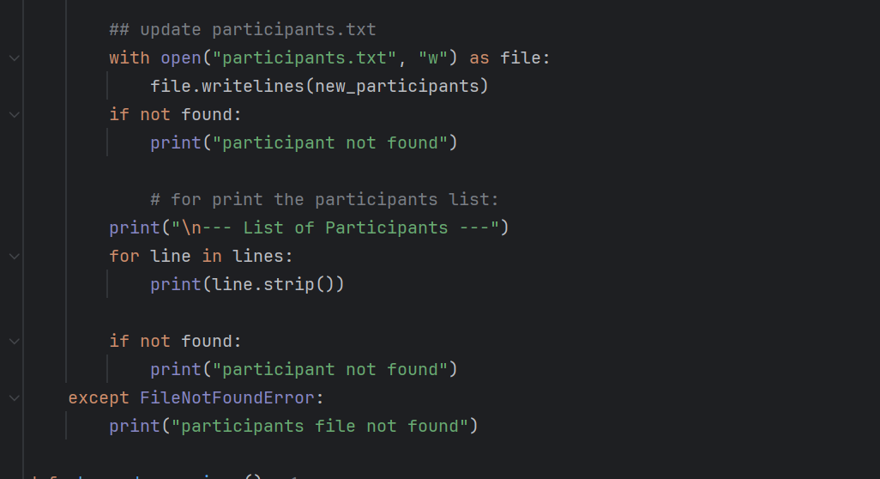
The code above is an extension of the changed_participants() function The new_participants list is rewritten to the participants.txt file with write mode, replacing the entire contents of the file. An error message is displayed if the participant is not found (found = False). In addition, the current list of participants is displayed for confirmation. If the participants.txt file is not found, error handling has been performed.
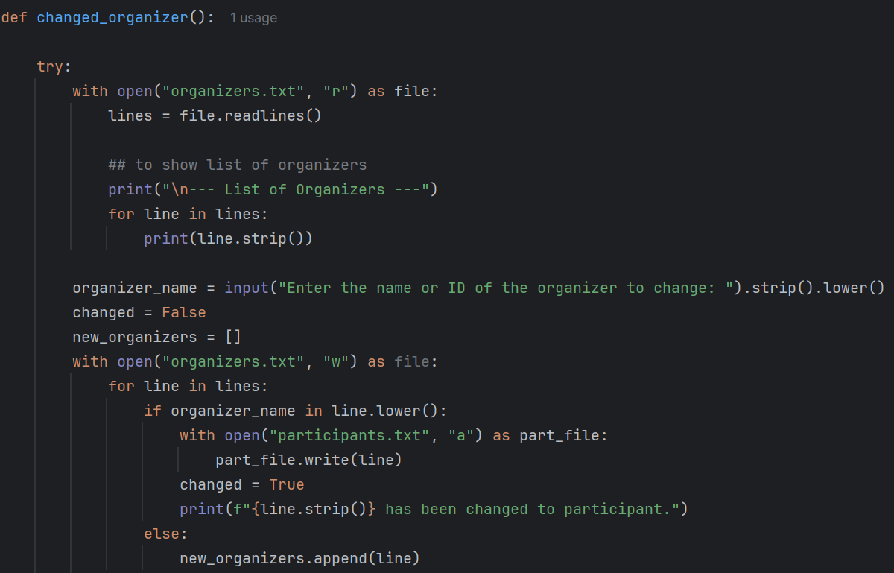

This function converts an organizer to participate by checking the organizers.txt file, displaying the list of organizers, and asking for the name that should be converted. As already stated, the list of organizer data is kept in the participants.txt file and is created by reading the list of organizers. The program then displays organizers.txt by way of the last paragraph. If the name is not entered, an error will appear. If there is no organizers.txt file, this function will also cause problems. Its purpose is to facilitate the transition from organizers to participants.
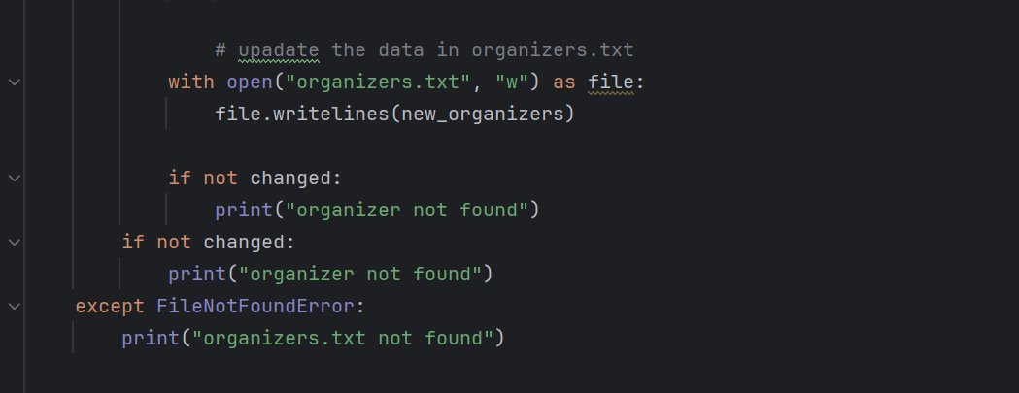
The list of new_organizers, without the moved organizers, is rewritten to organizers.txt using write mode. If the organizer is not found (changed = False), and if the organizers.txt file does not exist, an error message is displayed.

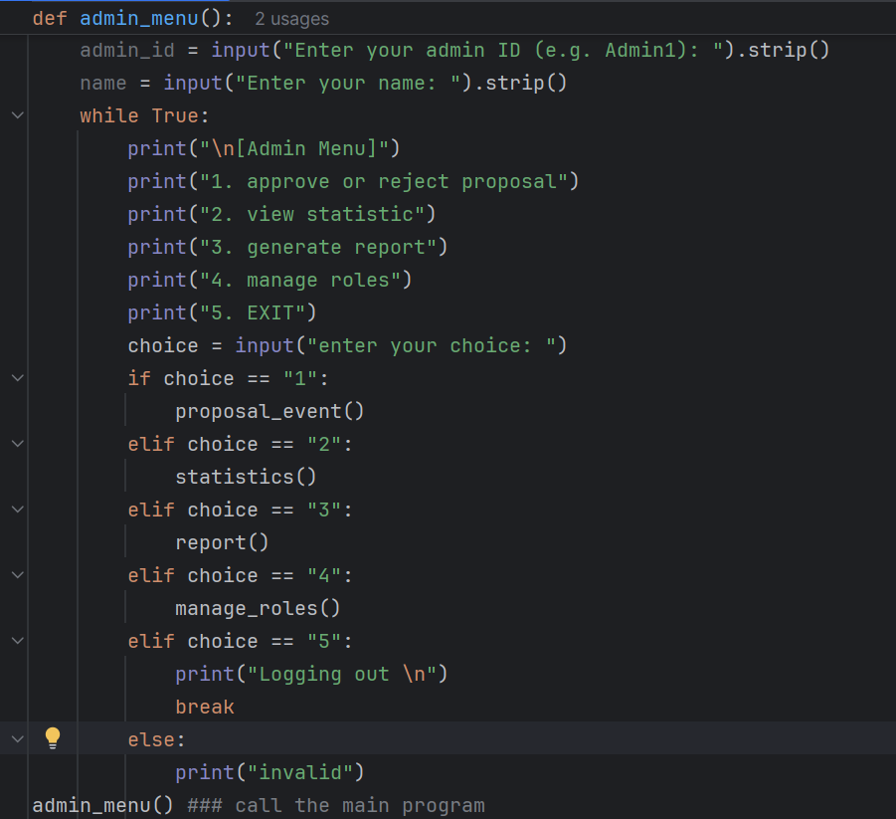
The admin_menu() function in this code displays the main menu for administrators. After enter name and id as administrator, the program will print options 1. Approve or reject proposals, 2. View statistics, 3. Generate reports, 4. Manage roles, 5. Exit. The if-elif-else branching is used to process user input. The program will exit the loop if the selection is invalid. This function uses strings for input and output, and a while True loop to condition the menu to remain active until the user chooses exit. After finishing the code, the admin_menu() function is called to start the program.

3.3.3 Input & Output Screenshot & Explanation

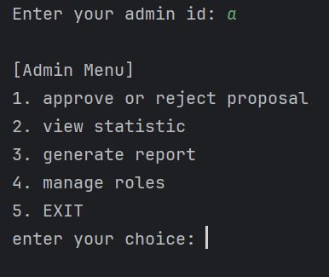
This image shows the output of admin_menu(), which allows you to see statistics, generate reports, modify roles, approve or reject proposals, and depart. The user gets asked to select an option by input the number that corresponds to that option.
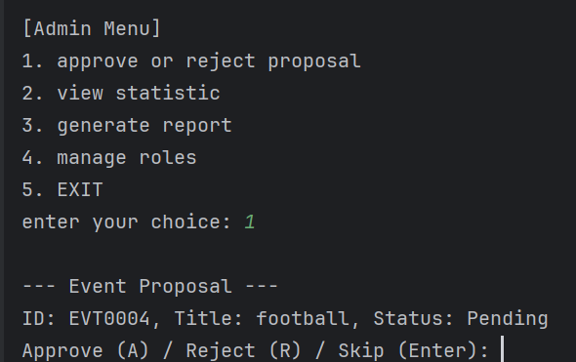
If admin chooses first option the system displays the details of the event proposal with event ID, title, status. The admin is given the option to approve, reject the proposal, or skip the proposal by pressing enter. Here, the string data type is used to store the event ID, title, and status, as well as to receive input from the admin.
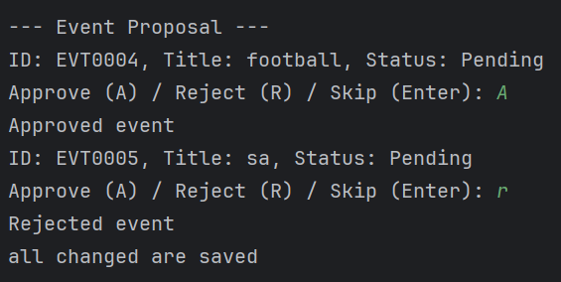
This picture shows the process of approving or rejecting a proposal. Admin approves the event by pressing ‘A’, and the program will print others events that need to approve. IF the admin rejects the event by pressing ‘R’. The last message indicates that all changes have been saved. At this stage, strings are used to store event information and admin input, while lists or arrays are used to store the list of proposals that need to be processed.

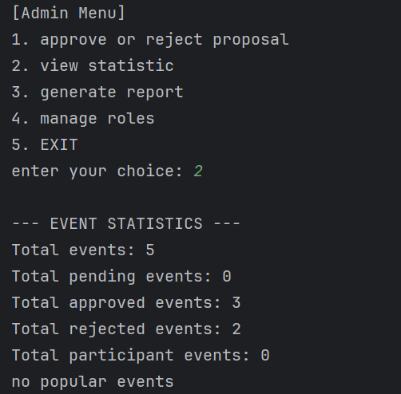
In the first image, the admin selects option 2 (view statistics) to view event statistics. The system displays a summary of total events (5), pending events (0), approved (3), rejected (2), and events with participants (0). The message “no popular events” indicates there are no popular events. The results are taken from string, list and int to display the statistics results. This function helps admins to view the overall event list
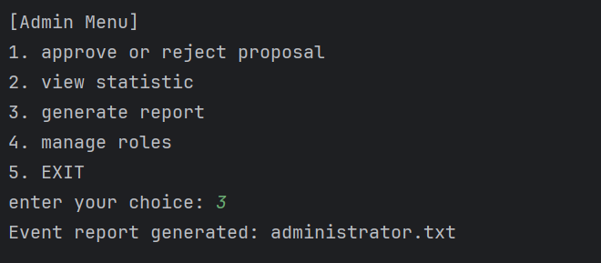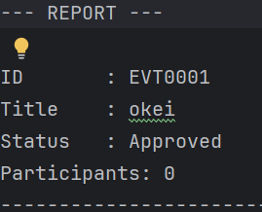
When the user chooses the "3" menu, the application will instantly generate a report in a text file named administrator.txt. Event data, including event ID, title, status, and participant count, are included in the report that the system creates as an administrator.txt text file.
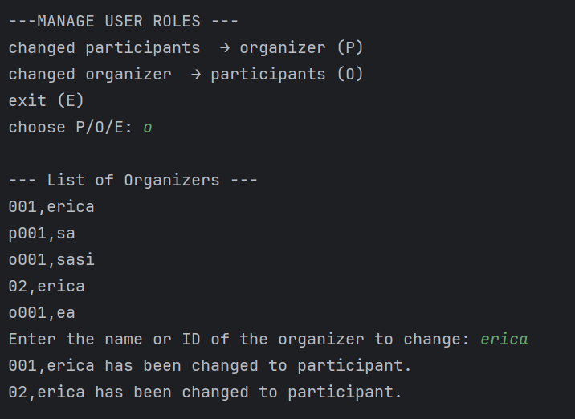
The admin menu's "Manage Roles" function is displayed in this picture. Administrators can change the user role from organizer to participant by selecting the "O" option. Administrators also can change the user role from participant to organizer by selecting the “P”, or “E” for exit the manage user roles program. Before entering name or id the program will display a list of organizers, then display the results of the change.

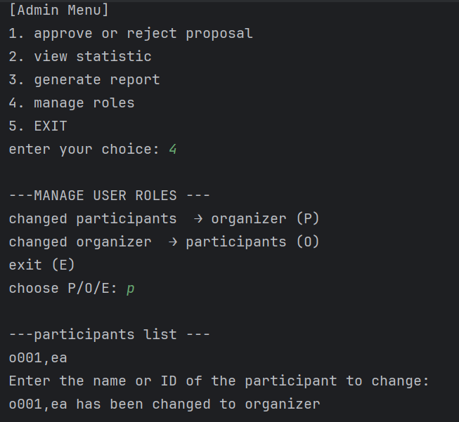
Display the process when the admin selects P and enters the participant ID/name (e.g. "1" or "SA"). The program looks up the data in the Participants.txt file, moves it to organizers.txt with a (append) mode, and prints the success message “P001, SA has been changed to organizer.” Before entering name or id the program will display a list of organizers, then display the results of the change.

3.4 Venue Manager
The Venue Manager plays a key role in managing the availability and scheduling of venues across the campus. This role ensures that venues are appropriately marked as available or unavailable, with reasons documented for administrative clarity. The Venue Manager also handles venue request approvals and suggests alternative options when a requested venue is not available.
There are four functionalities of the Venue Manager:
- View Upcoming Events Scheduled for Each Venue
Venue Manager can view all approved events by venue from event.txt.
- Update Venue Status
Venue Manager can manually change a venue’s availability status to either “available” or “unavailable”. If marked unavailable, a reason must be recorded in venues.txt.
- Approve or Reject Venue Requests:
Venue Manager can view venue requests made by Event Organizers which are stored in venue_requests.txt and decide whether to approve or reject them. Approved requests will update venue’s status to ‘approved’ in event.txt and the venue's status to ‘unavailable’ in venues.txt.
- Suggest Alternative Venues
Venue Manager will suggest other available venues based on the venues.txt list.
- Return to Main Menu
Return to the main interface to allow switching roles or exiting the program.
These functionalities ensure smooth coordination between event organizers and campus facilities and help avoid double-bookings or conflicts in venue scheduling.

3.4.1 Program Design with Pseudocode

venue_manager_menu() | Main menu loop for venue manager interactions
view_upcoming_events() | View the upcoming events that have not been in the past.
mark_venue_status() | Mark the venue status to “available” or “unavailable”
Mark_Venue_Status() | Mark and update the new venue status back to the file.
View_Venue_Status() | Show all the venues with their status in the file.
venue_requestment() | Mark venue requestment by approving or rejecting the requests.
View_Venue_Request() | Show all the venue requestments in file.
Approve_Deny_Booking_Request() | Approve or deny the venue booking requests and write the new request status with reason back to the file.
suggest_venue() | Suggest available venue details.

Function 1: View Upcoming Events
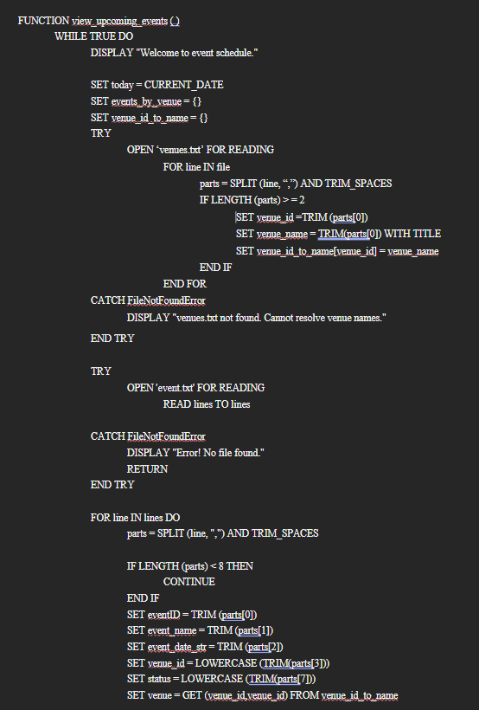
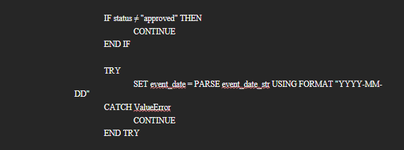
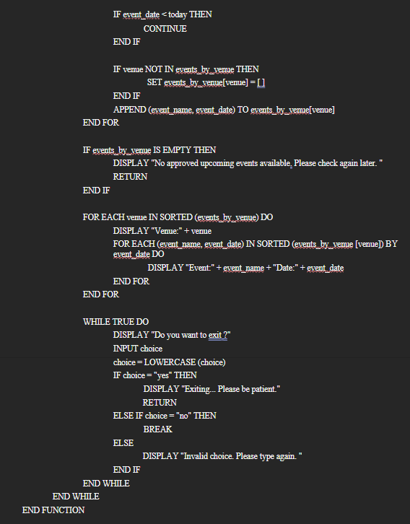

Function 2: Mark Venue Status
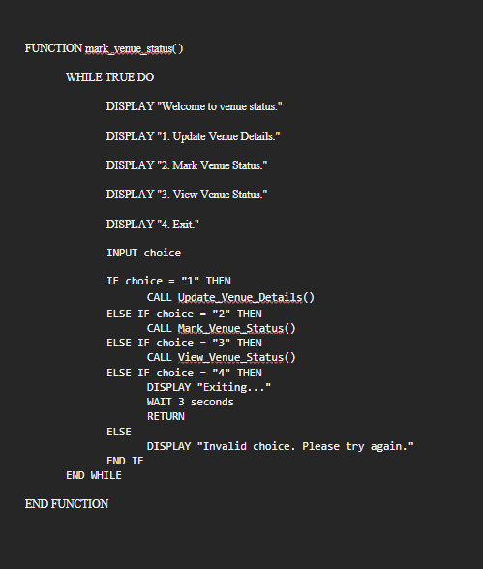

Function 2.1: Update Venue Details
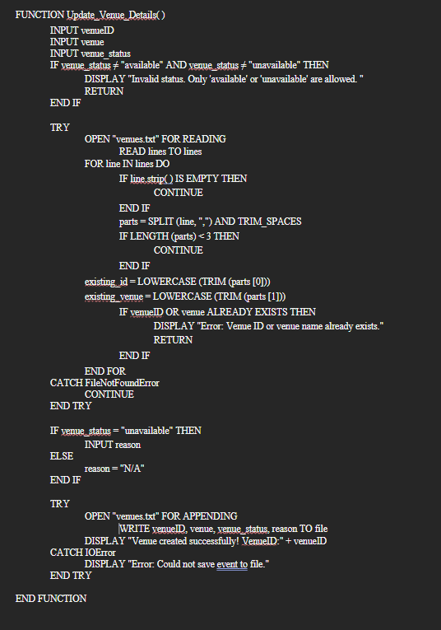

Function 2.2: Mark Venue Status
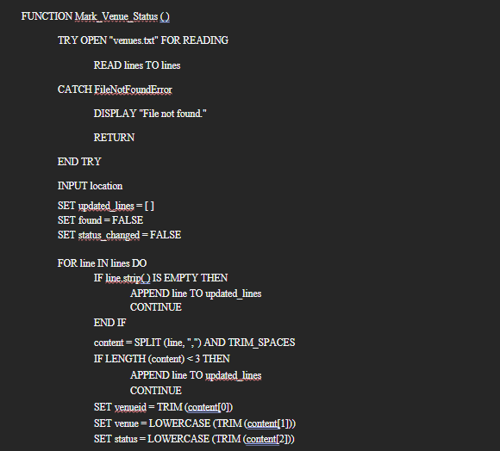

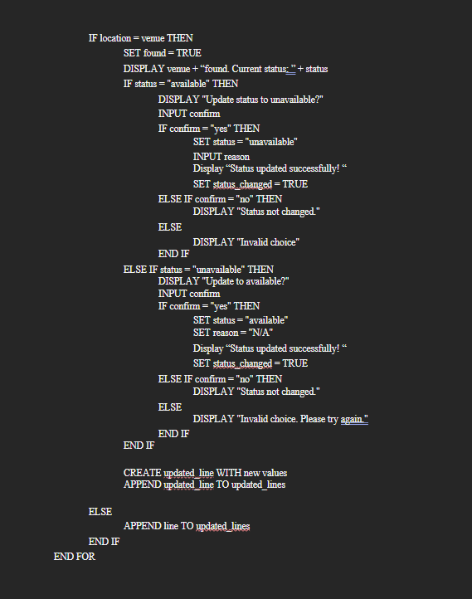
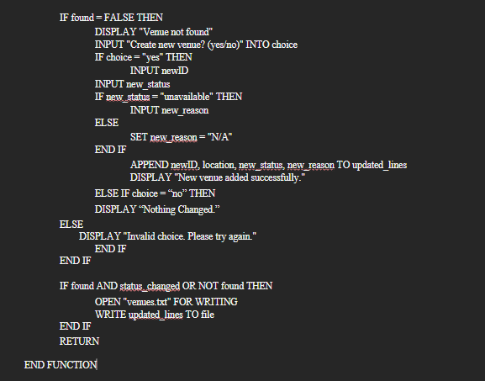

Function 2.3: View Venue Status
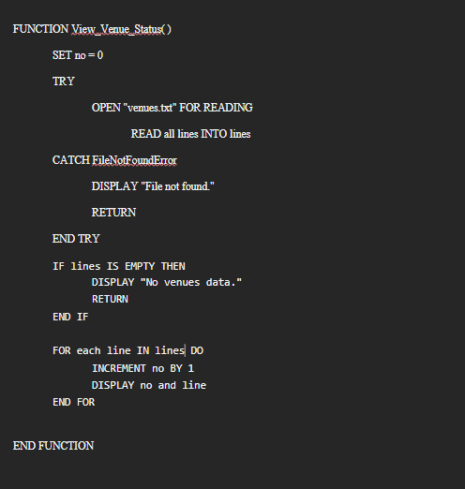

Function 3: Venue Requestment
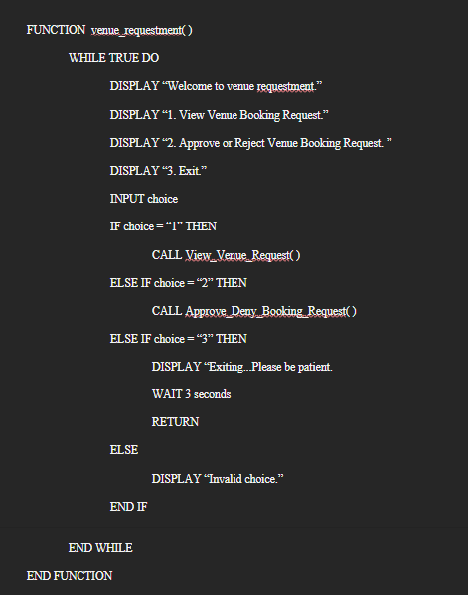

Function 3.1: View Venue Request
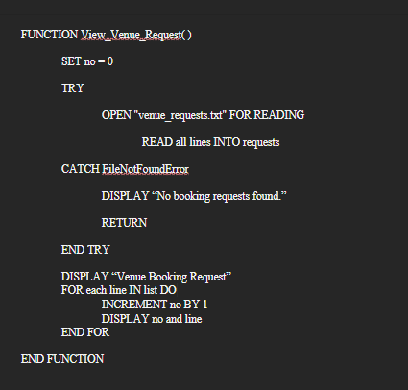

Function 3.2: Approve Deny Booking Request
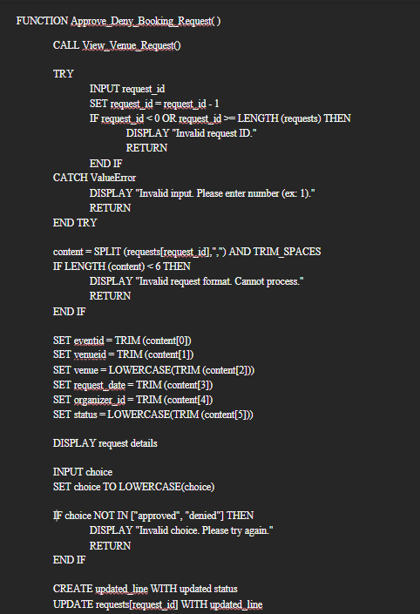
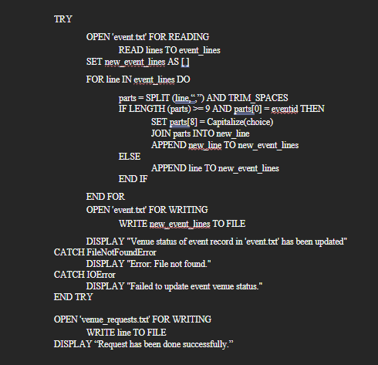
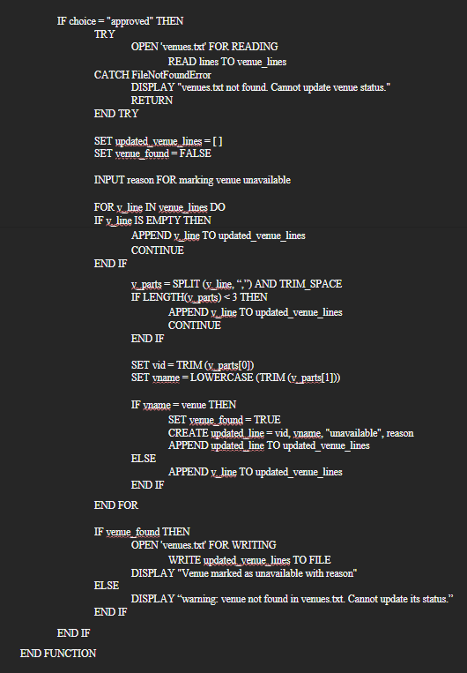

Function 4: Suggest Alternative Venues
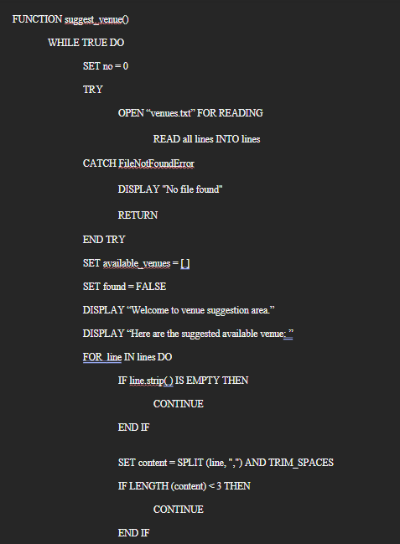
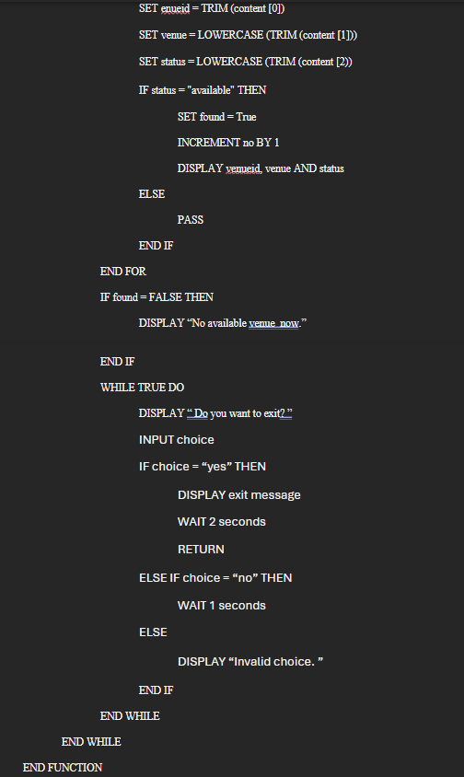

Function: Venue Manager Menu
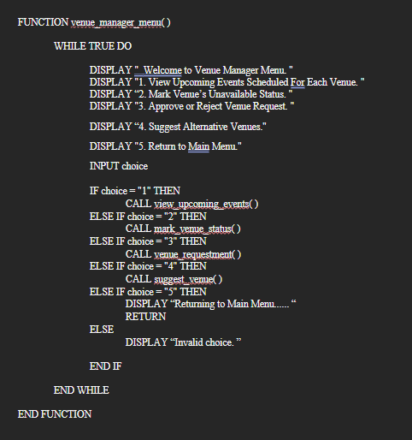

3.4.2 Screenshot & Explanation of Programming Concepts
Application of storage types (list, dictionary and text files)
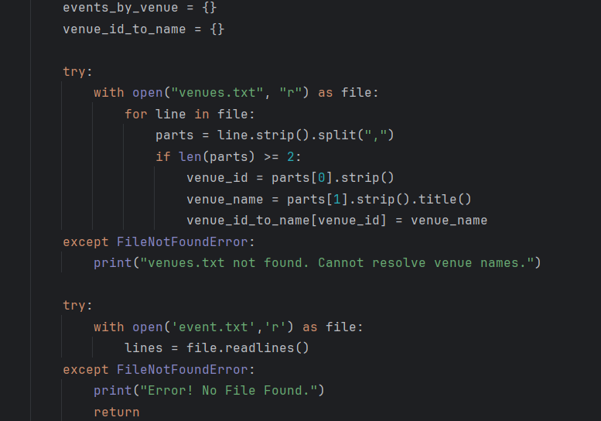
The system uses text files such as event.txt, venues.txt and venue_requests.txt to store data persistently. These files are opened, read and written using built-in Python file handling methods like open(), .readlines(), .append() and .write(). This ensure that the data remain available even the program is closed. Moreover, the system uses lists and dictionaries to store tempory storage of data during execution. A list such as lines = file.readlines() is used to store all lines read from venues.txt for further processing. A dictionary like venue_id_to_name = {} is used in the view_upcoming_events() function to store venue ID and name pairs, which allows fast lookup of venue names when the user gives an ID. This improves readability and usability when displaying event and venue information. Another dictionary, events_by_venue = {} is used in the view_upcoming_events() function to group future events by their venues for organized display. This combination of persistent file storage and temporary data structures like lists and dictionaries supports both reliability and performance in the program.
Application of Control Structures (while loop, for loop, if-elif-else, continue and nested if)
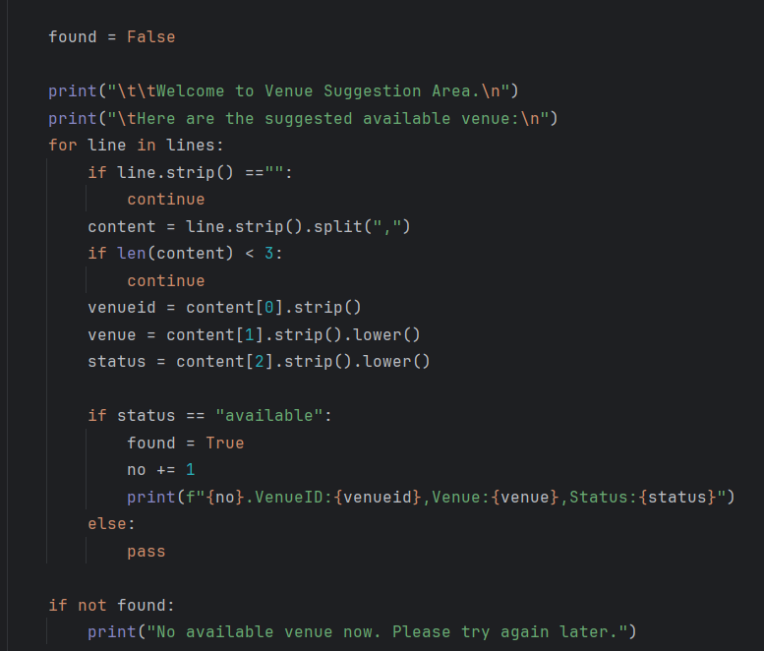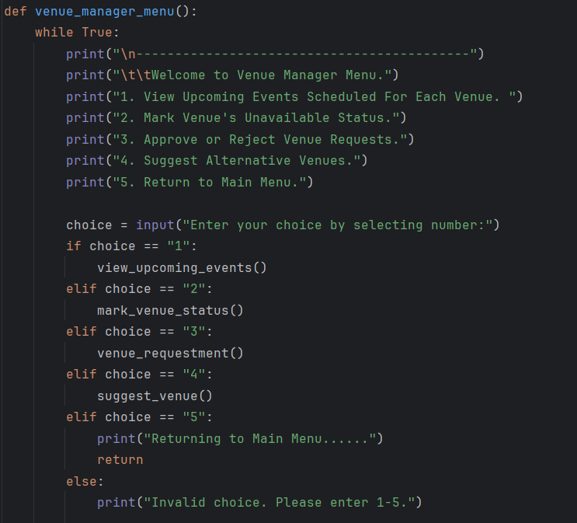

The Venue Manager role also uses the while loop, if-elif-else, for loop, continue and nested if concepts.
In screenshot 1, the While True loop ensures that the Venue Manager Menu is continuously displayed until the user chooses to exit by entering "5" to select option 5. Inside the loop, there are a series of if-elif-else statements used to direct the flow of the program based on user input called choice. Each menu option directs to a different function and the program only calls the function if the number is entered correctly. The else provides validation feedback to the user if the input is invalid.
In screenshot 2, a For loop is used to iterate through each line in the venues.txt file. The if line.strip() == " " check and skips empty lines using continue. A nested if structure such as If len (content) < 3 ensures the line is properly formatted before further processing. Inside the loop, a conditional if status =="available": check whether a venue is available. If so, it sets found = True, increases a counter, and prints the venue details.The else contains a pass, indicating no action is needed if the venue is unavailable. At the end, if not found: checks whether any venue was found and gives appropriate feedback.

Application of Try…Except

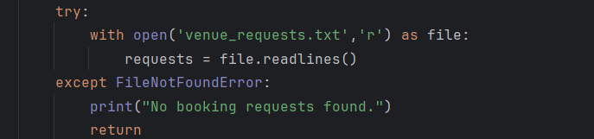
The system uses try...except blocks to handle file-related exceptions and ensure that the program can continue running even when certain files are missing. This is a basic but important application of exception handling in Python, which improves the system's robustness and user experience.
For example, when the system tries to open external files such as venues_requests.txt, it wraps the file-opening operations within a try block. If the file does not exist, a FileNotFoundError will be raised. The except block catches this error and displays a user-friendly message rather than allowing the program to crash.
This technique is used consistently throughout the system whenever accessing external .txt files, such as:
- venues.txt – for venue data,
- event.txt – for event scheduling,
- venue_requests.txt – for pending booking requests.
By applying try...except, the system maintains stability and guides the user properly even in cases where critical files are missing or corrupted.

Function: Venue Manager Menu
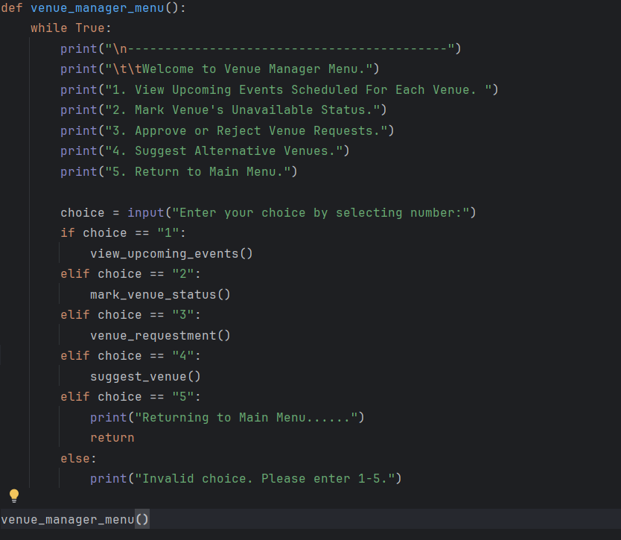
This is the main menu of Venue Manager. Defines the function named venue_manager_menu. It allows the user to manage venue-related actions through a simple text-based menu interface.
It begins with a while True loop to keep displaying the menu until the user chooses to exit the roles. When entering the function, a welcome message is displayed, followed by a menu with five options:
- View Upcoming Events Scheduled For Each Venue: Call function named view_upcoming_events()
- Mark Venue’s Unavailable Status: Call function named mark_venue_status()
- Approve or Reject Venue Requests: Call function named venue_requestment()
- Suggest Alternative Venues: Call function named suggest_venue()
- Exit: Display an exit message and exit the function by using return.
Users are expected to enter only number between 1 and 5. If the input is invalid, an error message is displayed and the menu is shown again.

The datetime module is a built-in Python module that supplies classes for manipulating dates and times.
In the Venue Manager module, it is mainly used to:
- Get the current date (datetime.date.today()) to compare with event dates.
- Convert strings into date objects using datetime.datetime.strptime(date_string, format), so the system can sort and filter events based on actual dates.
This allows the system to only display upcoming events that are scheduled after today's date, ignoring past or invalid entries.
The time module provides various time-related functions. In this system, it is used primarily for:
- Delaying outputs with time.sleep(seconds) to simulate loading or transition delays, making the user experience smoother and more realistic.
  - For example, when exiting a function, the program might display "Exiting... Please be patient." and then pause for 2–3 seconds.
This helps to improve user interaction flow without affecting logic or file handling.

Function 1: View Upcoming Events
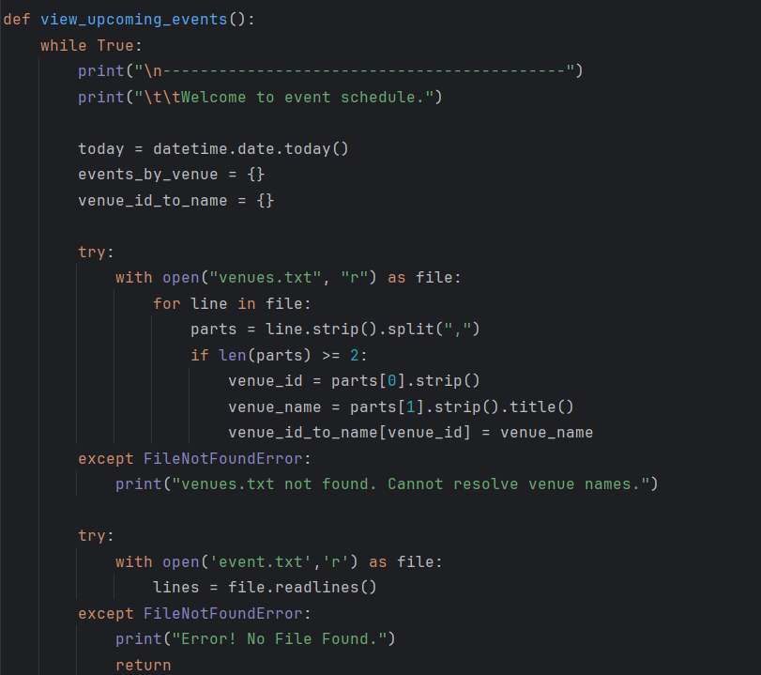
This is the first functionality of Venue Manager. Defines the function named view_upcoming_events. The function reads all events from event.txt, filters out non-approved or past events, groups them by venue, and displays them in order. It repeats until the user exits.
It begins with a while True loop to keep displaying upcoming events until the user chooses to exit. When entering the function, it will display a welcome message. Then, the current date is retrieved using today = datetime.date.today(), which is later used to filter out past events. An empty dictionary named events_by_venue is to group events by their venue. An empty dictionary named venue_id_to_name is set to store the relationship between each venue_id and venue_name. This dictionary helps find the venue_name based on their IDs quickly. The function tries to open venues.txt file and reads content line by line into a list called parts. Each line is split by commas "," and stripped of extra spaces. If the line contains at least two elements, it extracts the venue_id and venue_name, removes extra spaces and converts the venue_name to title case format. If file is not found, "venues.txt not found. Cannot resolve venue names." is displayed. The function tries to open the file ‘event.txt’ and read the data line by line into a list called lines. If the file event.txt is not found, it will display an error message and exit the function.
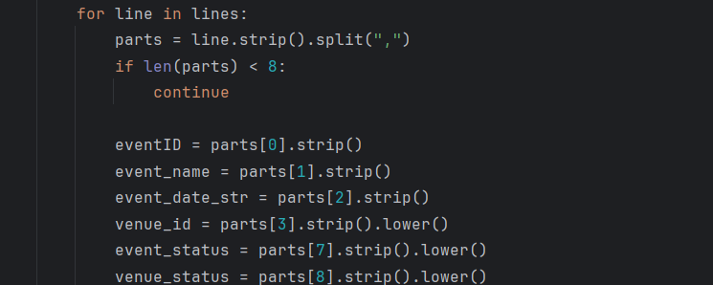
The function loops through each line from the lines list. It removes the space using .strip() and splits the line into a list named parts using commas “,”. If the length of parts is less than 8, it means the data is imcomplete so the function will just skip and continue the next line using continue. Then, the function extracts the important event details from the parts list, which including eventID, event_name, event_date_str, venue_id, event_status and venue_status. Each details is stripped of extra spaces using .strip(). The values for venue, event_status and venue_status will be transformed into lowercase using .lower() to avoid errors caused by case sensitivity.
This line attempts to retrieve the venue_name corresponding to the given venue_id from the venue_id_to_name dictionary.
- If the venue_id exists in the dictionary, its corresponding venue name is returned and assigned to the variable venue.
- If the venue_id does not exist in the dictionary, the .get() method returns the default value provided. In this case, the venue_id itself, which is then assigned to venue. This ensures the program has a value to use even if the mapping is missing, avoiding a Key Error.
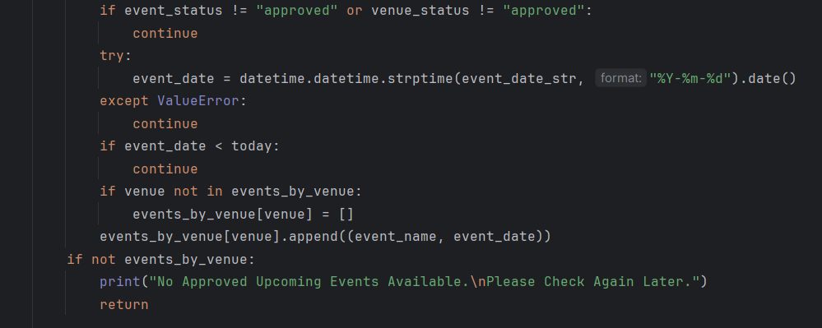
If the event_status is not approved by Adminstartor or the venue_status is not approved by Venue Manager, the event will be skipped by using continue and continue the next event. Next, the event date(a string) is converted into a datetime.date object using datetime.datetime.strptime(event_date_str,"%Y-%m-%d").date(), where the date format is YYYY-MM-DD. If the date format is invalid or incorrect, the function will catch a ValueError and skip this event. If the event _date is in the past,which mean earlier than today's date, the function will also skip this event. If the venue is not in the events_by_venue dictionary, a new list is created for this venue. Then, the function will append the event_name and event_date as (event_name, event_date) into the venue list in events_by_venue dictionary. After checking all the events in event.txt, there is still nothing in the events_by_venue dictionary, the function will display “No Approved Upcoming Events Available. Please Check Again Later.” and exit the function.
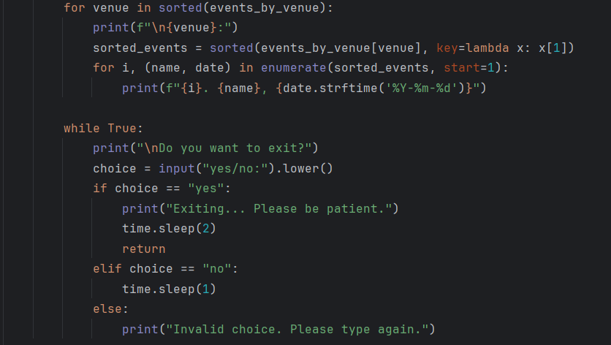
The function loops through the venues in alphabetical order using sorted (events_by_venue) and display each venue name as a heading. For each venue, event list is sorted by event date using sorted(events_by_venue[venue], key=lambda x:x[1]). The function displays each event for the venue with an index number, event_name and formated event_date. After all the upcoming events are displayed, the function asks users if they want to exit the function with an input named choice. Set the choice to lowercase by using .lower() to avoid errors caused by case sensitivity. User is expected to input either "yes" or "no". If the user enters "yes", the function displays an exit message, waits for two seconds using time.sleep(2) and exits the function by using return. If the user enters "no", the function pauses for 1 second using time.sleep(1) and loops back to display the question again. Otherwise, if user enter invalid input, the function shows "Invalid choice. Please type again." and display the exit question again.

Function 2: Mark Venue Status
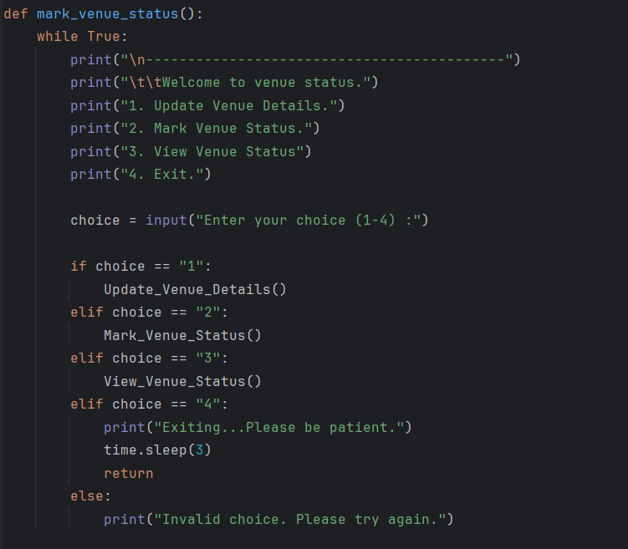
This is the second functionality of Venue Manager. Defines the function mark_venue_status. It allows the user to manage venue-related actions through a simple text-based menu interface.
It begins with a while True loop to keep displaying the menu until the user chooses to exit the function. When entering the function, a welcome message is displayed, followed by a menu with four options:
- Update Venue Details: Call function named Update_Venue_Details()
- Mark Venue Status: Call function named Mark_Venue_Status()
- View Venue Status: Call function named View_Venue_Status()
- Exit: Display an exit message and waits 3 seconds to exit the function by using return.
Users are expected to enter only numbers between 1 and 4. If the input is invalid, an error message is displayed and the menu is shown again.
Function 2.1: Update Venue Details
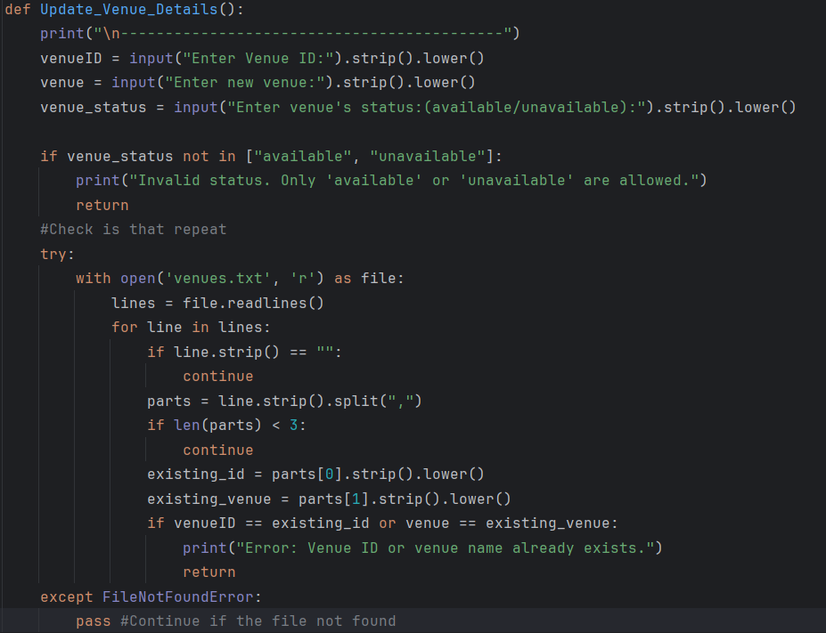
The first function called from the menu function mark_venue_status is Update_Venue_Details. This function allows Venue Manager to add a new venue to the system by entering the venue ID, venue name, venue status and a reason if the venue is marked as unavailable.
The function begins with the input venueID, venue and venue_status. All the values from these input are converted to lowercase and removed the extra spaces. Next, the function validates the venue_status input. Only "available" or "unavailable" are accepted. If the input is invalid, the function displays an error message and exits. The function tries to open the file venues.txt and read the data line by line into a list named lines. Then, it takes a loop and skip the line if the line is empty or improperly formatted (less than 3 parts). It also checks whether the input venueID or venue name exists. If the input is already exists, the function displays an error message and exits. Also, if the file venues.txt is not found, the program will continue without error and will create a new file later.
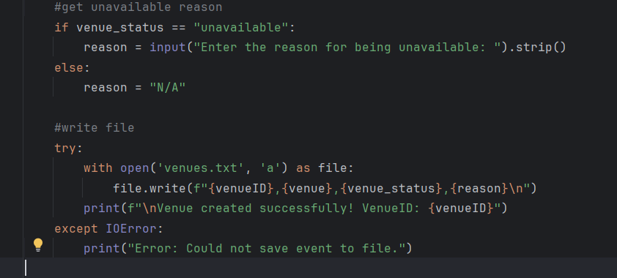
If the status input is "unavailable", user needs to enter the reason. Otherwise, the reason will be written "N/A" automatically. The function opens the file venues.txt to append a new line with venue information without deleting old data. After writing, it will process a success message and show the new Venue ID. If any writing errors, it displays an error message.
Function 2.2: Mark Venue Status
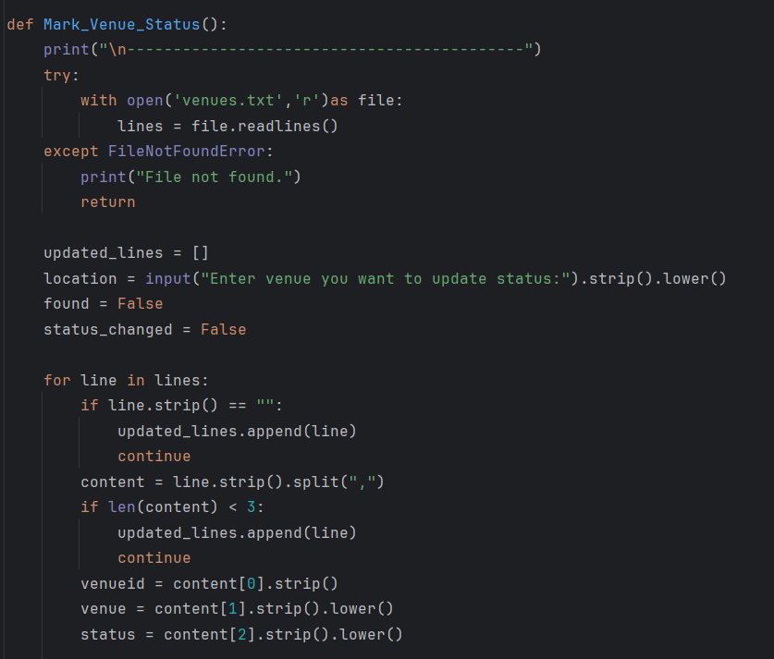
The second function called from the menu function mark_venue_status is Mark_Venue_Status. It allows the Venue Manager to update the venue status to either "available" or "unavailable" with a reason if the venue is unavailable.
The function begins with trying to open the venues.txt file and reading the content line by line into a list named lines. If the file not found, an error message is displayed and the function exits. Next, the function sets an empty list named updated_lines and two Boolean flags, found and status_changed, both set to False. It also create an input named location to let user enter the venue they want to update.
The function then read the line in lines. If a line is empty, it is preserved by appending it directly to updated_lines, and the loop continues. If the length of the content is incorrect format (less than 3), the line will be retained and skipped. For each line, the function extracts the venueid, venue and status from the list of content, removing extra spaces using .split() and converting them into lowercase by using .lower().
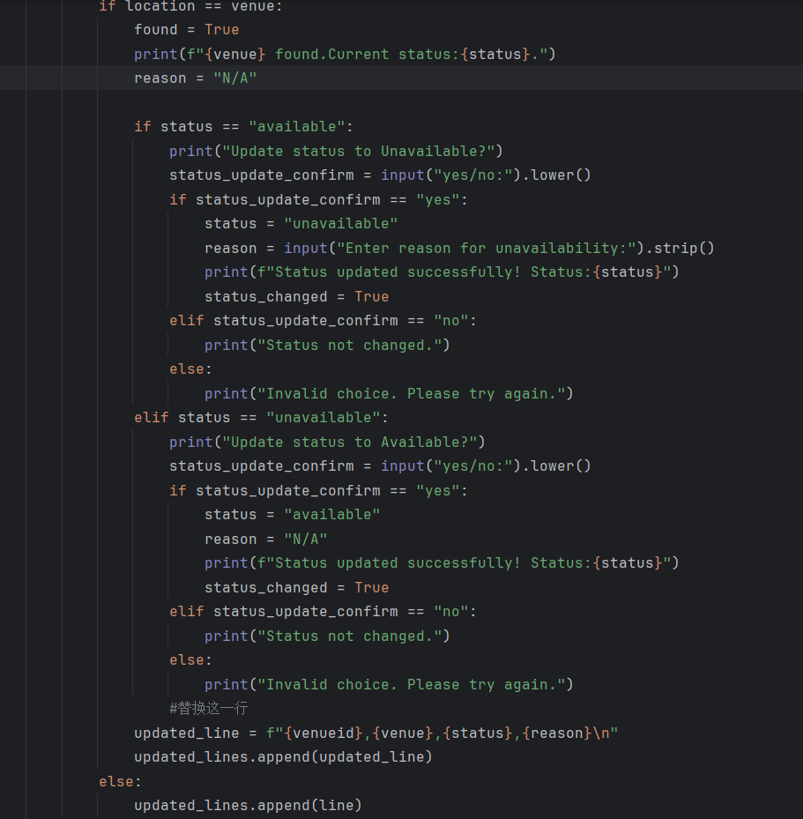
If the location input matches the venue, it means the venue exists, the function sets found = True and displays a message with the current status. Depending on the current status, the user is prompted to confirm whether they would like to change it. If the user confirm "yes", the status is updated.
- If changing to "unavailable", the user must also enter a reason.
- If changing to "available", the reason is set to "N/A".
If the user enter "no", "Status not changed." is displayed and the function exits. Otherwise, the invalid input will display an invalid choice message. After the status is updated, a new line with the updated venueid, venue, status and reason is added to updated_lines. If the venue in line does not match the location input, the line is added to updated_lines unchanged. 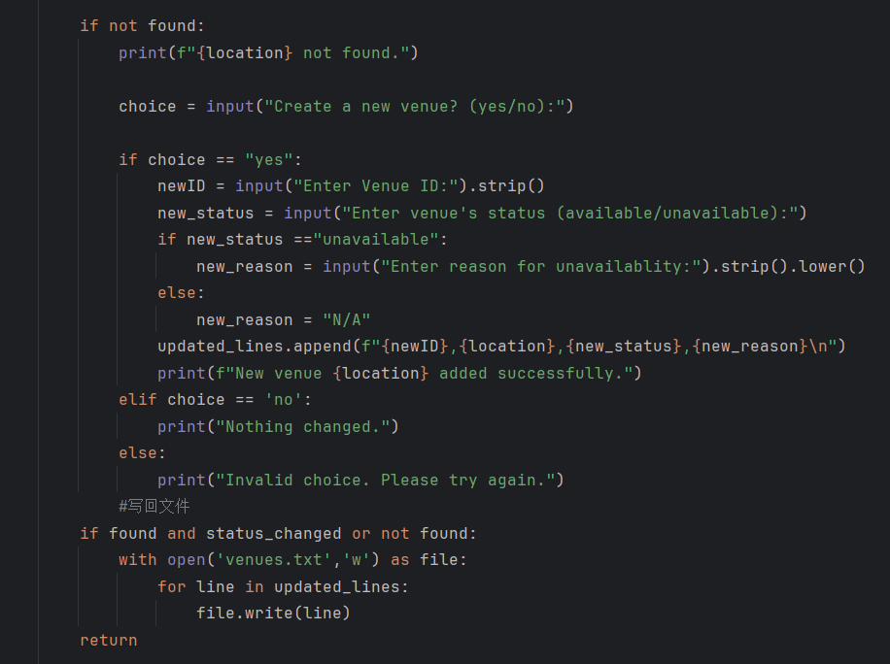
After checking all lines, if no venue is found (found == False), 'Location not found' message is displayed and an input named choice is created to ask whether the user wants to create a new venue. If the user enter "yes", they need to enter the new details as input newID, new_status and new_reason if new_status is "unavailable". The new details are appended to the updated_lines and a success message is displayed. If the user enter "no", 'Nothing changed.' is displayed. Otherwise, the function will display 'Invalid choice.' Finally, if a venue was found and its status was updated (status_changed == True) or a new venue was added (not found), the function opens the venues.txt file to write line in updated lines into the file.

Function 2.3: View Venue Status
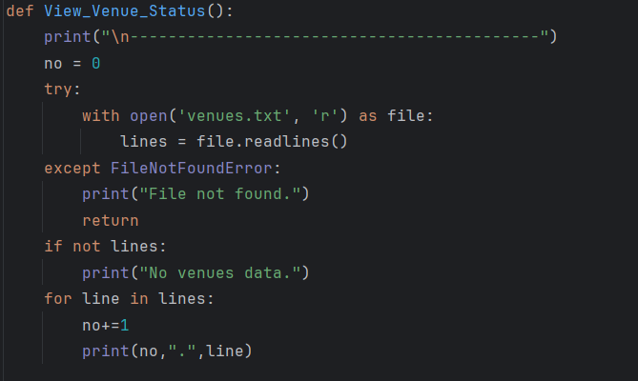
The third function called from the menu function mark_venue_status is View_Venue_Status. This function allows the Venue Manager to view all current venue records and their statuses in a numbered list.
The function begins by setting a counter variable (no = 0), which is used to display line numbers. Then, the function tries to open the venues.txt file and read contents line by line into a list named lines. If the file is not found, the function displays a message "File not found" and exits. If the file is found but the lines list is empty, a message "No venues data" is displayed. For each line, the counter no is added by 1 and the function displays no and line in lines list.

Function 3: Venue Requestment
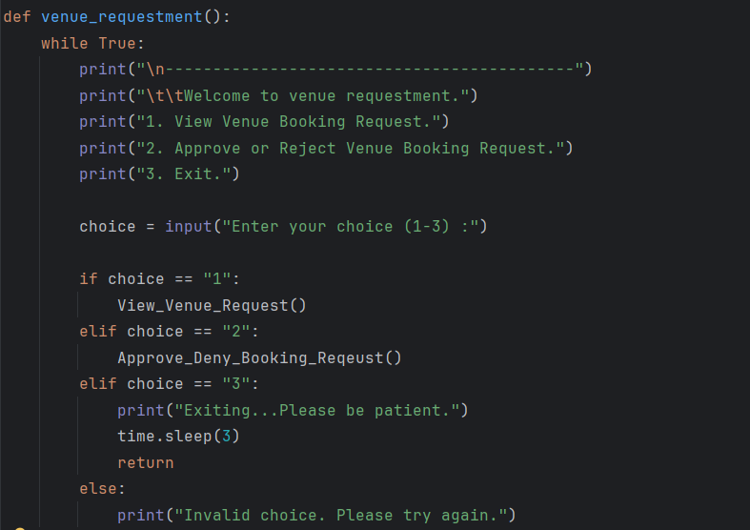
This is the third functionality of Venue Manager. Defines the function named venue_requestment. It allows the user to manage venue requestment which requested by Event Organizer.
It begins with a while True loop to keep displaying the menu until the user chooses to exit the function. When entering the function, a welcome message is displayed, followed by a menu with three options:
- View Venue Booking Request: Call function named View_Venue_Request()
- Approve or Reject Venue Booking Request: Call function named Approve_Deny_Booking_Request()
- Exit: Display an exit message and waits 3 seconds to exit the function by using return.
Users are expected to enter only number between 1 and 3. If the input is invalid, an error message is displayed and the menu is shown again.

Function 3.1: View Venue Request
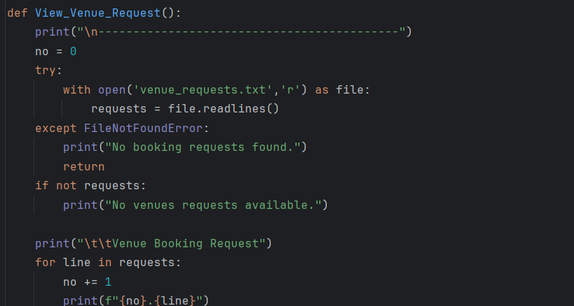
The first function called from the menu function venue_reqeustment is View_Venue_Request. This function allows the Venue Manager to view all current venue requests in a numbered list.
The function begins by setting a counter variable (no = 0), which is used to display line numbers. Then, the function tries to open the venue_requests.txt file and read contents line by line into a list named requests. If the file is not found, the function displays a message "No booking requests found" and exits by using return. If the file is found but the requests list is empty, a message "No venues requests available" is displayed. For each line, the counter no is added by 1 and the function displays no and line in requests list.

Function 3.2: Approve Deny Booking Request
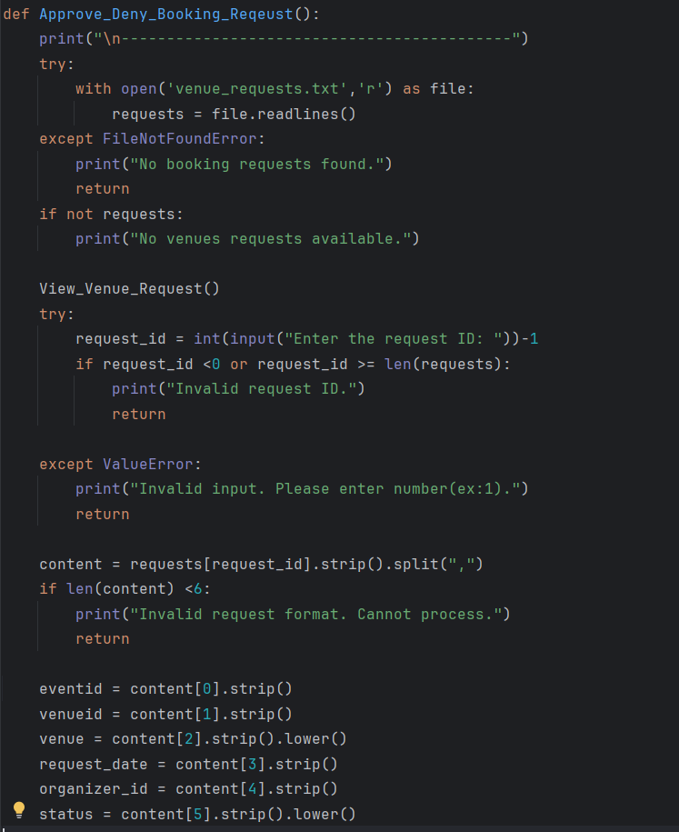
The second function called from the menu function venue_reqeustment is Approve_Deny_Booking_Request. It allows the Venue Manager to approve or deny a venue booking request submitted by the event organizer. The function also ensures that, once approved, the venue status in venues.txt file is automatically updated to unavailable along with a reason.
The function begins by displaying a separation line, trying to open venue_requests.txt file and read the file line by line into a list named requests. If no file found or file found but the list is empty, an error message is displayed. Then, the function calls the function View_Venue_Request() to show the list of all pending venue requests to the user. Next, it asks the user to input the request ID. The input is converted to an integer and adjusted by subtracting 1 since list indices start at 0. If the input is not a valid number or falls outside the valid range of the request list, an error message is displayed and the function exits.
After entering the ID, the selected request line is split by commas "," and checked for format (must contain at least 6 parts). If the request format is invalid, the function displays an error message and exits. The function then assigns values to several variables from the request, which are eventid, venueid, venue, request_date, organizer_id, and status.
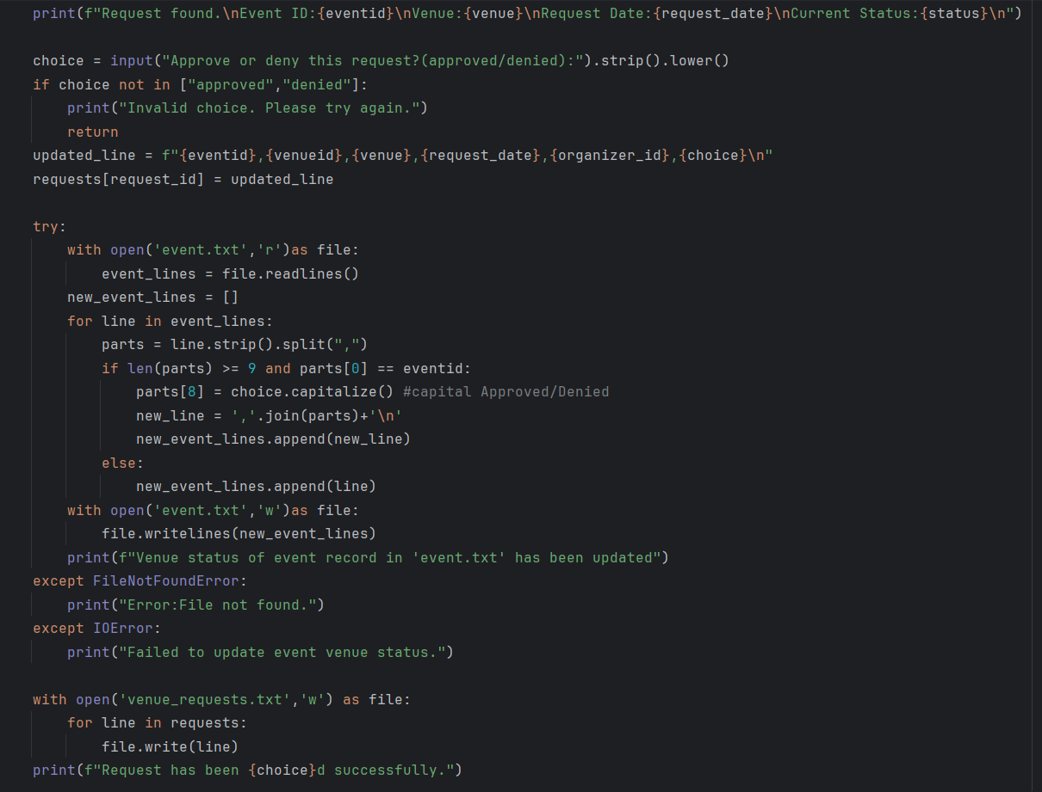
These details are displayed so the user can review the request information easily. Next, the user is asked to approve or deny the request by entering input named choice, which either "approved" or "denied". If the input is invalid, an error message is shown and the function exits. If the input valid, the request is updated with the new status in lowercase by .lower() and the updated line replaces the original one in the requests list.
Then, the function tries to open event.txt file to update the event's booking status as well. It reads the file line by line into list named event_lines and create an empty list named new_event_lines. The function takes loops through the list and finds the event that matches the current eventid. Once matched, it updates the parts[8] with a capitalized status ("Approved" or "Denied"). It opens event.txt file and writes the updated list of events back into the event.txt file or displays an error message if the file is missing or there is a write error. After updating the event.txt file, the function opens venue_requests.txt and writes all updated request lines to show the new status. A success message is displayed.
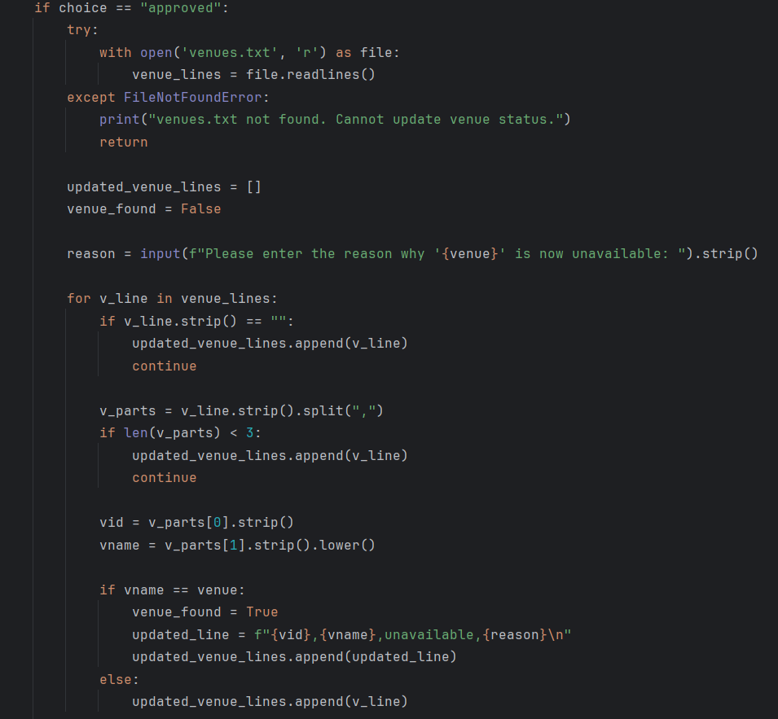
If the venue request was approved, the function proceeds to automatically mark the venue as unavailable. It begins by opening the venues.txt file and reading the content line by line into a list named venue_lines. If the file is not found, an error message is displayed and the function exits. Next, an empty list named updated_venue_lines is created to store the updated venue data and a boolean variable venue_found is set to False. The function then askes the user to enter the reason why the venue is now unavailable using an input named reason. The function loops through each line in venue_lines. If a line in venue_lines is empty or the length of parts in line is less than 3, the function skips and retains the line. For all other lines,the function compares the venue name from the file with the current venue. If the venue is matched and found, it updates the line with status "unavailable" and the reason input and stores this in updated_venue_lines list. If the venue does not match, the original line is retained.
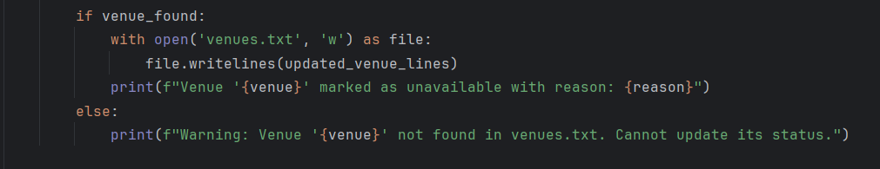
If venue_found is True, this means the venue exists in the venues.txt file. The function opens the file and writes the updated venue information, which stored in the updated_venue_lines into the file. A success message is displayed to confirm the venue has been marked as unvailable with the reason input. Otherwise, if the venue was not found (venue_found = False), the function displays a warning message to the user.
Function 4: Suggest Venue
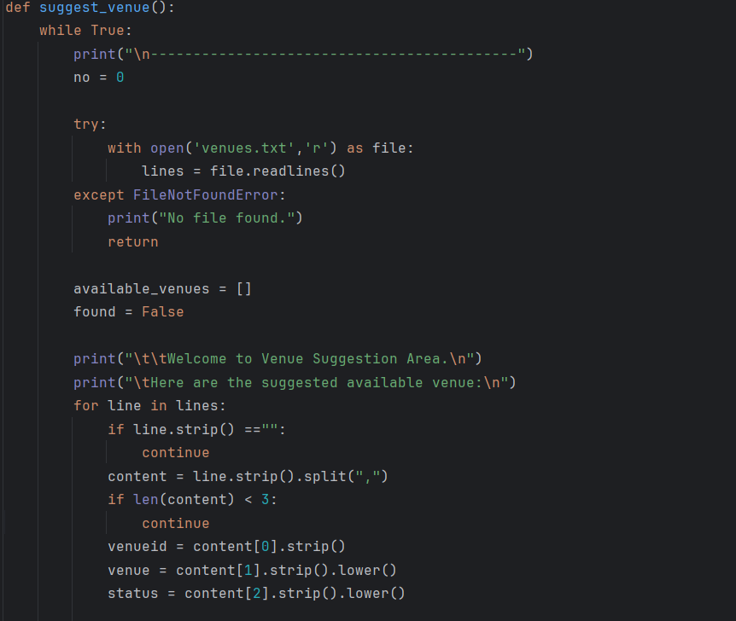
This is the fourth functionality of Venue Manager. Defines the function named suggest_venue. It allows the Venue Manager to view and suggest available venues.
The function begins with a while True loop to keep repeated viewing available venue until the user chooses to exit. It first initializes a counter no = 0, which will be used to number the available venues. The function then tries to open the venues.txt file and read the content line by line into a list named lines. If the file is not found, an error message is shown and the function exits. A boolean flag found is set to False to track whether any available venues exist. When entering the function, it will display a welcome message. Then, the function iterates over each line in the file. If the line is empty, it will skip. The function splits each line by commas "," and checks whether the format correct (the length of content is at least 3). If the format is correct, it extracts venueid, venue and status. All values are removed extra spaces and converted to lowercase.
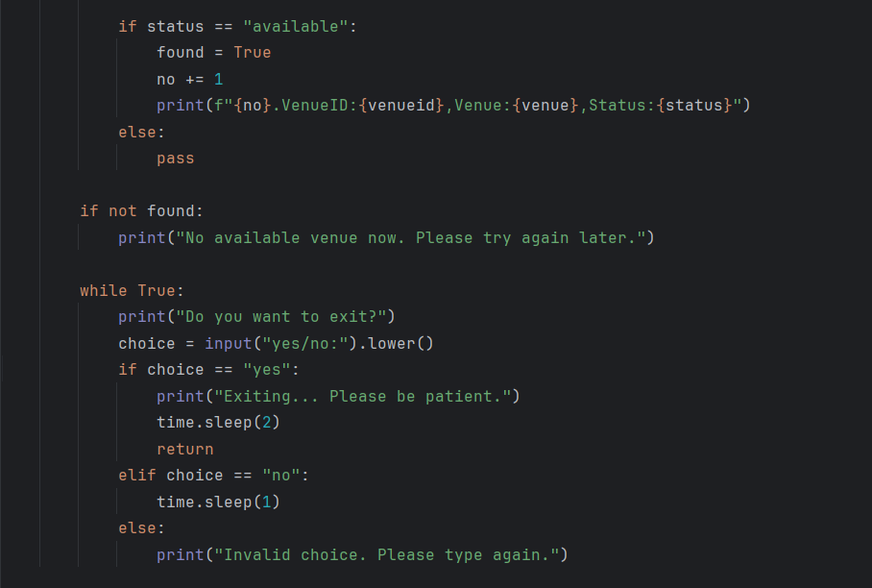
If the status of venue is "available", found is set to True and the counter no is added by 1 for each line. The function displayed no, venueid, venue and status. If the venue is "unavailable", it is skipped.
After all venues are listed, if none were found (found = False), a message "No available venue now. Please try again later." is displayed. Then, a while True loop begins to ask user whether they want to exit using an input called choice. Users are expected to answer either "yes" or "no". If the input is "yes", the function displays an exit message and exits after waiting 2 seconds. If the input is ”no", the function wait a second and display the question again. If the inpur is invalid, the user have to answer again the question with a correct input.

3.4.3 Input & Output Screenshot & Explanation

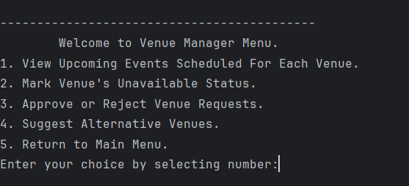
Screenshot 3.4.3.1
This screenshot shows the output of venue_manager_menu(), which allows you to view upcoming events schedule according to each venue, mark venue’s unavailable status, approve or reject venue requests by event organizer, view and suggest alternative venues and return to main menu. The user is asked to select a choice by entering the number from 1 to 5 that corresponds to that option.

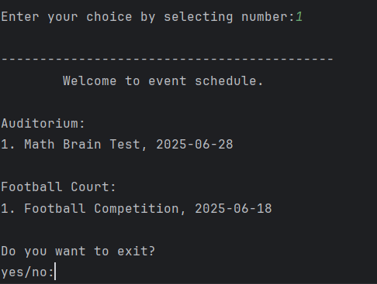
Screenshot 3.4.3.2
This screenshot shows the output after entering number “1” to select “View Upcoming Events”. The system reads data from event.txt, filters for approved events that are scheduled in the future and groups them by venue. Each venue is displayed with a list of its upcoming events and dates.
At the end of the listing, user is prompted with a choice to exit the event schedule view by typing "yes" or continue browsing by typing "no".

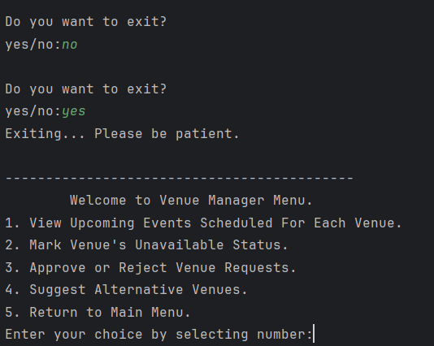
Screenshot 3.4.3.3
This screenshot shows the output after entering “no” followed by “yes” to exit the Events Schedule view.
When the user enters “no”, the program waits for a second and then repeats the exit confirmation prompt. When the user enters “yes”, they are returned to the Venue Manager Menu, where they are prompted to select an option by entering a number from 1 to 5, each corresponding to a specific venue management function.

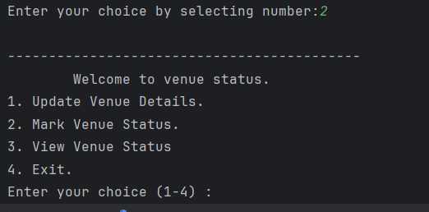
Screenshot 3.4.3.4
This screenshot shows the output after entering number “2” to select “Mark Venue’s Unavailable Status”. There are 4 options for users to select a choice by entering the number from 1 to 4 that corresponds to that option.

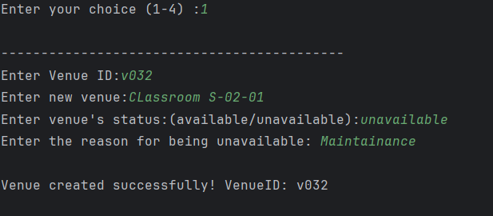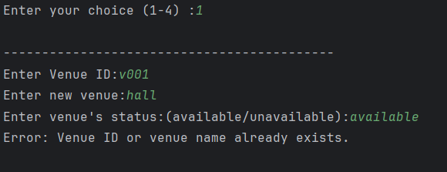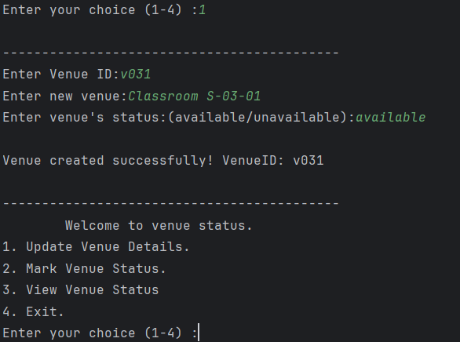
Screenshot 3.4.3.5
Screenshot 3.4.3.6
Screenshot 3.4.3.7
These three screenshots show the output after entering number “1” to select “Update Venue Details”. The user is asked to enter the new venue details, including the venue ID, venue name and venue status (either available or unavailable).
- If the venue status is set to unavailable, the user is also asked to provide a reason. (screenshot 3.4.3.5)
- If the venue status is set to available, the reason will automatically be written in "N/A". (screenshot 3.4.3.7)
- If the venue ID or the venue nams already exists in the file, it displays an error message. (screenshot 3.4.3.6)
After successfully entering, the system displays a success message with the Venue ID. The venue details will be saved in the venues.txt file. After that, the system will automatically return to the Venue Status Menu. Users can choose to update another new venue or perform a different task.

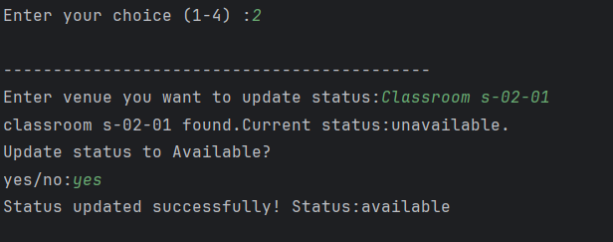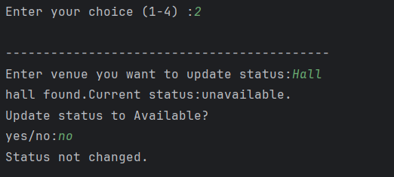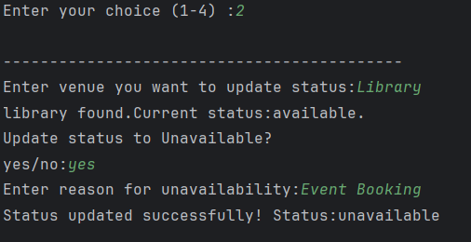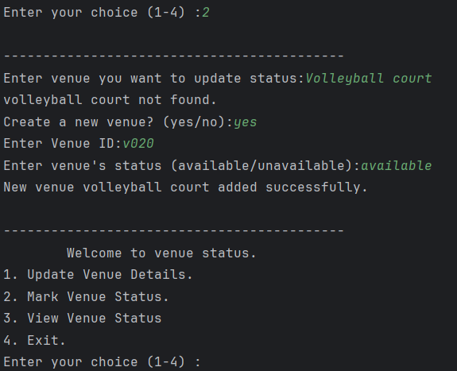
Screenshot 3.4.3.8
Screenshot 3.4.3.9
Screenshot 3.4.3.10
Screenshot 3.4.3.11
These four screenshots show the output after entering number “2” to select “Mark Venue Status”. The user is asked to enter the venue name they wish to update. The system checks the current status of the venue and asks the user to confirm whether they want to update the status to “available” or “unavailable” by entering “yes” or “no”.
- If the current status is available and the user chooses to change it to unavailable, they are asked to provide a reason for unavailability. (Screenshot 3.4.3.9)
- If the current status is unavailable and the user chooses to update it to available, the reason will automatically be set to “N/A”. (Screenshot 3.4.3.8)
- If user enter “no”, the system will display “Status not changed.” and no updates are made. (Screenshot 3.4.3.10)
- If the venue is not found in the file, the system notifies the user with a message “[venue] not found.” and asks whether they want to create a new venue by providing new ID, status and reason if status marked as "unavailable". (Screenshot 3.4.3.11)
After successfully entering, the system displays a success message showing the new status. All changes are saved in the venues.txt file. After the update, the system will automatically return to the Venue Status Menu. Users can choose to mark venue status or perform a different task.

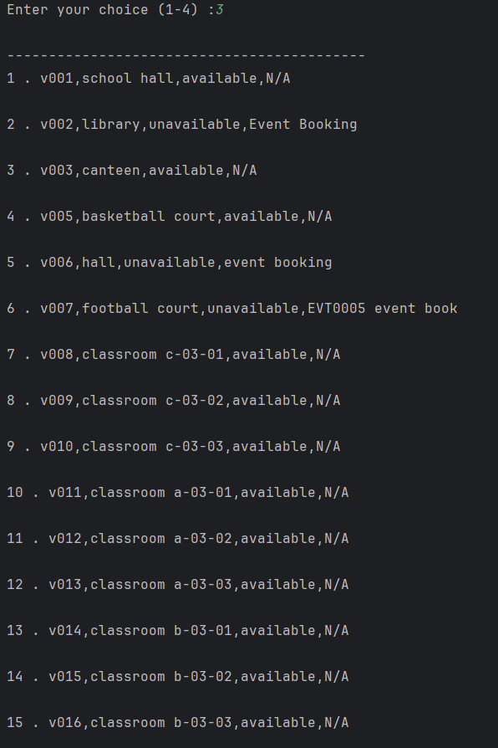
Screenshot 3.4.3.12
This screenshot shows the output after entering number “3” to select “View Venue Status”. The system reads the data from the venues.txt file and displays the details of each venue, including the venue ID, venue name, status, and reason.
After displaying all the venue information, the system will automatically return to the Venue Status Menu. Users can choose to view venue status or perform a different task.

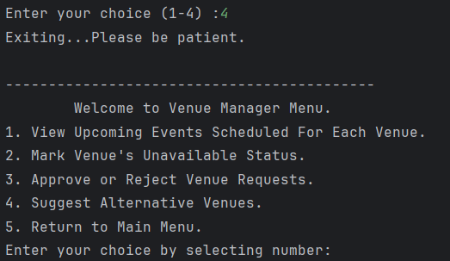
Screenshot 3.4.3.13
This screenshot shows the output after entering number “4” to exit and return to the Venue Manager Menu. The user is asked to select a choice by entering the number from 1 to 5 that corresponds to that option.

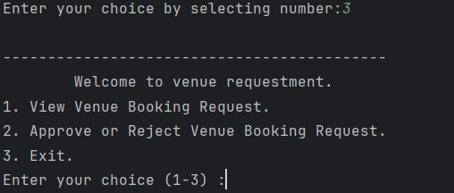
Screenshot 3.4.3.14
This screenshot shows the output after entering number “3” to select “Approve or Reject Venue Requests”. There are 3 options for users to select a choice by entering the number from 1 to 3 that corresponds to that option.
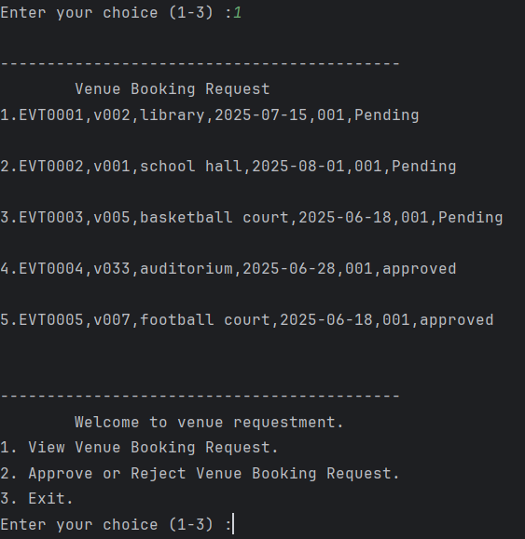
Screenshot 3.4.3.15
This screenshot shows the output after entering number “1” to select “View Venue Booking Request”. The system reads the data from the venue_requests.txt file and displays the details of each venue booking request. The information includes Event ID, Venue ID, Venue, Event Date, Organizer ID and Venue Request Status (Pending, Approved or Rejected).
After displaying all booking request information, the system will automatically return to the Venue Requestment Menu. Users can choose to view requests or perform other tasks.
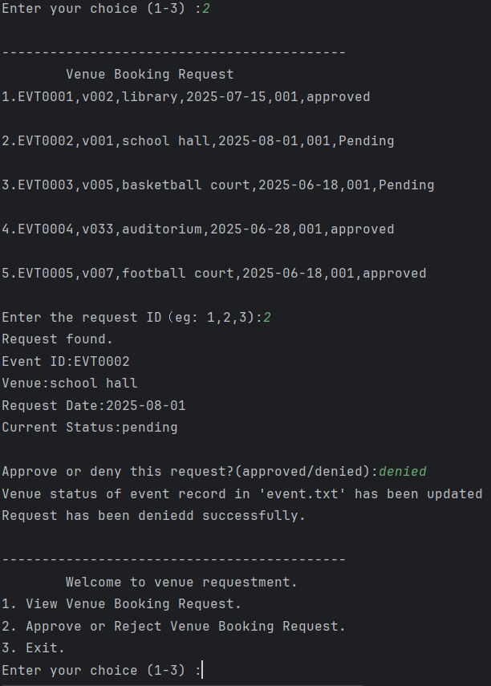
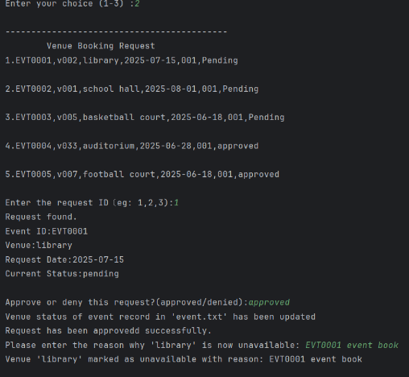
Screenshot 3.4.3.16
Screenshot 3.4.3.17
These two screenshots show the output after entering number “2” to select “Approve or Reject Venue Booking Request”. The system reads the data from both venue_requests.txt and venues.txt and displays the details of each venue booking request. The information includes Event ID, Venue ID, Venue, Event Date, Organizer ID and Venue Request Status (Pending, Approved or Rejected). After listing all the requests, the system prompts the user to enter the request ID they want to process. If the request is found, the system will display the corresponding details and prompt the user to enter either “Approved” or “Rejected”. If approved, the user is also asked to enter the reason if the venue is unavailable. New updates are saved in both event.txt and venue_requests.txt.
After displaying all request details, the system will automatically return to the Venue Requestment Menu. Users can choose to approve or reject requests or perform other tasks.
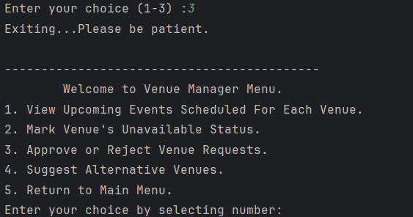
Screenshot 3.4.3.18
This screenshot shows the output after entering number “3” to exit and return to the Venue Manager Menu. The user is asked to select a choice by entering the number from 1 to 5 that corresponds to that option.

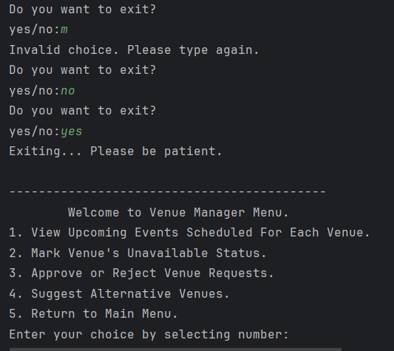
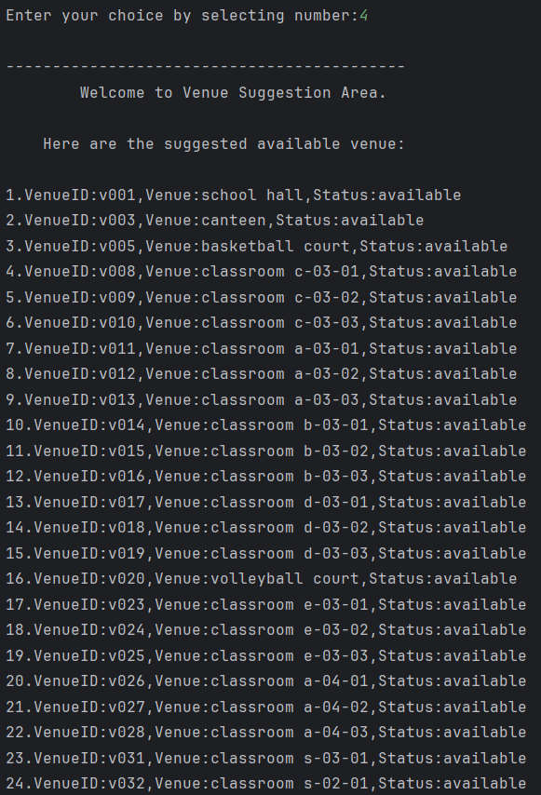
Screenshot 3.4.3.19 Screenshot 3.4.3.20
This screenshot shows the output after entering number “4” to select “Suggest Alternative Venues”. The system reads the data from the venues.txt file and displays a list of available venues with their details, including the venue ID, venue and status. Only venues marked as "available" are shown as alternative suggestions.
After displaying all available venues, the system will automatically return to the Venue Status Menu. Users can choose to view available more suggestions or perform a different task.
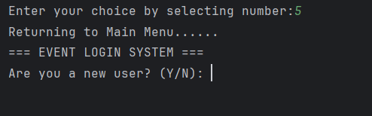
Screenshot 3.4.3.21
This screenshot shows the output after entering number “5” to return to Main Menu. The system will log out of the system and redirect them to the Login Menu, allowing them to re-enter the system or switch roles.

4.0 Conclusion
The Smart Campus Event Management System successfully demonstrates a functional, text-based event management tool for the campus. By implementing distinct user roles such as Event Organizer, Participant, Administrator and Venue Manager, the system provides a structured and organized workflow. Its use of Python’s fundamental programming constructs, such as control structures, file handling, lists, dictionaries, and exception handling, ensures a strong foundation for logic-based functionality.
One of the main advantages of our system is that it is simple and clear to use. The text file-based storage enables straightforward data without requiring complex databases. Error handling through try...except enhances system stability, while validation logic and role-based access make the user experience more consistent and purposeful. Each role’s functionalities reflect real-world tasks, helping users understand the basic operations behind event and venue management.
However, the system has several limitations. It lacks a graphical user interface, which may reduce user-friendliness, especially for those who are unfamiliar with command-line interfaces. The reliance on .txt files also limits scalability and data integrity, especially when handling larger volumes of data. Moreover, the system operates in a single-user mode and provides limited input validation, which may lead to errors if users enter invalid data formats.
To enhance the system in the future, it is recommended to use a relational database such as MySQL as it is more secure. Adding a graphical interface using tools like Tkinter or PyQt would make the system more accessible. Further improvements could include increasing input validation checks and enabling multi-user or real-time interaction functions through networked communication.
In conclusion, this project serves as a valuable learning platform for understanding fundamental programming concepts, system design, and the logic behind managing events and venues. While the current system is functional and serves its intended purpose, there should be a significant improvement to enhance real-world demands and user expectations.

5.0 References
Basic python login system. (2020). Welcome to python-forum.io. https://python-forum.io/thread-30396.html
How to make a simple GUI in Python without using any tools such as Tkinter, Eclipse etc? (n.d.). Stack Overflow. https://stackoverflow.com/questions/20587886/how-to-make-a-simple-gui-in-python-without-using-any-tools-such-as-tkinter-ecli
eventmanagementproj. (2017). Event-Management-Project/flask_app.py at master · eventmanagementproj/Event-Management-Project. GitHub. https://github.com/eventmanagementproj/Event-Management-Project/blob/master/flask_app.py
Kumar, Y. (2023, January 26). Event Management System project in Python. CopyAssignment. https://copyassignment.com/event-management-system-project-in-python/
W3Schools. (n.d.). Python Tutorial. https://www.w3schools.com/python/default.asp

6.0 Appendix

6.1 Workload Matrix
Name | TP No | TASK
LEE WEI YI | TP089398 | Responsible for creating program for venue managers, pseudocode and the explanation of the code.
NURSASI ALFIAH | TP087290 | Responsible for creating program for adminstrators, pseudocode and the explanation of the code.
WAYNE TIEW CHEN YUAN | TP088030 | Responsible to create program for organizers, pseudocode, and the explanation of the code
LIM JIA HOW | TP088710 | Responsible to create program for participants, pseudocode, and the explanation of the code

6.2 Text File Contents

6.2.1 users.txt
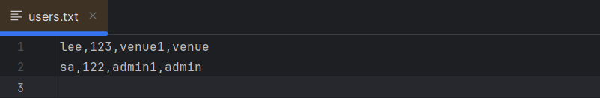

6.2.2 organizers.txt
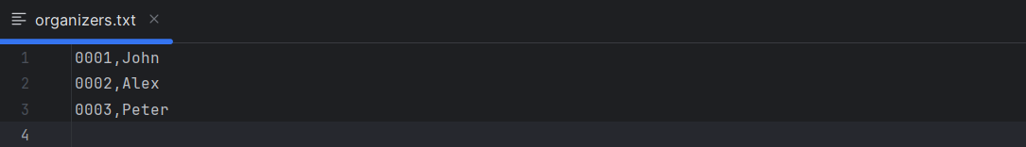
- 0001 appears in all venue requests (so that organizer is active).
- Other organizers (0002, 0003) are added for completeness.

6.2.2 event.txt
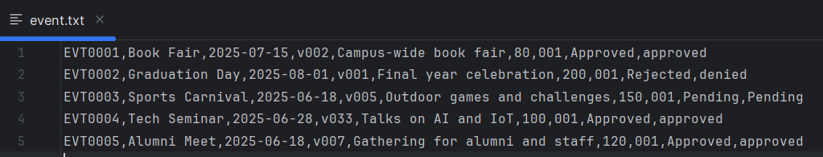
- These entries are synced with your venue_requests.txt:
- EVT0001 uses v002 (library), status: approved.
- EVT0002 was denied, so status is Rejected/denied.
- EVT0003 is still pending.
- EVT0004 and EVT0005 are both approved.
- All events are created by organizer 001 to match your venue request file.

6.2.3 participants.txt

6.2.4 registrations.txt
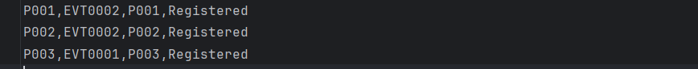

6.2.5 adminstrator.txt
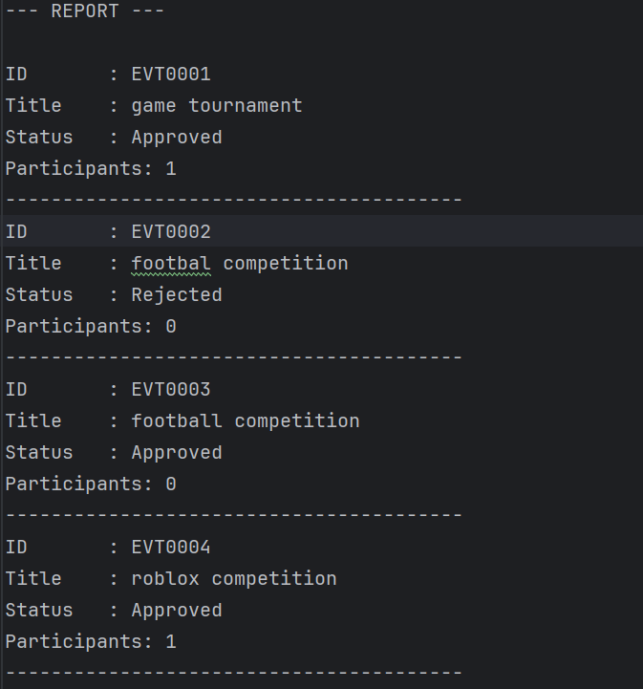

6.2.6 venues.txt
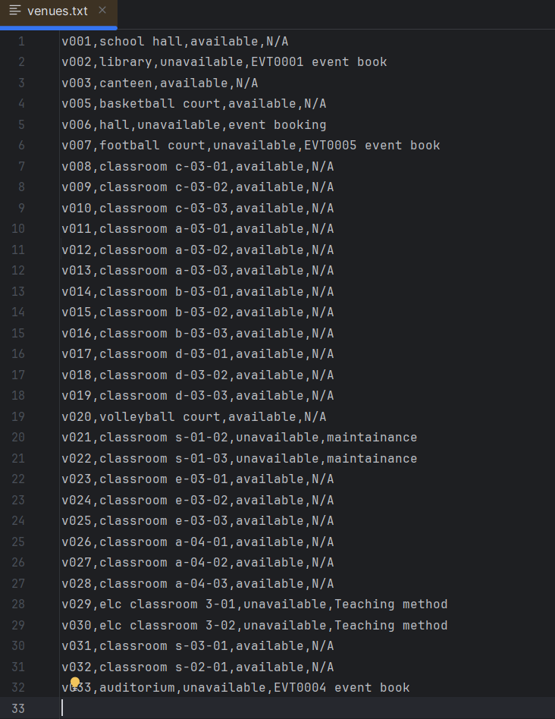

The venues.txt file was created and maintained entirely through the Venue Manager module. All venue details shown here (such as venue ID, name, status, and reason) are generated using the system’s own functions, such as updating venue status or approving booking requests. No manual editing was involved. This demonstrates the system's ability to manage and persist with venue-related data through file operations.

6.2.7 venue_requests.txt
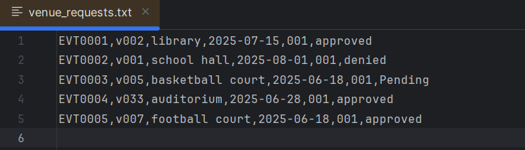
The venue_requests.txt content shown here was generated by the Event Organizer module during testing. The Venue Manager module reads this file to display venue booking requests.

