Part 1: Metro Visual Study

1.1–1.4: Introduction
The Reddit post harbors a user who underwent a personal project to map out and visualize the 98 Washington Metro stations under a descriptive layout that utilizes GitHub for documentation. The PDFs showcasing the exit guides were created using field data and observations from WMATA. The diagrams within the PDF file have detailed instructions on how to read and interact with them for reliable usage. Every symbol, color, layout, light, sign, label, and directional convention is examined under a consistent visual structure that rarely fluctuates throughout the pages. In being easy to follow or generally read, the validity of the file can be extrapolated to each and every metro station in the general area. It’s logical and practical enough to have language that aligns with one’s understanding of the domain on the most basic level. However, even without riding the DC Metro, a low level of knowledge about subway system platforms, transfers, and exits will help one to determine what the diagram is trying to say about routes. The underlying metadata and specifications help to set the images within their proper railcar context.

1.5: Comments on the Data
The data is split across multiple files in the repo so that the granular nature of it can be preserved. Each file serves a different functional purpose, and shares labeling of variables and observations that should be analyzed separately as a result of this. For instance, the meta.csv file has info on what exactly these variables mean, while doors.csv and exits.csv have details about where train doors and station exits will be respectively (In each present situation). These things are then all assimilated into two different versions of a PDF that serve as the final visualization output. In keeping things broken apart, consistent documentation breakdowns, and overall file maintenance within the GitHub repo will prove to be more fluid despite such a large metro system being in place. Data must be organized and reusable enough for one to achieve adaptability. If something were to change, then the structure of how it is now makes it so that things can be broken down and reviewed individually (exits, railcars, lights, station count, etc.). Lots of this information was collected by the Reddit user’s observations on the site, and then extrapolated and validated by whatever he could get from other public sources or foundations (Google maps, WMATA resources, various datasets, etc.).

1.6: How the Visualization Was Created
The diagrams look flawless and proficient enough to be considered official layouts, and likely were created by design software that has tools for effectively emulating common train system map layouts. Templates from various websites, Adobe, or data-focused hubs were likely utilized as a collective for the precise creation of the visual elements and designations within the visual (Due to the consistent nature of it). Any touch-ups or reviews done after the fact were likely done with a prospective scope or goal in mind.

1.7: Usefulness
For me personally, this visualization is quite useful, as I am a frequent commuter along the DC Metro. Due to the high volume of users and the quick arrival time of the trains and events that I travel to by train, it would be to my benefit if I could significantly shorten the amount of time I spend walking when trying to exit each station. This diagram helps me quickly identify the best exit for every platform, and does so seamlessly. Society at large seems to share this sentiment, as the users on Reddit find it helpful enough for everyday use in stations filled with people rushing to get to their destination.

1.8: Context-Based Usefulness
Those who need to plan out a trip to a specific location for any given reason will find these visuals the most useful, as it can be tough navigating through new areas without the proper resources to help you throughout the endeavor. Since something like this didn’t exist prior to its creation by the Reddit user, the number of individuals thankful for its adoption is very high. Metro-goers who have been familiar with the current system in place for years might not need this station diagram, but the use of it could still be convenient if they ever forget their placement or need to expand outside of the few stations that they regularly engage with. In this case, all diagrams would be valid for them, since the range of their travel could forever be changing.

1.9: Questions
How long did it take to build out these diagrams for efficient and practical use?
What features stood out as most important to you when building this diagram, and why?
How did you handle potential policy violations with WMATA in the creation of this diagram?
Why did you decide to handle version control and file operations on GitHub rather than other platforms?
What was the closest thing to these diagrams prior to their existence, and how much time has it personally saved you on your commutes on the metro?
Do you plan to consistently update this diagram throughout the years, or build a team around the upkeep of it so that updates are seamless and accurate?

Part 2: Sankey Diagram

2.1: Sankey Diagram Definition
A Sankey diagram is a flow visualization where movement and change from one state to another are emphasized in place of other elements. Arrow width is often proportional to flow rates of properties, and their connection with one another is signaled by nodes and links (similar to network graphs). Examples of these diagrams in data-driven spaces include energy accounts, material flow accounts, and cost breakdowns.

2.2-2.4: Sankey Diagram (Personal)
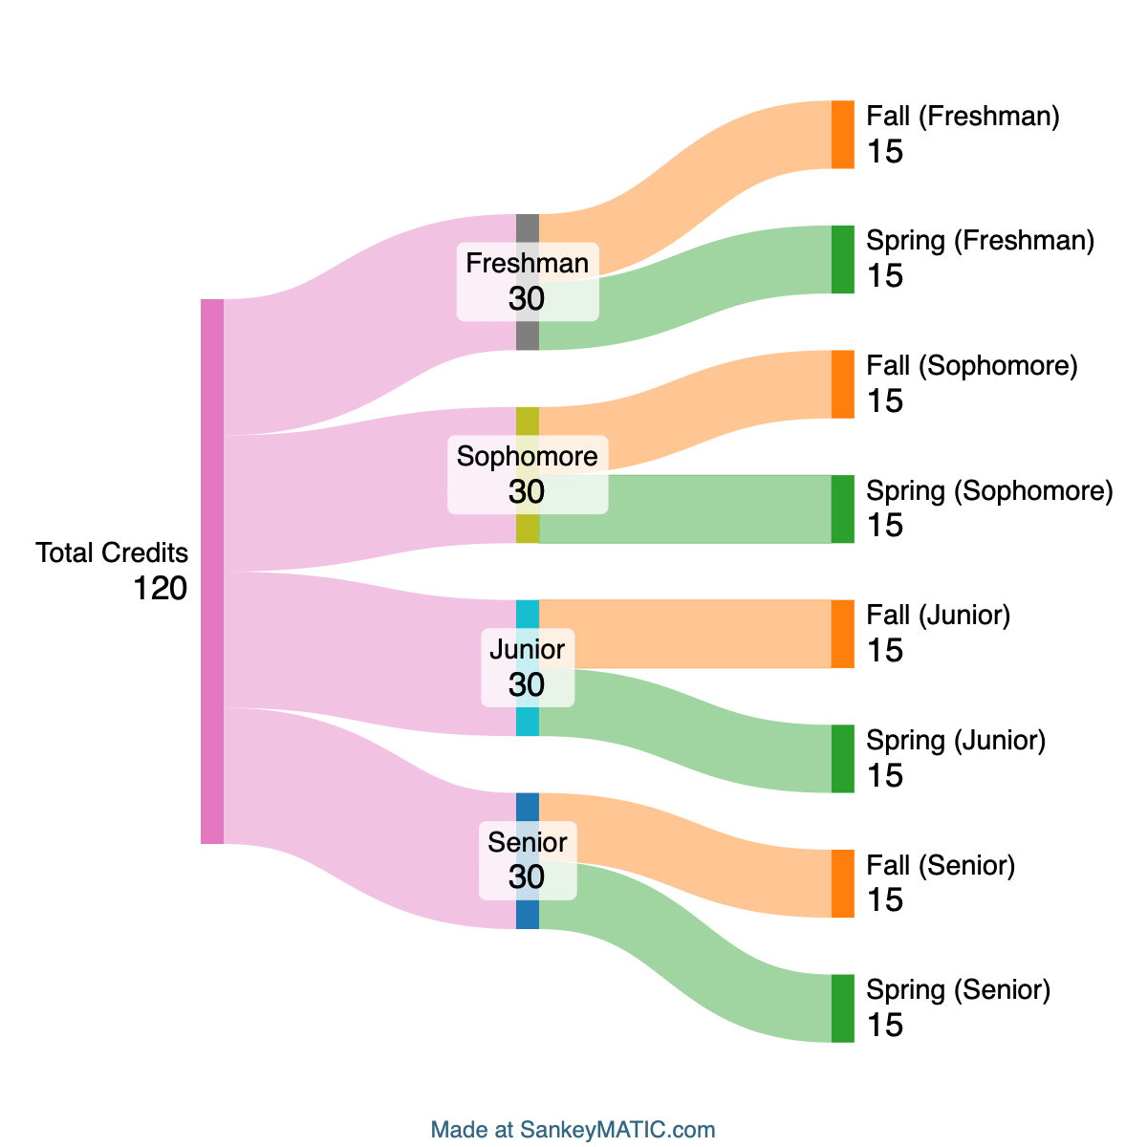
I chose to visualize the general 4-year plan that an incoming university student with no outside college-level course credits could find themselves enrolling in when attending a school like UMD. By incorporating this scenario on the most basic level without the inclusion of major-specific delineations or general education requirements, the total credits node sits at 120, while the freshman, sophomore, junior, and senior year links branch out at 30 credits each. From here, the fall and spring semesters for each year level out at a value of 15 credit hours, making for a scenario that is valid, replicable, and easy to follow. At a glance, you can get all the necessary information that you would need in a narrative format. Since it’s a visual, the details can be identified and understood without having to be written down or retold inefficiently in a manner that undermines certain components.

