Graphics for Qualitative/Categorical DATA (MOL4)
- Make a Dotplot of the DATA Battery_Life.xlsx:
  - The title “Distribution of Battery Life for Sample of 20 Batteries”
  - X Label to units in hours
  - Copy and paste your code (1 pt) and the resultant Dotplot here (1 pt) :
Results:
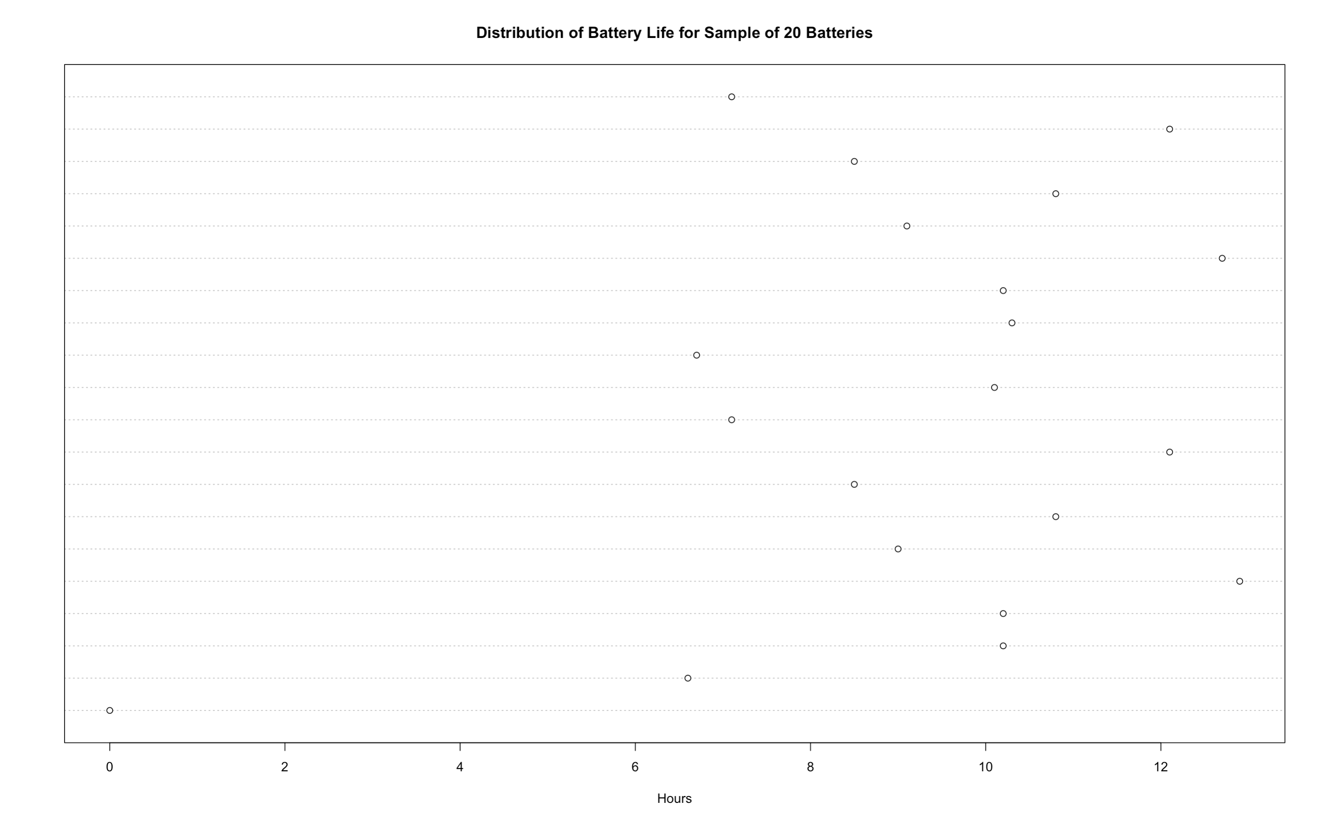
- Make a Stem-and_Leaf plot using the file Battery_Life.xlsx:
  - Make a stem-and-leaf plot
  - Copy and paste your code (1 pt) and the resultant Stem-and-Leaf plot here (1 pt) :
Results: 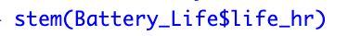 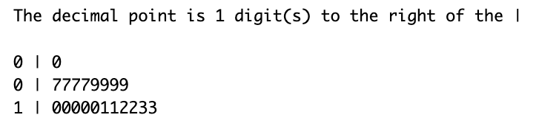

- Make a histogram of the DATA Battery_Life.xlsx that is standard (including left endpoint) with about 5 bars:
  - The title “Distribution of Battery Life for Sample of 20 Batteries”
  - X Label hours
  - Copy and paste your code (1 pt) and the resultant histogram here (1 pt) :
Results:
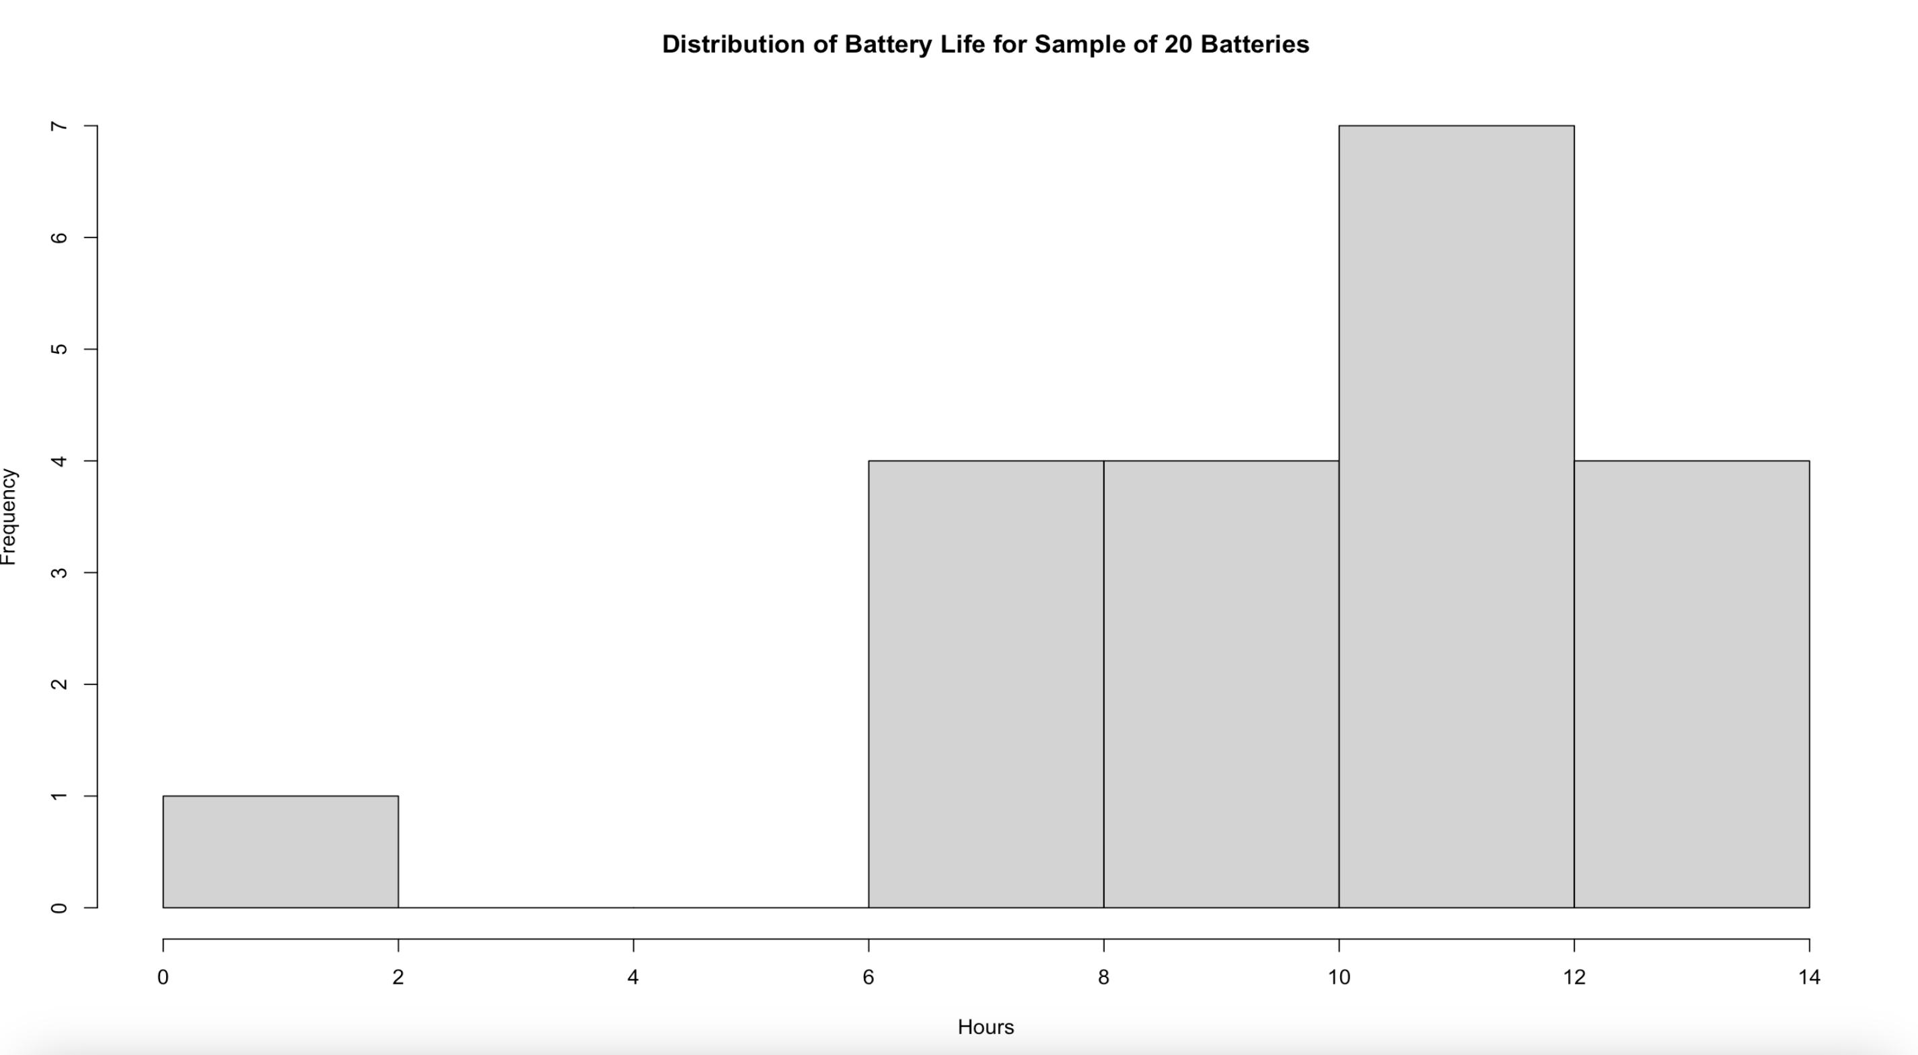
- Make a boxplot (horizontal) of the DATA Battery_Life.xlsx:
  - The title “Distribution of Battery Life for Sample of 20 Batteries”
  - X Label hours
  - Copy and paste your code (1 pt) and the resultant boxplot here (1 pt) :
Results:
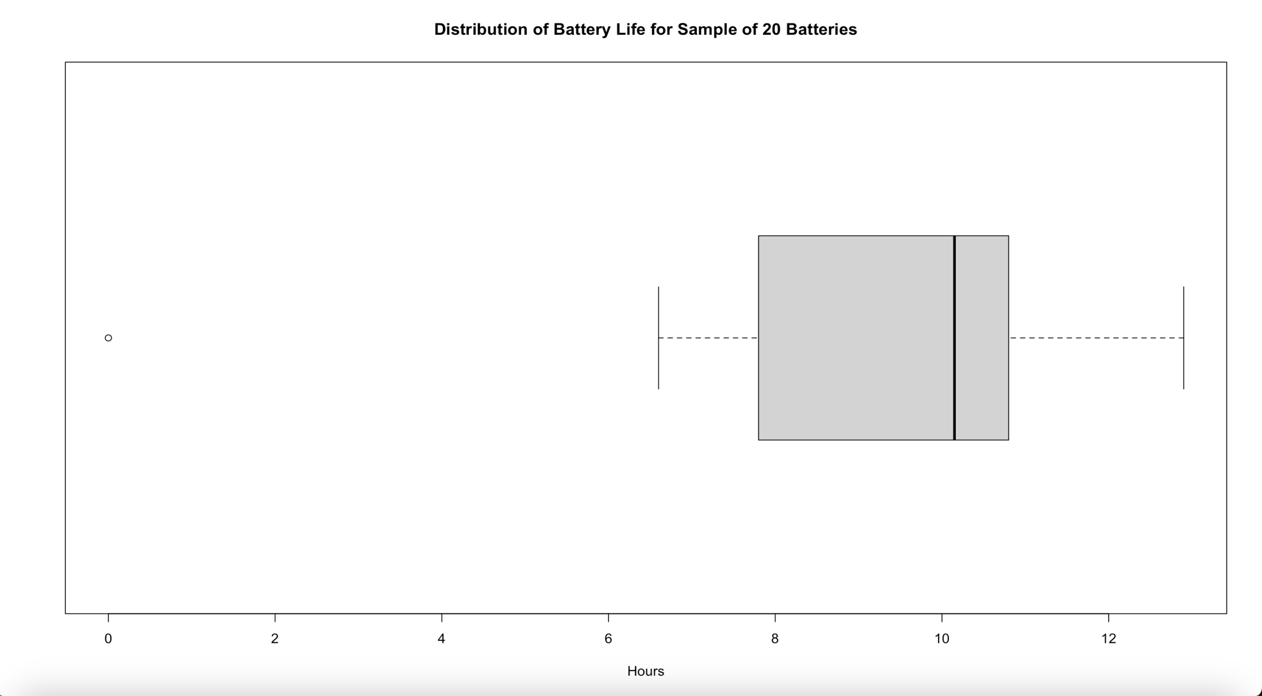
- Make a probability plot of the DATA Battery_Life.xlsx with line:
  - The title “Probability Plot of Battery Life for Sample of 20 Batteries”
  - Copy and paste your code (1 pt) and the resultant probability plot here (1 pt) :
Results:
