R and Inferential Techniques (MOL8
- A bolt diameter is measured in inches. Here is a simple random sample of 11 bolt diameter measurements:
1.11 1.07 1.11 1.07 1.12 1.08 1.08 1.15 1.18 1.18 1.12
  - Make a probability plot and a boxplot and see if there are any major deviations from Normality and if there are any outliers. Is it reasonable to use the t procedures? Why or why not? (Copy and paste the graphs that result with your determination on whether it is reasonable to use the t procedures. Make sure you have meaningful titles and labels for your graph.)
Copy and paste your code (2 pt) and resultant graphs (2 pt):
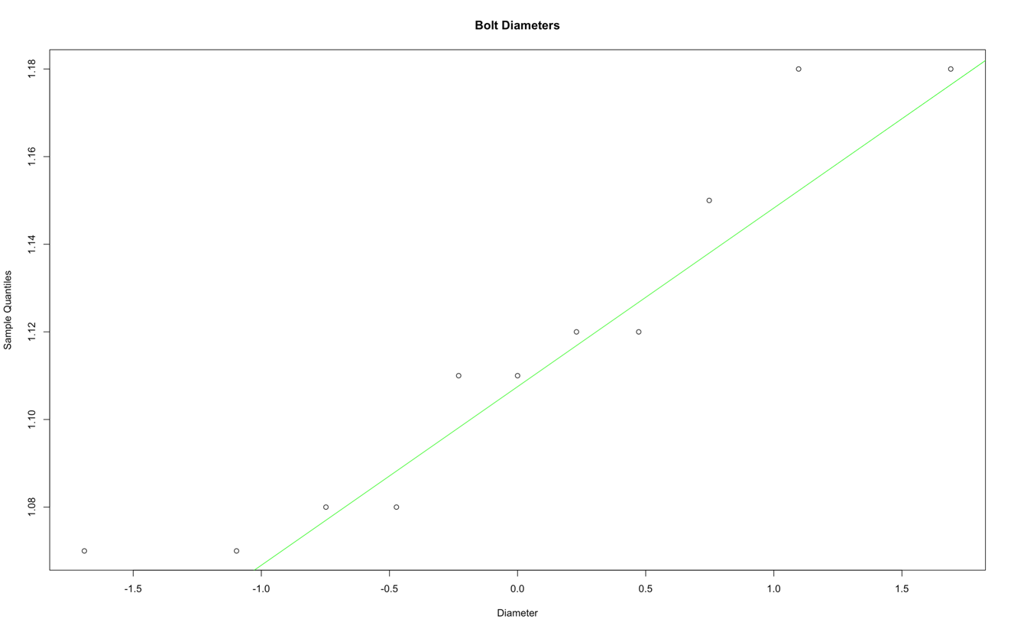
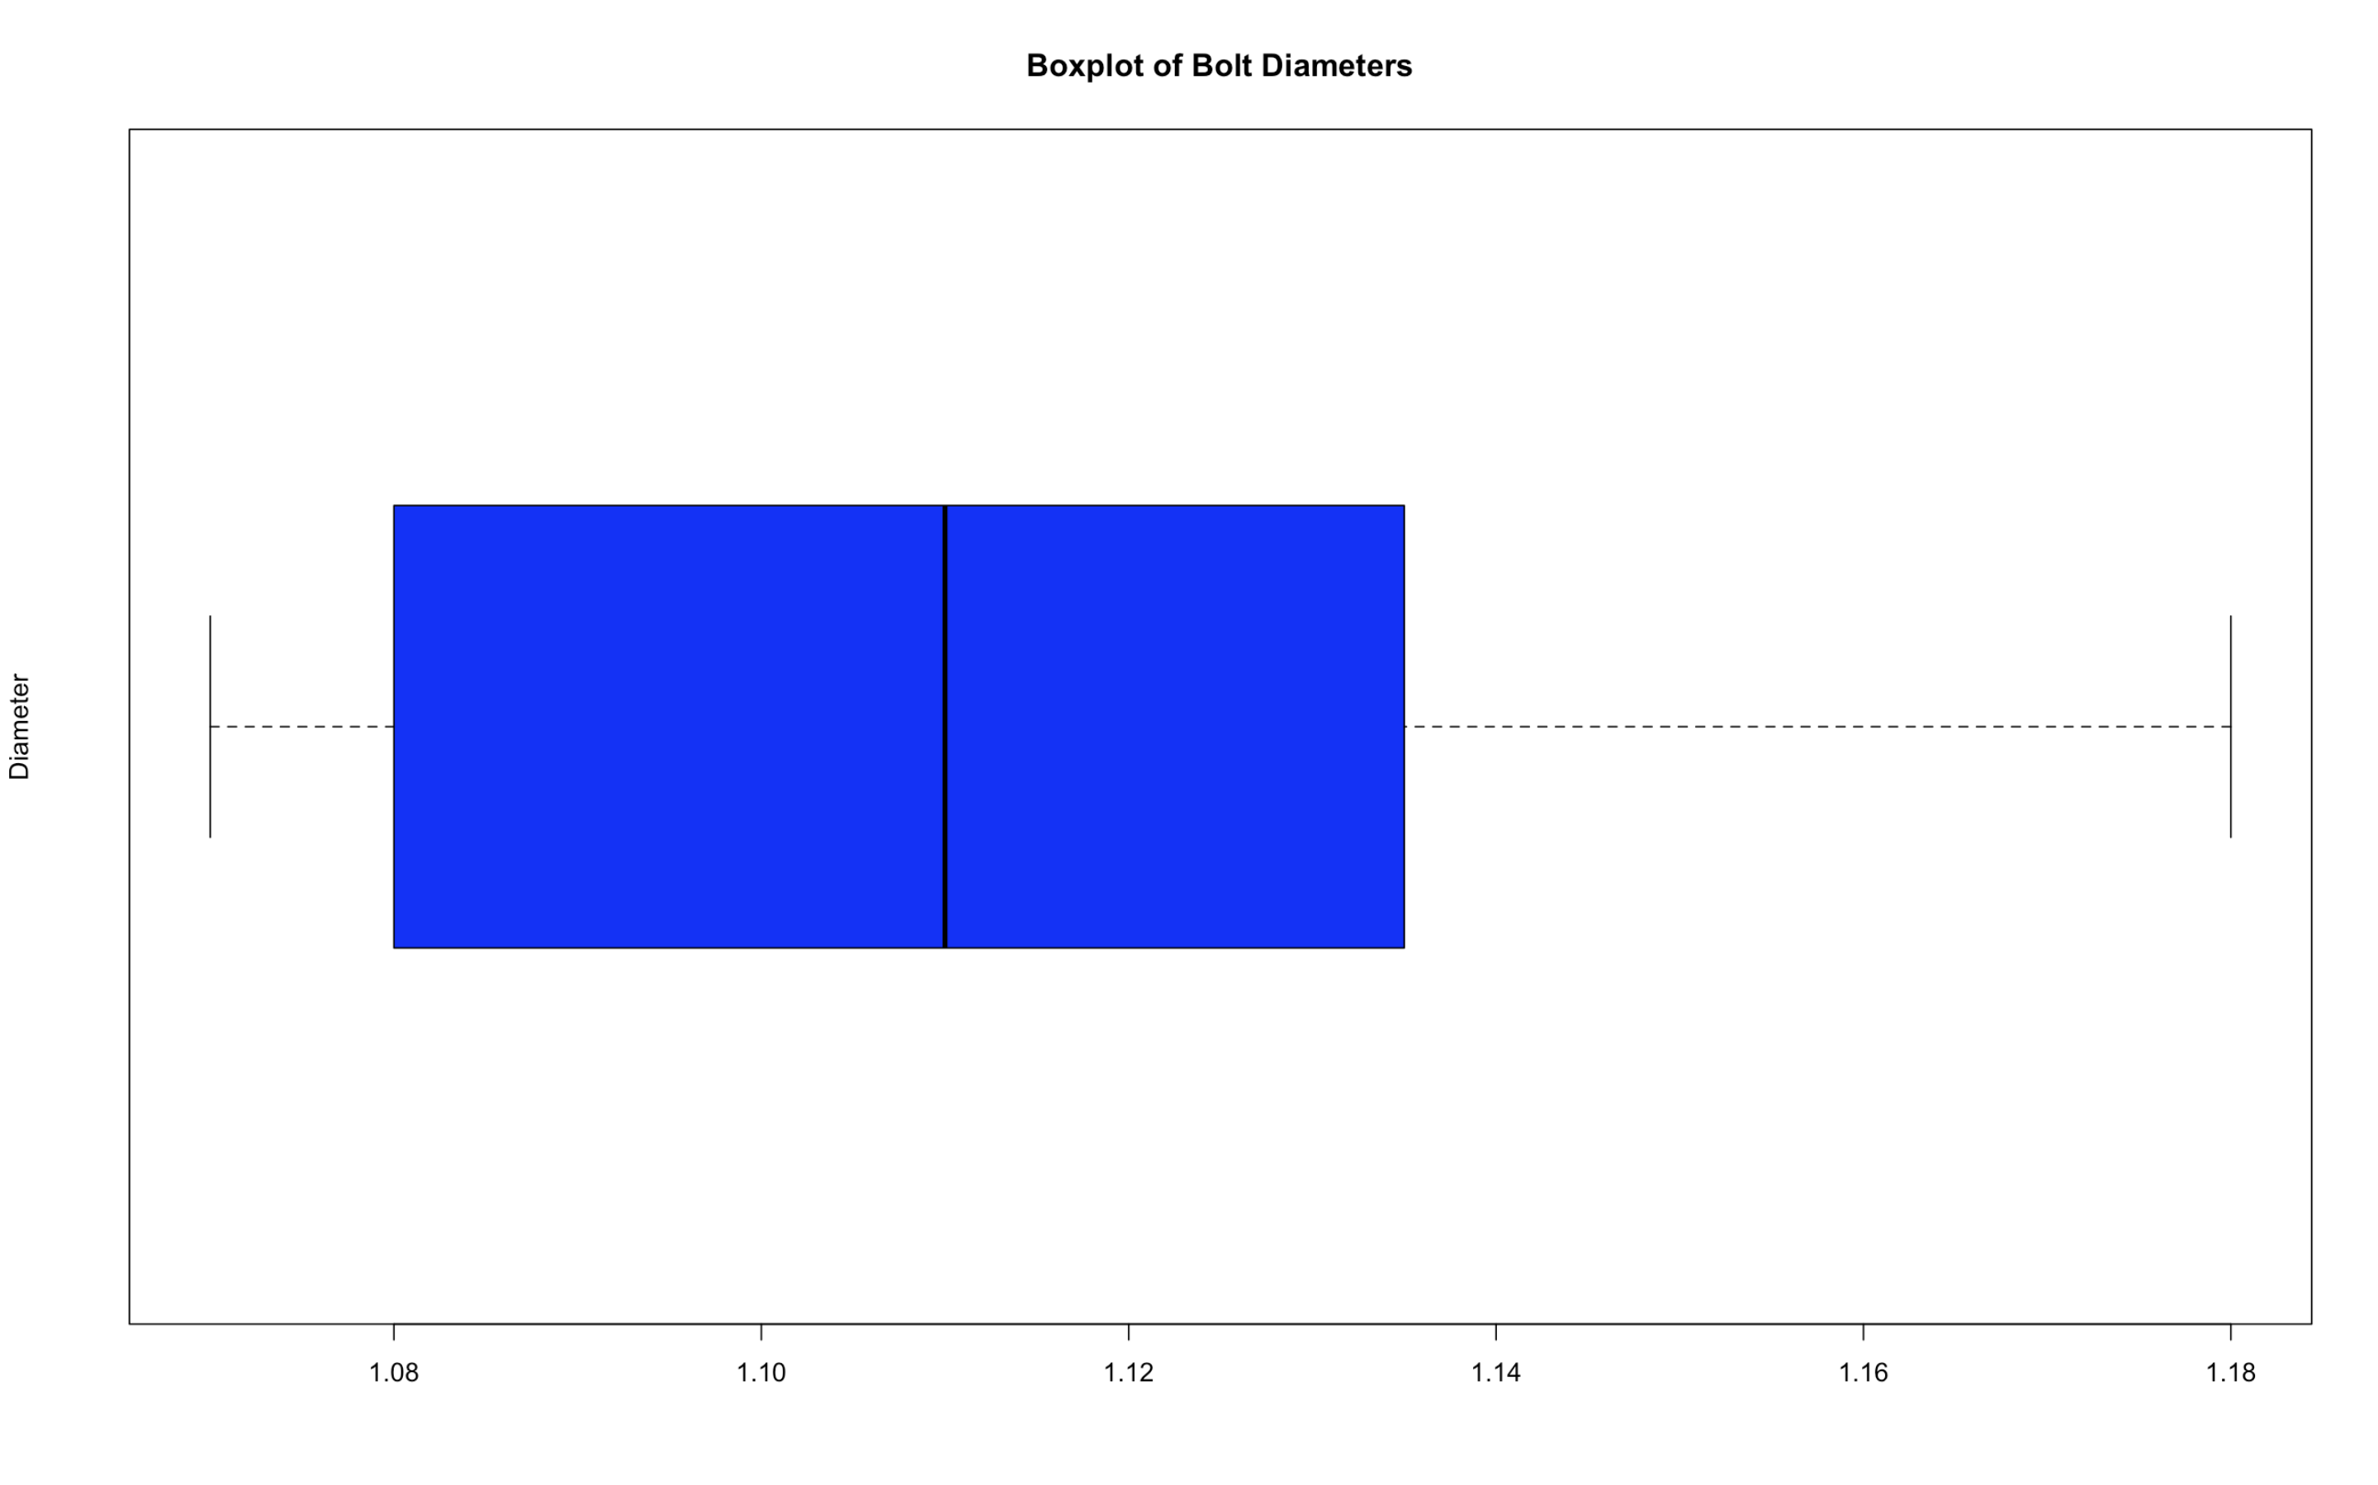

State your conclusion: (1 pt):
it is quite reasonable to use t-procedures, since the sample set consists of a small sample size with no major number of outliers shown in the boxplot and probability plot. Furthermore, the line shown in the probability plot is rather linear for the data, so it is safe to assume that the data is normally distributed as well.

  - Determine the 90% confidence interval for the mean diameter of these bolts.
Copy and paste your code (2 pt) , results (1 pt) , and state the 90% confidence interval rounding to 2 decimal places (2 pt)
90 % confidence interval: (1.09, 1.14)
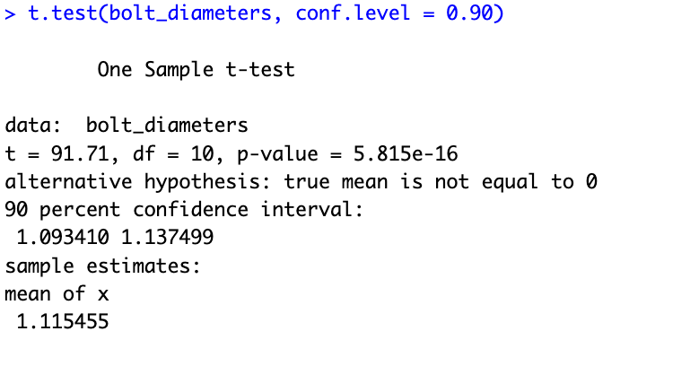

  - Does the data give convincing evidence that the mean diameter of these bolts is less than 1.15 at a 0.05 significance level (doing a t test)?

Copy and paste your code (1 pt) , results (1 pt) , and conclusion (1 pt)
Yes, the data does give convincing evidence that the mean diameter of these bolts is less than 1.15 at a 0.05 significance level (true, mean is less than 1.15).
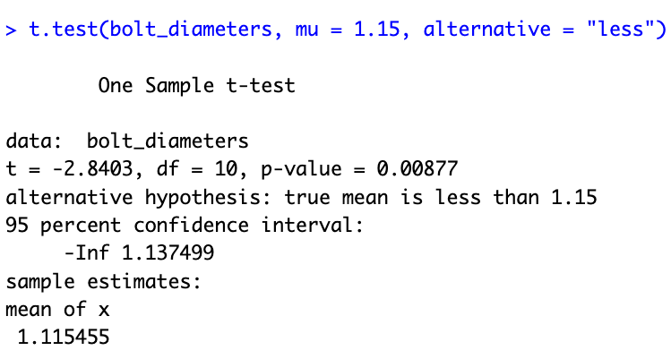

- Suppose that a random sample of n = 5 was selected from the vineyard properties for sale in Sonoma County,California, in each of three years. The following data are consistent with summary information on price per acre for disease-resistant grape vineyards in Sonoma County. Carry out an ANOVA (also test to see if assumptions are met – do analysis on residues for normality and for outliers) to determine whether there is evidence to support the claim that the mean price per acre for vineyard land in Sonoma County was not the same for at least one of the three years considered. Test at the 0.05 level. If there is a difference, which year(s) are different?
1996: 30000 34000 36000 38000 40000
1997: 32000 35000 37000 38000 40000
1998: 40000 41000 43000 44000 48000

Copy and paste your code (2pts), results(2pts), graphs (2pts), and conclusion(1pts):
Based on my results from ANOVA, there is enough evidence to support the claim that at least one of the year’s prices is different from the others, since the p-value 0.00694 is less than 0.05 (testing at the 0.05 level against the p-value I found from the ANOVA results). I tested and found no real deviations from normality in the probability plot line, and no real outliers in the given boxplot, so assumption 3 met. Furthermore, the largest standard deviation was less than 2 times the smallest standard deviation value from the data, so assumption 4 was met as well. The Tukey’s HSD test also indicates that the 1998 price per acre is significantly different from both 1996 and 1997 prices’, since the p-value between 1998 and 1996 was 0.0097871, and the p-value between 1998 and 1997 was 0.0192560. Both of these are significantly less than the p-value between 1996 and 1997, which was 0.9251845, a value that is very close to one, suggesting little variation between these two years (likely to be similar).
