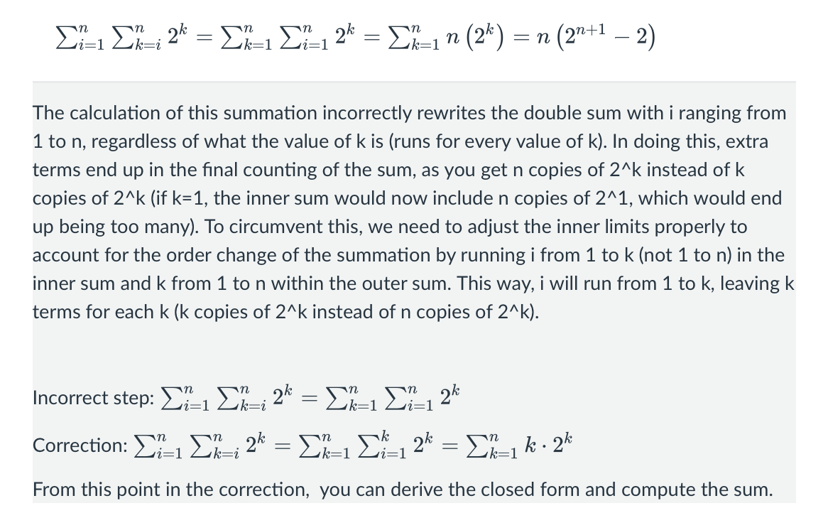
https://chat.deepseek.com/a/chat/s/abb5f45b-7f0c-4f29-87e2-a53d4c80e0a4

