R16:
The delay components in the end-to-end delay include processing delays, transmission delays, propagation delays, and queuing delays. The processing, transmission, and propagation delays are constant, while the queueing delay remains variable.
R23:
The five layers in the Internet protocol stack include the application layer, transport layer, network layer, link layer, and the physical layer. The application layer deals with network applications like HTTP, FTP, and SMTP. In managing communications between each of them, packets are exchanged back and forth. The transport layer (TCP, UDP) manages end-to-end communication between two endpoints for reliable and fast delivery. The network layer routes packets of data across networks by utilizing IP routing protocols. The link layer handles packets of data by transferring them between various network branches at a specific pace (Ethernet, Wi-Fi). The physical layer channels bits over a pathway through the use of physical connections (cables, fiber, coaxial, etc.).
R24:
An application-layer message is data that an application creates before sending it onto the transport layer (Email, requests, etc.). The transport-layer segment is created by the transport layer, and it seeks to encapsulate an application-layer message with transport layer headers. A network-layer datagram is a packet that encapsulates a transport-layer segment with a network-layer header (IP). The link layer frame is an element that encapsulates the datagram with a link-layer header and trailer (Ethernet).
R25:
A router processes layers 1 through 3 (network layer), a link layer switch processes layers 1 through 2 (link layer), and the host processes all five layers.
T1:
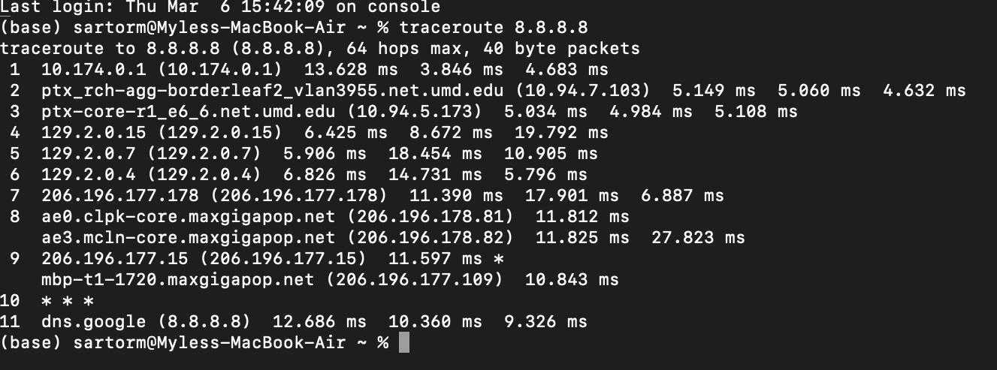
T2:
Based on the data transmitted by the tracerouting, it is safe to say that my computer doesn’t necessarily have “one” physical connection to the web or the DNS server, as the output displays many different hops between routers and networks before ending up at the final destination (Google’s DNS server). At first, we come from the local routing address (10.174.0.1) to establish a starting gateway. Then we move on to the intermediary routing hops across different networks around the University of Maryland. When my packets of data finally reach Google’s DNS server, the routing ceases activity, indicating that it was successful after going through 10 different stages or routing hops.
T3:
The strings that appear tell me that my computer has a very specific pathway that my packets decide to take across different web domains throughout the network. In starting at the University of Maryland’s network (umd.edu), it transitions into a structure of different routers (Various IP addresses) that converge onto more routers with the domain name of maxgigapop.net before ending up at an unnamed router (***) and dns.google (8.8.8.8). This convoluted journey to Google’s DNS server suggests that routing decisions can be detailed and integral to reliable data communication.

