Reflection:
The switching and routing model that I built reveals the importance of switches and how they’re able to map IP addresses back and forth from a computer to a router in multiple transactions. Through the use of MAC addresses and static or DHCP IPv4 assignments, one can create an infinite number of connections to foster whatever design network design they wish to build. The cloned components of the other side of the network simply had to be mapped to slightly different IP addresses that followed a similar enough structure for the user’s memory. Through the inclusion of another switch, every relevant network protocol could be included for potential use in the future. The router then takes the components of both sides of the network and encapsulates the information without utilizing it (Sending packets) for either one if it doesn’t have to. This process makes for a streamlined experience that only helps begin a complex structure in the long run. The two-router problem model effectively mapped the relevant IP address information between two LANs that functioned as 3 networks and one WAN (Overall description). By keeping naming conventions consistent and useful for port connections and protocols, I was able to use an enabled (Privileges authorized) command line interface to configure the two routers and their related properties. The first switch provided a stable ethernet connection to the computer so that it was able to come into contact with the two routers that were being backed by a server (Which was also guided by a switch). In both model situations, none of the switches needed IP addresses of their own assigned as long as they had the right physical components built-in since they would dynamically take on MAC addresses to effectively join the network. By inserting a simple PDU (ping test) into each of the different constituents in both models, I was able to visibly confirm the origin of every packet that the devices sent and received (And their respective protocol events).

Screenshots:
1.
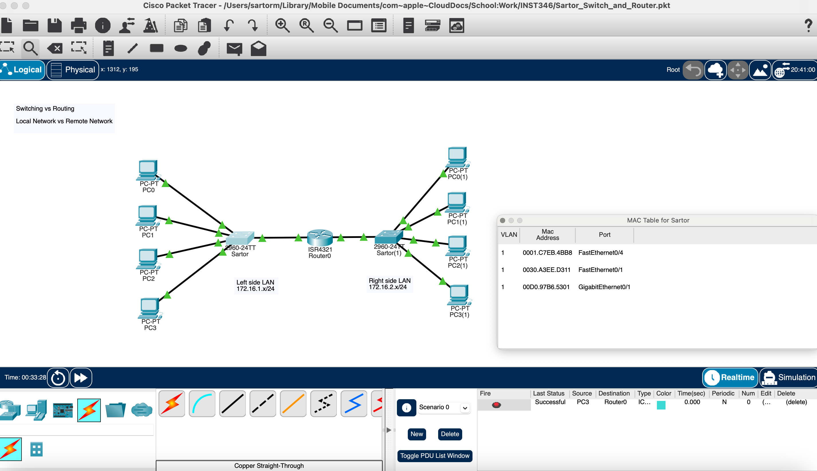
2. 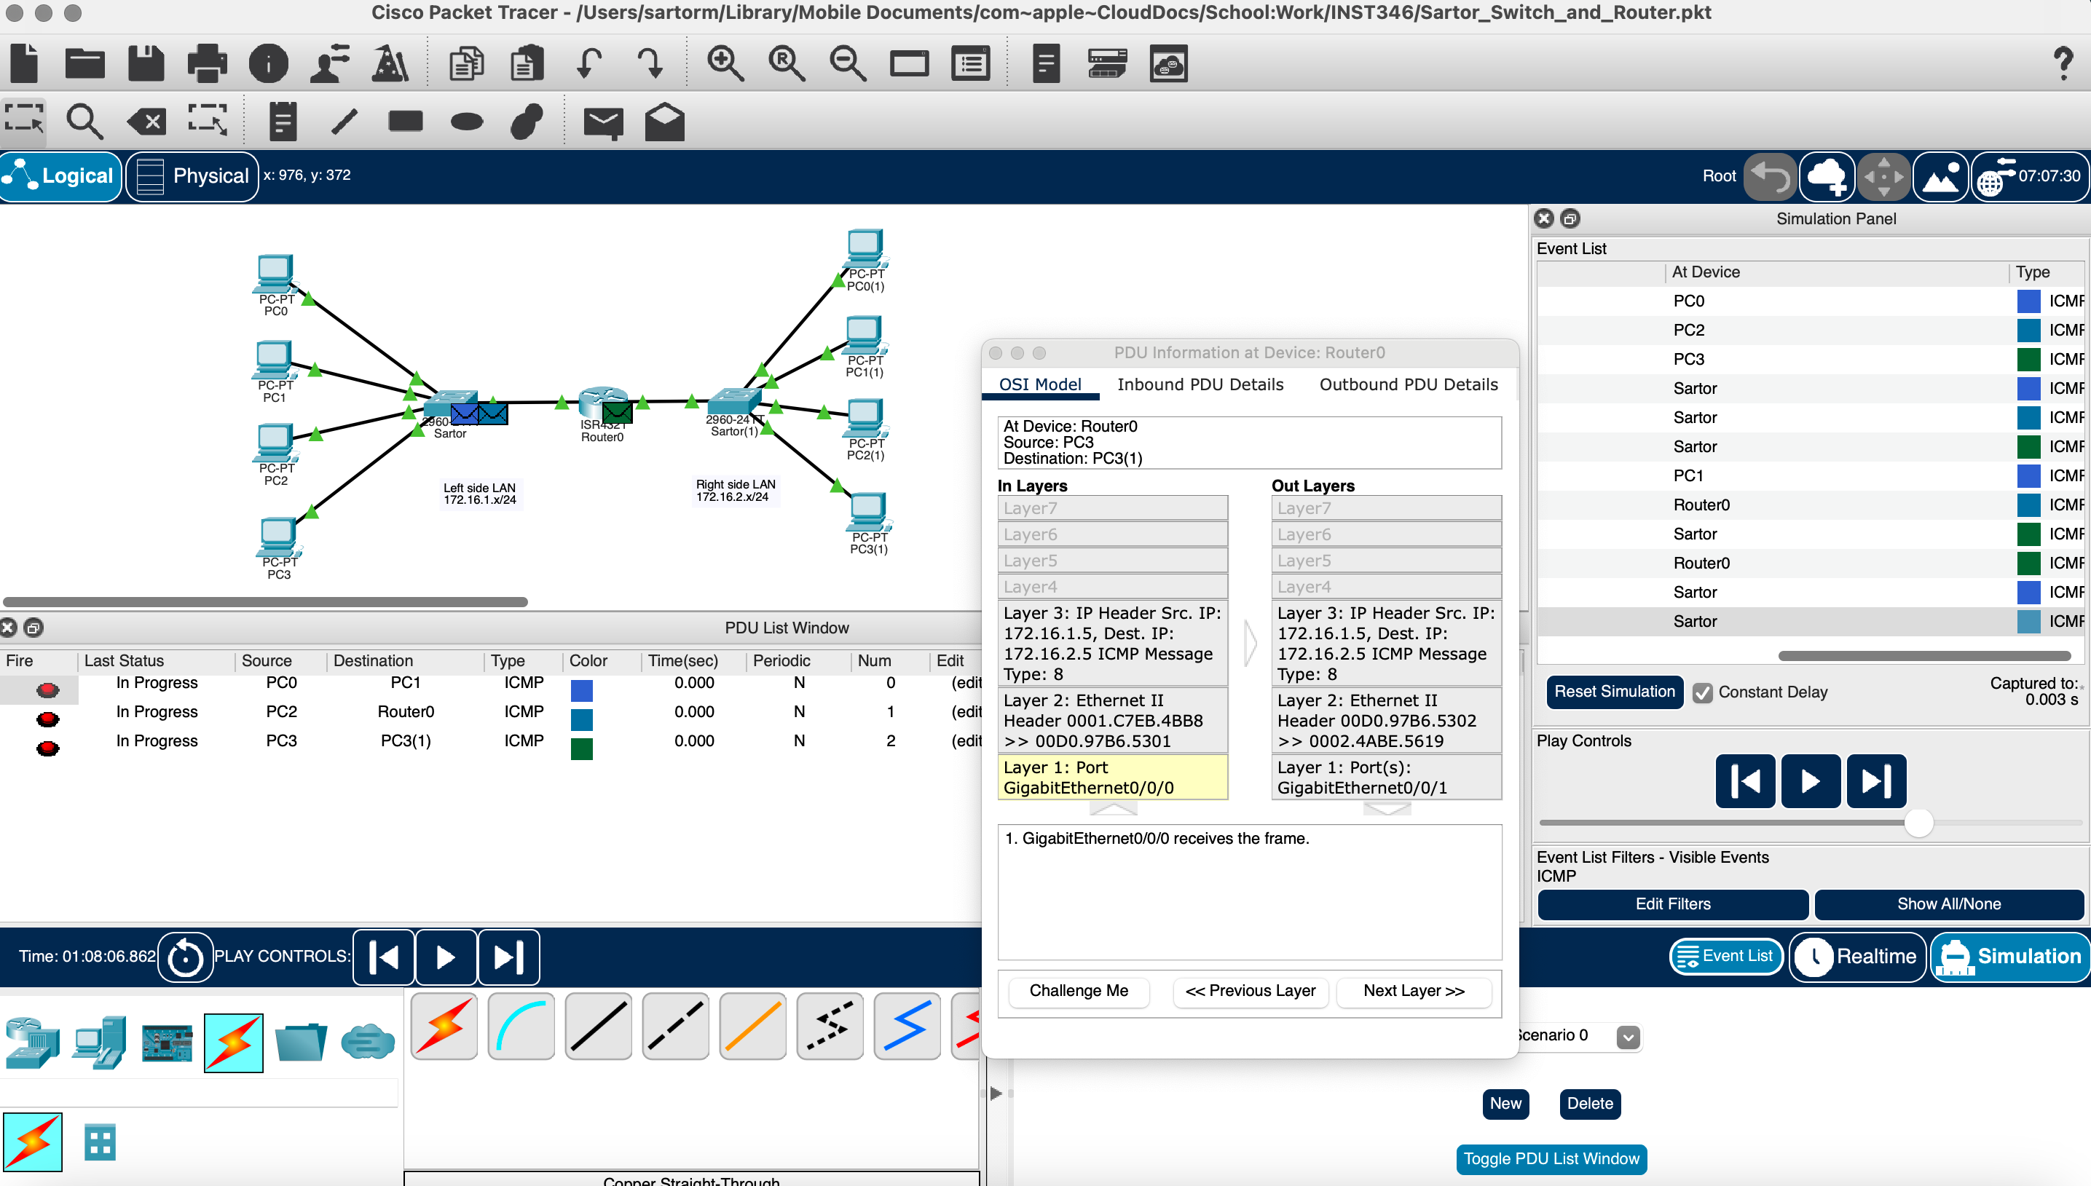
3.
