EID Updates

Daniel Fedha

28/06/2018

Table of Contents

1. Enrolment Statistics 2

a. Weekly Enrolment by Lab - Table: 2

b. Lab Enrolment by Gender - Bar Graph 3

c. Sample Entry Point by Lab - Bar Graph: 3

d. Infant Feeding by Lab - Bar Graph: 3

e. PCR Test Requested by Lab - Bar Graph: 4

f. Mother PMTCT Regimen by Lab - Bar Graph: 4

g. Age distribution - Histogram 4

2. Missing Data: 5

3. Inconsistent Data: 5

a. Wrong SID format 5

b. Date sample added to database earlier than Sample DBS collection date 5

c. Date Sample DBS Collected is earlier than Infant DoB or Infant Age is greater than 18 months 6

e. Duplicate SIDs 6

###### 

###### 

###### 

###### 

###### 

# 1. Enrolment Statistics

## Weekly Enrolment by Lab - Table:

| **Lab Name** | **wk1** | **wk2** | **wk3** | **wk4** | **Total** | **Sample Size** | **difference** | **% Achieved** |
| --- | --- | --- | --- | --- | --- | --- | --- | --- |
| AMPATH, Eldoret | 9 | 1 | 3 | 8 | 21 | 82 | -61 | 25 |
| KEMRI CIPDCR, Alupe Busia | 4 | 0 | 4 | 0 | 8 | 54 | -46 | 14 |
| KEMRI CDC HIV/R, Kisumu | 2 | 0 | 8 | 6 | 16 | 148 | -132 | 10 |
| Coast Provincial General Hospital | 0 | 1 | 2 | 0 | 3 | 36 | -33 | 8 |
| National HIV Reference Laboratory | 0 | 0 | 0 | 1 | 1 | 27 | -26 | 3 |
| KEMRI CVR HIV-P3, Nairobi | 0 | 0 | 0 | 0 | 0 | 125 | -125 | 0 |
| Kenyatta National Hospital | 0 | 0 | 0 | 0 | 0 | 23 | -23 | 0 |
| KEMRI/WRP CRC, Kericho | 0 | 0 | 0 | 0 | 0 | 65 | -65 | 0 |
| Total | 15 | 2 | 17 | 15 | 49 | 560 | -511 | 8.8 |

Summary:

* 49 samples have been enrolled over a period of 4 weeks
  + AMPATH, Eldoret has enrolled the highest no. of samples: 21,
  + 3 labs have not enrolled any sample:
    - KNH, P3, and NHRL. WRP is inactive
  + most samples [N=30, (61%)] are through MCH/PMTCT sample entry point
  + most samples [N= 22, (45%] are on BF
  + Initial PCR at 6 weeks or first contact is the most requested [N= 43, (88%]
  + most mothers [N= 31, (63 %] are on TDF+3TC+EFV
  + Missing data for all primary variables is 0%
  + 2 inconsistencies: SID is longer than 12 digits, and infant age >18 months

## Lab Enrolment by Gender - Bar Graph

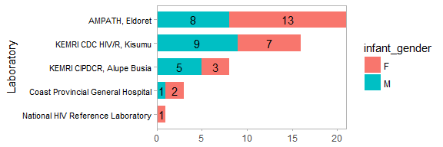

## Sample Entry Point by Lab - Bar Graph:

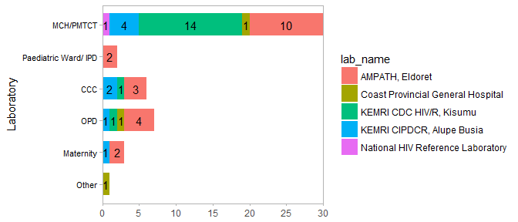

## Infant Feeding by Lab - Bar Graph:

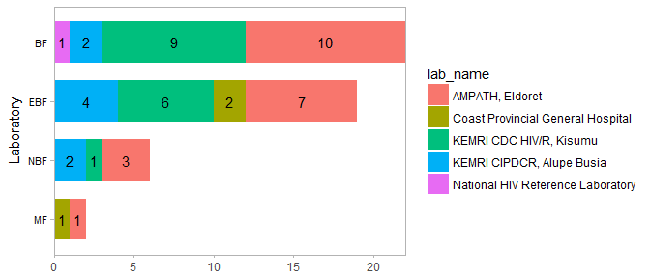

## PCR Test Requested by Lab - Bar Graph:

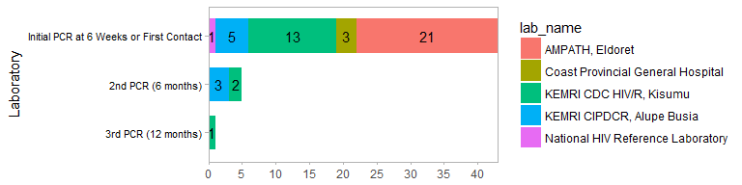

## Mother PMTCT Regimen by Lab - Bar Graph:

* 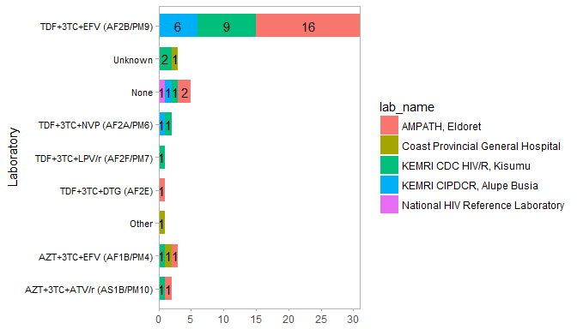

## Age distribution - Histogram

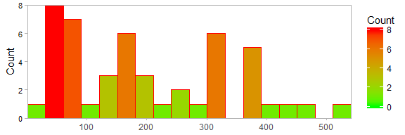

# 2. Missing Data:

N=total no. missing per variable,

% = percentage of missing data per variable

| **Lab Name** | **SID - N(%)** | **DBS collection date - N(%)** | **viable blood spots - N(%)** | **infant DoB - N(%)** | **infant prophylaxis - N(%)** | **mother PMTCT regimen - N(%)** | **requested PCR Test - N(%)** | **PCR test positive result date - N(%)** |
| --- | --- | --- | --- | --- | --- | --- | --- | --- |
| AMPATH, Eldoret | 0 ( 0 % ) | 0 ( 0 % ) | 0 ( 0 % ) | 0 ( 0 % ) | 0 ( 0 % ) | 0 ( 0 % ) | 0 ( 0 % ) | 0 ( 0 % ) |
| Coast Provincial General Hospital | 0 ( 0 % ) | 0 ( 0 % ) | 0 ( 0 % ) | 0 ( 0 % ) | 0 ( 0 % ) | 0 ( 0 % ) | 0 ( 0 % ) | 0 ( 0 % ) |
| KEMRI CDC HIV/R, Kisumu | 0 ( 0 % ) | 0 ( 0 % ) | 0 ( 0 % ) | 0 ( 0 % ) | 0 ( 0 % ) | 0 ( 0 % ) | 0 ( 0 % ) | 0 ( 0 % ) |
| KEMRI CIPDCR, Alupe Busia | 0 ( 0 % ) | 0 ( 0 % ) | 0 ( 0 % ) | 0 ( 0 % ) | 0 ( 0 % ) | 0 ( 0 % ) | 0 ( 0 % ) | 0 ( 0 % ) |
| National HIV Reference Laboratory | 0 ( 0 % ) | 0 ( 0 % ) | 0 ( 0 % ) | 0 ( 0 % ) | 0 ( 0 % ) | 0 ( 0 % ) | 0 ( 0 % ) | 0 ( 0 % ) |

# 3. Inconsistent Data:

## Wrong SID format

| **lab_name** | **sid** |
| --- | --- |
| AMPATH, Eldoret | 02EIDKE180014 |

## Date sample added to database earlier than Sample DBS collection date

| **lab_name** | **sid** | **date_dbscollected** | **date_sampleadded** |
| --- | --- | --- | --- |

## Date Sample DBS Collected is earlier than Infant DoB or Infant Age is greater than 18 months

| **lab_name** | **sid** | **infant_dob** | **infantage_days** |
| --- | --- | --- | --- |
| AMPATH, Eldoret | 02EIDKE18018 | 28/10/2016 | 594 |

## Duplicate SIDs

| **lab_name** | **sid** |
| --- | --- |