Shiva Teja Merugu
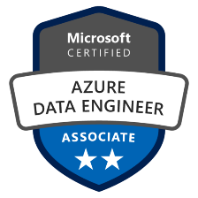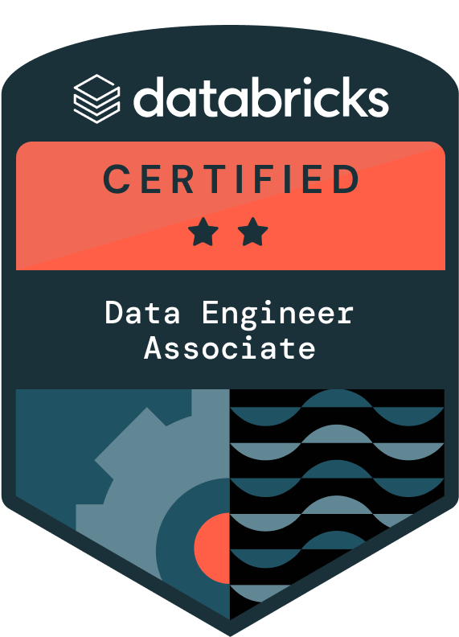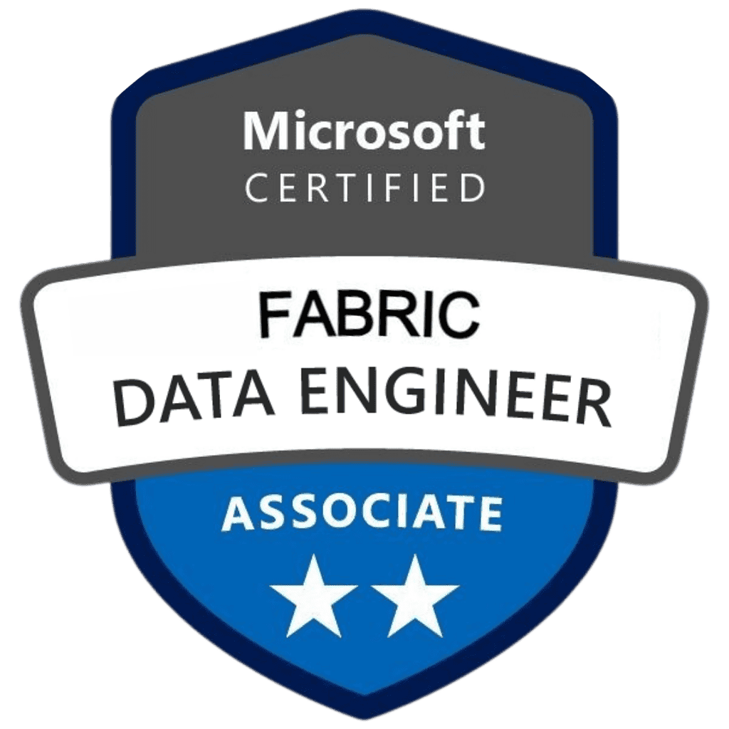

Azure Data Engineer
Mobile: +1(469) 720-0812
Email: shivatejamerugu3@gmail.com
LinkedIn: https://www.linkedin.com/in/merugu-shiva/
-

PROFESSIONAL SUMMARY
- 12+ years of experience architecting and implementing complex data solutions, including cloud, data warehousing, ETL/ELT pipelines, and real-time data processing, utilizing advanced techniques like data governance, security, and automation.
- Designed and deployed highly scalable Change Data Capture (CDC) Azure data pipelines using Azure Data Factory (ADF), Azure Databricks, Azure Purview, Azure Fabric, Azure Synapse Analytics for seamless data flow across diverse sources and destinations enabling improved consistency.
- Designed a secure and versatile data solution on Azure for various needs, utilizing Azure Blob Storage for general storage, Azure Data Factory (ADF), Azure Data Lake Gen2 and Azure Databricks and Delta live tables(DLT) for analytics, Azure Event Hubs for real-time data ingestion, Azure Stream Analytics for processing, Azure Logic Apps for workflow automation, Azure Fabric for microservices, Azure Functions for event-driven actions, and Azure Key Vault and Power BI.
- Proactively monitored and optimized Synapse Analytics using tools like Monitor, Application Insights, and Query Performance Insights, identifying, and resolving bottlenecks to continuously improve data access speed and reduce query execution time.
- Efficiently handled large-scale data volumes through distributed processing and optimized resource utilization within Databricks clusters, implementing data integration solutions with Azure Logic Apps, Azure Data Factory (ADF), and Azure DevOps, leveraging Pyspark for transformations.
- Extensively worked on Spark transformations and actions to perform various data cleansing, shaping, and processing tasks such as filtering, joining, aggregating, and grouping data within Azure Databricks for efficient data preparation and analysis.
- Fine-tuned Spark configuration and enabled Adaptive Query Execution and utilized spark performance tuning techniques like Catalyst optimizer and Tungsten Execution Engine to ensure resources are used effectively and queries run optimally, leading to improved performance and scalability.
- Delivered AI-powered insights and NLP pipelines across healthcare, eCommerce, and public sector projects, specializing in fraud detection, recommendation systems, and customer intelligence with scalable cloud-first data architectures.
- Automated data classification and labeling across diverse sources with Azure Purview, orchestrated data movement with Azure Data Factory (ADF) ensuring consistent data protection and regulatory adherence.
- Operationalized ML models using Azure ML, HuggingFace, Spark NLP, and MLflow, including building BERT-based embedding pipelines for semantic search and integrating real-time LLM inference into production pipelines for customer-facing personalization.
- Established and enforced stringent data governance practices with Azure Data Catalog and Polybase, guaranteeing data quality, security, and compliance with regulations. Leveraged Azure Cosmos DB for scalable and globally distributed storage of NoSQL data, ensuring high availability, low latency, and consistent performance for diverse data demands.
- Employed Azure Active Directory (AAD) and Identity Access Management (IAM) policies for secure access control and data governance across Azure resources and Azure Key Vault for sensitive data encryption., ensuring data quality and reliability through Azure Data Factory (ADF).
- Extensively worked on Azure Monitor for comprehensive performance monitoring, log analysis, and troubleshooting of data pipelines, ensuring optimal resource utilization and data flow efficiency.
- Skilled in Data Warehousing, Data Mart, and Data Wrangling using Azure Synapse Analytics with Delta Live Table (DLT) and Snow Pipes through an understanding of business requirements such as database analysis and application development with OLAP and OLTP methodologies.
- Extensively worked on schema design expertise to bridge the gap between real-time operations and data-driven insights, fostering a streamlined and unified analytical and transactional environment within Snowflake.
- Leveraged Hadoop, HDFS, MapReduce, Hive, for distributed data management and processing, skilled in writing complex Pyspark UDFs, Spark SQL, and HiveQL for high-performance data processing with Python and Azure DataBricks and Delta Live Tables(DLT).
- Implemented robust ETL/ELT processes using Sqoop, Flume, for reliable data integration and high-quality data reliability through Azure Data Factory (ADF) pipelines and Delta Live Table (DLT).
- Extensively worked on Spark 1.0 to 3.5 and Kafka for high-performance processing of large-scale datasets, efficiently handling growing data volumes using PySpark for scalable data transformations, real-time streaming, and pipeline development.
- Implemented PySpark, Spark SQL, and Scala for complex data transformations and analytics within Azure Databricks to perform complex data transformations and analytics. Enabled scalable processing of large datasets, supporting downstream data modeling and reporting needs.
- Designed and developed performant, scalable, and user-friendly data models using dimensional modeling techniques with Master Data Management (MDM) and RDBMS for efficient data access and analysis.
- Implemented Slowly Changing Dimensions (SCD) to handle time-varying data stored in dimensional tables in data warehouse, ensuring accurate representation.
- Extensively worked on diverse data formats like Avro, JSON, CSV, Parquet, ORC, XML across the data management lifecycle, implementing optimal configurations based on specific needs.
- Proficient in Python (Pandas, NumPy), SQL (T-SQL, SQL Server), Scala (Spark), and PowerShell for efficient data manipulation, automation, and scripting.
- Implemented Infrastructure as Code (IaC) with Terraform for automated infrastructure provisioning and streamlined deployments, ensuring consistency and efficiency.
- Possess expertise in various programming languages and scripting tools like UNIX/ LINUX for data manipulation, automation, and data serialization techniques.
- Followed established Software Development Life Cycle (SDLC) methodologies throughout the data pipeline development process, ensuring quality, consistency, and adherence to best practices.
- Embraced Agile working methodologies (e.g., Scrum, Kanban) and Waterfall methodologies to promote rapid development, iterative delivery, and adaptability to changing requirements.
- Collaborated effectively with cross-functional teams (data scientists, analysts, business users) through sprints, planning meetings, and retrospectives to deliver impactful data-driven solutions.

TECHNICAL SKILLS:
Cloud Services: Azure Data Factory (ADF), Azure Databricks, Azure Blob Storage, Azure Data Lake Storage Gen2 (ADLS Gen2), Azure Synapse Analytics, Azure Stream Analytics, Azure Logic Apps, Azure Functions, Azure Event Hubs, Azure IoT Hub, Azure Cosmos DB, Azure SQL Database, Azure Data Lake Analytics, Azure Data Explorer (ADX), Azure Analysis Services, Azure Purview, Unity Catalog, MS Fabric, Azure Key Vault, Azure DevOps, Azure Boards, Azure Monitor, Azure Virtual Machines, Azure Active Directory (Azure AD), Entra ID.
Big Data Technologies: Hadoop (HDFS, YARN, MapReduce), Hive, Sqoop, Flume, Oozie, Zookeeper, Apache Kafka, Apache Spark, Spark Core, Spark Streaming, Spark SQL, Spark Performance Tuning, DBT, Informatica-IICS.
Cloud Data Warehouses: Snowflake, Azure Synapse Analytics, Azure SQL Database.
Programming languages: Python, PySpark, SQL, T-SQL, PL/SQL, K-SQL, Scala, HiveQL, Java, Unix Shell Scripting, Bash scripting.
ETL and data Integration
Tools: Azure Data Factory (ADF), Azure Databricks, SSIS, Informatica-IICS, DBT, Talend, Snow Pipes, Data Transformation Services (DTS).
Visualization & BI Tools: Power BI, Tableau, SSRS, SSAS.
Data Modeling: Erwin Data Modeler, Star Schema Modeling, Snowflake Schema Modeling, Dimensional Modeling, Data Vault, Slowly Changing Dimensions (SCD), Change Data Capture (CDC).
Build Automation Tools: Ant, Maven, Jenkins, Azure DevOps, GitHub Actions.
Scheduling: Control-M, Apache Airflow, Oozie, Azure Logic Apps.
DevOps Technologies: Git, GitHub, Bitbucket, GitLab, Jenkins, Docker, Kubernetes, Terraform.
IDE & Build Tools: Visual Studio, Eclipse, Azure Data Studio.
Monitoring and
Logging Tools: Azure Monitor, Splunk, Elasticsearch.
Databases: NoSQL: Azure Cosmos DB, Cassandra, MongoDB, HBase
Row-Oriented: SQL Server, Oracle 11g/12c, Teradata, MySQL, PostgreSQL, DB2
Columnar: Cosmos DB and HP Vertica.
Other: MS Access, Excel, OLAP, OLTP
Methodologies: Agile, Scrum, Kanban, Waterfall.

EDUCATION:
- Masters in Business Analytics at University of North Texas Dec 2013
- Bachelors in Electrical & Electronics Engineering at JNTUH May 2011

CERTIFICATIONS:
- DP-203 Microsoft Certified Azure Data Engineer Associate
- Databricks Certified Data Engineer Associate
- Microsoft Certified Fabric Data Engineer Associate

WORK EXPERIENCE:
Credit Karma – Charlotte, North Carolina Oct 2022- Present
Senior Azure Data Engineer
Responsibilities:
- Developed personalized email campaigns for retirement customers using Azure Data Factory (ADF) for seamless data extraction from diverse sources and utilized PySpark for data cleansing, transformation, and enrichment to enable targeted segmentation and campaign optimization at scale.
- Leveraged Copy Activity for efficient data movement in a pipeline to consolidate customer data using Azure Data Factory (ADF) and Pyspark, enabling profound insights into behavior, preferences, and purchasing patterns with Zero Copy Cloning for efficient data management supported by Azure Data Bricks analytics analytics capabilities.
- Collaborated with AI/ML platform engineers to enable real-time LLM inference, semantic search with BERT embeddings, and model orchestration via Azure ML and Spark NLP, leading to a 25% increase in user engagement on retirement tools and a 30% boost in campaign conversion rates through intelligent targeting.
- Developed and maintained end-to-end operations of ETL data pipeline and worked with large data sets in Azure Data Factory (ADF) for large-scale data ingestion, integrated PySpark for scalable processing and optimized workflows through Azure DevOps.
- Designed and implemented data pipelines with Azure Data Lake Storage Gen2 (ADLS) for scalable and secure data landing, and Azure Databricks with Spark SQL and Python for high-performance data transformation.
- Integrated ML workflows within Azure Databricks using MLflow and PMML-based model chaining to operationalize recommendation models for retirement planning personalization, supporting scalable deployment of over 100 models and delivering more than 20 billion predictions annually across millions of users.
- Extensively worked on Azure Data Factory (ADF) connectors to ingest data from internal sources and HTTPS, RESTful APIs for extracting data from external sources for fast and efficient ingestion of data into ADLS Gen2.
- Accessed marketing campaign data via an Application Programming Interface (API) and utilized the Azure Blob Storage connector to save it easily and transfer it to Azure Blob Storage (ABS) for further processing using Azure Databricks and Pyspark.
- Cleansed, transformed, and enriched data with Azure Databricks and Delta Live Tables (DLT) for scalable processing and feature engineering, automated data integration across diverse datasets using Azure Data Factory (ADF) and streamlined operations with Azure Logic Apps for workflow orchestration.
- Optimized Spark configurations in Azure Databricks, leveraging Adaptive Query Execution to enhance resource utilization, dynamically adjust query plans, and improve overall job performance in large-scale data processing environments.
- Leveraged Kyro serialization within Spark for efficient data exchange between compute nodes, reducing network overhead and boosting processing speed within Azure Synapse Analytics by 20%.
- Optimized partition strategies and distribution in Azure Synapse Analytics tables, employing Round Robin distribution for high join cardinality and hash distribution for frequently joined tables, resulting in a 15% improvement in join performance.
- Implemented compression formats like Parquet and ORC within Azure Synapse Analytics tables, reducing data storage footprint and accelerating data scans by 10%, Applied partition keys for efficient filtering. Ensured compatibility with modern OLAP processing.
- Implemented Parquet format with partitioning and Delta Cache for efficient data access, filtering, and reducing recomputation, utilized PySpark for transformation logic and applied Unity Catalog for consistent data governance across environments.
- Leveraged Azure Purview to create a unified data landscape, streamlining discovery, lineage tracking, and access control, boosting data findability and compliance and Azure Polybase for joining tables from diverse sources.
- Automated data classification and labeling across diverse sources with Azure Purview, with Azure Data Factory (ADF) enabling seamless data integration and movement ensuring consistent data protection.
- Promoted data discovery, lineage tracking best practices through Azure Data Catalog. Integrated Unity Catalog to unify metadata management across workspaces and applied data modeling principles to maintain standardized structures across datasets.
- Monitored performance with Spark UI, Ganglia, and Databricks Profiler to identify bottlenecks and optimize resource allocation using PySpark and RDD (Resilient Distributed Dataset) tuning techniques within Azure Databricks, while ensuring data governance and lineage tracking through Unity Catalog.
- Leveraged Spark SQL, DataFrames, and Python libraries (Pandas, NumPy) within Azure Databricks for data transformations like filtering, joining, aggregating, and grouping, for efficient data preparation and analysis.
- Designed data integration pipelines with Informatica IICS, streamlining data acquisition and guaranteeing quality/consistency using PySpark for complex transformations, Python for custom logic scripting, and integrated with Azure Data Factory (ADF) for orchestrated pipeline execution.
- Developed custom activities using Azure Functions, Azure Databricks, and PowerShell scripts, Azure Logic Apps to perform data transformations, data cleaning, and data validation, automated workflows and orchestrated data movement.
- Established a single Source of Truth for critical business data by integrating Azure Power Apps with data pipelines built using Azure Data Factory (ADF), leveraging Delta Lake for unified storage and Delta Live Tables for continuous ingestion and transformation.
- Established robust data governance with Azure Active Directory (Azure AD) for secure access control and user management, integrating Unity Catalog for fine-grained permissions and leveraging Azure Fabric to support scalable identity-driven data workflows.
- Implemented zero copy cloning within Snowflake to achieve rapid data replication minimizing downtime and data loss while integrating Snow Pipes for continuous data loading and leveraging Partition Keys to optimize query performance and storage efficiency.
- Demonstrated understanding of OLTP and OLAP data models, designing Snowflake schemas optimized for both transactional processing and analytical workloads.
- Leveraged Snowflake's time travel functionality to access historical data snapshots for auditing, compliance, and trend analysis, incorporating Snow SQL for temporal querying and data wrangling techniques to prepare datasets for retrospective reporting.
- Implemented efficient data ingestion pipelines into Delta Lake tables using batch and streaming approaches within Azure Databricks. Enabled real-time and scheduled data processing to support reliable analytics workflows.
- Implemented complex Slowly Changing Dimensions (SCDs) for historical data integrity and accurate trend analysis/reporting and
delivered refined data to Azure Synapse Analytics for advanced analysis and storage, ensuring efficient access and insights.
- Established comprehensive data governance across diverse sources via Azure Purview, ensuring data lineage, access control, and compliance while simplifying data discovery and trust.Enhanced data pipeline performance by fine-tuning setups and query execution with TSQL and SQL, which leads to increased efficiency and scalability leveraging K-SQL for complex queries.
- Collaborated with cross-functional teams, including data engineers, developers, and business stakeholders, to gather requirements, prioritize work, and develop value-added solutions with Dimensional Modeling and Python scripting.
- Developed a robust CI/CD framework using Jenkins, automating data pipeline updates, and reducing manual intervention. Migrated datasets from Vertica and Oracle for unified reporting and analytics.
- Developed and maintained Shell and UNIX scripts for automating data processing and system administration tasks. Worked with Atlassian suite including JIRA, Confluence to report on Projects, for Development, QA, and Partner validation.
- Experience in full breadth of agile methodologies, from daily stand-ups to internationally coordinated PI Planning, as well as the ability to orchestrate efficient project life cycles with a focus on Data Governance principles.
Environment: Azure Databricks, Azure Data Factory (ADF), Azure Logic Apps, Azure Data Lake Storage Gen2 (ADLS), Azure Functions, MS SQL Server, Spark SQL, Azure AD, Azure Key Vault, Delta live tables, Azure Cosmos DB, Azure Virtual Machines, Unity Catalog, Azure Databricks Profiler, Terraform, Azure Data Catalog, Azure Synapse Analytics, Azure Fabric, Azure SQL Database, Azure Purview, Azure Storage Explorer, Oracle, SQL, PLSQL, Entra ID RESTful API, HTTPS, Python, Scala, Pyspark, GitHub, JIRA, Jenkins, Power BI.

Quest Diagnostics – Secaucus, New Jersey Mar 2018 – Sep 2022
Azure Data Engineer
Responsibilities:
- Implemented Azure Event Hubs with auto-scaling capabilities to handle surges in high-volume, and ensure seamless data flow within the application integrated with Azure IoT Hub and Azure Data Lake Analytics with Azure Data Factory pipelines.
- Leveraged Event Hubs partitioning to efficiently distribute, and process data streams based on source, type, or timestamp for optimized performance, integrating with Azure Data Factory (ADF) pipelines to ensure seamless data flow and downstream analytics.
- Guaranteed data delivery even during failures with Event Hubs built-in durability features, preventing data loss and ensuring information integrity and developed Azure Data Bricks processes for data transformation. Developed Python scripts for monitoring delivery pipelines and logging stream events.
- Integrated ML model scoring pipelines using PySpark and Azure ML to enable predictive analytics for lab data trends. Leveraged Azure Databricks Profiler to analyze execution logs and optimize data partitioning strategies, resulting in a 15% improvement in query performance and improving provider decision-making efficiency in critical lab operations.
- Leveraged Azure Data Factory (ADF) for secure and efficient data extraction from diverse on-premises and cloud sources using dedicated connectors and ODBC/JDBC drivers.
- Ensured data consistency and integrity within data lakes with Delta Lake's ACID transactions, even for concurrent updates, with Azure Data Factory (ADF) orchestrating reliable data pipelines to support scalable ingestion and transformation.
- Worked on Migrating SQL database to Azure Data Lake, Azure data lake analytics, Azure SQL Database, Azure Databricks and Azure SQL Data warehouse while using Python and PySpark for schema conversion, data profiling, and performance benchmarking.
- Worked on Microsoft Azure services like HDInsight Clusters, Azure Blob Storage, Azure Data Factory and Azure Logic Apps and have done POC on Azure Databricks.
- Built NLP pipelines using Spark NLP and MLflow within Azure Databricks for real-time anomaly detection in healthcare data streams. Implemented Delta Lake Optimize and Vacuum operations to maintain data quality and minimize query execution time for fraud detection, enhancing early diagnosis accuracy and reducing data latency by 20%.
- Extensively worked on Azure Data Lake Storage Gen2 (ADLS) for scalable and cost-effective raw data storage, partitioning based on source, date, and other relevant criteria for efficient management.
- Filtered data streams based on pre-defined business rules and conditions within Stream Analytics and built logic using Python UDFs for conditional checks, focusing on relevant information for immediate insights and action.
- Architected and implemented real-time data pipelines using Apache Kafka and Azure Event Hubs, Azure Data Factory (ADF), ingesting massive IoT data volumes efficiently and scalably.
- Stored processed real-time data in Azure Cosmos DB, a NoSQL database offering low-latency access and horizontal scalability for efficient storage and retrieval.
- Ensured secure and authorized data access with Azure Active Directory (AAD) for Event Hubs, restricting access based on roles and permissions and integrating with Azure Virtual Machines for isolated, permission-managed data streaming environments.
- Developed and implemented data pipelines using Delta Lake, a unified table format for efficient data storage, processing, and serving in data lakes, built scalable ingestion workflows with Azure Data Factory and processed data with PySpark and Python.
- Developed and maintained materialized views in Snowflake for query performance and faster data retrieval, applying data modeling principles to optimize view structures and ensure alignment with business reporting requirements.
- Extensively worked on DDL, DML, DQL and DCL commands for efficient schema creation, modification, and management within Snowflake, used Python automation scripts to manage metadata, perform role-based access audits, and document lineage.
- Implemented CRUD operations (Create, Read, Update, Delete) using Snowflake SQL for data manipulation, incorporating TSQL and PL SQL best practices to optimize transactional workflows and maintain data integrity.
- Integrated Power BI with Stream Analytics for seamless data flow and visualization, facilitating quick decision-making based on real-time data insights and used Azure SQL Database to stage curated metrics and automated refresh jobs via Python scripts.
- Designed and implemented an end-to-end data migration pipeline from Data sources like Oracle, Teradata, Netezza on Azure using Python and PySpark, modernizing the data architecture cost optimization, and deeper customer insights.
- Captured and streamed real-time data using Apache Kafka and Azure Event Hubs, leveraging MapReduce and YARN frameworks to ensure scalable, fault-tolerant data movement and processing across distributed systems.
- Configured clustered column store indexes for frequently accessed columns within Azure Synapse Analytics tables, minimizing disk I/O and enhancing query execution speed by 30%.
- Implemented complex Slowly Changing Dimensions (SCDs) using dimensional modeling techniques and TSQL to maintain historical data integrity and support accurate trend analysis and reporting in data warehouse environments.
- Transformed and integrated data using Azure Synapse Analytics, a serverless data warehouse, leveraging its serverless architecture for scalability and cost-effectiveness.
- Performed schema standardization, data quality checks, and error handling within Synapse Analytics using T-SQL to ensure data consistency and accuracy and created automated error logging with Python for invalid rows, schema mismatches, and null anomalies.
- Joined data from different sources based on business needs to create a unified view of customer, account, and usage data in Synapse Analytics. Designed dimensional models with star schemas for scalable OLAP analysis and Power BI integration.
- Enabled interactive data exploration and ad-hoc analysis with Synapse Analytics and integrated with Power BI for visually appealing reports and dashboards to share insights with stakeholders.
- Implemented robust data governance with Azure Active Directory (AAD) for secure access control and user management, and Azure Key Vault for sensitive data encryption.
- Deployed and optimized Python and Pyspark applications to Azure DevOps CI/CD pipelines, focusing on development efficiency and automation to ensure consistent integration, delivery, and performance across environments.
- Developed and maintained PowerShell scripts for automating data processing and system administration tasks on Windows-based systems and Employed Git as version control tools to maintain the code repository.
- Enhanced team efficiency by 20% utilizing Atlassian tools like JIRA, Confluence for issue tracking, prioritization, and agile workflow management, streamlining project planning, documentation, and communication .
Environment: Azure Stream Analytics, Azure Data Factory (ADF), Python, Azure Virtual Machines, Azure Key Vault, Azure Event Hubs, Azure Databricks, Delta Lake, Azure Databricks Profiler, User Defined Functions (UDF), Azure Data Factory, Azure Active Directory (AAD), Pyspark, Azure Data Lake Storage Gen2 (ADLS), Azure Synapse Analytics, Azure Cosmos DB, Azure SQL Database, Azure SQL Data Warehouse, MS SQL, Oracle, YARN, GIT, JIRA, Entra ID, Azure DevOPS, Kafka, TSQL, Power BI.

State of New Jersey – Trenton, New Jersey Aug 2015 – Feb 2018
Big Data Engineer
Responsibilities:
- Automated seamless data transfer from MySQL to HDFS using Sqoop, ensuring regular refreshes for analysis. Coordinated with OLTP-based systems to ensure real-time data consistency across the pipeline.
- Processed massive datasets with Apache Spark & Scala, aggregating data and storing it in Hive for further exploration. Executed MapReduce jobs for distributed computation on large datasets. Maintained compatibility with OLAP systems to support multi-dimensional queries.
- Leveraged HBase/Hive integration for efficient table creation and analysis in the Analytics Zone and Designed scalable NoSQL tables to support high-throughput and low-latency access.
- Built data pipelines using Kafka & Spark Streaming for real-time data processing in specific scenarios, ensured integrity and performance across OLTP systems for near real-time analytics.
- Leveraged Apache Spark's power (RDD (Resilient Distributed Dataset) & DataFrames) to orchestrate high-performance data processing within Hadoop clusters, accelerating analytical capabilities.
- Developed a Flume/Sqoop pipeline to ingest customer behavioral data for analysis in HDFS. Built staging and semantic layers using Python for transformation and table joins.
- Developed and executed CDC solutions with Apache NiFi and Airflow, capturing data changes in real-time for near-instantaneous analysis and insights.Architected and implemented Hadoop clusters using Hortonworks/Cloudera distributions for efficient large-scale data processing while using python for scripting.
- Automated data processing & CI/CD pipelines using scripting to optimize efficiency and speed. Incorporated DBT for data transformation and modular SQL development in the pipeline.
- Implemented data cleansing and data validation techniques to ensure data integrity throughout the pipeline. Performed data wrangling operations to standardize raw data from diverse sources.
- Optimized data extraction processes using techniques like incremental loads and partition pruning. Designed performance-tuned SQL queries using PL/SQL and T-SQL for complex transformations.
- Automated tasks and workflows within Hadoop clusters using tools like YARN and Oozie. Orchestrated job scheduling using Oozie workflow engine, ensuring efficient task management.
- Leveraged Directed Acyclic Graphs (DAGs) within Apache Airflow to orchestrate complex data pipelines with dependencies and conditional workflows, ensuring smooth and reliable data processing execution.
- Migrated data from RDBMS (Oracle) to Hadoop using Sqoop, ensuring smooth data processing and integration. Employed PySpark and Spark SQL for fast data testing and processing within Spark 1.5.0.
Environment: Sqoop, Spark streaming, Flume, Apache Nifi, Apache Airflow, MYSQL, HDFS, Apache Spark, Scala, JDBC, YAML, Pyspark, Spark SQL, TSQL, HiveQL, Hive, UDFs, Entra ID, Hortonworks, Cloudera, HBASE, HQL, Kafka, MapReduce, Pig, Zookeeper, Oozie, Data Pipelines, RDBMS, Python, YARN, UNIX.

Nordstorm – Seattle, Washington Jan 2014 – Jul 2015
Data Warehouse Developer
Responsibilities:
- Created and maintained database for Server Inventory, Performance Inventory and Built logic using PL/SQL and integrated OLTP principles to manage transactional data efficiently.
- Employed Data warehouse for developing Data Mart which for feeding downstream reports, development of User Access Tool using which users can create ad-hoc reports and run queries to analyze data in the proposed Cube.
- Implemented error handling and debugging techniques in PL/SQL to write robust code, minimizing application errors, and enhancing data integrity. Included T-SQL routines for operational reporting layers and compatibility with multiple SQL engines.
- Designed and implemented Star Schema data models for efficient data warehousing and analysis. Integrated HQL for querying dimensional data models and OLAP-style slicing. Deployed the SSIS Packages and created jobs for efficient running of the packages. Used HDFS as the intermediate storage layer for all distributed job outputs.
- Developed and maintained Snowflake Schema data models for complex data relationships and dimensional hierarchies. Built supporting scripts in Pig for flattening nested records prior to relational joins.
- Normalized dimension tables in Snowflake schema to reduce data redundancy and improve data integrity. Leveraged MapReduce to preprocess large volumes of operational logs from staging systems.
- Extensively worked on triggers, packages, and functions in PL/SQL and T-SQL to interact with the database and encapsulate logic, promoting code modularity and reusability.
- Implemented Change Data Capture (CDC) solutions using MySQL's Debezium, PostgreSQL's Debezium, Oracle's Oracle GoldenGate to track data changes in real-time.
- Expertise in creating ETL packages using SSIS to extract data from heterogeneous databases and then transform and load into the data mart. Used Pig scripts to pre-aggregate raw data before modeling into fact and dimension tables.
- Great Expertise in Deploying SSIS Package to Production and used different types of Package configurations to export various package properties to make package environment independent.
- Developed stored procedures and triggers to facilitate consistent data entry into the database. Implemented backend logic in PL/SQL to ensure referential integrity and business logic enforcement.
Environment: Windows SQL Server (TSQL), Stored Procedures, Pig, PL/SQL, Python, CDC, MySQL, PostgreSQL, HQL, Oracle, Debezium, SSIS, SSRS, SQL Profiler, MS Office, Tableau, Debezium, Oracle GoldenGate, CDC, Visual Studio 2010.

