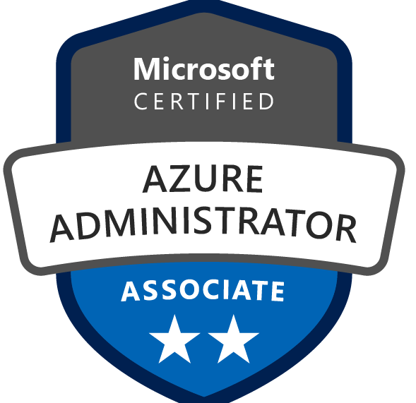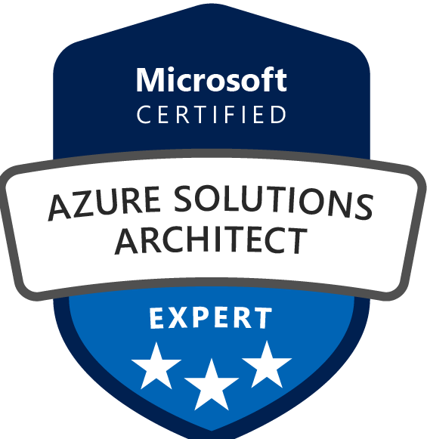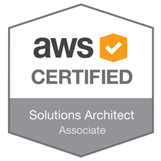

RAJU JAVVAJI
Systems Administrator
Infrastructure Management Services

Contact: 210-827-5565 Email: rajujavvaji155@gmail.com

Summary:
- IT Professional with 13+ years of experience. Expertise includes Windows 2008R2, 2012R2,2016 & 2019,2022, Linux, CentOS, VMware 5.5/6.5 Hyper-V 2008/2012, AWS Solutions Architect and Exchange 2007/2010, Cisco UCS B200 M3 Blades Administration, IBM Xclarity Administration, SCCM/Bigfix Administration. Held various positions as Windows System Engineer, Consolidation Engineer and Administrator in the Financial (Banking) Sector, Manufacturing and Corporate infrastructure environment.
- Implemented system integration, administration TCP/IP, LAN / WAN / Windows 2012R2, 2016,2019, IIS 6.0 Servers, VMware Infrastructure ESX, ESXi Server and VDI Desktop Provisioning.
- Extensive experience in Implementation, troubleshooting, system integration, Administration and Maintenance in Windows 2008 / 2012 Active Directory (AD), DHCP, DNS and DFS.
- Hands on experience on System Center 2012 R2 Configuration Manager with 15 distribution Points.
- Carrying out support activities with level L1& L2, L3 on 2008R2/2012/2016 and VMWare 6.0/6.5.
- Experience in Azure & AWS Cloud Technologies as IaaS, PaaS, and SaaS services & Private, Public, and Hybrid cloud deployment model & DevOps process implementation.
- Expertise in Microsoft Azure Cloud-native solutions by learning, training, certifying, migrating, and implementing it to the clients by using cloud technologies and native services.
- Maintenance of Production and Development Servers ensure the availability of the production databases to end-users and development database to developers in a 24x7 environment.
- Establish and maintain Backup & Recovery policies and procedures.
- Experienced and involved in designing and implementation of plan (BCP) and Disaster Recovery (DR) procedures.
- Implemented ITIL Policy and Procedures under Change Management for IT operations and Support.
- Experienced in constant monitoring of System Performance and involved in Day-to-Day trouble shooting for the end users.
- Experience in working large Data Centers spanning of 10000 + servers on 24/7 and on-call Production environment.
- Maintaining servers (Windows 2012/2008R2 Exchange 2003, DNS, DHCP, and VMware.
- Configuration of SCSI disks for RAID 0, 1, 5, 01, for IBM / HP / DELL & Blade Logic Servers.
- Installed and configured LAN/WAN equipment, Network Laser printer, Print Servers, TCP/IP Printers.
- Installed and configured backup and recovery solutions on Symantec Netback up, ArcServ and MS-Native Backups.

Certifications:

- Windows Server 2008 Active directory, Configuring.
- Windows Server 2008 Network Infrastructure, Configuring.
- ITIL V3 Foundation- Information Technology Infrastructure Library.
- VCP – VMware Certified Professional.
- AWS Certified Solutions Architect – Associate.

PROFESSIONAL EXPERIENCE
Client: Kyndryl -Viewpointe – Financial Settlement Systems.
April’02 2018–Till Date
Role: Sr. Wintel Engineer

- Perform day to day troubleshooting and maintaining of Windows\Linux Servers and VMWARE systems.
- Understanding of Data Center technologies and work with different team within a Data Center for a medium to large scale.
- Resolve incident from security scan minimizing any high to medium security threats on servers.
- Maintain and Administrate Windows 2012R2/2016/2019 Active Directory Services\ DNS for different forests with multiple site levels, federation between the AD forest.
- Created and provided an easy-to-use PowerShell scripts for generating the reports of environment like AD health check report, VM’s disk space report etc.
- Regularly monitor FSMO role owners and ensure they are healthy and accessible to avoid disruptions.
- Use tools like repadmin, dcdiag, and Event Viewer to monitor AD replication health and diagnose issues.
- Deployed enterprise-grade PKI infrastructure using Active Directory Certificate Services (AD CS) on Windows Server
- Configured Root and Subordinate Certificate Authorities, CRL distribution, and certificate templates for secure issuance and lifecycle management
- Integrated PKI with Azure VMs, IIS, RDP, and VPN endpoints to enforce secure authentication and encrypted communication
- Designed and implemented CaaS workflows for automated certificate provisioning, renewal, and revocation across hybrid environments
- Leveraged Ansible playbooks and Azure DevOps pipelines to automate certificate deployment and policy enforcement.
- Utilized ADMT and Quest tools for seamless domain migration and integration, ensuring minimal downtime and secure data transition.
- Led the migration of virtual machines (VMs) from on-premises infrastructure to Microsoft Azure cloud, ensuring minimal downtime and seamless transition.
- Utilized Azure Migrate and Azure Site Recovery to plan, execute, and optimize VM migration, ensuring compatibility and performance improvements.
- Designed and implemented migration strategies using lift-and-shift, re-platforming, and re-factoring approaches based on business needs.
- Managed DNS, DHCP, and DFS services, ensuring optimal replication and network resilience across all sites.
- Administered Active Directory Certificate Services (ADCS) to handle certificate distribution, ensuring secure communications within the organization.
- Assisted in the migration from on-premises Active Directory to Azure Active Directory, integrating with Microsoft Intune for mobile device management.
- Managed and optimized MECM infrastructure for patch management, application deployment, and operating system deployment (OSD).
- Implemented Microsoft Intune for mobile device management and integration with SCCM for hybrid environments.
- Coordinated with the security team to ensure all devices met compliance standards, using Windows Defender and BitLocker encryption.
- Supported LDAP-based integrations for enterprise applications, enhancing security and compliance
- Utilized vulnerability management solutions tenable scans to continuously monitor and assess the security posture of both Windows and Linux systems.
- Installed, configured and maintained the VMWare Horizon 7.6 VDI environment.
- Involved in deploy applications, upgrades and operating system security updates in the virtual desktop environment while working with application teams.
- Managed and maintained the security and performance of Linux servers by regularly applying critical security patches and updates using package managers (APT, YUM, DNF) on Ubuntu, CentOS, and RHEL systems.
- Managed IIS web servers, ensuring optimal performance and uptime for hosted applications.
- Provided technical support and training to users on IIS administration and security practices.
- Hardened Linux servers by configuring firewalls (e.g., iptables, firewalld) and implementing system hardening practices following industry best practices (e.g., CIS Benchmarks).
- Managed and maintained Red Hat Linux servers across multiple environments, ensuring optimal performance and reliability
- Assisted in upgrading Red Hat Satellite installations from version 5 to version 6, following best practices and minimizing disruptions
- Hands-on experience in create custom Bigifx Fixlet and Task to deploy the IBM WebSphere automation.
- Managed ThinApp and AppVolumes application delivery technologies.
- Managed user profiles with View persona management.
- Maintain and troubleshooting of ESXi servers, Virtual Center servers and windows virtual machines using VMware
- Configured and managed desktop pools, including automated provisioning and dynamic scaling based on user demand.
- Installed and managed VMware ESXi server 5.5/6.5/7.5 and created virtual machines on ESXi Servers.
- Using VMware vCenter, created Datacenter Environment by creating VMware clusters, adding ESX hosts in the clusters, and implemented HA and DRS.
- Performed Snapshots, Cloning, Cold Migrations and Hot Migrations using vMotion deploying new virtual servers, maintain templates, and perform updates when necessary
- Mitigate security vulnerabilities found in vulnerability scans and Plan & design the patch cycle and administrating of patch tools (SCCM 2012, Shavlik and BigFix).
- Monitoring Active Directory Replication, Active Directory Security like pwd lock outs etc.
- Managed multiple EMC DMX storage arrays, including provisioning and maintenance of LUNs and managing storage across multiple servers.
- Played a key role in developing the company’s DR plan, including defining RTO/RPO metrics, backup schedules, and data replication strategies.
- Led Windows Server 2019/2022 configuration and management, incorporating Windows Defender and Web Application Firewall (WAF) for secure server operations
- Supported the implementation and daily administration of Veritas NetBackup and TSM, including backup verification, job scheduling, and recovery tasks.
- Perform DISA STIGs against Windows servers and related installed software create and maintain system documentation and Standard Operating Procedures.

Company: Infosys, Alpharetta, GA Jan 2017 to March30th 2018
Client: CVS- Platform Support and Engineering Operations
Role: Sr. Windows Engineer

- Involved in Datacenter Migration.
- Managed successful migration of critical production and contingency servers with no impact to business.
- Managed migration of multiple application instances from infrastructure discovery to execution phase.
- Co-ordinated with all the infrastructure teams involved to ensure delivery of all clusters on schedule for application on-boarding.
- Using VMware vCenter, created Datacenter Environment by creating VMware clusters, adding ESX hosts in the clusters, and implemented HA and DRS.
- Cisco UCS 5000 Chassis implementation with B200 M3 blades.
- Corporation in initial UCS builds. Largest encoding farm architecture running is two UCS Pods (10 Chassis) with a total of 200 M3 Servers
- Cisco Unified Computing System (UCS) B200 M3 running ESX cluster
- Provided customer support for issues related to Active directory, DNS, Clusters, Antivirus, Group Policies, VM’s.
- Microsoft Office 365 (Cloud) and Microsoft Exchange Server 2010/2007 Administration and
Implementation and Migration specialist.
Implementing Lync Edge servers to establish communication between domains.
- Planning the batch for migration of mailboxes in Exchange 2007\2010 environment and
Preparing it for successful migration to Microsoft Office 365(Cloud).
- For ITSM (BMC Remedy) & Discovery (BMC ADDM) projects {Client – Leading US Insurance Company}, able to set equilibrium between contractual obligations, client requests, and team member’s deliverables. Thereby customer quality criteria is met and projects are delivered within schedules, yielding high CSAT rating.
- On technical front, performed BMC Discovery (ADDM) tool upgrades from 9.0 to 10.1 version and also from 10.1 to 11.1 versions.
- For multiple projects, Implemented BMC ADDM and scheduled scan jobs to inventory discovered assets into BMC remedy CMDB and also to ServiceNow CMDB. Designed an architecture to integrate BMC ADDM with ServiceNow CMDB via XML export scripts.
- Routine maintenance activities of ADDM servers like monthly TKU updates, taking a backup & performing compaction tasks are handled manually.

Company: Infosys, Atlanta, GA Aug 2016 to Jan 2017
Client: VOYA-Financial - AD Operations and VMware support
Role: Senior VDI Engineer
- Migrate Physical Servers to Virtual Server using VMware Converter (P2V Converter).
- Migrating of Virtual Machines using V Motion
- Creating Clusters for High Availability and Dynamic Resource Scheduling.
- Responsible to perform Tier III VDI design, troubleshooting and incident management.
- Responsible for system administrative functions to the VDI environment.
- Manage existing Health ways VDI environment (VMWare Horizon View), including desktop pools, image management, and physical/virtual infrastructure
- Provisioning VDI manual pools to end users support.
- Deploying VDI's Through Templates
- Develop and maintain O&S Standard Operating Procedures for VDI Environment
- Work directly with customers on boarding VDI
- Administered DNS, DHCP and WINS.
- Configured Group Policy Objects to create a secure Windows Infrastructure.
- Transitioned users from multiple legacy domains into a consolidated access configuration
- Creating and Managing Virtual Machines and Templates.
- Creating Clusters for High Availability (HA) and Distributive Resource Scheduling (DRS).

Company – Infosys Ltd, Texas May2011 to July 2016
Project: Capital Group- Infrastructure & Operations Server & VMware Team
Role: VMWare Windows Engineer

- Implemented VMware ESX5.x server to provide multiple virtual hardware platforms while keeping hardware costs and energy consumption down.
- Migrated obsolete hardware platforms to VMs via VMware Converter.
- VMware infrastructure administration such as, installation, migration, configuration and troubleshooting of ESX 3.x, 4.x & 5.x versions.
- Understanding of virtual infrastructure architecture and platform build.
- Extensive knowledge in advance features of ESX VMOTION, SVMOTION, HA and DRS.
- VM deployment using templates and P2V for production and development.
- Responsible to perform Tier III VDI design, troubleshooting and incident management.
- Using VMware vCenter, created Datacenter Environment by creating VMware clusters, adding ESX hosts in the clusters, and implemented HA and DRS.
- Administration of Windows 2000 and 2003 Servers.
- Provided support for Wintel Servers for the SCCM Patching Activity & Remediation task for entire global.
- Supported the deployment of Windows 7 to Windows 10 upgrade for 2,000+ users, leveraging SCCM and MDT for efficient rollout.
- Provided support for SCCM infrastructure, including content distribution, software update management, and reporting.
- Provided customer support for issues related to Active directory, DNS, Microsoft Clusters, Antivirus, Group Policies, VM’s. More than 7000+ servers etc.
- Handled issues of servers like Server Reboot, Power Cycling, Login issues, ESM remediation, SAV Remediation, DVMT Remediation...etc.
- Patched for Windows 2008R2/2012R2 Servers of Entire Global Operations using SCCM 2012.
- Hands on Data center migration: Managed successful migration of critical production and contingency servers with no impact to business.
- Migrated datacenters and converted physical servers to virtual servers using VMware convertor and HP Blade servers resulting in a reduction of racks and power usage, decrease downtime during maintenance and upgrades and improved monitoring.
- Implementation of changes on production servers in a large Web Center environment.
- Built servers for production and test environments following strict build procedures.
- Assisted in troubleshooting production issues with members of other teams within I.T.
- Troubleshoot server hardware issues and work with service providers to facilitate repairs.
- Responded to server alerts (e.g., disk space utilization, NetBackup alerts; and other alerts) also includes Monitoring Server Availability, Server health monitoring through OMI console.
- Data management: Add Group Permissions to NAS Shares, Move or Copy Files, Add/Remove Active Directory Group(s) to server for access according to established processes owned by Information Security, Share management.
- Storage Hardware Replacement Call outs in co-ordination with vendors like HP, IBM etc.
- Backup restores includes tape backups for 2003 & 2008 servers using VERITAS\Symantec Net Backup tool.
- PSP Firmware upgrades on Physical servers 2003 & 2008 R2.
- Server patching remediation (Deploy patches using SCCM/scripts, Reboot servers using script, help in patch compliance reporting, participate in patching related meetings).
- Experienced in writing scripts in some administrative language (batch file).
- Administered Microsoft IIS 7.5 and IIS 8.0 web servers.
- Installed and configured the IIS.

Previous Organization: Tech Mahindra (March2008 to Mar’ 2011)
Description:
Tech Mahindrais a leading global business and information Technology Company, delivering consulting, systems integration, and outsourcing solutions to clients in over 20 industries.
Project:

Client : Microsoft
Duration : March2008 to Mar’ 2011
Designation : Team Lead

Roles and Responsibilities:
- Aided clients, both internal and external to MS, in resolving and tracking complex issues with production servers.
- Support experience on Windows 2000/2003/2008 Servers.
- Supported and managed servers in production, pre-production and integration environments.
- Acted as liaison between the various business groups and IT groups to communicate issues and coordinate resolutions to production issues.
- Updated existing and create new knowledge base Articles for incidents and problems.
- Created and troubleshoot network connections for Hyper-V Virtual machines.
- Troubleshooting any DNS or name issues between servers in different domains.
- Hyper-V VM builds and Migrating VM’s from VS 2005 to Hyper-V hosts.

